Microbiology: An Introduction, 13e (Tortora et al.)
Chapter 2 Chemical Principles

2.1 Multiple-Choice Questions

1) Which of the following statements about the atom is 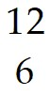C FALSE?
A) It has 6 protons in its nucleus.
B) It has 12 neutrons in its nucleus.
C) It has 6 electrons orbiting the nucleus.
D) Its atomic number is 6.
E) Its atomic weight is 12.
Answer: B
Section: 2.1
Bloom's Taxonomy: Understanding
Learning Outcome: 2.1
Global Outcome: 2

2) Table 2.1

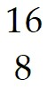O C 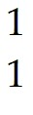H
Using the information in Table 2.1, calculate the molecular weight of ethanol, C2H5OH.
A) 96
B) 46
C) 34
D) 33
E) The answer cannot be determined.
Answer: B
Section: 2.1
Bloom's Taxonomy: Applying
Learning Outcome: 2.1
Global Outcome: 2

3) Antacids neutralize acid by the following reaction. Identify the salt in the following equation:
Mg(OH)2 + 2HCl → MgCl2 + H2O
A) Mg(OH)2
B) HCl
C) MgCl2
D) H2O
E) None of the answers is correct.
Answer: C
Section: 2.4
Bloom's Taxonomy: Understanding
Learning Outcome: 2.5

4) Which of the following statements is FALSE?
A) Salts readily dissolve in water.
B) Water molecules are formed by hydrolysis.
C) Water freezes from the top down.
D) Water is formed as a part of a dehydration synthesis reaction.
E) Water is a polar molecule.
Answer: B
Section: 2.4
Bloom's Taxonomy: Remembering
Learning Outcome: 2.4

5) Which of the following is the type of bond holding K+ and I- ions in KI?
A) ionic bond
B) covalent bond
C) hydrogen bond
Answer: A
Section: 2.2
Bloom's Taxonomy: Remembering
Learning Outcome: 2.2

6) Which of the following is the type of bond between molecules of water in a beaker of water?
A) ionic bond
B) covalent bond
C) hydrogen bond
Answer: C
Section: 2.2
Bloom's Taxonomy: Understanding
Learning Outcome: 2.2
Global Outcome: 7

7) What is the type of bond holding hydrogen and oxygen atoms together in a single H2O molecule?
A) ionic bond
B) covalent bond
C) hydrogen bond
Answer: B
Section: 2.2
Bloom's Taxonomy: Remembering
Learning Outcome: 2.2

8) Identify the following reaction: Glucose + Fructose → Sucrose + Water
A) dehydration synthesis reaction
B) hydrolysis reaction
C) exchange reaction
D) reversible reaction
E) ionic reaction
Answer: A
Section: 2.5
Bloom's Taxonomy: Analyzing
Learning Outcome: 2.7

9) Identify the following reaction: Lactose + H2O → Glucose + Galactose
A) dehydration synthesis reaction
B) hydrolysis reaction
C) exchange reaction
D) reversible reaction
E) ionic reaction
Answer: B
Section: 2.5
Bloom's Taxonomy: Analyzing
Learning Outcome: 2.7

10) Identify the following reaction: HCl + NaHCO3 → NaCl + H2CO3
A) dehydration synthesis reaction
B) hydrolysis reaction
C) exchange reaction
D) reversible reaction
E) ionic reaction
Answer: C
Section: 2.3
Bloom's Taxonomy: Analyzing
Learning Outcome: 2.3
Global Outcome: 2

11) Identify the following reaction: NH4OH ⇌ NH3 + H2O
A) dehydration synthesis reaction
B) hydrolysis reaction
C) exchange reaction
D) reversible reaction
E) ionic reaction
Answer: D
Section: 2.3
Bloom's Taxonomy: Analyzing
Learning Outcome: 2.3
Global Outcome: 2

12) Which type of molecule contains the alcohol glycerol?
A) carbohydrate
B) phospholipids
C) DNA
D) protein
Answer: B
Section: 2.5
Bloom's Taxonomy: Remembering
Learning Outcome: 2.9

13) Which type of molecule is composed of (CH2O) units?
A) carbohydrate
B) lipid
C) nucleic acid
D) protein
Answer: A
Section: 2.5
Bloom's Taxonomy: Remembering
Learning Outcome: 2.8

14) Which type of molecule contains -NH2 (amino) groups?
A) carbohydrate
B) triglycerides
C) nucleic acid
D) protein
Answer: D
Section: 2.5
Bloom's Taxonomy: Remembering
Learning Outcome: 2.10

15) Which type of molecule NEVER contains a phosphate group?
A) triglycerides
B) phospholipid
C) nucleic acid
D) ATP
Answer: A
Section: 2.5
Bloom's Taxonomy: Understanding
Learning Outcome: 2.9

16) Based upon the valence numbers of the elements magnesium (2) and hydrogen (1), predict how many covalent bonds would form between these atoms to achieve the full complement of electrons in their outermost energy shells.
A) one
B) two
C) three
D) four
Answer: B
Section: 2.2
Bloom's Taxonomy: Analyzing
Learning Outcome: 2.2
Global Outcome: 2

17) Table 2.1

O C H
Using the information in Table 2.1, calculate the number of moles in 92 grams of ethanol, C2H5OH.
A) 1
B) 2
C) 3
D) 4
E) The answer cannot be determined.
Answer: B
Section: 2.2
Bloom's Taxonomy: Analyzing
Learning Outcome: 2.2
Global Outcome: 4

18) Which of the following statements regarding protein structure is FALSE?
A) The primary structure is formed by covalent bonding between amino acid subunits.
B) Secondary structures are formed only from hydrogen bonds.
C) Tertiary structures are formed only from covalent bonds.
D) Quaternary structures involved multiple polypeptides.
Answer: C
Section: 2.5
Bloom's Taxonomy: Understanding
Learning Outcome: 2.10

19) Which of the following pairs is mismatched?
A) NaOH ⇌ Na+ + OH- is a base
B) HF ⇌ H+ + F- is an acid
C) MgSO4 ⇌ Mg2+ + 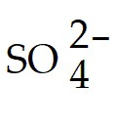 is a salt
D) KH2PO4 ⇌ K+ + H2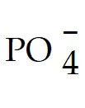 is an acid
E) H2SO4 ⇌ 2H+ + is an acid
Answer: D
Section: 2.4
Bloom's Taxonomy: Analyzing
Learning Outcome: 2.5
Global Outcome: 2

20) Table 2.2

NaOH ⇌ Na+ + OH- is a base
HF ⇌ H+ + F- is an acid
MgSO4 ⇌ Mg2+ + is a salt
KH2PO4 ⇌ K+ + H2 is an acid
H2SO4 ⇌ 2H+ + is an acid
Which of the following statements about the reactions in Table 2.2 is FALSE?
A) They are exchange reactions.
B) They are ionization reactions.
C) They occur when the reactants are dissolved in water.
D) They are dissociation reactions.
E) They are reversible reactions.
Answer: A
Section: 2.3
Bloom's Taxonomy: Analyzing
Learning Outcome: 2.3
Global Outcome: 2

21) What is the type of weak bond between the hydrogen of one molecule and the nitrogen of another molecule, where the two don't actively share an electron?
A) ionic bond
B) covalent bond
C) hydrogen bond
D) disulfide bond
E) hydrophobic bond
Answer: C
Section: 2.2
Bloom's Taxonomy: Remembering
Learning Outcome: 2.2
Global Outcome: 7

22) What is the type of strong chemical bond between carbon, hydrogen, and oxygen atoms in a single organic molecule?
A) ionic bond
B) covalent bond
C) hydrogen bond
Answer: B
Section: 2.2
Bloom's Taxonomy: Remembering
Learning Outcome: 2.2
Global Outcome: 7

23) What is the type of bond between ions in salt?
A) ionic bond
B) covalent bond
C) hydrogen bond
Answer: A
Section: 2.2
Bloom's Taxonomy: Remembering
Learning Outcome: 2.2
Global Outcome: 7

24) A scientist wants to perform a test that will indicate whether a nucleic acid sample is composed of either RNA or DNA. Testing for the presence of which of the following is most appropriate in this situation?
A) phosphate
B) nitrogen
C) guanine
D) uracil
E) thymine
Answer: D
Section: 2.5
Bloom's Taxonomy: Understanding
Learning Outcome: 2.11
Global Outcome: 2

25) Structurally, ATP is most like which type of molecule?
A) carbohydrate
B) lipid
C) protein
D) nucleic acid
Answer: D
Section: 2.5
Bloom's Taxonomy: Understanding
Learning Outcome: 2.12

26) What do genes consist of?
A) carbohydrates
B) lipids
C) proteins
D) nucleic acids
Answer: D
Section: 2.5
Bloom's Taxonomy: Remembering
Learning Outcome: 2.11
Global Outcome: 7

27) Which molecule is composed of a chain of amino acids?
A) carbohydrate
B) lipid
C) protein
D) nucleic acid
Answer: C
Section: 2.5
Bloom's Taxonomy: Remembering
Learning Outcome: 2.10

28) Which are the primary molecules making up plasma membranes in cells?
A) carbohydrates
B) lipids
C) proteins
D) nucleic acids
Answer: B
Section: 2.5
Bloom's Taxonomy: Remembering
Learning Outcome: 2.9
Global Outcome: 7

29) The antimicrobial drug imidazole inhibits sterol synthesis. This would most likely interfere with
A) bacterial cell walls.
B) fungal cell walls.
C) eukaryotic plasma membranes.
D) prokaryotic plasma membranes.
E) genes.
Answer: C
Section: 2.5
Bloom's Taxonomy: Analyzing
ASMcue Outcome: 3.4
Learning Outcome: 2.9
Global Outcome: 2

Figure 2.1

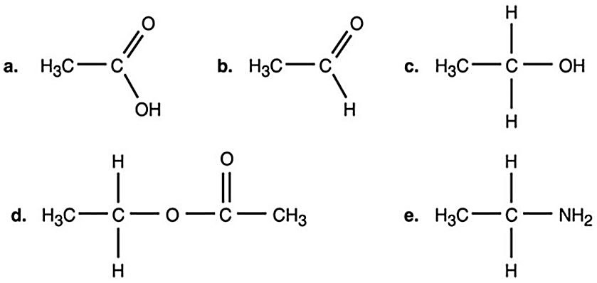

30) In Figure 2.1, which is an alcohol?
A) a
B) b
C) c
D) d
E) e
Answer: C
Section: 2.5
Bloom's Taxonomy: Analyzing
Learning Outcome: 2.7
Global Outcome: 3

31) Which compound in Figure 2.1 is an ester?
A) a
B) b
C) c
D) d
E) e
Answer: D
Section: 2.5
Bloom's Taxonomy: Analyzing
Learning Outcome: 2.7
Global Outcome: 3

32) Which compound in Figure 2.1 is an organic acid?
A) a
B) b
C) c
D) d
E) e
Answer: A
Section: 2.5
Bloom's Taxonomy: Analyzing
Learning Outcome: 2.6
Global Outcome: 3

33) Most amino acids found in cells demonstrate what type of chirality?
A) L-isomers
B) D-isomers
C) C-isomers
D) B-isomers
E) A-isomers
Answer: A
Section: 2.5
Bloom's Taxonomy: Remembering
Learning Outcome: 2.10

34) Figure 2.3

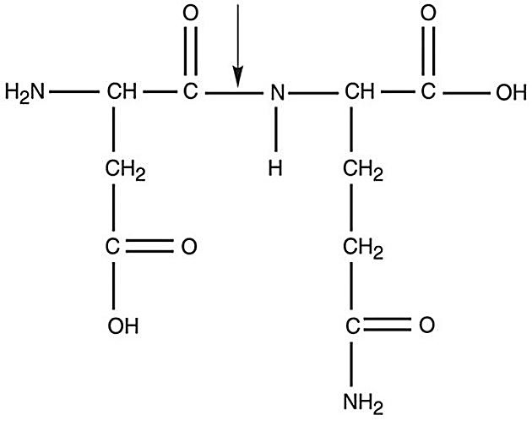

What kind of bond is at the arrow in Figure 2.3?
A) disulfide bridge
B) double covalent bond
C) hydrogen bond
D) ionic bond
E) peptide bond
Answer: E
Section: 2.5
Bloom's Taxonomy: Analyzing
Learning Outcome: 2.10
Global Outcome: 3

35) An E. coli culture that has been growing at 37°C is moved to 25°C. Which of the following changes must be made in its plasma membrane to help it cope with the decrease in temperature?
A) The number of phosphate groups must increase.
B) The viscosity must increase.
C) The number of saturated chains must increase.
D) The number of unsaturated chains must increase.
E) No changes are necessary.
Answer: D
Section: 2.5
Bloom's Taxonomy: Understanding
Learning Outcome: 2.9

36) Radioisotopes are frequently used to label molecules in a cell. The fate of atoms and molecules in a cell can then be followed. Assume Saccharomyces cerevisiae is grown in a nutrient medium containing the radioisotope 35S. After a 48-hour incubation, the 35S would most likely be found in the S. cerevisiae's
A) carbohydrates.
B) nucleic acids.
C) water.
D) lipids.
E) proteins.
Answer: E
Section: 2.5
Bloom's Taxonomy: Understanding
Learning Outcome: 2.10
Global Outcome: 2

37) Radioisotopes are frequently used to label molecules in a cell. The fate of atoms and molecules in a cell can then be followed. Assume Saccharomyces cerevisiae is grown in a nutrient medium containing the radioisotope 32P. After a 48-hour incubation, the majority of the 32P would be found in the S. cerevisiae's
A) plasma membrane.
B) cell wall.
C) water.
D) proteins.
E) carbohydrates.
Answer: A
Section: 2.5
Bloom's Taxonomy: Understanding
Learning Outcome: 2.9
Global Outcome: 2

38) Starch, dextran, glycogen, and cellulose are polymers of
A) amino acids.
B) glucose.
C) fatty acids.
D) nucleic acids.
E) acids.
Answer: B
Section: 2.5
Bloom's Taxonomy: Remembering
Learning Outcome: 2.8

39) Which of the following is a base?
A) C2H5OCOOH → H+ + C2H5OCOO-
B) C2H5OH
C) NaOH → Na+ + OH-
D) H2O → H+ + OH-
E) H2CO
Answer: C
Section: 2.4
Bloom's Taxonomy: Analyzing
Learning Outcome: 25
Global Outcome: 2

40) Two glucose molecules are combined by a dehydration synthesis reaction to make a maltose molecule. What is the chemical formula for maltose?
A) C3H6O3
B) C6H12O6
C) C12H24O12
D) C12H22O11
E) C12H23O10
Answer: D
Section: 2.5
Bloom's Taxonomy: Understanding
Learning Outcome: 2.8
Global Outcome: 3

41) If an amino acid contained a large hydrocarbon (a group of multiple carbons and hydrogens linked together) as its side group, in which of the following categories could it be appropriately designated?
A) hydrophilic
B) polar
C) nonpolar
D) basic
E) acidic
Answer: C
Section: 2.5
Bloom's Taxonomy: Analyzing
Learning Outcome: 2.10
Global Outcome: 2

42) Identify the two functional groups that interact to form a peptide bond.
A) amino group and carboxyl group
B) carboxyl group and ester group
C) amino group and ester group
D) ester group and hydroxyl group
E) hydroxyl group and amino group
Answer: A
Section: 2.5
Bloom's Taxonomy: Applying
Learning Outcome: 2.10

43) A dehydration synthesis reaction between glucose (C6H12O6) and fructose (C6H12O6) produces a molecule of sucrose (C12H22O11). Why don't the two individual molecular formulae add up to the same number of atoms in the sucrose product?
A) Oxygen must be burned/consumed during the reaction.
B) In a dehydration reaction, a water molecule (H2O) is removed from the final molecule formed.
C) In a dehydration reaction, a water molecule (H2O) is added to the final molecule formed.
D) Hydrogen must be burned/consumed during the reaction.
Answer: B
Section: 2.5
Bloom's Taxonomy: Applying
Learning Outcome: 2.7

44) In terms of similarities, which two molecules would be isomers of each other?
A) glucose and sucrose
B) glucose and maltose
C) sucrose and fructose
D) fructose and glucose
Answer: D
Section: 2.5
Bloom's Taxonomy: Applying
Learning Outcome: 2.8

45) Subtle differences exist in the plasma membrane molecules of the organisms in the three Domains. _______ functional groups are found in the plasma membrane molecules of bacteria and eukarya, while ________ functional groups are found in the plasma membrane molecules of archaea.
A) amino; carboxyl
B) ether; ester
C) ester; ether
D) ketone; aldehyde
E) aldehyde; ketone
Answer: C
Section: 2.5
Bloom's Taxonomy: Applying
Learning Outcome: 2.9

46) What is the main/most important factor that differentiates methanol, ethanol, and isopropanol from each other?
A) the specific location of the hydroxyl functional group
B) the number of carbon atoms in the molecule
C) the number of hydrogen atoms in each molecule
D) the location of the carboxyl functional group
E) the number of hydroxyl functional groups present
Answer: B
Section: 2.5
Bloom's Taxonomy: Applying
Learning Outcome: 2.7

47) A friend tells you that he recently read an article claiming that you need to work to restore the alkalinity of your blood to remain healthy. Why is this impossible and impractical (and unhealthy even if you could make it happen)?
A) The normal pH of human blood is in the acidic range, so making it alkaline would kill you.
B) Blood is usually around the neutral (pH 7) range, not the alkaline range, in healthy human beings.
C) Blood contains buffers that prevent the pH from changing too drastically, so trying to forcibly alter blood pH wouldn't work effectively.
D) The normal pH of human blood is already in the alkaline range, so it isn't necessary to "restore" it to that point.
E) Blood is usually around the neutral (pH 7) range, not the alkaline range, in healthy human beings AND blood contains buffers that prevent the pH from changing too drastically, so trying to forcibly alter blood pH wouldn't work effectively.
Answer: E
Section: 2.4
Bloom's Taxonomy: Applying
Learning Outcome: 2.5

48) Which one of the following microbes would grow best at pH 1-3.5?
A) Cyanobacteria in ocean water
B) Propionibacterium acnes bacteria on human skin
C) Acidithiobacillus ferrooxidans in the runoff from a copper mine
Answer: C
Section: 2.4
Bloom's Taxonomy: Applying
ASMcue Outcome: 3.3
Learning Outcome: 2.5

49) You put a spoonful of table salt, NaCl, into a glass of water and it dissolves. You repeat this test, but drop the spoonful of salt into a glass of vegetable oil instead. What happens, and why?
A) The salt doesn't dissolve because oil is nonpolar, and couldn't dissociate the ionic bond between the Na+ and Cl- ions.
B) The salt dissolves in the oil just the same as it did in the water.
C) The salt dissolves in the oil, but takes much longer to do so because oil molecules move more slowly than water, slowing the dissolution process down.
D) The salt doesn't dissolve because oil is polar, and only nonpolar solvents would cause the dissociation of the Na+ and Cl- ions in the table salt.
Answer: A
Section: 2.2
Bloom's Taxonomy: Applying
Learning Outcome: 2.2

50) Which one of the following would be the most difficult covalent bond to break in a chemical reaction?
A) Na+ and Cl- in NaCl
B) two oxygen atoms in a molecule of O2
C) two nitrogen atoms in a molecule of N2
D) two hydrogen atoms in a molecule of H2
Answer: C
Section: 2.2
Bloom's Taxonomy: Applying
Learning Outcome: 2.2

2.2 True/False Questions

1) Elements only achieve the full complement of electrons in outermost energy shells by donating away or sharing electrons.
Answer: FALSE
Section: 2.1
Bloom's Taxonomy: Understanding
Learning Outcome: 2.1

2) Covalent bonds are always shared equally.
Answer: FALSE
Section: 2.2
Bloom's Taxonomy: Remembering
Learning Outcome: 2.2
Global Outcome: 7

3) Individual covalent bonds are stronger than individual ionic bonds.
Answer: TRUE
Section: 2.2
Bloom's Taxonomy: Remembering
Learning Outcome: 2.2

4) All chemical reactions are, in theory, reversible.
Answer: TRUE
Section: 2.3
Bloom's Taxonomy: Remembering
Learning Outcome: 2.3

5) The formation of ADP from ATP can be defined as a hydrolytic reaction.
Answer: TRUE
Section: 2.5
Bloom's Taxonomy: Remembering
Learning Outcome: 2.12

6) The density of liquid water is greater than the density of ice.
Answer: TRUE
Section: 2.4
Bloom's Taxonomy: Remembering
Learning Outcome: 2.4

7) A basic solution is expected to contain more hydrogen ions than hydroxyl ions.
Answer: FALSE
Section: 2.4
Bloom's Taxonomy: Understanding
Learning Outcome: 2.5
Global Outcome: 7

8) All forms of life function optimally at a pH of 7.
Answer: FALSE
Section: 2.4
Bloom's Taxonomy: Remembering
Learning Outcome: 2.5

9) Water has recently been discovered to be lying just underneath the soil on Mars. This means it is possible life as we know it may also exist (or may once have existed) on Mars.
Answer: TRUE
Section: 2.4
Bloom's Taxonomy: Understanding
Learning Outcome: 2.4
Global Outcome: 2

10) Carbon dioxide is an organic molecule.
Answer: FALSE
Section: 2.4
Bloom's Taxonomy: Remembering
Learning Outcome: 2.6
Global Outcome: 2

2.3 Essay Questions

1) Describe how the properties of phospholipids make these molecules well suited for plasma membranes.
Section: 2.5
Bloom's Taxonomy: Evaluating
Learning Outcome: 2.9
Global Outcome: 8

2) Figure 2.5

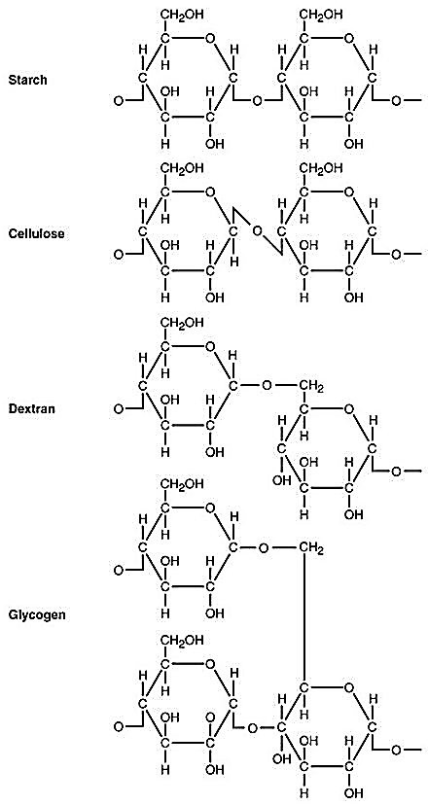

Use Figure 2.5 to answer the following. Starch, cellulose, dextran, and glycogen are polysaccharides. How are they similar? To what are their different properties due? Why can't an enzyme that hydrolyzes starch degrade cellulose?
Section: 2.5
Bloom's Taxonomy: Evaluating
Learning Outcome: 2.8
Global Outcome: 8

3) Compare a molecule of a nucleotide to ATP. Could a cell simply insert ATP into DNA without altering it? Explain.
Section: 2.5
Bloom's Taxonomy: Evaluating
Learning Outcome: 2.12
Global Outcome: 8

4) A scientist claims that when a protein is denatured, it can be expected that its secondary structure will more likely be retained when compared to all other levels of protein structure structures. Do you agree? Explain.
Section: 2.5
Bloom's Taxonomy: Creating
Learning Outcome: 2.10
Global Outcome: 8

5) Water has recently been found just beneath the soil on Mars, but in frozen form. What does this mean for both the prospect of finding life on Mars in some form, but also for the possibility of humans to survive on/colonize the surface of Mars?
Section: 2.4
Bloom's Taxonomy: Evaluating
Learning Outcome: 2.4
Global Outcome: 2

