CHAPTER 2
SOCIAL RESPONSIBILITY AND HUMAN RESOURCE MANAGEMENT

A. OVERVIEW
This chapter discusses the some of the challenges face by human resource management in responding to changes in society as well as issues related to ethics and social responsibility.
Near-constant changes in workforce composition, skills, worker expectations and work-life relationships require well-conceived and effectively implemented HR practices and systems that must be continuously reviewed from a strategic point of view. Pressure from a variety of external constituents and/or the desire to “do the right thing” greatly influence decisions related to ethics and social responsibility and are influenced and affected by human resource management.

B. LECTURE OUTLINE

- OPENING CASE - Safeway
In response to escalating competition, Safeway developed a program designed to make it an employer of choice. Given that most of its customers were female, Safeway developed a “Championing Change for Women” program designed to promote the development of its female employees into managers. The program provided flexibility relative to its hours, allowing employees to achieve work/family balance. As part of its program it also developed the Women’s Road show, in which female executives visited various locations throughout the country to assist with learning, networking and development.

- WORKFORCE DEMOGRAPHIC CHANGES AND DIVERSITY
  - Demographic changes in society have greatly impacted the composition of the workforce. In addition, numerous laws protect diverse groups in our society from discrimination in employment Most organizations have developed some kind of diversity management program in response to one or both of these factors.
  - Diversity initiatives can be designed to ensure legal compliance or to truly promote and encourage respect for others and differences. There is a marked difference between a diversity programs that attempt to address these motivations, as illustrated in Exhibit 2.1.
  - Diversity is a strategic business issue for an overwhelming majority of organizations/employers. Pricewaterhouse Coopers has created the position of Chief Diversity Officer which reports directly to the Chairman of the Board.
  - Generational diversity is becoming increasingly prevalent as individuals live and remain in the workplace longer than in previous years. Different generations need to be able to work alongside each other in contemporary organizations. Exhibit 2.2 illustrates some of the characteristics of different generations found in the workplace. Retailer Abercrombie and Fitch has developed practices which effective allow it to manage Generation Y employees. Generation Z employees share many similarities with those of Generation Y but also have some important differences.
  - Increasing laws and company policies which prohibit discrimination based on sexual orientation have been implemented. The ongoing evolution of same-sex marriage has created dilemmas and challenges for employees. Similarly, gender identity has become an increasingly important diversity issue with many state and local laws which prohibit discrimination based on gender identity or expression as noted in Exhibit 2.3.
  - Religion and religious expression has is becoming an increasingly salient issue for organizations with a significant increase in discrimination claims being filed.
  - Individuals with disabilities are protected by the Americans With Disabilities Act yet still suffer from stigmatization and underemployment. Walgreens has implemented a model program to assist with the employment of individuals with disabilities.

  - Hasbro, Texas Instruments, Intel and PepsiCo have both developed innovative approaches for managing diversity in the workplace.
  - Other dimensions of diversity which create challenges for organizations include the management of professionals, shifting employee loyalty and personal and family life dynamics.
  - The development and support of affinity groups is one way in which organizations manage and encourage diversity. Both Frito-Lay and PepsiCo have successfully embraced this strategy with successful business results.

- ETHICAL BEHAVIOR
  - Many employers are now considering ethics and ethical behavior in light of major bankruptcies, scandals and business meltdowns. However, ethics are subject to personal values and convictions.
  - Common ethical concerns for HR include off-duty behavior, ownership of work and non-compete clauses. These latter two issues have been dealt with at Intel through an intraprenuership program. The use of medical marijuana has become an important consideration for employers given the conflict between federal and state laws.
  - Ownership of work and the use of non-complete clauses are two areas of ethical concern for employers and employees.
  - The Sarbanes-Oxley Act of 2002 provides sweeping measures to control deception in accounting and management practices by increasing government oversight of financial reporting, holding senior executives more responsible that previously and protecting whistle blowers.
  - Many organizations and some industries have developed their own code of ethics. The Society of Human Resource Management (SHRM) has developed such a code for HR professionals, displayed in Exhibit 2.6. This code presents core principles, intent and guidelines in a number of areas, including: Professional Responsibility; Professional Development; Ethical Leadership; Fairness and Justice; Conflicts of Interest; and Use of Information. Exhibit 2.7 provides some guides for developing a code of ethics or code of conduct.

- CORPORATE SOCIAL RESPONSIBILITY/SUSTAINABILITY

Corporate social responsibility in the form of sustainability involves taking a more macro approach to managing an organization’s relationship with its external environment. Organizations are being increasingly expected to consider the effects of their operations, decision and business on the social and natural environment. Exhibit 2.8 examines some of the proven positive links between environment and economic performance. General Electric has developed a model program related to sustainability and Gap has set standards for offshoring of its manufacturing operations. Exhibit 2.9 provides some HR-related standards of the Global Reporting Initiative. Brandix has been a model employer in the area of social responsibility.

- CONCLUSION
  - Organizations operate in dynamic environments are must evolve and adapt to changes in society, including changing demographics and lifestyles and expectations to contribute to, rather than take from, the larger society.
  - Human resource management strategies can facilitate organizational responses to society.

C. EXHIBITS

EXHIBIT 2.1

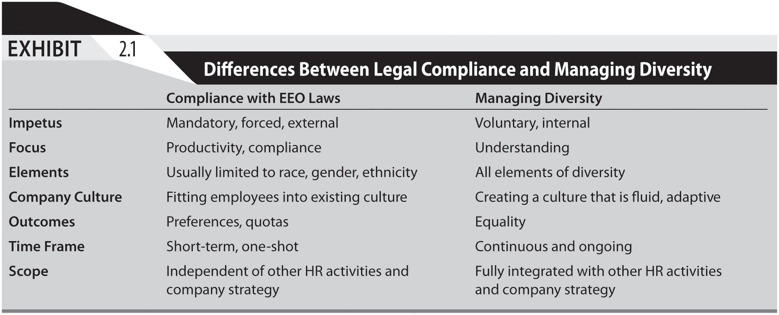

EXHIBIT 2.2
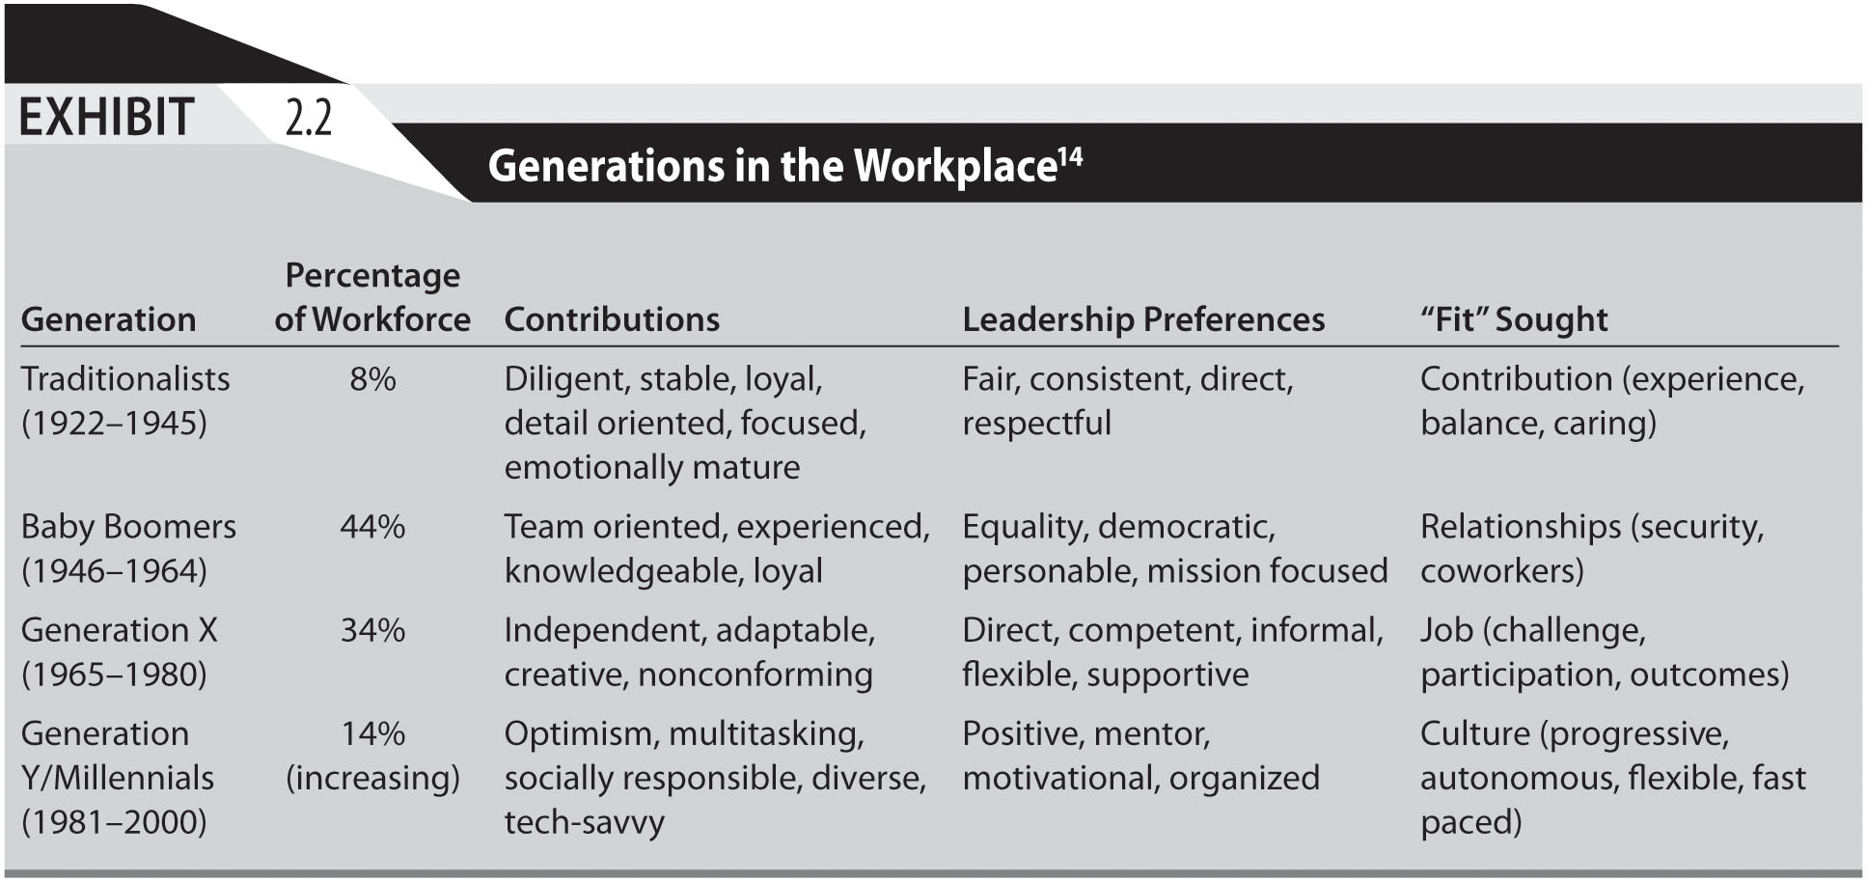
EXHIBIT 2.3
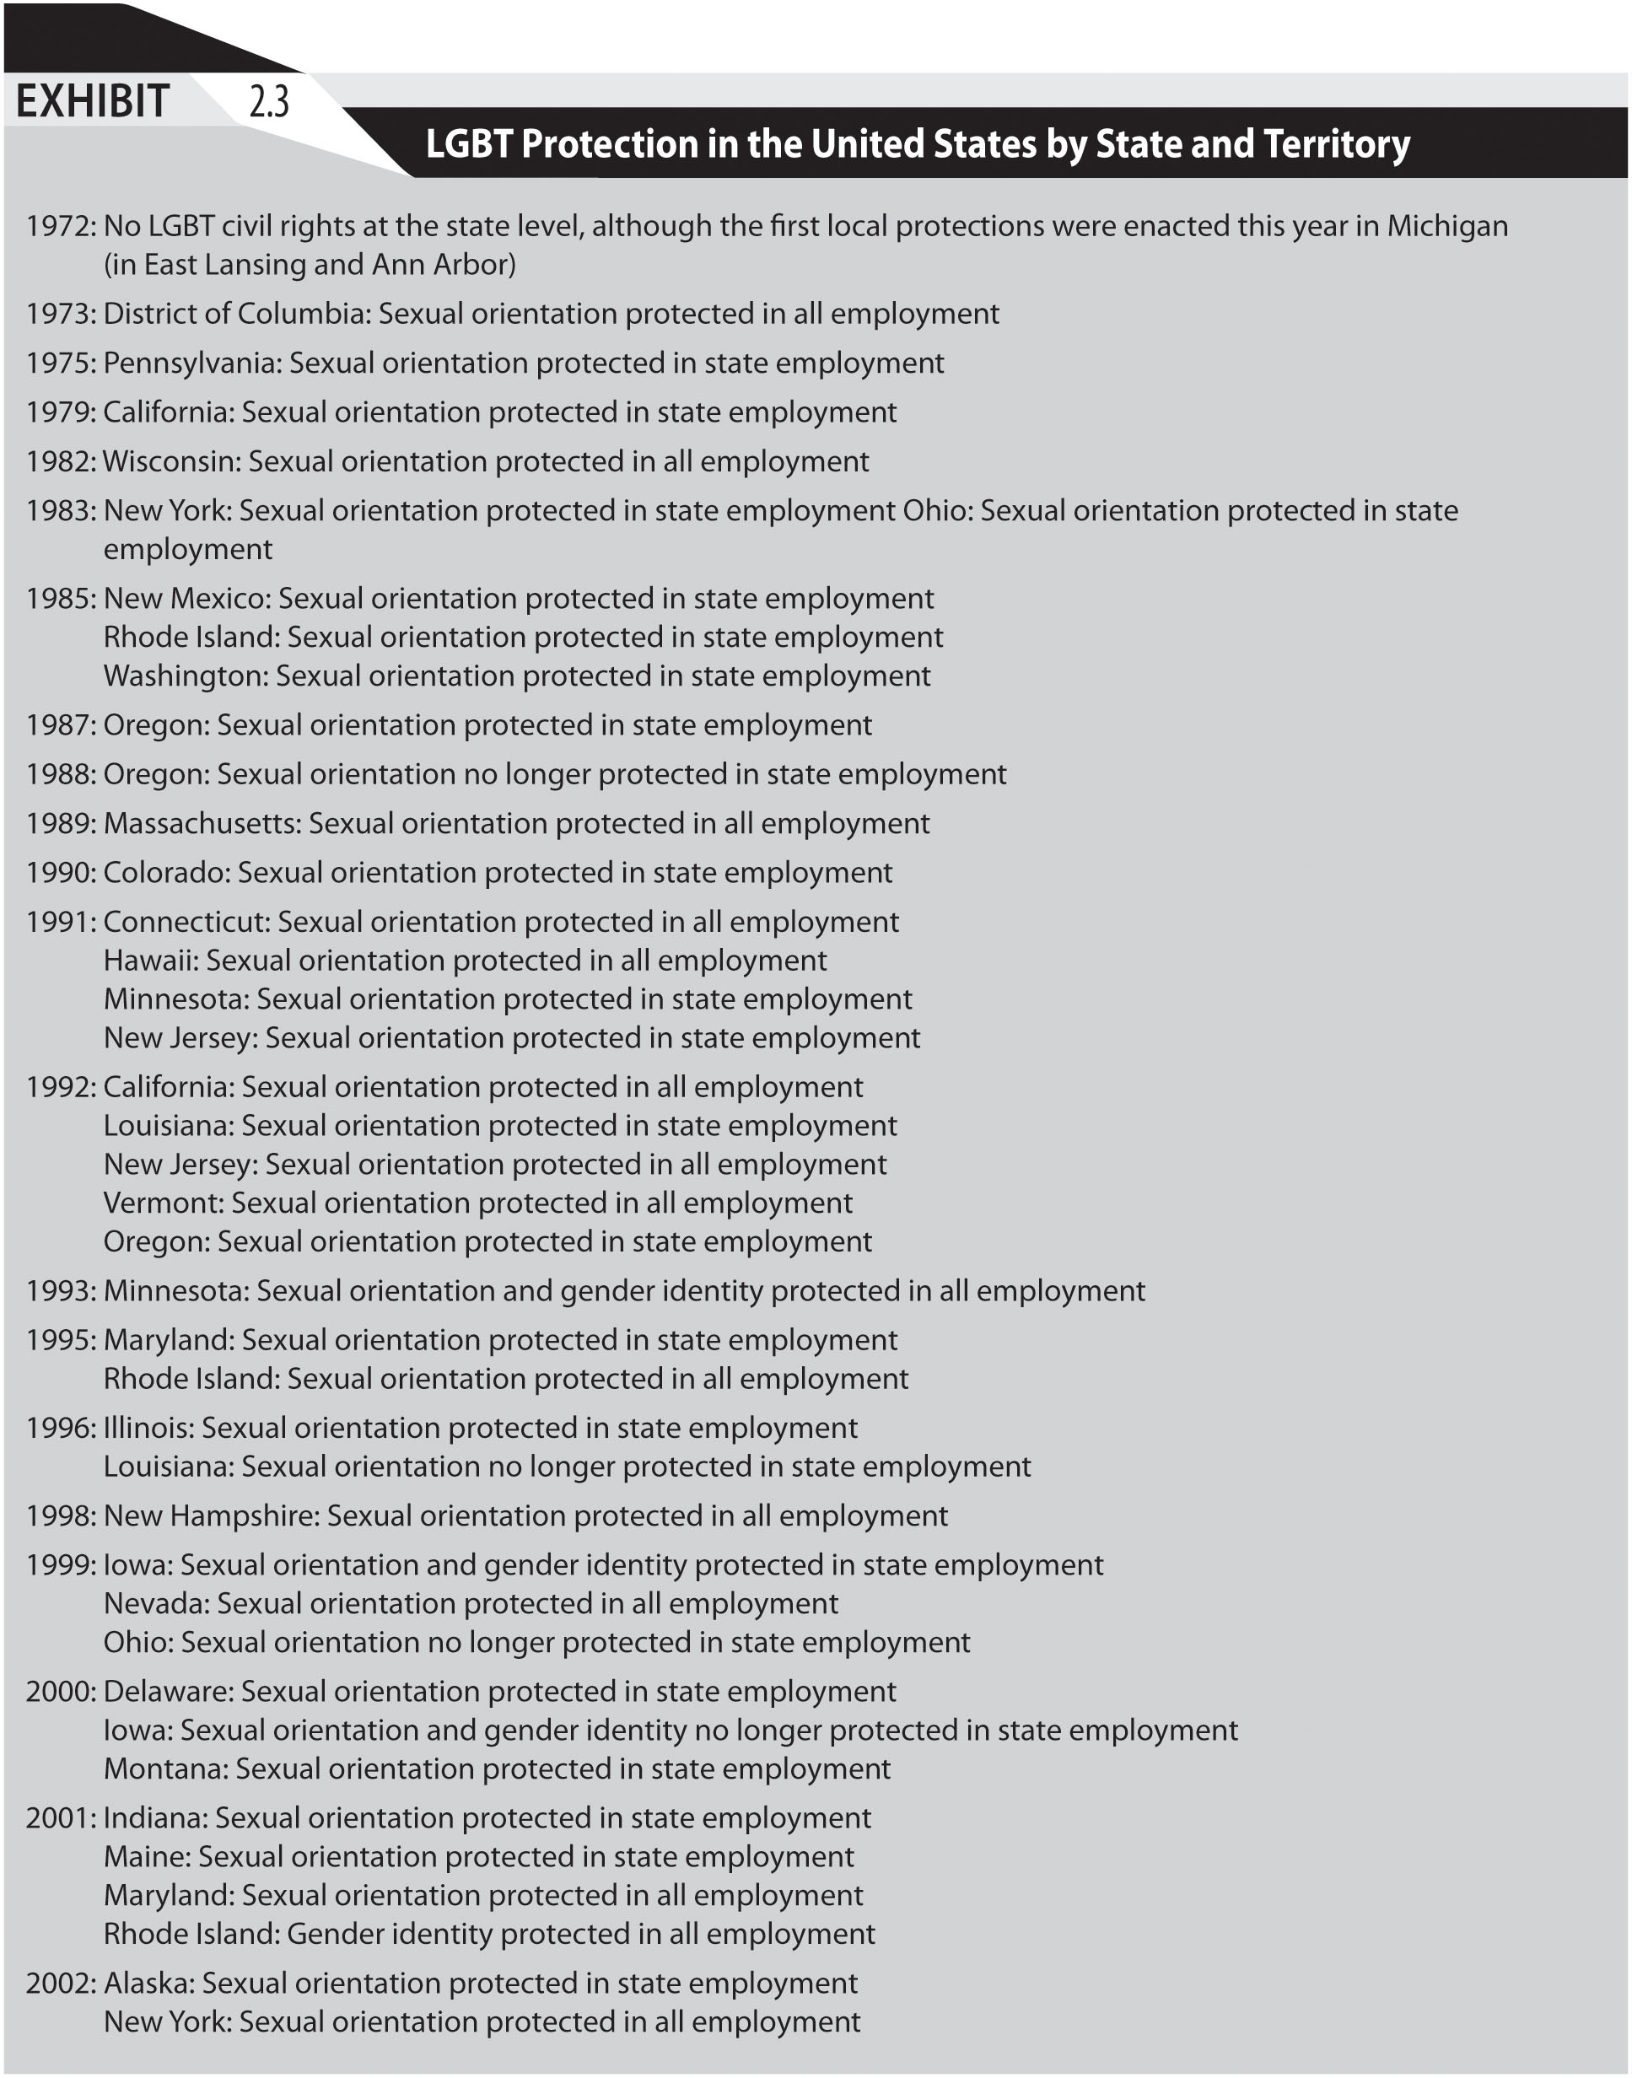
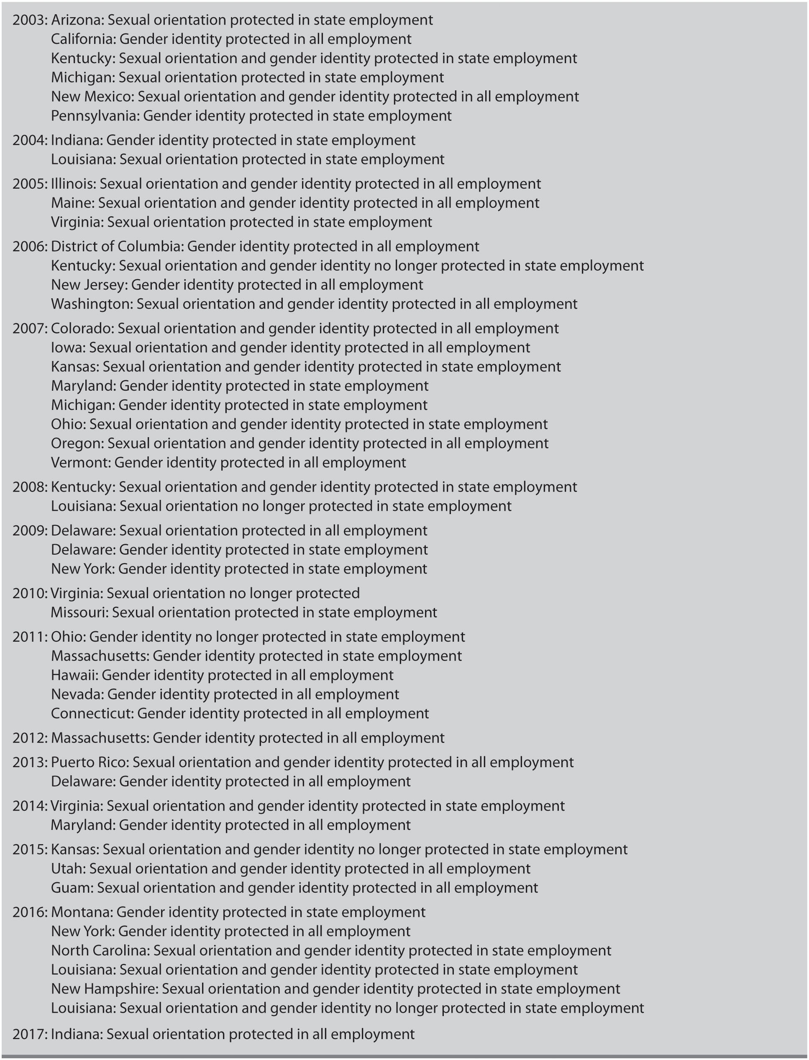

EXHIBIT 2.4

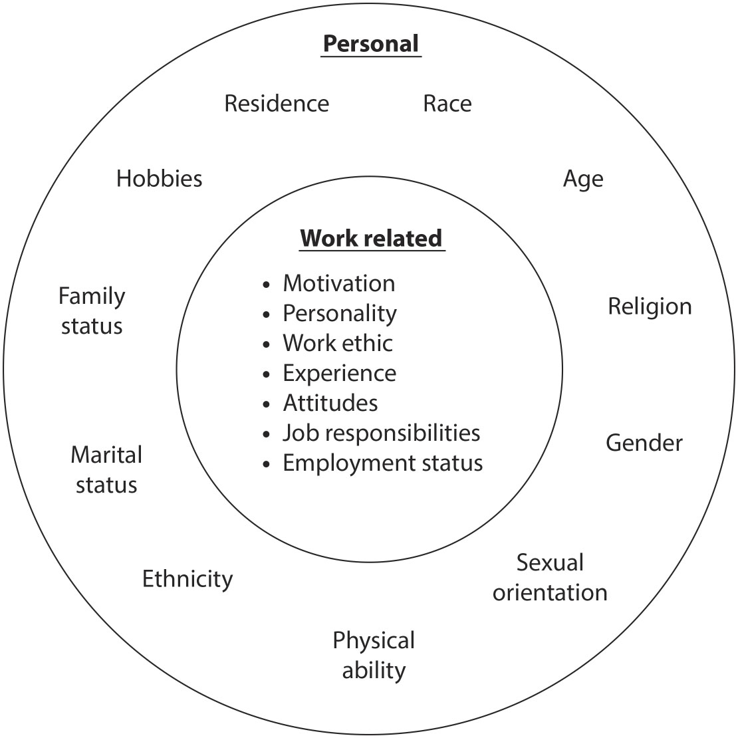

EXHIBIT 2.5

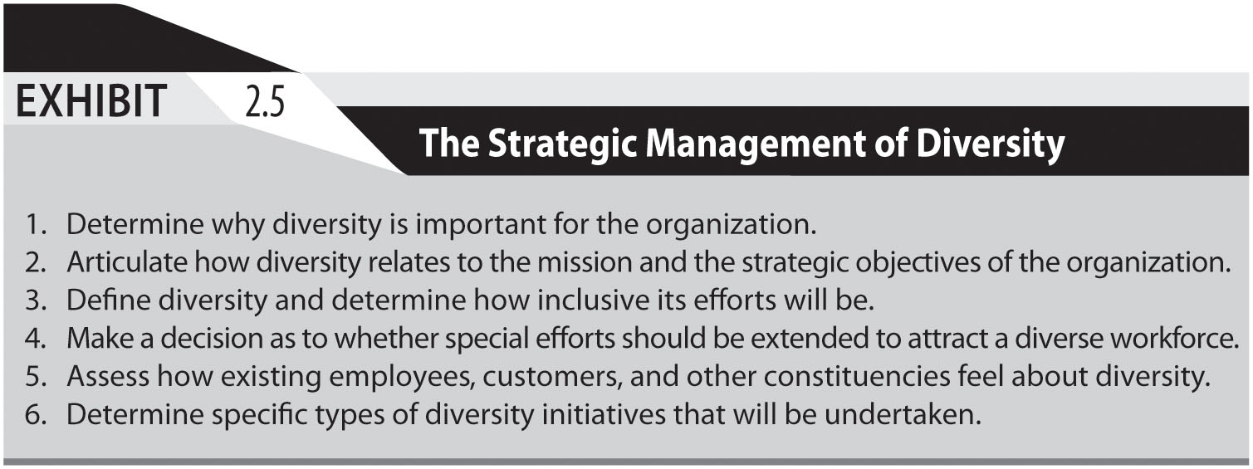

EXHIBIT 2.6
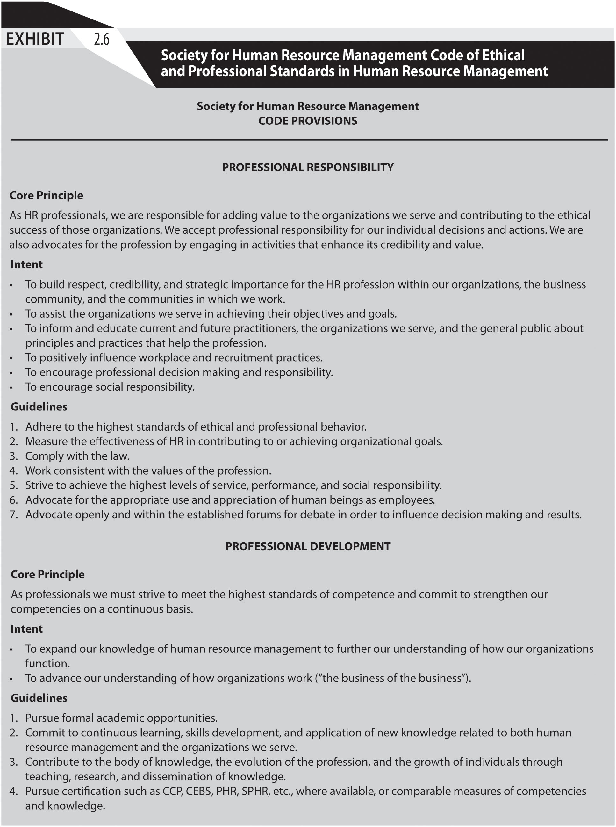
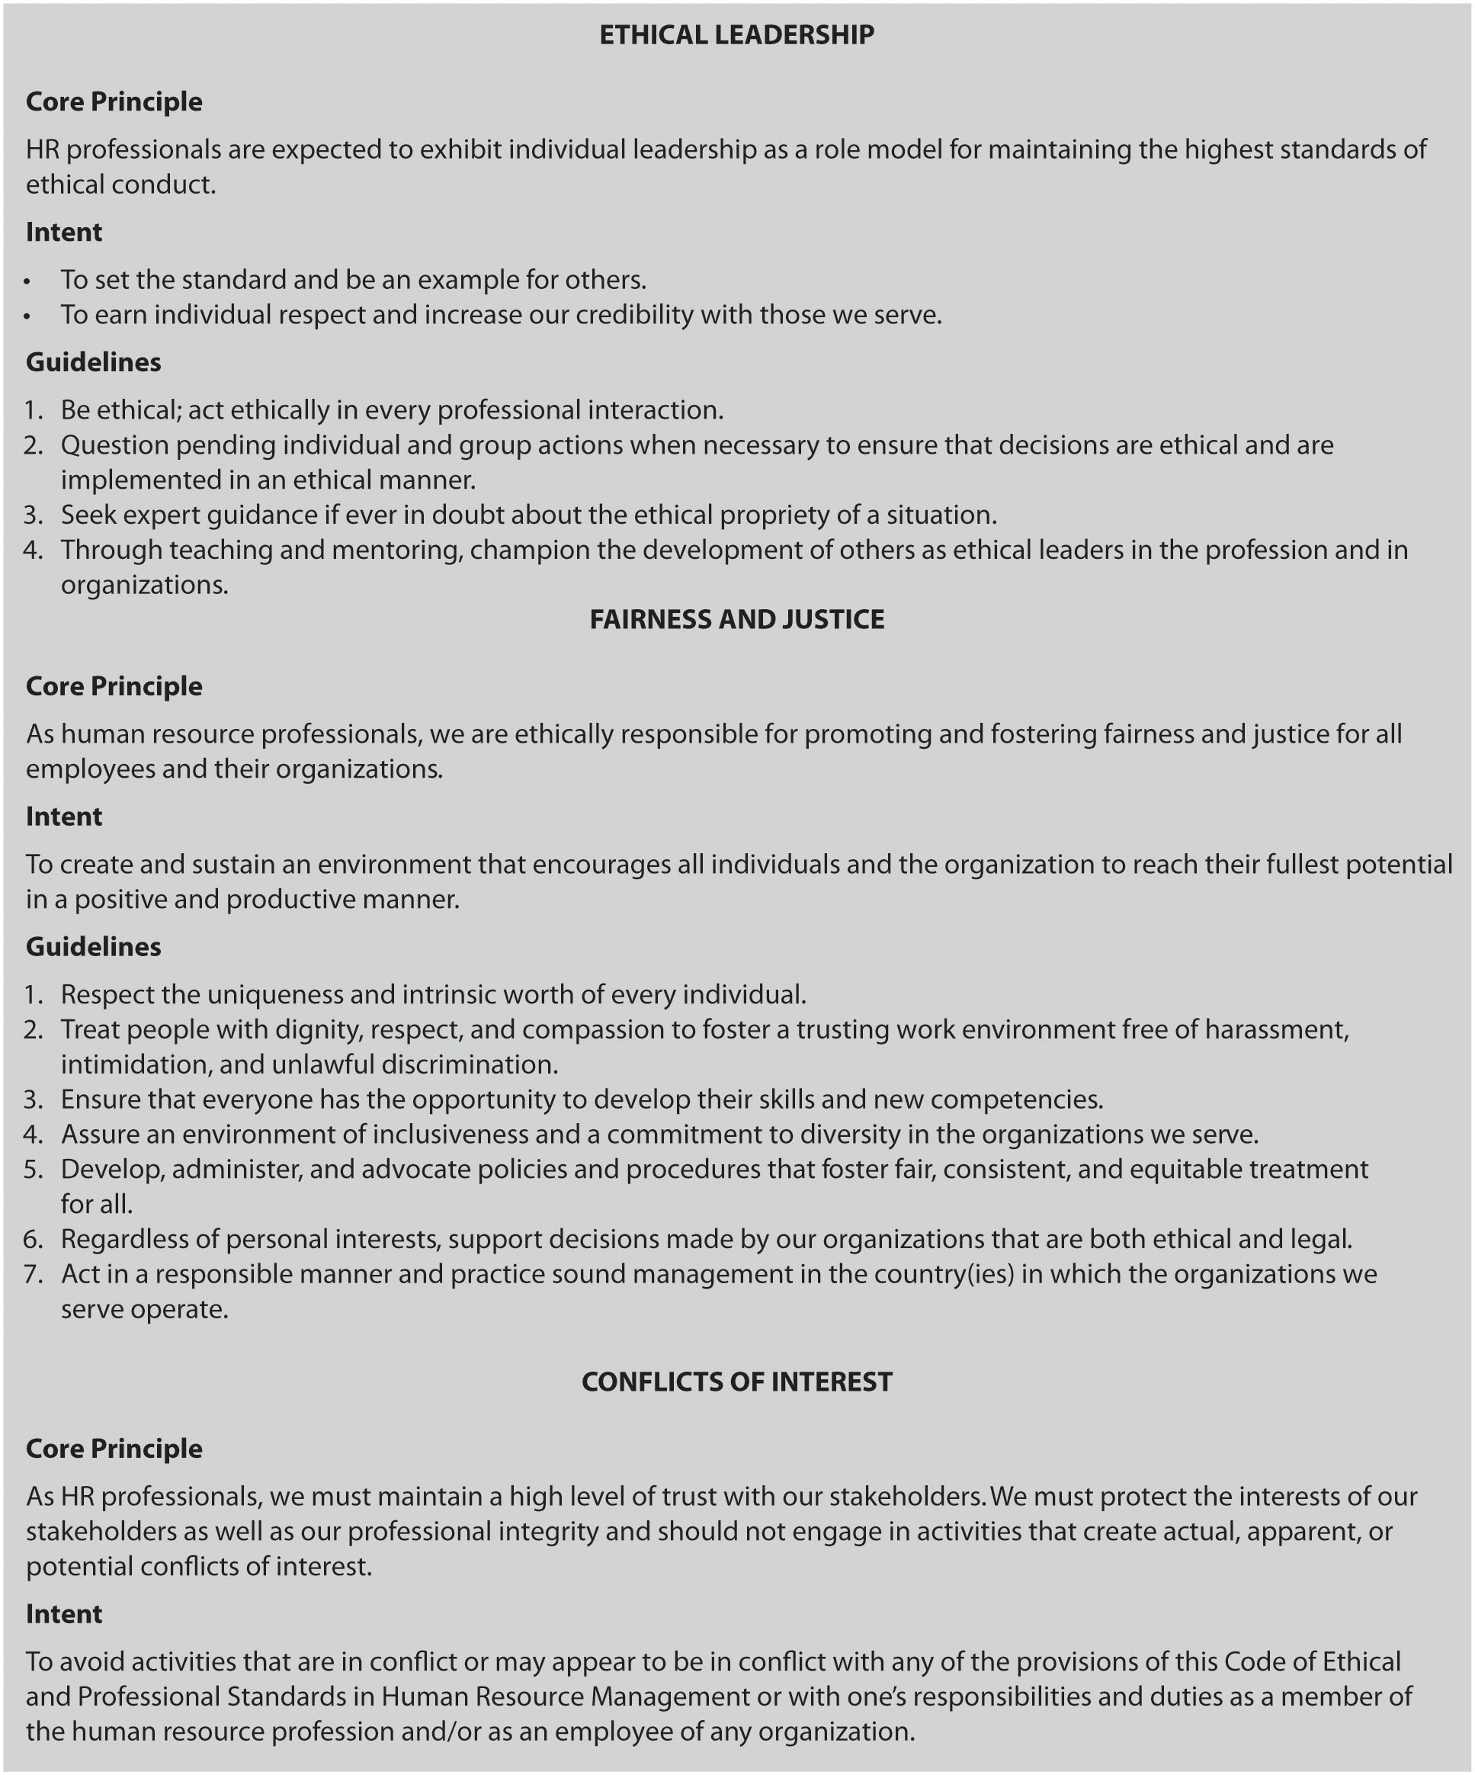
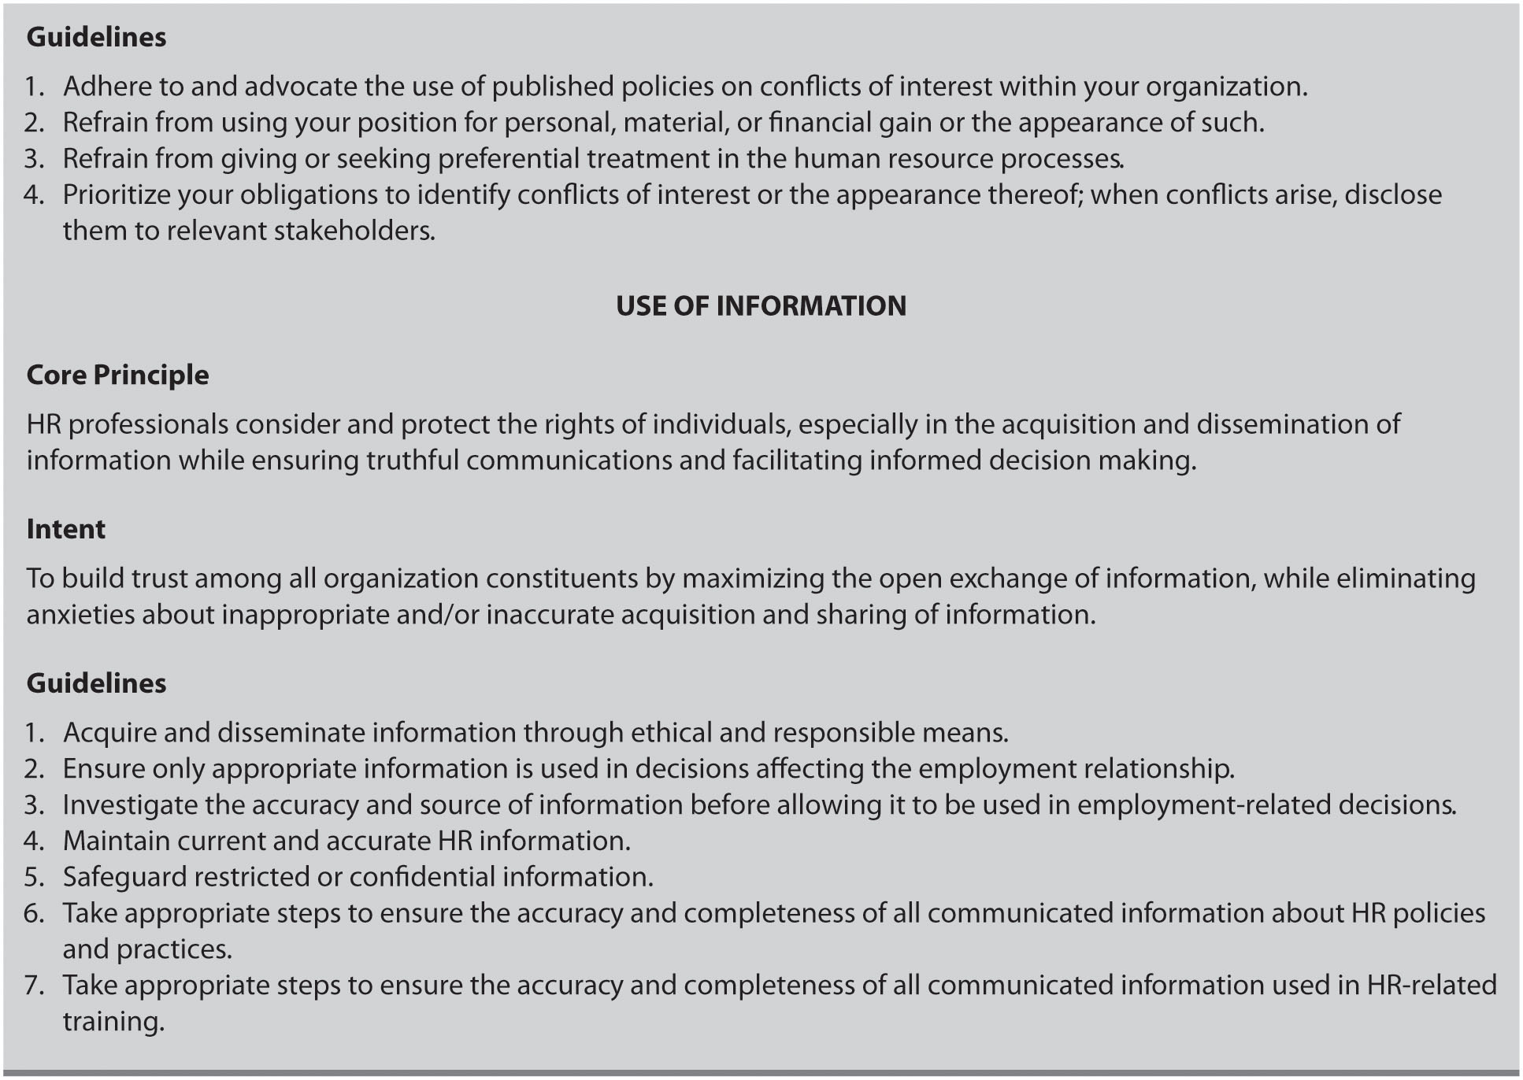

EXHIBIT 2.7

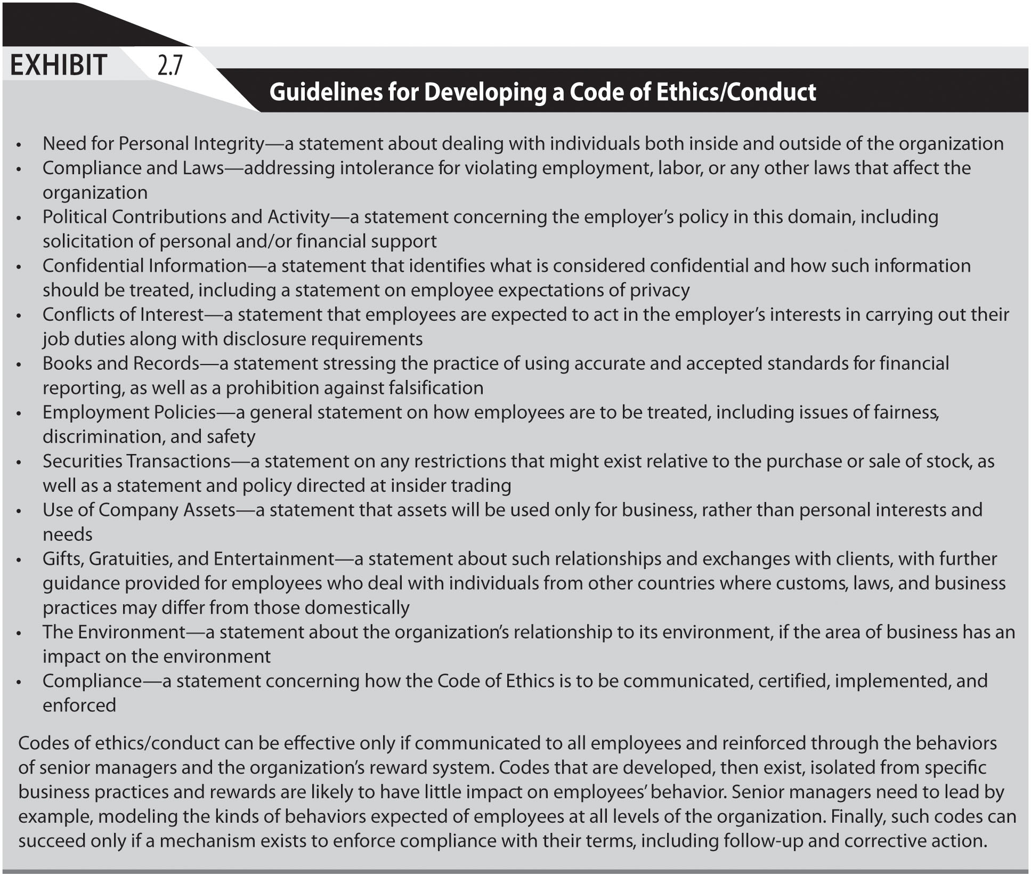

EXHIBIT 2.8

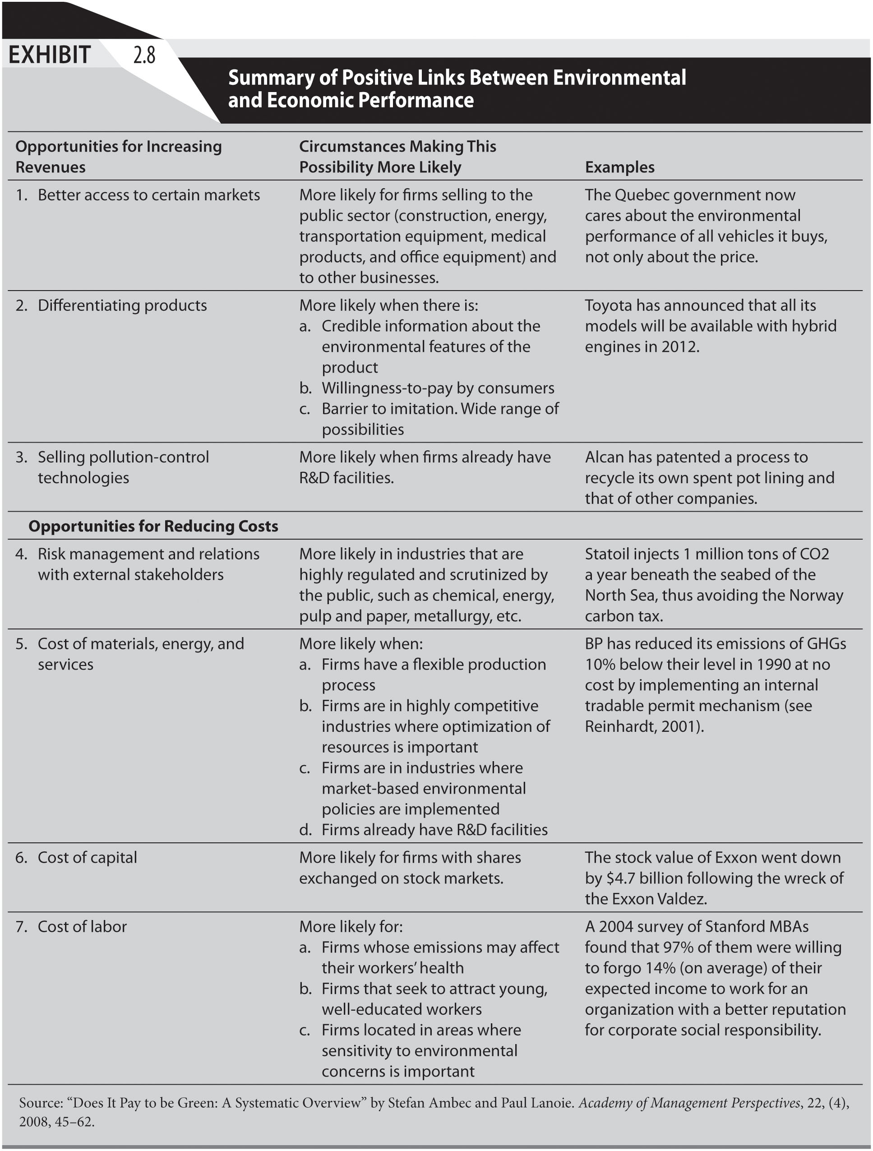
EXHIBIT 2.9

