University Physics with Modern Physics, 14e, Global Edition (Young/Freedman)
Chapter 2 Motion Along a Straight Line

2.1 Conceptual Questions

1) If the acceleration of an object is negative, the object must be slowing down.
A) True
B) False
Answer: B
Var: 1

2) If the graph of the position as a function of time for an object is a horizontal line, that object cannot be accelerating.
A) True
B) False
Answer: A
Var: 1

3) If an object is accelerating toward a point, then it must be getting closer and closer to that point.
A) True
B) False
Answer: B
Var: 1

4) When can we be certain that the average velocity of an object is always equal to its instantaneous velocity?
A) always
B) never
C) only when the velocity is constant
D) only when the acceleration is constant
E) only when the acceleration is changing at a constant rate
Answer: C
Var: 1

5) Suppose that an object is moving with constant nonzero acceleration. Which of the following is an accurate statement concerning its motion?
A) In equal times its speed changes by equal amounts.
B) In equal times its velocity changes by equal amounts.
C) In equal times it moves equal distances.
D) A graph of its position as a function of time has a constant slope.
E) A graph of its velocity as a function of time is a horizontal line.
Answer: B
Var: 1
6) Suppose that a car traveling to the west (the -x direction) begins to slow down as it approaches a traffic light. Which statement concerning its acceleration in the x direction is correct?
A) Both its acceleration and its velocity are positive.
B) Both its acceleration and its velocity are negative.
C) Its acceleration is positive but its velocity is negative.
D) Its acceleration is negative but its velocity is positive.
Answer: C
Var: 1

7) The motion of a particle is described in the velocity versus time graph shown in the figure. We can say that its speed

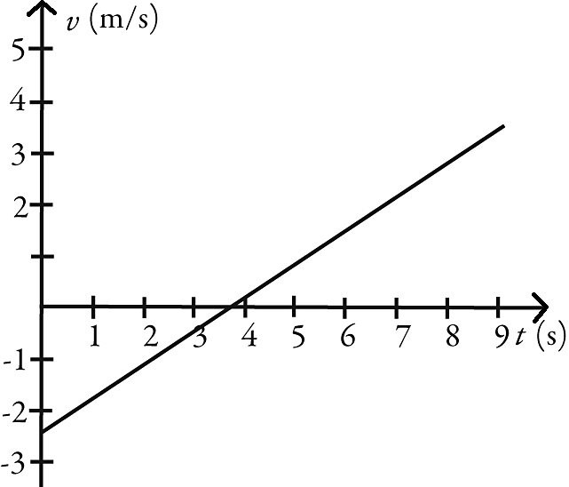

A) increases.
B) decreases.
C) increases and then decreases.
D) decreases and then increases.
Answer: D
Var: 1
8) The motions of a car and a truck along a straight road are represented by the velocity-time graphs in the figure. The two vehicles are initially alongside each other at time t = 0. At time T, what is true about these two vehicles since time t = 0?

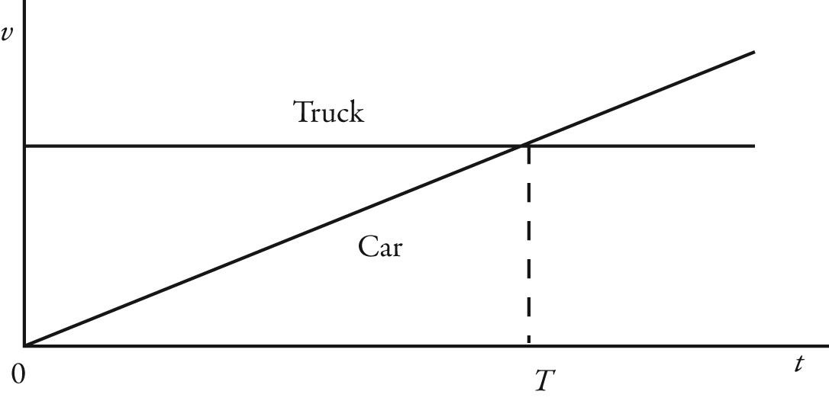
A) The truck will have traveled further than the car.
B) The car will have traveled further than the truck.
C) The truck and the car will have traveled the same distance.
D) The car will be traveling faster than the truck.
Answer: A
Var: 1

9) The graph in the figure shows the position of an object as a function of time. The letters H-L represent particular moments of time. At which moments shown (H, I, etc.) is the speed of the object
(a) the greatest?
(b) the smallest?

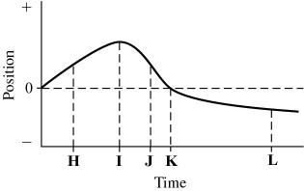
Answer: (a) J (b) I
Var: 1
10) The figure shows the position of an object (moving along a straight line) as a function of time. Assume two significant figures in each number. Which of the following statements about this object is true over the interval shown?

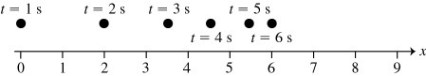

A) The object is accelerating to the left.
B) The object is accelerating to the right.
C) The acceleration of the object is in the same direction as its velocity.
D) The average speed of the object is 1.0 m/s.
Answer: A
Var: 1

11) The figure shows the graph of the position x as a function of time for an object moving in the straight line (the x-axis). Which of the following graphs best describes the velocity along the x-axis as a function of time for this object?
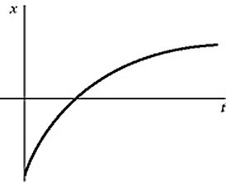

A)
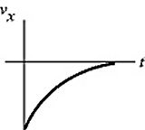
B)
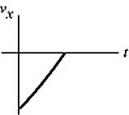
C)
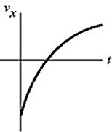
D)
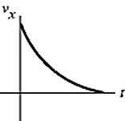
E)
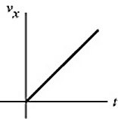
Answer: D
Var: 1
12) An object is moving with constant non-zero acceleration along the +x-axis. A graph of the velocity in the x direction as a function of time for this object is
A) a horizontal straight line.
B) a vertical straight line.
C) a straight line making an angle with the time axis.
D) a parabolic curve.
Answer: D
Var: 1

13) An object is moving in a straight line along the x-axis. A plot of its velocity in the x direction as a function of time is shown in the figure. Which graph represents its acceleration in the x direction as a function of time?

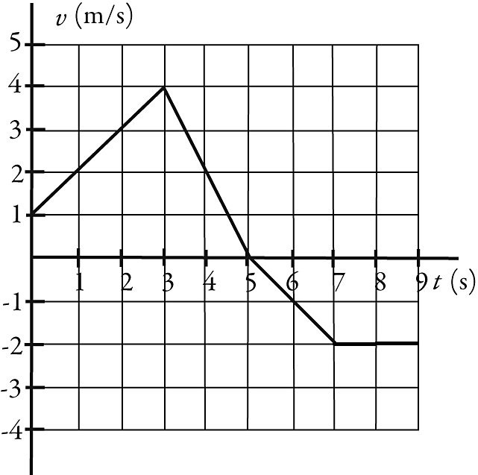

A)
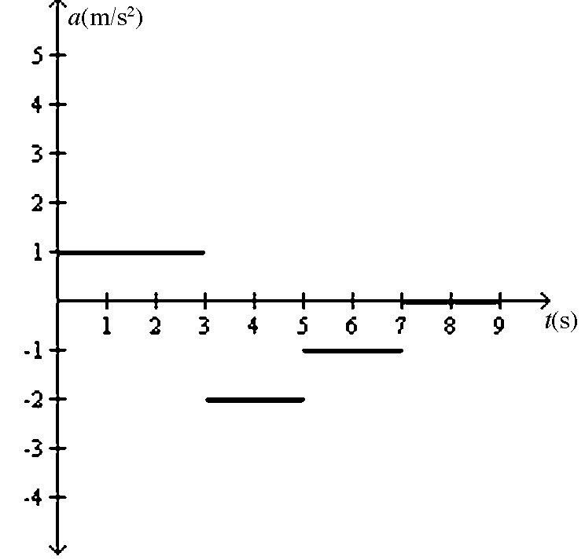
B)
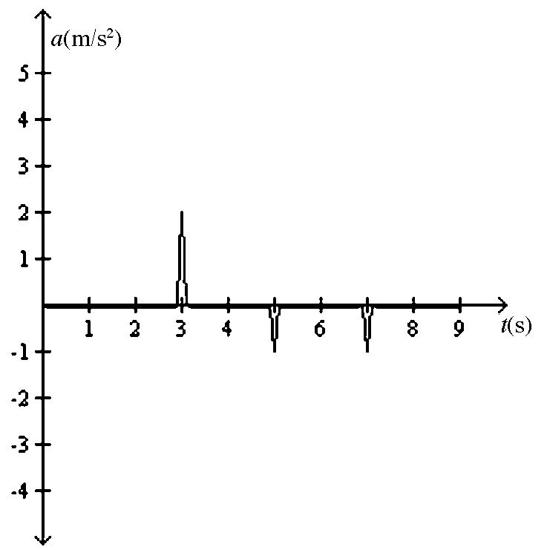
C)
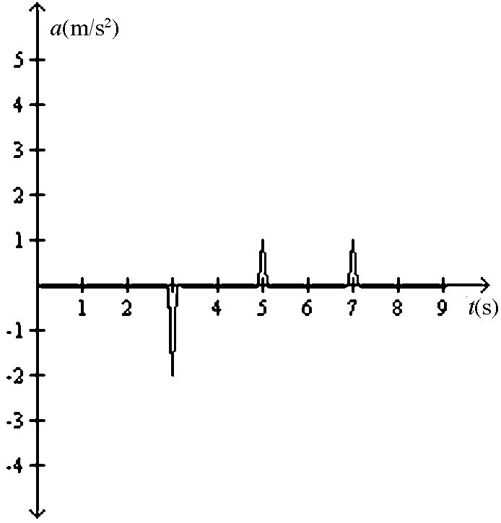
D)
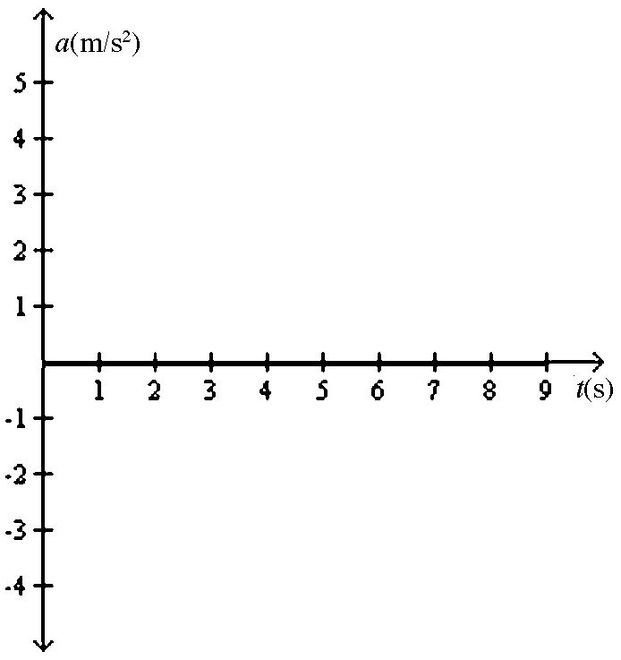
E)
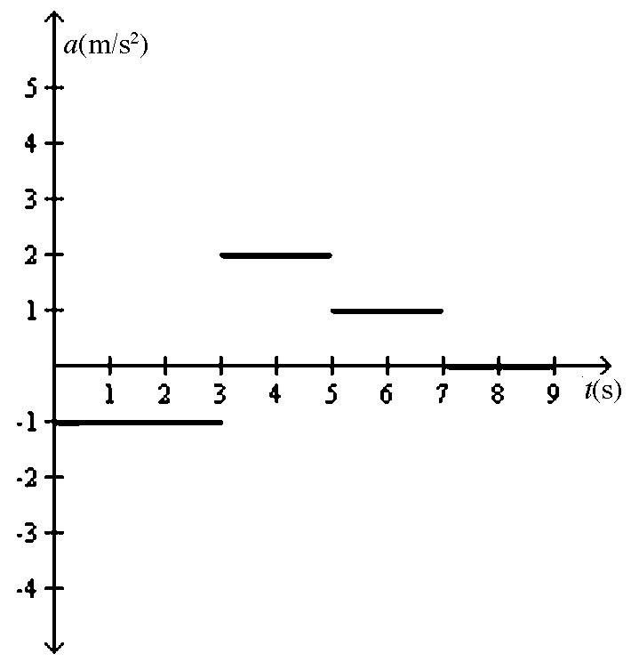
Answer: C
Var: 1

14) An object starts its motion with a constant velocity of 2.0 m/s toward the east. After 3.0 s, the object stops for 1.0 s. The object then moves toward the west a distance of 2.0 m in 3.0 s. The object continues traveling in the same direction, but increases its speed by 1.0 m/s for the next 2.0 s. Which graph below could represent the motion of this object?
A)
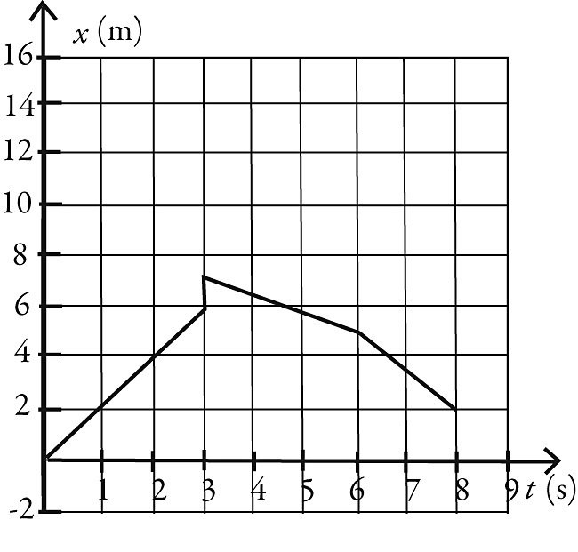
B)
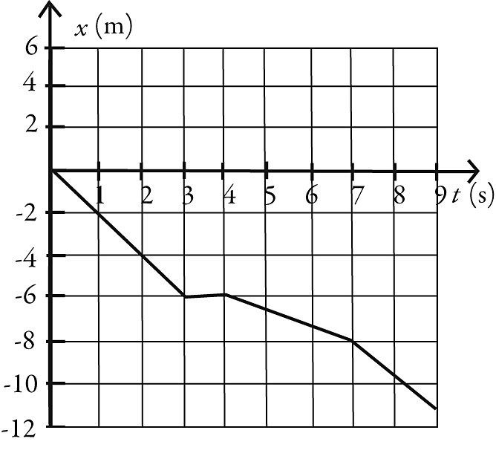
C)
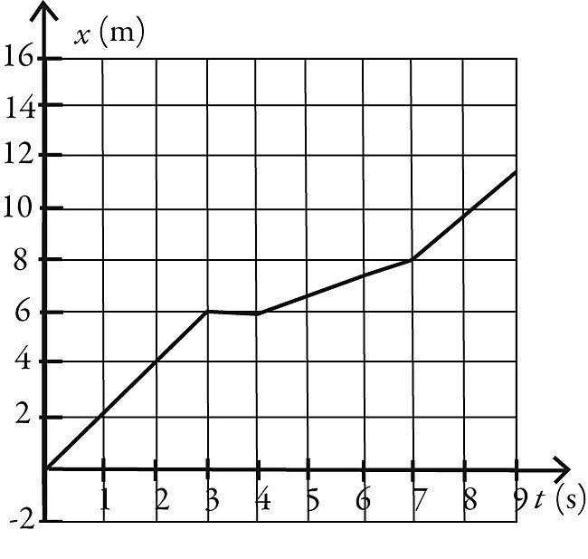
D)
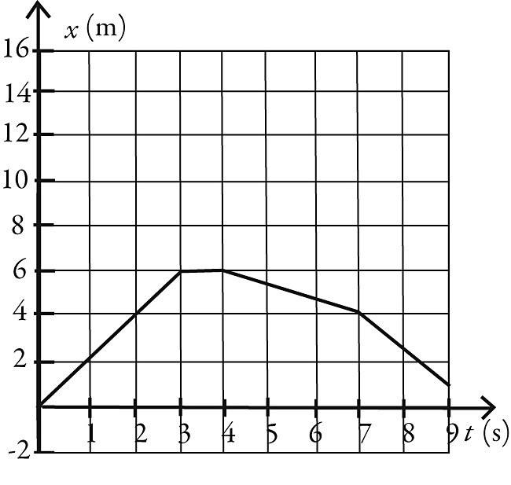
Answer: D
Var: 1

15) The figure shows the velocity of a particle as it travels along the x-axis. What is the direction of the acceleration at t = 0.5 s?
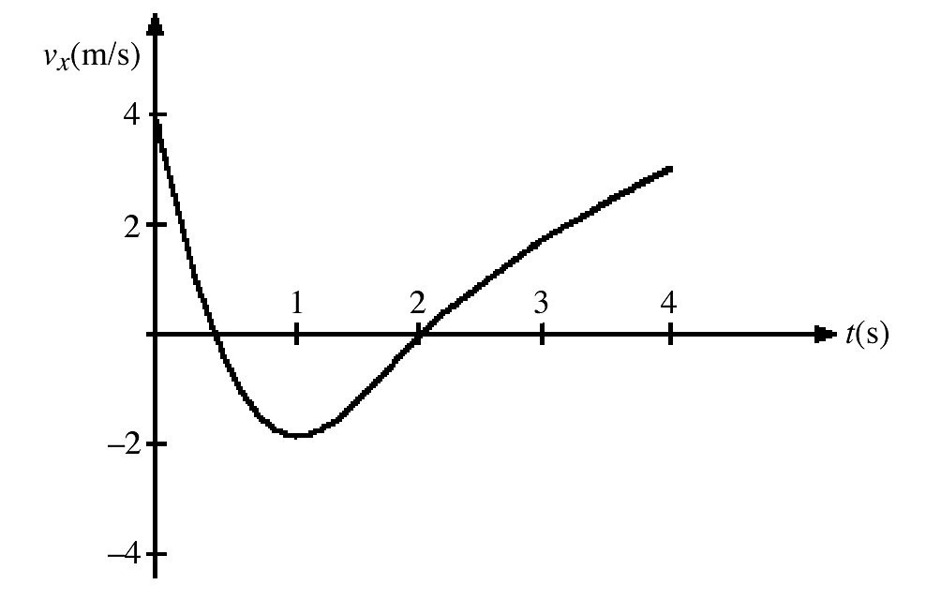
A) in the +x direction
B) in the -x direction
C) The acceleration is zero.
Answer: B
Var: 1
16) The figure represents the velocity of a particle as it travels along the x-axis. At what value (or values) of t is the instantaneous acceleration equal to zero?
A) t = 0
B) t = 0.5 s and t = 2 s
C) t = 1 s
Answer: C
Var: 1

17) A ball is thrown directly upward and experiences no air resistance. Which one of the following statements about its motion is correct?
A) The acceleration of the ball is upward while it is traveling up and downward while it is traveling down.
B) The acceleration of the ball is downward while it is traveling up and upward while it is traveling down.
C) The acceleration is downward during the entire time the ball is in the air.
D) The acceleration of the ball is downward while it is traveling up and downward while it is traveling down but is zero at the highest point when the ball stops.
Answer: C
Var: 1

18) Two objects are thrown from the top of a tall building and experience no appreciable air resistance. One is thrown up, and the other is thrown down, both with the same initial speed. What are their speeds when they hit the street?
A) The one thrown up is traveling faster.
B) The one thrown down is traveling faster.
C) They are traveling at the same speed.
Answer: C
Var: 1
19) Two objects are dropped from a bridge, an interval of 1.0 s apart, and experience no appreciable air resistance. As time progresses, the DIFFERENCE in their speeds
A) increases.
B) remains constant.
C) decreases.
D) increases at first, but then stays constant.
E) decreases at first, but then stays constant.
Answer: B
Var: 1

20) Which one of the following graphs could possibly represent the vertical position as a function of time for an object in free fall?
A)
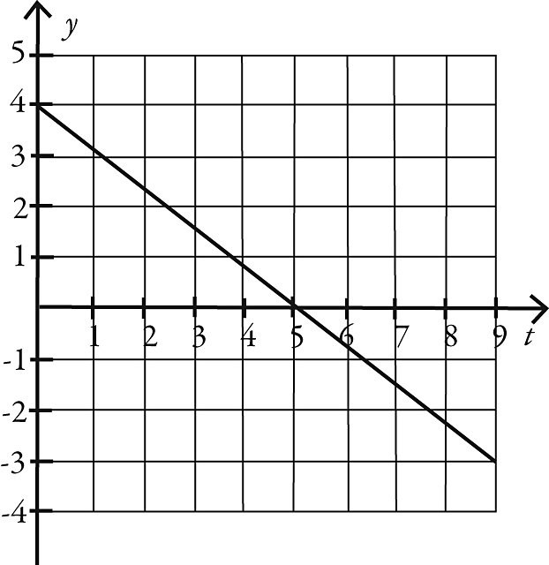
B)
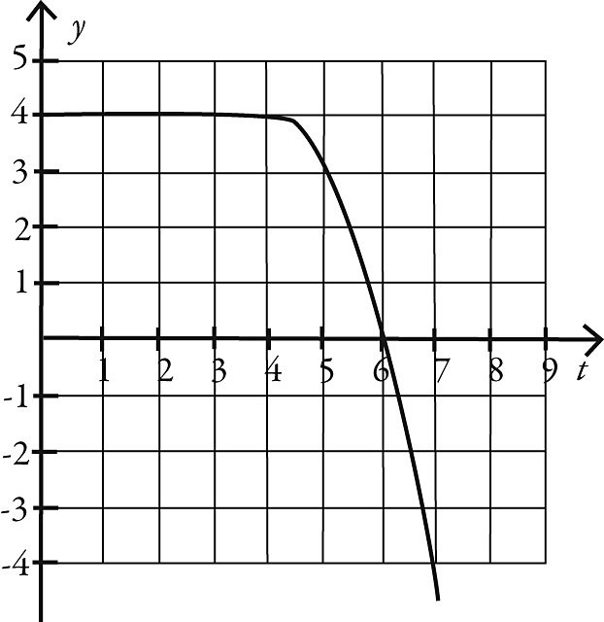
C)
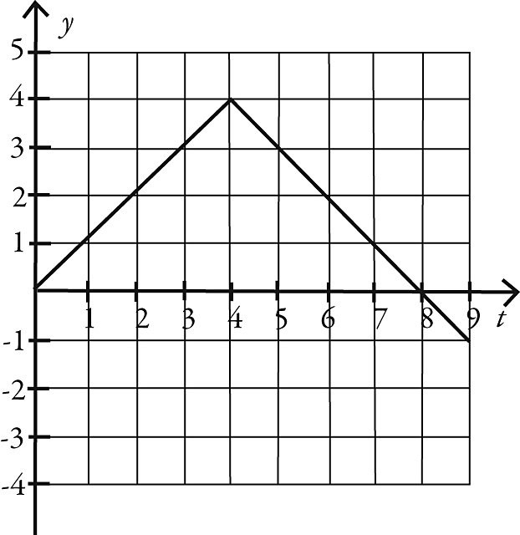
D)
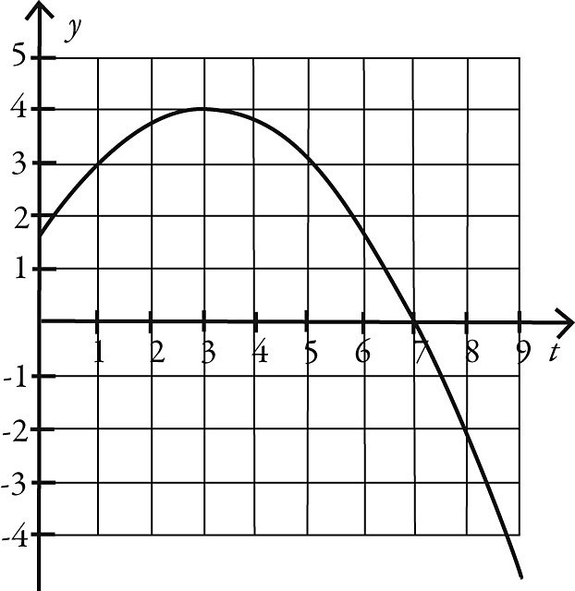
E)
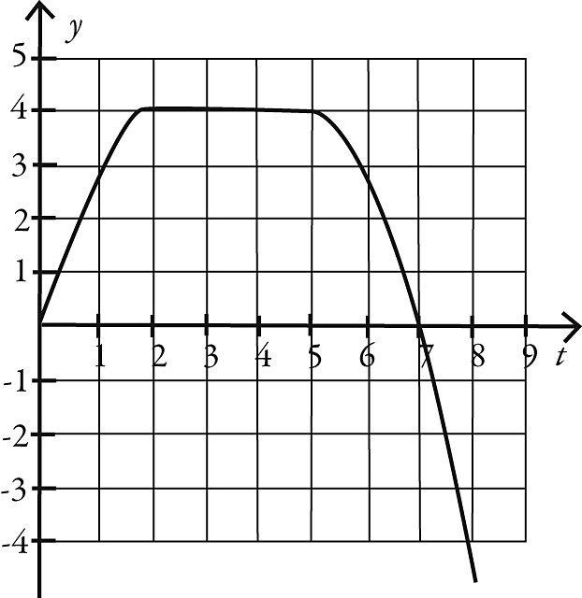
Answer: D
Var: 1

2.2 Problems

1) A cat runs along a straight line (the x-axis) from point A to point B to point C, as shown in the figure. The distance between points A and C is 5.00 m, the distance between points B and C is 10.0 m, and the positive direction of the x-axis points to the right. The time to run from A to B is 20.0 s, and the time from B to C is 8.00 s. As the cat runs along the x-axis between points A and C
(a) what is the magnitude of its average velocity?
(b) what is its average speed?

Answer: (a) 0.179 m/s (b) 0.893 m/s
Var: 1
2) The figure shows the position of an object as a function of time. During the time interval from time 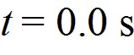 and time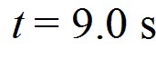
(a) what is the length of the path the object followed?
(b) what is the displacement of the object?
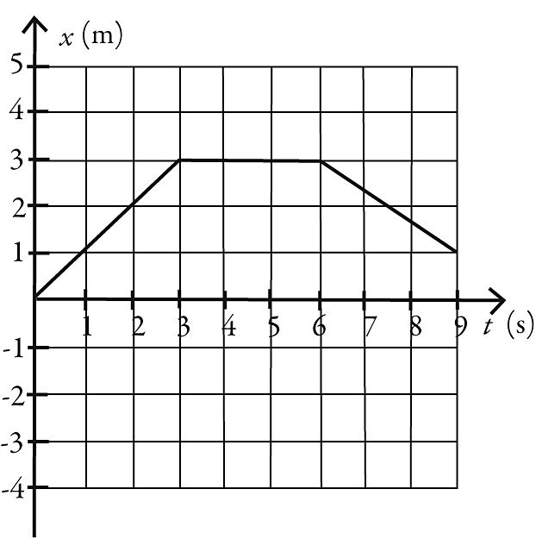
Answer: (a) 5.0 m (b) 1.0 m
Var: 1

3) As part of an exercise program, a woman walks south at a speed of 2.00 m/s for 60.0 minutes. She then turns around and walks north a distance 3000 m in 25.0 minutes
(a) What is the woman's average velocity during her entire motion?
A) 0.824 m/s south
B) 1.93 m/s south
C) 2.00 m/s south
D) 1.79 m/s south
E) 800 m/s south
(b) What is the woman's average speed during her entire motion?
A) 0.824 m/s
B) 1.93 m/s
C) 2.00 m/s
D) 1.79 m/s
E) 800 m/s
Answer: (a) A (b) C
Var: 1
4) The figure shows the position of an object as a function of time, with all numbers accurate to two significant figures. Between time and time
(a) what is the average speed of the object?
(b) what is the average velocity of the object?
Answer: (a) 0.56 m/s (b) 0.11 m/s
Var: 1

5) If the fastest you can safely drive is 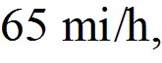 what is the longest time you can stop for dinner if you must travel 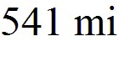 in 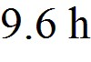 total?
A) 1.0 h
B) 1.3 h
C) 1.4 h
D) You can't stop at all.
Answer: B
Var: 50+

6) Arthur and Betty start walking toward each other when they are 100 m apart. Arthur has a speed of  and Betty has a speed of 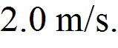 Their dog, Spot, starts by Arthur's side at the same time and runs back and forth between them at 5.0 m/s. By the time Arthur and Betty meet, what distance has Spot run?
Answer: 100 m
Var: 1
7) A racing car accelerates uniformly from rest along a straight track. This track has markers spaced at equal distances along it from the start, as shown in the figure. The car reaches a speed of 140 km/h as it passes marker 2. Where on the track was the car when it was traveling at 70 km/h?

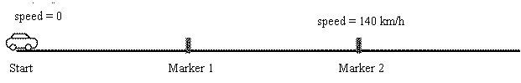
A) before marker 1
B) at marker 1
C) between marker 1 and marker 2
Answer: A
Var: 1

8) The figure represents the position of a particle as it travels along the x-axis. Between 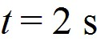 and 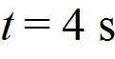, what is (a) the average speed of the particle and (b) the average velocity of the particle?

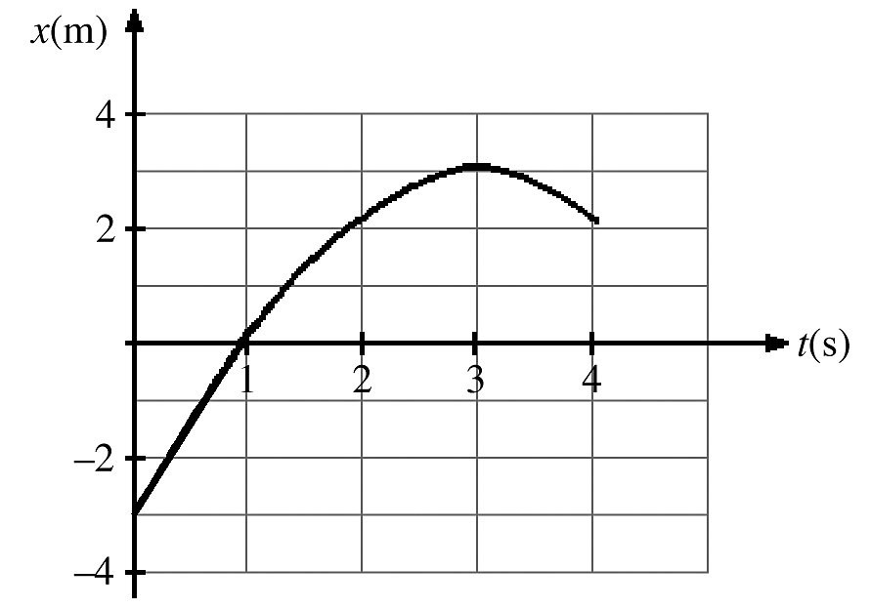
Answer: (a) 1.0 m/s (b) 0.00 m/s
Var: 1
9) The figure shows a graph of the velocity as a function of time for a basketball player traveling up and down the court in a straight-line path. for the 10 s shown on the graph, find
(a) the net displacement of the player.
(b) the total distance run by the player.

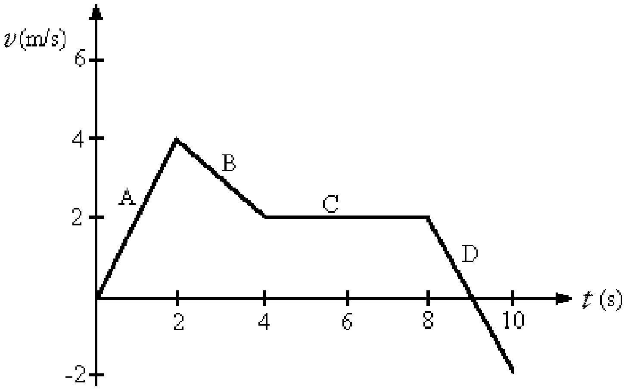
Answer: (a) 18 m (b) 20 m
Var: 1

10) The position of an object as a function of time is given by x = 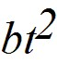 - ct, where 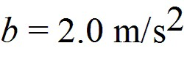 and 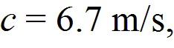 and x and t are in SI units. What is the instantaneous velocity of the object when 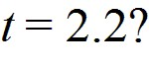
A) 1.7 m/s
B) 2.1 m/s
C) 2.3 m/s
D) 2.7 m/s
Answer: B
Var: 22

11) The position of an object is given by 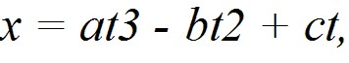 where 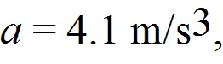 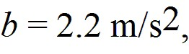 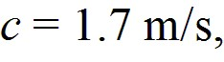 and x and t are in SI units. What is the instantaneous acceleration of the object when 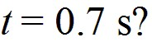
A) -13 m/s2
B) 2.9 m/s2
C) 4.6 m/s2
D) 13 m/s2
Answer: D
Var: 36
12) The velocity of an object as a function of time is given by v(t) = 2.00 m/s + 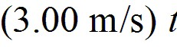 - 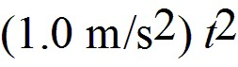. Determine the instantaneous acceleration of the object at time 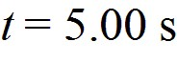.
A) -8.00 m/s2
B) -7.00 m/s2
C) 2.00 m/s2
D) 0.00 m/s2
E) -2.00 m/s2
Answer: B
Var: 5

13) The position of an object as a function of time is given by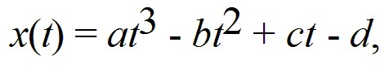 where 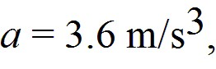 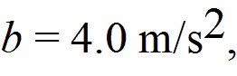 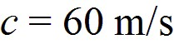 and 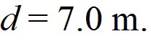
(a) Find the instantaneous acceleration at t = 2.4 s.
(b) Find the average acceleration over the first 2.4 seconds.
Answer: (a) 44 m/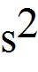 (b) 18 m/
Var: 1

14) The velocity of an object is given by the expression 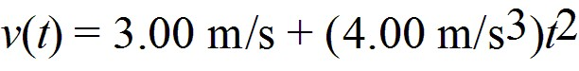, where t is in seconds. Determine the position of the object as a function of time if it is located at 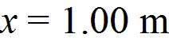 at time 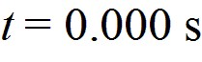.
A) (4.00 m/s)t + 1.00 m
B) (3.00 m/s)t + (1.33 m/s3)t3
C) (4.00 m/s)t
D) 1.33 m
E) 1.00 m + (3.00 m/s)t + (1.33 m/s3)t3
Answer: E
Var: 5

15) The acceleration of an object as a function of time is given by a(t) = (3.00 m/s3)t, where t is in seconds. If the object is at rest at time t = 0.00 s, what is the velocity of the object at time 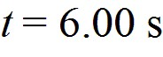?
A) 18.0 m/s
B) 54.0 m/s
C) 0.00 m/s
D) 15.0 m/s
E) 108 m/s
Answer: B
Var: 5
16) The acceleration of an object as a function of time is given by a(t) = (3.00 m/s3)t, where t is in seconds. If the object has a velocity 1.00 m/s at time 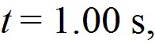 what is the displacement of the object between time t = 2.00 s and time t = 4.00 s?
A) 33.0 m
B) 30.0 m
C) 36.0 m
D) 27.0 m
Answer: D
Var: 1

17) A car accelerates from 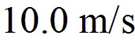 to 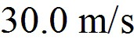 at a rate of 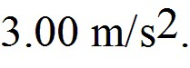 How far does the car travel while accelerating?
A) 80.0 m
B) 133 m
C) 226 m
D) 399 m
Answer: B
Var: 50+

18) A dragster starts from rest and travels 1/4 mi in 6.70 s with constant acceleration. What is its velocity when it crosses the finish line?
A) 296 mi/h
B) 269 mi/h
C) 188 mi/h
D) 135 mi/h
Answer: B
Var: 40

19) A airplane that is flying level needs to accelerate from a speed of  to a speed of 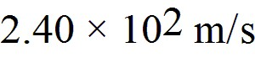 while it flies a distance of 1.20 km. What must be the acceleration of the plane?
A) 4.44 m/s2
B) 2.45 m/s2
C) 7.33 m/s2
D) 5.78 m/s2
E) 1.34 m/s2
Answer: C
Var: 1
20) A runner maintains constant acceleration after starting from rest as she runs a distance of 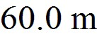. The runner's speed at the end of the 60.0 m is 9.00 m/s. How much time did it take the runner to complete the 60.0 m distance?
A) 6.67 s
B) 15.0 s
C) 9.80 s
D) 10.2 s
E) 13.3 s
Answer: A
Var: 1

21) An object starts from rest at time t = 0.00 s and moves in the +x direction with constant acceleration. The object travels 12.0 m from time t = 1.00 s to time 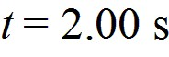. What is the acceleration of the object?
A) -12.0 m/s2
B) 24.0 m/s2
C) -4.00 m/s2
D) 4.00 m/s2
E) 8.00 m/s2
Answer: E
Var: 5

22) A car starts from rest and accelerates with a constant acceleration of 1.00 m/s2 for . The car continues for 5.00 s at constant velocity. How far has the car traveled from its starting point?
A) 24.0 m
B) 9.00 m
C) 19.5 m
D) 4.50 m
E) 15.0 m
Answer: C
Var: 1
23) A ball rolls across a floor with an acceleration of 0.100 m/s2 in a direction opposite to its velocity. The ball has a velocity of 4.00 m/s after rolling a distance 6.00 m across the floor. What was the initial speed of the ball?
A) 4.15 m/s
B) 5.85 m/s
C) 4.60 m/s
D) 5.21 m/s
E) 3.85 m/s
Answer: A
Var: 1

24) A car is 200 m from a stop sign and traveling toward the sign at 40.0 m/s. At this time, the driver suddenly realizes that she must stop the car. If it takes 0.200 s for the driver to apply the brakes, what must be the magnitude of the constant acceleration of the car after the brakes are applied so that the car will come to rest at the stop sign?
A) 2.89 m/s2
B) 3.89 m/s2
C) 4.17 m/s2
D) 3.42 m/s2
E) 2.08 m/s2
Answer: C
Var: 1

25) A speeding car is traveling at a constant 30.0 m/s when it passes a stationary police car. If the police car delays for 1.00 s before starting, what must be the magnitude of the constant acceleration of the police car to catch the speeding car after the police car travels a distance of 300 m?
A) 6.00 m/s2
B) 3.00 m/s2
C) 7.41 m/s2
D) 1.45 m/s2
E) 3.70 m/s2
Answer: C
Var: 1
26) A soccer ball is released from rest at the top of a grassy incline. After 8.6 seconds, the ball travels 87 meters and 1.0 s after this, the ball reaches the bottom of the incline.
(a) What was the magnitude of the ball's acceleration, assume it to be constant?
(b) How long was the incline?
Answer: (a) 2.4 m/ (b) 110 m
Var: 50+

27) A package is dropped from a helicopter moving upward at 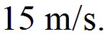 If it takes 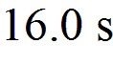 before the package strikes the ground, how high above the ground was the package when it was released if air resistance is negligible?
A) 810 m
B) 1000 m
C) 1200 m
D) 1500 m
Answer: B
Var: 25

28) A ball is projected upward at time t = 0.0 s, from a point on a roof 90 m above the ground. The ball rises, then falls and strikes the ground. The initial velocity of the ball is 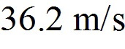 if air resistance is negligible. The time when the ball strikes the ground is closest to
A) 9.4 s.
B) 9.0 s.
C) 8.7 s.
D) 9.7 s.
E) 10 s.
Answer: A
Var: 50+

29) At the same moment from the top of a building 3.0 × 102 m tall, one rock is dropped and one is thrown downward with an initial velocity of 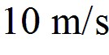. Both of them experience negligible air resistance. How much EARLIER does the thrown rock strike the ground?
A) 0.95 s
B) 0.86 s
C) 0.67 s
D) They land at exactly the same time.
Answer: A
Var: 21
30) Two identical objects A and B fall from rest from different heights to the ground and feel no appreciable air resistance. If object B takes TWICE as long as object A to reach the ground, what is the ratio of the heights from which A and B fell?
A) hA/hB = 1/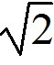
B) hA/hB = 1/2
C) hA/hB = 1/4
D) hA/hB = 1/8
Answer: C
Var: 1

31) A foul ball is hit straight up into the air with a speed of 30.0 m/s.
(a) Calculate the time required for the ball to rise to its maximum height.
(b) Calculate the maximum height reached by the ball.
(c) Determine the time at which the ball pass a point 25.0 m above the point of contact between the bat and ball.
(d) Explain why there are two answers to part (c).
Answer: (a) 3.06 s (b) 45.9 m (c) 0.995 s and 5.13
(d) One value is for the ball traveling upward; one value is for the ball traveling downward.
Var: 1

32) A rock is dropped from the top of a vertical cliff and takes 3.00 s to reach the ground below the cliff. A second rock is thrown vertically from the cliff, and it takes this rock  to reach the ground below the cliff from the time it is released. With what velocity was the second rock thrown, assuming no air resistance?
A) 4.76 m/s upward
B) 5.51 m/s downward
C) 12.3 m/s upward
D) 4.76 m/s downward
E) 12.3 m/s downward
Answer: E
Var: 1
33) To determine the height of a flagpole, Abby throws a ball straight up and times it. She sees that the ball goes by the top of the pole after 0.50 s and then reaches the top of the pole again after a total elapsed time of 4.1 s. How high is the pole above the point where the ball was launched? (You can ignore air resistance.)
A) 10 m
B) 13 m
C) 16 m
D) 18 m
E) 26 m
Answer: A
Var: 1

34) A test rocket is fired straight up from rest with a net acceleration of 20.0 m/s2. After 4.00 seconds the motor turns off, but the rocket continues to coast upward with no appreciable air resistance. What maximum elevation does the rocket reach?
A) 487 m
B) 327 m
C) 320 m
D) 408 m
E) 160 m
Answer: A
Var: 1

35) A toy rocket is launched vertically from ground level 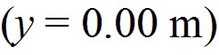, at time 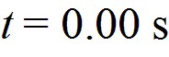. The rocket engine provides constant upward acceleration during the burn phase. At the instant of engine burnout, the rocket has risen to 72 m and acquired a velocity of 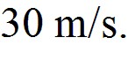 The rocket continues to rise in unpowered flight, reaches maximum height, and falls back to the ground with negligible air resistance. The speed of the rocket upon impact on the ground is closest to
A) 48 m/s.
B) 44 m/s.
C) 39 m/s.
D) 54 m/s.
E) 59 m/s.
Answer: A
Var: 50+
36) A ball is projected upward at time t = 0.00 s, from a point on a roof 70 m above the ground and experiences negligible air resistance. The ball rises, then falls and strikes the ground. The initial velocity of the ball is 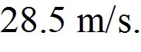 Consider all quantities as positive in the upward direction. The velocity of the ball when it is 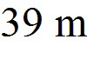 above the ground is closest to
A) -38 m/s.
B) -30 m/s.
C) -23 m/s.
D) -15 m/s.
E) -45 m/s.
Answer: A
Var: 50+

37) On the earth, when an astronaut throws a 0.250-kg stone vertically upward, it returns to his hand a time T later. On planet X he finds that, under the same circumstances, the stone returns to his hand in 2T. In both cases, he throws the stone with the same initial velocity and it feels negligible air resistance. The acceleration due to gravity on planet X (in terms of g) is
A) g/4.
B) g/2.
C) g/.
D) g.
E) 2g.
Answer: B
Var: 1

38) Two identical stones are dropped from rest and feel no air resistance as they fall. Stone A is dropped from height h, and stone B is dropped from height 2h. If stone A takes time t to reach the ground, stone B will take time
A) 4t.
B) 2t.
C) t.
D) t/.
E) t/2.
Answer: C
Var: 1
39) A rock is thrown directly upward from the edge of the roof of a building that is 66.2 meters tall. The rock misses the building on its way down, and is observed to strike the ground 4.00 seconds after being thrown. Neglect any effects of air resistance. With what speed was the rock thrown?
Answer: 3.05 m/s
Var: 50+

40) A rocket takes off vertically from the launchpad with no initial velocity but a constant upward acceleration of 2.25 m/s2. At 15.4 s after blastoff, the engines fail completely so the only force on the rocket from then on is the pull of gravity.
(a) What is the maximum height the rocket will reach above the launchpad?
(b) How fast is the rocket moving at the instant before it crashes onto the launchpad?
(c) How long after engine failure does it take for the rocket to crash onto the launchpad?
Answer: (a) 328 m (b) 80.2 m/s (c) 11.7 s
Var: 1

