**CHAPTER 2 – Thinking like an economist**

**TRUE/FALSE**

1. Both scientists and economists make assumptions to simplify their analysis.

ANS: T PTS: 1 DIF: Easy TOP: The role of assumptions

2. Most economic theories have been developed and tested by using controlled experiments.

ANS: F PTS: 1 DIF: Easy TOP: The scientific method: Observation, theory and more observation

3. The difference between natural scientists and economists is that natural scientists do not use simplifying assumptions in their models.

ANS: F PTS: 1 DIF: Moderate TOP: The role of assumptions

4. Understanding how an economic system works is aided by the use of many complex and rigorous, true assumptions.

ANS: T PTS: 1 DIF: Easy TOP: The role of assumptions

5. The art in scientific thinking is in deciding which assumptions to make.

ANS: T PTS: 1 DIF: Easy TOP: The role of assumptions

6. Scientific models are designed to simplify reality because they are built with simplifying assumptions.

ANS: T PTS: 1 DIF: Easy TOP: Economic models

7. All scientific models, including economic models, simplify reality in order to improve our understanding of it.

ANS: T PTS: 1 DIF: Easy TOP: Economic models

8. A circular-flow diagram is a simple, equation-based model of how an economy is organised.

ANS: F PTS: 1 DIF: Easy TOP: Our first model: The circular-flow diagram

9. In a simple circular-flow diagram, the two types of markets in which households and firms interact are the markets for goods and services and the markets for factors of production.

ANS: T PTS: 1 DIF: Easy TOP: Our first model: The circular-flow diagram

10. In the circular-flow model, the markets for goods and services, as in the markets for the factors of production, households are buyers and firms are sellers.

ANS: F PTS: 1 DIF: Easy TOP: Our first model: The circular-flow diagram

11. In a circular-flow diagram, one loop shows the flow of real goods and services and the other loop shows the corresponding flow of dollars.

ANS: T PTS: 1 DIF: Moderate TOP: Our first model: The circular-flow diagram

12. In a circular-flow diagram, spending on goods and services flows from households to firms and income flows from firms to households.

ANS: T PTS: 1 DIF: Easy TOP: Our first model: The circular-flow diagram

13. In the circular-flow diagram, the only return households get from supplying factors of production to firms are wages.

ANS: F PTS: 1 DIF: Easy TOP: Our first model: The circular-flow diagram

14. A production possibilities frontier is a graph that shows the various combinations of outputs the economy can possibly produce, given its factors of production and technology.

ANS: T PTS: 1 DIF: Easy TOP: Our second model: The production possibilities frontier

15. The production possibilities frontier illustrates that it is not possible for an economy to produce an output that is outside the frontier.

ANS: T PTS: 1 DIF: Easy TOP: Our second model: The production possibilities frontier

16. Any point inside the production possibilities frontier is an efficient one.

ANS: F PTS: 1 DIF: Moderate TOP: Our second model: The production possibilities frontier

17. The efficient production points for the production possibilities frontier, all lie on the actual frontier itself.

ANS: T PTS: 1 DIF: Easy TOP: Our second model: The production possibilities frontier

18. An economy is being efficient if it is impossible to produce more of one good without producing less of another.

ANS: T PTS: 1 DIF: Moderate TOP: Our second model: The production possibilities frontier

**Graph 2-1**

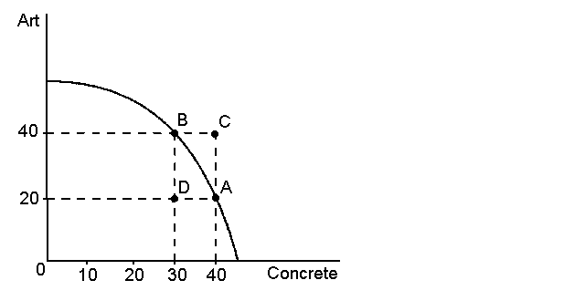

19. Refer to Graph 2-1. In the graph shown, points A, B and C represent feasible or attainable outcomes for society.

ANS: F PTS: 1 DIF: Easy TOP: Our second model: The production possibilities frontier

20. Refer to Graph 2-1. In the graph shown, points A, B and D represent efficient outcomes for society.

ANS: F PTS: 1 DIF: Moderate TOP: Our second model: The production possibilities frontier

21. Refer to Graph 2-1. In the graph shown, the opportunity cost to the economy of moving from point A to point B is 20 units of concrete.

ANS: F PTS: 1 DIF: Moderate TOP: Our second model: The production possibilities frontier

22. Refer to Graph 2-1. In the graph shown, the opportunity cost of moving from point D to point B is 20 pieces of art.

ANS: F PTS: 1 DIF: Moderate TOP: Our second model: The production possibilities frontier

23. Refer to Graph 2-1. In the graph shown, the opportunity cost of more art increases as more art is produced.

ANS: T PTS: 1 DIF: Moderate TOP: Our second model: The production possibilities frontier

24. If computers become easier to produce because of technological improvements, then producing more computers will mean a larger trade-off in the production of other goods.

ANS: F PTS: 1 DIF: Easy TOP: Our second model: The production possibilities frontier

25. Given a two-good production possibilities frontier, an increase in the economy’s productivity will cause the frontier to shift outward.

ANS: T PTS: 1 DIF: Easy TOP: Our second model: The production possibilities frontier

26. The circular-flow diagram and the production possibilities frontier both illustrate opportunity cost, economic growth and efficiency.

ANS: F PTS: 1 DIF: Moderate TOP: Our second model: The production possibilities frontier

27. Microeconomics is the study of decision making at the level of the individual household and firm, while macroeconomics is the study of the economy as a whole.

ANS: T PTS: 1 DIF: Easy TOP: Microeconomics and macroeconomics

28. Inflation is a microeconomic issue because it affects what households decide to buy.

ANS: F PTS: 1 DIF: Moderate TOP: Microeconomics and macroeconomics

29. Normative statements describe how the world is, while positive statements prescribe how the world should be.

ANS: F PTS: 1 DIF: Easy TOP: Microeconomics and macroeconomics

30. Australia harvests five to seven million kangaroos a year. Consider the statement ‘Australia would be better off if the harvest of kangaroos was banned’. This is an example of a normative statement.

ANS: T PTS: 1 DIF: Moderate TOP: Positive versus normative analysis

31. Consider the statement ‘banning the export of live parrots from Australia has resulted in the black market price for cockatoos rising and an increase in poaching’. This is an example of a normative statement.

ANS: F PTS: 1 DIF: Moderate TOP: Positive versus normative analysis

32. Normative statements are essentially value judgements about the issue being considered.

ANS: T PTS: 1 DIF: Easy TOP: Positive versus normative analysis

33. Economists try to avoid looking at history in case it will unduly influence their judgment.

ANS: F PTS: 1 DIF: Easy TOP: The scientific method: Observation, theory and more observation

34. Sometimes economists who have the same positive views about how the economy works give conflicting advice on policy because they have different values.

ANS: T PTS: 1 DIF: Easy TOP: Economists in government

35. The parameters chosen by economists may be a reason why differences of judgements result from the same issue.

ANS: F PTS: 1 DIF: Medium TOP: Differences in scientific judgements

36. Treating everyone equitably is a common value shared by all economists.

ANS: F PTS: 1 DIF: Easy TOP: Differences in values

37. According to John Maynard Keynes, an economist should only give advice based on disinterested observations.

ANS: F PTS: 1 DIF: Easy TOP: Perception versus reality

**MULTIPLE CHOICE**

1. Which of the following does economics NOT attempt to do?

|  |  |
| --- | --- |
| A. | study the past to learn lessons for the future |
| B. | devise theories, collect data, then analyse the data to test the theories |
| C. | use assumptions to make the world easier to understand |
| D. | conduct laboratory experiments that exactly replicate the real world |

ANS: D PTS: 1 DIF: Moderate TOP: Introduction

2. The scientific method can best be defined as:

|  |  |
| --- | --- |
| A. | the use of modern laboratory equipment to discover scientific laws |
| B. | the careful design of controlled experiments to test theories about how the world works |
| C. | the unbiased development of and testing of theories about how the world works |
| D. | the selective search for evidence that supports preconceived theories of how the world works |

ANS: C PTS: 1 DIF: Easy TOP: Introduction

3. Assumptions are sometimes necessary because:

|  |  |
| --- | --- |
| A. | controlled experiments need to reflect the way things happen in real life |
| B. | there are often many factors in an analysis and it helps to focus our thinking |
| C. | every model is different and that must be explained clearly |
| D. | short-term effects differ from long-term effects |

ANS: B PTS: 1 DIF: Moderate TOP: Introduction

4. Data to test economic theories generally come from:

|  |  |
| --- | --- |
| A. | laboratory experiments undertaken in strict, controlled conditions |
| B. | personal introspection |
| C. | public opinion surveys |
| D. | observations from previous episodes of economic change |

ANS: D PTS: 1 DIF: Easy TOP: The scientific method: Observation, theory and more observation

5. The rationale for using assumptions in economics is:

|  |  |
| --- | --- |
| A. | it avoids having to collect any data |
| B. | it is a useful way to ensure models are as realistic as possible |
| C. | because economics is not a science |
| D. | that it makes the world easier to understand |

ANS: D PTS: 1 DIF: Easy TOP: The role of assumptions

6. The art of scientific thinking involves:

|  |  |
| --- | --- |
| A. | deciding which assumptions to make |
| B. | understanding every scientific discipline |
| C. | knowing which presumptions to make |
| D. | being able to mathematically express natural forces |

ANS: A PTS: 1 DIF: Easy TOP: The role of assumptions

7. If an economist develops a theory about international trade based on the assumption that there are only two countries and two goods:

|  |  |
| --- | --- |
| A. | the theory can be useful only in situations involving two countries and two goods |
| B. | it is a total waste of time, since the actual world has many countries trading many goods |
| C. | the theory can help explain trade involving many countries and many goods |
| D. | the theory can be useful in the classroom, but has no use in the real world |

ANS: C PTS: 1 DIF: Easy TOP: The role of assumptions

8. In constructing models, economists must:

|  |  |
| --- | --- |
| A. | employ simplifying assumptions |
| B. | include as much detail as possible |
| C. | exclude as much detail as possible |
| D. | employ simplifying presumptions |

ANS: A PTS: 1 DIF: Easy TOP: The role of assumptions

9. Economists use models in order to:

|  |  |
| --- | --- |
| A. | develop insights into how the economy works |
| B. | develop insights into mathematical theorems |
| C. | make economics hard for students to understand |
| D. | help businesses decide what investments will be profitable |

ANS: A PTS: 1 DIF: Easy TOP: Economic models

10. If Lauren builds a circular-flow diagram including markets for goods and services, markets for factors of production and firms, will the model be able to accurately represent a simple economy?

|  |  |
| --- | --- |
| A. | No, it is missing the government |
| B. | No, it is missing international trade |
| C. | No, it is missing households |
| D. | Yes, it includes all the key actors |

ANS: C PTS: 1 DIF: Easy TOP: Economic models

11. Which of the following is the most accurate statement about economic models?

|  |  |
| --- | --- |
| A. | economic models attempt to mirror reality as closely as possible |
| B. | economic models are useful, but should not be used for policymaking |
| C. | economic models cannot be used in the real world because they omit details |
| D. | economic models omit many details to allow us to see what is important |

ANS: D PTS: 1 DIF: Moderate TOP: Economic models

12. The foundation stones from which economic models are built are:

|  |  |
| --- | --- |
| A. | economic policies |
| B. | presumptions |
| C. | assumptions |
| D. | statistical forecasts |

ANS: C PTS: 1 DIF: Easy TOP: The role of assumptions

13. The circular-flow diagram is a type of simple model that:

|  |  |
| --- | --- |
| A. | illustrates the carbon-cycle in forestry economic models |
| B. | illustrates how an economy is organised between key sectors |
| C. | shows how fish stocks grow and replenish from harvest |
| D. | shows the money flows that are managed by the banking system |

ANS: B PTS: 1 DIF: Easy TOP: Our first model: The circular-flow diagram

14. Factors of production are:

|  |  |
| --- | --- |
| A. | inputs into the production process |
| B. | weather, social and political conditions that affect production |
| C. | the physical relationships between economic inputs and outputs |
| D. | the mathematical calculations firms make to determine production |

ANS: A PTS: 1 DIF: Easy TOP: Our first model: The circular-flow diagram

15. In a circular-flow diagram:

|  |  |
| --- | --- |
| A. | households sell goods and services to the factors of production |
| B. | firms incur wages, rent and profit from households |
| C. | the factors of production are bought by the firms and sold by households |
| D. | firms sell goods and services as well as factors of production |

ANS: C PTS: 1 DIF: Easy TOP: Our first model: The circular-flow diagram

16. In the circular-flow diagram:

|  |  |
| --- | --- |
| A. | firms are sellers in the resource market and the product market |
| B. | households are sellers in the resource market |
| C. | firms are buyers in the product market |
| D. | spending on goods and services flow from firms to households |

ANS: B PTS: 1 DIF: Easy TOP: Our first model: The circular-flow diagram

17. The circular flow diagram illustrates the:

|  |  |
| --- | --- |
| A. | flow of goods and services from households to firms |
| B. | flow of spending on goods and services from households to firms |
| C. | flow of factors of production from firms to households |
| D. | flow of spending on goods and services flows from firms to households |

ANS: B PTS: 1 DIF: Easy TOP: Our first model: The circular-flow diagram

**Graph 2-2**

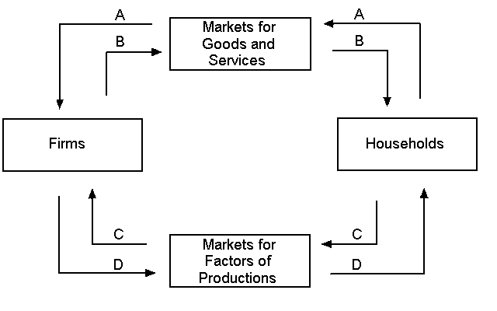

18. Refer to Graph 2-2. In the circular-flow diagram shown, which arrow shows the flow of goods and services?

|  |  |
| --- | --- |
| A. | A |
| B. | B |
| C. | C |
| D. | D |

ANS: B PTS: 1 DIF: Easy TOP: Our first model: The circular-flow diagram

19. Refer to Graph 2-2. In the circular-flow diagram shown, which arrow shows the flow of spending by households?

|  |  |
| --- | --- |
| A. | A |
| B. | B |
| C. | C |
| D. | D |

ANS: A PTS: 1 DIF: Moderate TOP: Our first model: The circular-flow diagram

20. Refer to Graph 2-2. In the circular-flow diagram shown, which arrow shows the flow of the inputs for production?

|  |  |
| --- | --- |
| A. | A |
| B. | B |
| C. | C |
| D. | D |

ANS: C PTS: 1 DIF: Moderate TOP: Our first model: The circular-flow diagram

21. Refer to Graph 2-2. In the circular-flow diagram shown, which arrow shows the flow of income payments?

|  |  |
| --- | --- |
| A. | A |
| B. | B |
| C. | C |
| D. | D |

ANS: D PTS: 1 DIF: Moderate TOP: Our first model: The circular-flow diagram

22. The production possibilities frontier is a:

|  |  |
| --- | --- |
| A. | graph that shows the various combinations of output the economy can possibly produce, given the available resources and technology |
| B. | graph that shows the various combinations of resources the economy can possibly produce, given the available output |
| C. | graph that shows the various combinations of concrete the economy can possibly produce, given the available agricultural land |
| D. | graph that shows the various combinations of wheat the economy can possibly produce, given the available cement |

ANS: A PTS: 1 DIF: Easy TOP: Our second model: The production possibilities frontier

23. An economic outcome is said to be efficient if the economy is:

|  |  |
| --- | --- |
| A. | using all of the resources it has available, which means producing on the production possibilities frontier |
| B. | conserving resources and not using all it has, which means producing on the production possibilities frontier |
| C. | using all of the resources it has available, which means producing inside the production possibilities frontier |
| D. | conserving resources and not using all it has, which means producing inside the production possibilities frontier |

ANS: A PTS: 1 DIF: Easy TOP: Our second model: The production possibilities frontier

24. In the production possibilities frontier model, production is inefficient if the production point is:

|  |  |
| --- | --- |
| A. | inside the frontier |
| B. | outside the frontier |
| C. | on or outside the frontier |
| D. | on or inside the frontier |

ANS: A PTS: 1 DIF: Easy TOP: Our second model: The production possibilities frontier

25. An economy is said to be efficient if it is:

|  |  |
| --- | --- |
| A. | possible to produce more of all goods |
| B. | possible to produce more of one good without producing less of another |
| C. | not possible to produce more of one good without producing less of another |
| D. | not possible to produce more of one good at any cost |

ANS: C PTS: 1 DIF: Easy TOP: Our second model: The production possibilities frontier

**Graph 2-3**

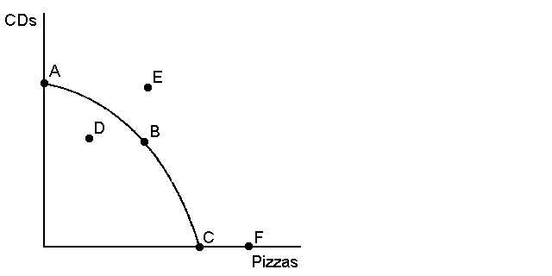

26. Refer to Graph 2-3. On the production possibilities frontier shown, at which point or points is it possible for this economy to produce?

|  |  |
| --- | --- |
| A. | A, B, C, D |
| B. | A, B, C, F |
| C. | A, B, C, D, E, F |
| D. | D |

ANS: A PTS: 1 DIF: Easy TOP: Our second model: The production possibilities frontier

27. Refer to Graph 2-3. On the production possibilities frontier shown, which point represents the maximum possible production of CDs?

|  |  |
| --- | --- |
| A. | A |
| B. | B |
| C. | C |
| D. | D |

ANS: A PTS: 1 DIF: Moderate TOP: Our second model: The production possibilities frontier

28. Refer to Graph 2-3. On the production possibilities frontier shown, what does point F represent?

|  |  |
| --- | --- |
| A. | an infeasible production point |
| B. | the amount of pizzas that would be produced if the economy only produced pizzas |
| C. | an inefficient outcome |
| D. | the outcome if nothing were to be produced |

ANS: A PTS: 1 DIF: Moderate TOP: Our second model: The production possibilities frontier

29. Refer to Graph 2-3. On the production possibilities frontier shown, at which point or points is the economy efficient?

|  |  |
| --- | --- |
| A. | A, B, C |
| B. | A, C, F |
| C. | E |
| D. | D |

ANS: A PTS: 1 DIF: Moderate TOP: Our second model: The production possibilities frontier

30. Refer to Graph 2-3. On the production possibilities frontier shown, at which point or points is the economy inefficient?

|  |  |
| --- | --- |
| A. | A, B, C |
| B. | E, F |
| C. | B |
| D. | D |

ANS: D PTS: 1 DIF: Moderate TOP: Our second model: The production possibilities frontier

**Graph 2-4**

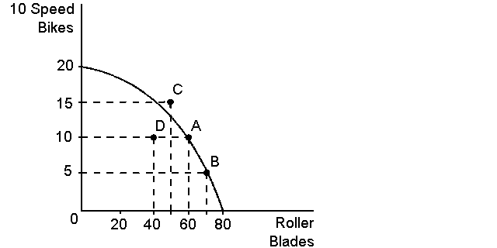

31. Refer to Graph 2-4. On the production possibilities frontier shown, the opportunity cost to the economy of getting 10 additional roller blades by moving from point A to point B is:

|  |  |
| --- | --- |
| A. | 15 bikes |
| B. | 10 bikes |
| C. | five bikes |
| D. | impossible to know without knowing the cost of the resources used to produce the additional roller blades |

ANS: C PTS: 1 DIF: Moderate TOP: Our second model: The production possibilities frontier

32. Refer to Graph 2-4. On the production possibilities frontier shown, the opportunity cost of getting five additional bikes by moving from point A to point C is:

|  |  |
| --- | --- |
| A. | 15 roller blades |
| B. | 10 roller blades |
| C. | five roller blades |
| D. | it is impossible for the economy to move from point A to point C |

ANS: D PTS: 1 DIF: Moderate TOP: Our second model: The production possibilities frontier

33. Refer to Graph 2-4. On the production possibilities frontier shown, the opportunity cost of moving from point A to point D is:

|  |  |
| --- | --- |
| A. | five bikes and 40 roller blades |
| B. | zero bikes and 20 roller blades |
| C. | five bikes and 20 roller blades |
| D. | zero bikes and 40 roller blades |

ANS: B PTS: 1 DIF: Difficult TOP: Our second model: The production possibilities frontier

**Graph 2-5**

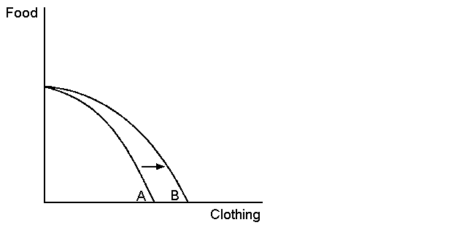

34. Refer to Graph 2-5. In the production possibilities frontier shown, the shift of the frontier from A to B was most likely caused by which of the following?

|  |  |
| --- | --- |
| A. | more capital available in the economy |
| B. | more labour available in the economy |
| C. | a general technological breakthrough |
| D. | technological improvement in the production of clothing |

ANS: D PTS: 1 DIF: Moderate TOP: Our second model: The production possibilities frontier

**Graph 2-6**

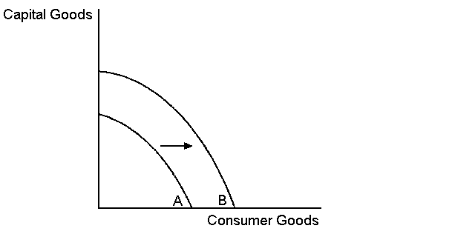

35. Refer to Graph 2-6. According to the graph, the shift of the production possibilities frontier from frontier A to frontier B was most likely caused by which of the following?

|  |  |
| --- | --- |
| A. | an improvement in the technology of producing capital goods |
| B. | an improvement in the technology of producing consumer goods |
| C. | a general improvement in technology |
| D. | a reduction in the availability of resources |

ANS: C PTS: 1 DIF: Moderate TOP: Our second model: The production possibilities frontier

36. Refer to Graph 2-6. In the graph shown, the movement from frontier A to B can best be described as:

|  |  |
| --- | --- |
| A. | economic growth |
| B. | a disaster for society |
| C. | an improvement in income distribution |
| D. | an improvement in the allocation of resources |

ANS: A PTS: 1 DIF: Moderate TOP: Our second model: The production possibilities frontier

**Graph 2-7**

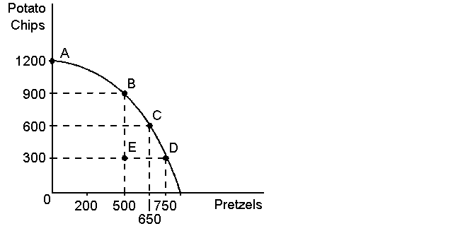

37. Refer to Graph 2-7. What is the opportunity cost to society of the movement from point C to point B, given the production possibilities frontier shown?

|  |  |
| --- | --- |
| A. | 650 pretzels |
| B. | 500 pretzels |
| C. | 300 pretzels |
| D. | 150 pretzels |

ANS: D PTS: 1 DIF: Moderate TOP: Our second model: The production possibilities frontier

38. Refer to Graph 2-7. In the production possibilities frontier shown, what is the opportunity cost to society of moving from point C to point E?

|  |  |
| --- | --- |
| A. | 150 pretzels |
| B. | 300 potato chips |
| C. | both A and B |
| D. | zero |

ANS: C PTS: 1 DIF: Moderate TOP: Our second model: The production possibilities frontier

39. Refer to Graph 2-7. In the production possibilities frontier unemployment most likely caused a movement from:

|  |  |
| --- | --- |
| A. | A to B |
| B. | B to D |
| C. | C to D |
| D. | C to E |

ANS: D PTS: 1 DIF: Moderate TOP: Our second model: The production possibilities frontier

**Table 2-1**

|  |  |
| --- | --- |
| Production possibilities for Poland | |
| Vodka (l) | Potatoes (kg) |
| 1000 | 0 |
| 850 | 400 |
| 650 | 760 |
| 430 | 900 |
| 175 | 1200 |
| 0 | 1700 |

40. Refer to Table 2-1. What is the opportunity cost to Poland of increasing the production of Vodka from 430 to 850?

|  |  |
| --- | --- |
| A. | 140 kg potatoes |
| B. | 500 kg potatoes |
| C. | 400 kg potatoes |
| D. | 300 kg potatoes |

ANS: B PTS: 1 DIF: Moderate TOP: Our second model: The production possibilities frontier

41. Refer to Table 2-1. What is the opportunity cost of increasing the production of potatoes from 900 kg to 1200 kg?

|  |  |
| --- | --- |
| A. | 255l vodka |
| B. | 200l vodka |
| C. | 150l vodka |
| D. | 175l vodka |

ANS: A PTS: 1 DIF: Moderate TOP: Our second model: The production possibilities frontier

42. Refer to Table 2-1. What is the most accurate statement about the opportunity cost of producing an additional 25 litres of vodka in Poland?

|  |  |
| --- | --- |
| A. | the opportunity cost of an additional 25 litres of vodka is 30kg of potatoes |
| B. | the opportunity cost of an additional 25 litres of vodka changes depending on how many potatoes are produced |
| C. | it is impossible to determine the opportunity cost of an additional 25 litres of vodka |
| D. | the opportunity cost of an additional 25 litres of vodka increases as more potatoes are produced |

ANS: B PTS: 1 DIF: Difficult TOP: Our second model: The production possibilities frontier

43. Microeconomics approaches the study of economics from the viewpoint of:

|  |  |
| --- | --- |
| A. | consumer behaviour |
| B. | the labour market |
| C. | government taxation and spending policies |
| D. | the entire economy |

ANS: A PTS: 1 DIF: Easy TOP: Microeconomics and macroeconomics

44. Select the macroeconomic statement from the following:

|  |  |
| --- | --- |
| A. | fish prices have risen this year due to inflation |
| B. | many households eat fish once a week |
| C. | the price of fish at Victoria market is lower today than yesterday |
| D. | the fish shop owner inflated the price of his fish |

ANS: A PTS: 1 DIF: Easy TOP: Microeconomics and macroeconomics

45. Select the statement below that is an example of a microeconomic issue?

|  |  |
| --- | --- |
| A. | due to widespread unemployment, clothes stores have begun to lay off workers |
| B. | a reduction in costs of producing clothes has made clothes cheaper for Anna and Sinead |
| C. | Anna and Sinead sometimes sell clothes to each other |
| D. | Australia buys a lot of clothes from China |

ANS: C PTS: 1 DIF: Easy TOP: Microeconomics and macroeconomics

46. For economists, positive statements are:

|  |  |
| --- | --- |
| A. | descriptive, making a claim about how the world is |
| B. | optimistic, putting the best possible interpretation on things |
| C. | affirmative, justifying existing economic policy |
| D. | prescriptive, making a claim about how the world ought to be |

ANS: A PTS: 1 DIF: Easy TOP: Positive versus normative analysis

47. Normative statements are:

|  |  |
| --- | --- |
| A. | descriptive, making a claim about how the world is |
| B. | statements about the normal condition of the world |
| C. | prescriptive, making a claim about how the world ought to be |
| D. | statements which establish production goals for the economy |

ANS: C PTS: 1 DIF: Easy TOP: Positive versus normative analysis

48. Which of the following is an example of a positive statement?

|  |  |
| --- | --- |
| A. | if welfare payments increase, the world will be a better place |
| B. | prices rise when the government prints too much money |
| C. | inflation is more harmful to the economy than unemployment |
| D. | the benefits to the economy of improved equity are greater than the costs of reduced efficiency |

ANS: B PTS: 1 DIF: Easy TOP: Positive versus normative analysis

49. Which of the following is an example of a normative statement?

|  |  |
| --- | --- |
| A. | prices coordinate the actions of people buying and selling in a marketplace |
| B. | trade makes countries better off |
| C. | productivity is important in increasing wages |
| D. | looking after the environment is more important than economic growth |

ANS: D PTS: 1 DIF: Easy TOP: Positive versus normative analysis

50. Graphs, charts and equations can be useful to:

|  |  |
| --- | --- |
| A. | represent normative statements |
| B. | represent economic concepts in a simple and clear way |
| C. | represent economic concepts to children |
| D. | represent mathematical concepts in a simple way |

ANS: B PTS: 1 DIF: Easy TOP: Economic models

51. Which of the following statements is correct?

|  |  |
| --- | --- |
| A. | the *x*-coordinate tells us the horizontal location of a point on a graph, and the *y*-coordinate tells us the vertical location of the point |
| B. | the origin of a graph is the point with both a maximum *x*-coordinate and a maximum *y*-coordinate |
| C. | the *x*-coordinate tells us the vertical location of a point on a graph, and the *y*-coordinate tells us the horizontal location of the point |
| D. | the origin of a graph is represented by an *x*-coordinate equal to 1 and a *y*-coordinate equal to 1 |

ANS: A PTS: 1 DIF: Easy TOP: Curves in the coordinate system

**Graph 2-8**

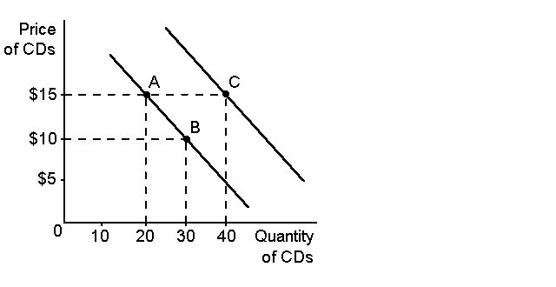

52. Refer to Graph 2-8. In the graph, the curves shown are:

|  |  |
| --- | --- |
| A. | cost curves |
| B. | supply curves |
| C. | demand curves |
| D. | production possibilities frontiers |

ANS: C PTS: 1 DIF: Easy TOP: Curves in the coordinate system

53. Refer to Graph 2-8. In the graph shown, the movement from point A to point B is:

|  |  |
| --- | --- |
| A. | a shift of the curve |
| B. | a change in preferences |
| C. | a movement along the curve |
| D. | all of the above |

ANS: C PTS: 1 DIF: Moderate TOP: Curves in the coordinate system

54. Refer to Graph 2-8. In the graph shown, the movement from point A to point C is a:

|  |  |
| --- | --- |
| A. | change in price |
| B. | shift of the curve |
| C. | movement along the curve |
| D. | change in costs to the firm |

ANS: B PTS: 1 DIF: Moderate TOP: Curves in the coordinate system

55. Refer to Graph 2-8. In the graph shown, the slope of the curve between points A and B is:

|  |  |
| --- | --- |
| A. | –2 |
| B. | –1/2 |
| C. | 1/2 |
| D. | 2 |

ANS: B PTS: 1 DIF: Moderate TOP: Curves in the coordinate system

56. The slope of a line is defined as:

|  |  |
| --- | --- |
| A. | the ratio of the horizontal distance covered to the vertical distance covered as we move along the line |
| B. | the rise divided by the run |
| C. | the ratio of the vertical distance covered to the horizontal distance covered as we move along the line |
| D. | both B and C |

ANS: D PTS: 1 DIF: Easy TOP: Slope and elasticity

57. Making the argument that because empty alcohol containers are found at many accidents, containers therefore cause accidents, is an example of:

|  |  |
| --- | --- |
| A. | reverse causality |
| B. | omitted variables |
| C. | sound logic |
| D. | slope |

ANS: B PTS: 1 DIF: Moderate TOP: Omitted variables

58. Dean says that, ‘the imposition of a tax on beer will raise its price’. Kylie argues that, ‘taxes should be imposed on beer because university students drink too much’. We can conclude that:

|  |  |
| --- | --- |
| A. | Dean's statement is normative, but Kylie’s is positive |
| B. | Kylie's statement is normative, but Dean’s is positive |
| C. | both statements are normative |
| D. | both statements are positive |

ANS: B PTS: 1 DIF: Easy TOP: Positive versus normative analysis

59. The policy results from economic modelling:

|  |  |
| --- | --- |
| A. | focus on the cheapest price option |
| B. | focus on the fairest result for everyone |
| C. | tend to be aimed at winning the most political votes |
| D. | none of the above |

ANS: D PTS: 1 DIF: Moderate TOP: Differences in values

**SHORT ANSWER**

1. All statements made by economists are made only as statements of fact. True or false? Explain.

ANS:

False. Economists develop hypotheses based on their observations, but they often cannot measure causality accurately. Economists make assumptions about many things in order to explain in a simple way the relationships between the things they are trying to measure. Often they will conduct experiments to test their hypotheses, under the constraint of these assumptions. Economics is about testing theories rather than simply observing and describing evident relationships between factors.

PTS: 1 DIF: Moderate TOP: The scientific method: Observation, theory

and more observation

2. What is the purpose of models in economics? What are the two economic models presented in chapter two?

ANS:

Economic models are designed to illustrate the important features of an economy. They are built from assumptions, and are most often composed of diagrams and equations. Like all useful models, economic models simplify reality in order to improve our understanding of it. The two economic models presented in chapter two are the circular-flow diagram and the production possibilities frontier.

PTS: 1 DIF: Easy TOP: The role of assumptions

3. Using this outline (see Graph 2-9), insert arrows and complete the circular-flow diagram representing the interactions between households and firms in a simple economy. Explain briefly the various parts of the diagram.

**Graph 2-9**

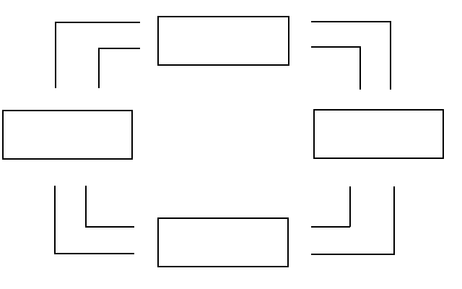

ANS:

This diagram should duplicate the essential characteristics of the diagram in the text, with an explanation of the meaning of each flow and each market. It is important that the student understands that the inner loop represents the flow of real goods and services, and that the outer loop represents the corresponding flow of payments.

**Graph 2-9 answer**

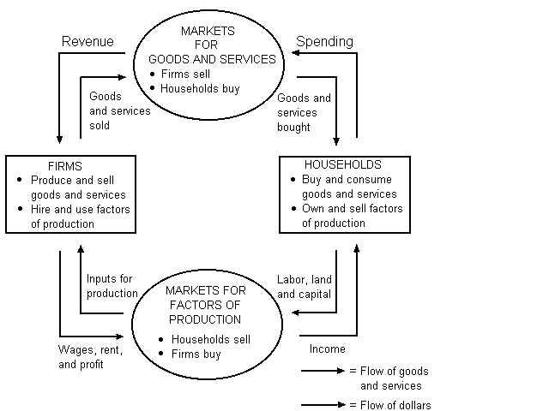

PTS: 1 DIF: Easy TOP: Our first model: The circular-flow diagram

4. Refer to Graph 2-10. For the production possibilities frontier illustrated in the graph shown:

**Graph 2-10**

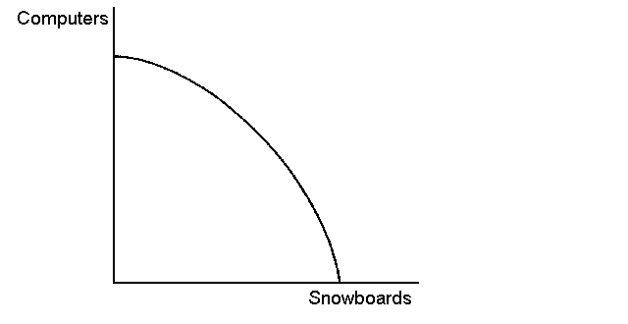

a. How would you measure the opportunity cost of obtaining more computers?

b. How does that opportunity cost change as society chooses to produce and consume more computers?

c. Why does the opportunity cost change that way?

ANS:

a. The opportunity cost of obtaining more computers is the number of snowboards that have to be given up to get more computers.

b. As the production and consumption of computers increases, the opportunity cost of each new computer (the number of snowboards which must be given up) also increases.

c. As the economy produces more and more computers, the resources best suited to making computers are used up and resources better suited to producing snowboards must be used. When this happens, the production of snowboards is reduced a lot for each new computer produced.

PTS: 1 DIF: Moderate TOP: The production possibilities frontier

5. Suppose an economy produces two products. These are fish and logs. If fish stocks become depleted by over-fishing, what would happen to the production possibilities frontier?

ANS:

This means the economy has suffered a loss in the available resources. The production possibilities frontier would pivot inwards. The maximum level of log production would be unchanged. The maximum level of fish production would move closer to the origin.

PTS: 1 DIF: Moderate TOP: The production possibilities frontier

6. Draw a production possibilities frontier representing the economy’s possible production of milk and eggs. Now show what will happen to the frontier or the production point under each of the following circumstances. Use a separate graph to illustrate each situation.

a. the outcome for the economy is efficient, with society choosing approximately equal amounts of milk and eggs

b. a recession causes a significant percentage of the labour force to become unemployed

c. some cows are found to be infected with mad cow disease and many of the cows must be destroyed

d. chickens are infected with a rare disease and egg-laying is reduced

e. improvements in animal nutrition raise the general productivity of cows and chickens

f. the cow and chicken populations increase

g. the Surgeon General announces that drinking milk prolongs life

ANS:

Refer to Graph 2-11 for answers.

**Graph 2-11 answer**

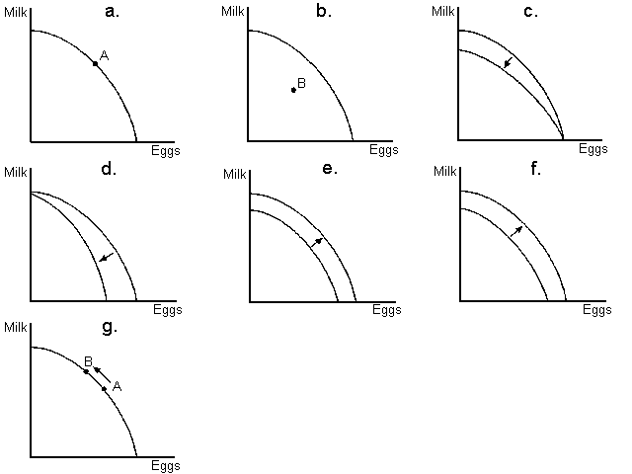

PTS: 1 DIF: Difficult TOP: The production possibilities frontier

7. If you were a firm producing personal computers would you pay more attention to microeconomic or macroeconomic factors? What would you take into account when making your business decisions?

ANS:

You would pay more attention to microeconomic factors such as what people look for in a computer, what households need and what kind of goods they are buying to make their lives easier.

PTS: 1 DIF: Easy TOP: Microeconomics and macroeconomics

8. If you were Australia and you wanted to sell canned tomatoes to China, would you pay more attention to microeconomic or macroeconomic factors? What would you take into account when making your business decisions?

ANS:

You would take into account both macroeconomic and microeconomic factors. You would first have to ensure that Chinese consumers wished to consume Australian tomatoes, and understand how many actors already existed in the canned tomato market in China. You would also have to understand the exchange rate, the trends in global tomato production and the possibilities for economic growth in China and elsewhere.

PTS: 1 DIF: Moderate TOP: Microeconomics and macroeconomics

9. Why do economists use graphs?

ANS:

Graphs serve two purposes. You’ve heard the old saying ‘A picture is worth a thousand words’. Graphs offer a way to express ideas visually that might be less clear if described with equations or words. Also, graphs provide a way of finding how variables are in fact related in the world. Graphs provide one way of expressing the relationship among variables.

PTS: 1 DIF: Moderate TOP: Graphing – a brief review

10. What is the difference between a movement along a curve and a shift of a curve? What is the simplest way to tell when it is necessary to shift a curve?

ANS:

When there is a change from one point to another point on the same curve that is a movement along the curve. This is caused by a change in a variable represented on either the *x*-axis or the *y*-axis. A shift of a curve occurs when the entire curve moves (either to the right or to the left for a demand curve). This would occur because a variable that affects the curve but is not represented on either the *x*-axis or *y*-axis has changed. The simplest way to tell is to look at the variables represented on the *x*-axis and *y*-axis.

PTS: 1 DIF: Moderate TOP: Curves in the coordinate system

11. If the y-axis label is price, and the *x*-axis label is quantity, what would occur, if there was a change in tastes and preferences?

ANS:

As the variable that has changed is on not on one of the axis labels, there is a shift of the curve.

PTS: 1 DIF: Moderate TOP: Curves in the coordinate system

12. If the y-axis label is price, and the *x*-axis label is quantity, what would occur if there was a change in the cost of producing the good/service?

ANS:

As the variable that has changed is on not on one of the axis labels, there is a shift of the curve.

PTS: 1 DIF: Moderate TOP: Curves in the coordinate system

13. Use the demand curve below to answer the following questions.

**Graph 2-12**

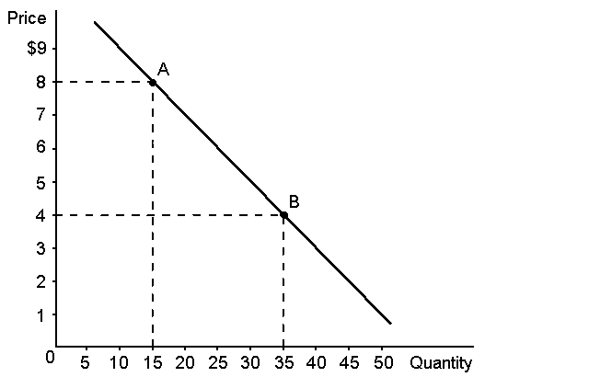

a. How would point A be represented as an ordered pair?

b. What type of curve is this?

c. Does this curve show a positive or negative correlation between price and quantity?

d. Compute the slope of the curve between points A and B.

ANS:

a. (15, 8).

b. a demand curve

c. a negative correlation between price and quantity

d. –4/20 = –1/5.

PTS: 1 DIF: Moderate TOP: Curves in the coordinate system

14. Describe two problems that economists should consider when dealing with graphs.

ANS:

1. Omitted variables: It is difficult to hold everything else constant when measuring how one variable affects another. It is possible that a person seeing the graph might decide that one

variable on the graph is causing changes in the other variable when actually those changes are caused by a third variable not pictured on the graph. This could lead to a wrong conclusion.

2. Reverse causality. This occurs when a person decides that event A causes event B to occur, when in fact event B causes event A to occur. An example given in the text is the correlation between police numbers and crime levels.

PTS: 1 DIF: Moderate TOP: Omitted variables

15. Both of the main political parties in Australia employ economists. When formulating a carbon tax policy, the economists disagree. Explain why this may be the case.

ANS:

Advocates of a carbon tax believed that the introduction would encourage polluters to minimise their carbon emissions by reducing their output, or invest in cleaner technology, as there would be a financial penalty for emitting carbon into the atmosphere. Those against the carbon tax believe that households would suffer, as the cost of driving cars and using electricity would increase, and that the households with least choice would be affected greatly.

These two groups of economists held (and continue to hold) different views about the carbon tax system because they have different positive views about the responsiveness of the tax incentives.

PTS: 1 DIF: Difficult TOP: Differences in scientific judgements