Essentials of Human Anatomy and Physiology, 11e, Global Edition (Marieb)
Chapter 2 Basic Chemistry

2.1 Multiple Choice Part I Questions

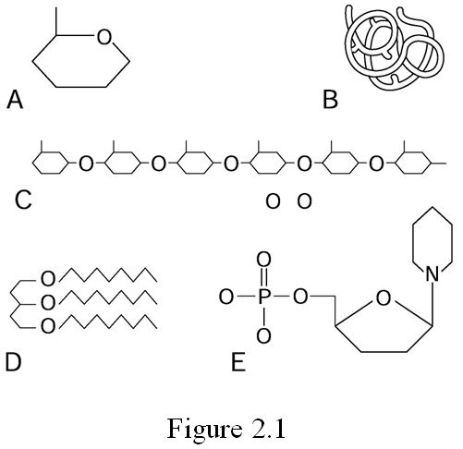

Using Figure 2.1, identify the following:

1) Which letter represents a carbohydrate polymer?
A) Label A
B) Label B
C) Label C
D) Label D
E) Label E
Answer: C
Page Ref: 68
Bloom's: 1) Knowledge

2) Letter D represents the structure of a(n) ________.
A) monosaccharide
B) amino acid
C) triglyceride
D) steroid
Answer: C
Page Ref: 70
Bloom's: 1) Knowledge

3) Letter E represents a nucleic acid building block known as a ________.
A) monosaccharide
B) triglyceride
C) saturated fat
D) nucleotide
Answer: D
Page Ref: 77
Bloom's: 1) Knowledge
4) Which letter represents a globular protein in its quaternary structure?
A) Label A
B) Label B
C) Label C
D) Label D
E) Label E
Answer: B
Page Ref: 74, 75
Bloom's: 1) Knowledge

5) Anything that has mass and takes up space is considered to be ________.
A) a solid
B) matter
C) an element
D) energy
Answer: B
Page Ref: 48
Bloom's: 1) Knowledge

6) Nerve impulses involve the flow of an electrical current, a type of energy known as ________ energy.
A) radiant
B) mechanical
C) electrical
D) chemical
Answer: C
Page Ref: 49
Bloom's: 1) Knowledge

7) Atoms that have lost or gained electrons are known as ________.
A) isotopes
B) reactants
C) molecules
D) ions
Answer: D
Page Ref: 57
Bloom's: 1) Knowledge

8) The most common element in the human body is ________.
A) carbon
B) oxygen
C) hydrogen
D) nitrogen
Answer: B
Page Ref: 51
Bloom's: 1) Knowledge
9) The atomic number of an atom is equal to the number of ________ an atom contains.
A) protons
B) neutrons
C) protons and neutrons
D) neutrons and electrons
Answer: A
Page Ref: 53
Bloom's: 1) Knowledge

10) Compounds that contain carbon-hydrogen bonding are collectively termed ________ compounds.
A) electrolytic
B) organic
C) inorganic
D) acidic
Answer: B
Page Ref: 62
Bloom's: 1) Knowledge

11) Polar molecules, like water, result when electrons are shared ________.
A) unequally between atoms
B) between ions
C) equally between atoms
D) or transferred between atoms
Answer: A
Page Ref: 58
Bloom's: 1) Knowledge

12) An atom's outermost shell is known as its ________ shell.
A) valence
B) ionic
C) isotopic
D) inorganic
Answer: A
Page Ref: 56
Bloom's: 1) Knowledge

13) An acid is a molecule that releases (donates) ________.
A) protons (hydrogen ions)
B) hydroxyl ions
C) neutrons
D) electrons
Answer: A
Page Ref: 64
Bloom's: 1) Knowledge
14) Proteins are synthesized from ________ during synthesis reactions.
A) monosaccharides
B) amino acids
C) glycerol and fatty acids
D) nucleotides
Answer: B
Page Ref: 66, 72
Bloom's: 1) Knowledge

15) Glycogen and starch are examples of a specific category of carbohydrates called ________.
A) monosaccharides
B) triglycerides
C) steroids
D) polysaccharides
Answer: D
Page Ref: 67
Bloom's: 1) Knowledge

16) A solution with a pH of 11.7 is ________ times more basic (alkaline) than a solution with a pH of 8.7.
A) 10
B) 100
C) 1000
D) 3
Answer: C
Page Ref: 65
Bloom's: 3) Application

17) Unsaturated fatty acid chains contain one or more ________ bonds between carbon atoms.
A) peptide
B) double
C) triple
D) monosaccharide
Answer: B
Page Ref: 71
Bloom's: 1) Knowledge

18) Enzymes are examples of ________ proteins.
A) structural
B) globular (functional)
C) fibrous
D) alpha
Answer: B
Page Ref: 73
Bloom's: 1) Knowledge
19) The complementary base to adenine in a molecule of DNA is ________.
A) guanine
B) cytosine
C) leucine
D) thymine
Answer: D
Page Ref: 78
Bloom's: 2) Comprehension

20) A nucleotide of DNA contain three components: ________, ________, and ________.
A) deoxyribose; a phosphate group; nitrogen-containing base
B) ribose; three phosphate groups; nitrogen-containing base
C) ribose; two phosphate groups; acid group
D) ribose; a phosphate group; nitrogen-containing base
Answer: A
Page Ref: 76
Bloom's: 1) Knowledge

2.2 Multiple Choice Part II Questions

1) Which of the following contains sodium?
A) H2O
B) NaCl
C) N2
D) CH4
E) H2SO4
Answer: B
Page Ref: 51
Bloom's: 4) Analysis

2) Elements are composed of building blocks known as ________.
A) molecules
B) atoms
C) compounds
D) polymers
E) protons
Answer: B
Page Ref: 50
Bloom's: 1) Knowledge

3) The movement of ions across plasma membranes is an example of ________.
A) radiant energy
B) chemical energy
C) electrical energy
D) mechanical energy
E) potential energy
Answer: C
Page Ref: 49
Bloom's: 1) Knowledge
4) Which of the following is classified as an inorganic compound?
A) glucose
B) triglyceride
C) water
D) protein
E) steroid
Answer: C
Page Ref: 62
Bloom's: 2) Comprehension

5) An atom of magnesium has lost two electrons. It is known as a(n) ________.
A) anion
B) molecule
C) isotope
D) cation
E) neutral atom
Answer: D
Page Ref: 57
Bloom's: 3) Application

6) Which of the following leads to an increase in the rate of a chemical reaction?
A) increased temperature
B) large particle size
C) lack of catalysts
D) decreased temperature
E) few particles
Answer: A
Page Ref: 63
Bloom's: 1) Knowledge

7) Atomic mass is equivalent to the number of ________ in an atom.
A) protons
B) neutrons
C) electrons
D) protons and electrons
E) protons and neutrons
Answer: E
Page Ref: 53
Bloom's: 1) Knowledge

8) The major function of potassium is to ________.
A) serve as a salt in bones and teeth
B) play a role in nerve impulse transmissions and muscle contractions
C) make functional thyroid hormones
D) influence the pH of body fluids
E) exist as the most abundant extracellularcation
Answer: B
Page Ref: 51, 64
Bloom's: 1) Knowledge
9) Which of the following elements is needed to make functional thyroid hormone?
A) magnesium
B) iodine
C) iron
D) potassium
E) chlorine
Answer: B
Page Ref: 51
Bloom's: 1) Knowledge

10) An atom with an atomic number of 14 will have ________ electrons in its valence shell.
A) 2
B) 4
C) 8
D) 10
E) 14
Answer: B
Page Ref: 56
Bloom's: 4) Analysis

11) An atom with 6 protons, 7 neutrons, and 6 electrons shares four pairs of electrons with four other atoms. This atom is now considered to be ________.
A) a cation
B) an anion
C) a neutral atom
D) stable
E) an ion
Answer: D
Page Ref: 56-57
Bloom's: 4) Analysis

12) An atom has 6 protons, 8 neutrons, and 6 electrons. Its atomic mass is ________.
A) 2
B) 6
C) 8
D) 14
E) 20
Answer: D
Page Ref: 53
Bloom's: 4) Analysis

13) The atomic number of an atom reveals the number of ________.
A) electrons in the atomic nucleus
B) protons in the atomic nucleus
C) protons plus neutrons
D) protons plus electrons
E) neutrons plus electrons
Answer: B
Page Ref: 53
Bloom's: 1) Knowledge
14) Isotopes have different numbers of ________; thus they also have different ________.
A) protons; atomic numbers
B) neutrons; atomic masses
C) electrons; atomic numbers
D) protons; atomic masses
E) neutrons; atomic numbers
Answer: B
Page Ref: 53-54
Bloom's: 1) Knowledge

15) A molecule of methane, CH4, is known specifically as a(n) ________.
A) compound
B) radioisotope
C) element
D) atom
E) anion
Answer: A
Page Ref: 55
Bloom's: 4) Analysis

16) The subatomic particles that are responsible for the chemical behavior of atoms are the ________.
A) protons
B) neutrons
C) electrons
D) isotopes
E) ions
Answer: C
Page Ref: 56
Bloom's: 4) Analysis
17)
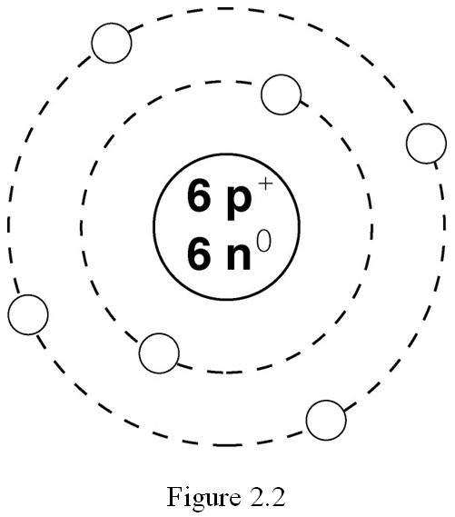

What is the atomic number of the atom in Figure 2.2?
A) 2
B) 3
C) 4
D) 6
E) 12
Answer: D
Page Ref: 53
Bloom's: 3) Application

18) What type of bond results when electrons are completely transferred from one atom to another?
A) ionic bond
B) hydrogen bond
C) carbon bond
D) polar covalent bond
E) nonpolar covalent bond
Answer: A
Page Ref: 57
Bloom's: 1) Knowledge

19) The growth of cells and repair of worn-out tissues is accomplished by ________.
A) decomposition reactions
B) catabolic reactions
C) hydrolysis reactions
D) synthesis reactions
E) neutralization reactions
Answer: D
Page Ref: 61
Bloom's: 1) Knowledge
20) In order to break a disaccharide down into simple sugar units ________.
A) water molecules must be added to each bond
B) water molecules must be removed from each bond
C) carbon atoms must be added to each bond
D) carbon atoms must be removed from each bond
E) water molecules and carbon atoms must be removed from each bond
Answer: A
Page Ref: 66
Bloom's: 1) Knowledge

21) The reaction sucrose + water → glucose + fructose is an example of a(n) ________.
A) double replacement reaction
B) synthesis reaction
C) decomposition reaction
D) neutralization reaction
E) anabolic reaction
Answer: C
Page Ref: 66, 67
Bloom's: 3) Application

22) Water absorbs and releases large amount of energy before changing temperature, a characteristic known as ________.
A) cushioning
B) buffering
C) chemical reactivity
D) high heat capacity
E) polarity
Answer: D
Page Ref: 63
Bloom's: 1) Knowledge

23) Hydrogen bonding between water molecules is responsible for ________.
A) polarity
B) denaturation of proteins
C) enzyme structure
D) nonpolar covalent bonding
E) surface tension
Answer: E
Page Ref: 61
Bloom's: 1) Knowledge

24) Which of the following solutions is the weakest acid?
A) a solution with a pH of 2.4
B) a solution with a pH of 5.2
C) a solution with a pH of 6.4
D) a solution with a pH of 8.6
E) a solution with a pH of 10.1
Answer: C
Page Ref: 65, 66
Bloom's: 4) Analysis
25) A solution with a pH of 7 ________.
A) is acidic
B) releases more hydrogen ions than hydroxyl ions into solution
C) releases more hydroxyl ions than hydrogen ions into solution
D) is basic
E) is neutral
Answer: E
Page Ref: 66
Bloom's: 1) Knowledge

26) Exchange reactions in which an acid and a base interact are known as ________.
A) decomposition reactions
B) neutralization reactions
C) anabolic reactions
D) hydrolysis reactions
E) catabolic reactions
Answer: B
Page Ref: 65
Bloom's: 1) Knowledge

27) Which of these vitamins is produced in skin upon exposure to ultraviolet (UV) radiation?
A) vitamin A
B) vitamin C
C) vitamin D
D) vitamin E
E) vitamin K
Answer: C
Page Ref: 69
Bloom's: 1) Knowledge

28) Which carbohydrate is also known as blood sugar?
A) sucrose
B) glucose
C) ribose
D) deoxyribose
E) cellulose
Answer: B
Page Ref: 67
Bloom's: 1) Knowledge

29) Which polysaccharide is formed of linked glucose molecules and stored in animal tissues?
A) ribose
B) cellulose
C) starch
D) glucose
E) glycogen
Answer: E
Page Ref: 67-68
Bloom's: 2) Comprehension
30) The organic compounds that function in building tissues and acting as enzymes are the ________.
A) nucleic acids
B) carbohydrates
C) salts
D) lipids
E) proteins
Answer: E
Page Ref: 72
Bloom's: 1) Knowledge

31) The building blocks of a triglyceride are ________.
A) three fatty acid chains and one glycerol molecule
B) one fatty acid chain and one glycerol molecule
C) four interlocking rings of carbon and hydrogen atoms
D) amino acids
E) nucleotides
Answer: A
Page Ref: 68
Bloom's: 1) Knowledge

32) Why is ATP categorized as a nucleic acid?
A) ATP has a polar region and a nonpolar region.
B) ATP contains four interlocking carbon rings.
C) ATP is a modified nucleotide with three phosphate groups, ribose, and adenine.
D) All nucleic acids, such as ATP, function as catalysts to increase reaction rates.
E) All nucleic acids have an amine and an acid functional group.
Answer: C
Page Ref: 76
Bloom's: 2) Comprehension

33) Which of the following DNA base pairs is complementary?
A) adenine and guanine
B) guanine and uracil
C) thymine and guanine
D) cytosine and adenine
E) adenine and thymine
Answer: E
Page Ref: 78
Bloom's: 1) Knowledge

34) Enzymes ________.
A) are essential to virtually every biochemical reaction in the body
B) help regulate growth and development
C) are highly specialized proteins that recognize, bind with, and inactivate bacteria, toxins, and some viruses
D) increase the rates of chemical reactions by at least a millionfold
E) when absent or destroyed, cause all biochemical reactions to cease
Answer: D
Page Ref: 75
Bloom's: 2) Comprehension
35) Enzymes are ________.
A) carbohydrates
B) stable at high temperatures
C) biological catalysts
D) not reuseable
E) required in large amounts in order to be effective
Answer: C
Page Ref: 75
Bloom's: 1) Knowledge

36) Saturated fats ________.
A) have two fatty acid chains
B) exist as solids at room temperature
C) are formed from four interlocking carbon rings
D) contain many double bonds
E) exist as liquids and are derived from plants
Answer: B
Page Ref: 71
Bloom's: 1) Knowledge

37) Identify the nucleic acid.
A) oxidase
B) cholesterol
C) glucose
D) DNA
E) triglyceride
Answer: D
Page Ref: 78
Bloom's: 1) Knowledge

38) Two or more polypeptides chains combine to form a complex structure called a ________.
A) primary structure
B) beta-pleated sheet
C) secondary structure
D) tertiary structure
E) quaternary structure
Answer: E
Page Ref: 73
Bloom's: 1) Knowledge

39) Which of the following statements about RNA is true?
A) RNA is single stranded.
B) RNA is composed of cytosine, guanine, adenine, and thymine.
C) RNA is found only in the nucleus of the cell.
D) RNA contains deoxyribose.
E) RNA is a double helix.
Answer: A
Page Ref: 78
Bloom's: 1) Knowledge
40) The most common steroid is ________.
A) phospholipid
B) cholesterol
C) triglyceride
D) trans fat
E) unsaturated fat
Answer: B
Page Ref: 72
Bloom's: 2) Comprehension

41) The nucleotide chains of DNA are held together by ________.
A) carbon bonds
B) hydrogen bonds
C) ionic bonds
D) nonpolar covalent bonds
E) polar covalent bonds
Answer: B
Page Ref: 78
Bloom's: 1) Knowledge

42) Which of the following statements about ATP is false?
A) It drives the transport of certain solutes (e.g., amino acids) across cell membranes.
B) It activates contractile proteins in muscle cells so that cells can shorten and perform mechanical work.
C) It provides the energy needed to drive energy-absorbing chemical reactions.
D) It is a modified nucleotide.
E) Its energy is captured in high-energy hydrogen bonds.
Answer: E
Page Ref: 79
Bloom's: 2) Comprehension

43) Which of the following is a protein?
A) cholesterol
B) antibody
C) glucose
D) triglyceride
E) RNA
Answer: B
Page Ref: 72-76
Bloom's: 1) Knowledge

44) The building blocks of proteins are ________.
A) monosaccharides
B) nucleotides
C) amino acids
D) nucleic acids
E) fatty acids
Answer: C
Page Ref: 72
Bloom's: 1) Knowledge
45) Shell 1 of an atom can hold a maximum of ________ electron(s).
A) 1
B) 2
C) 4
D) 8
E) 18
Answer: B
Page Ref: 56
Bloom's: 1) Knowledge

46) Trans fats are oils that have been solidified by the addition of ________.
A) oxygen atoms
B) carbon atoms
C) hydrogen atoms
D) nitrogen atoms
E) phosphorus-containing groups
Answer: C
Page Ref: 71
Bloom's: 1) Knowledge

47)
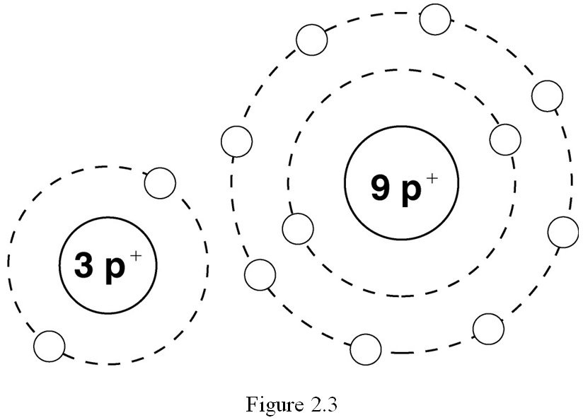

What type of chemical bond is pictured in Figure 2.3?
A) nonpolar covalent bond
B) polar covalent bond
C) ionic bond
D) single covalent bond
E) double covalent bond
Answer: C
Page Ref: 57
Bloom's: 2) Comprehension
48) The sugar found in DNA is ________.
A) ribose
B) sucrose
C) deoxyribose
D) lactose
E) starch
Answer: C
Page Ref: 77, 78
Bloom's: 1) Knowledge

49) Which of these enzymes catalyzes sucrose?
A) glucase
B) cholesterol
C) oxidase
D) cellulase
E) sucrase
Answer: E
Page Ref: 76
Bloom's: 2) Comprehension

50) Nucleotides are composed of ________.
A) three fatty acid chains and one glycerol
B) peptide bonds
C) a phosphate group, a five-carbon sugar, and a nitrogen-containing base
D) four fused carbon rings
E) amino acids with an amine group and an acid group
Answer: C
Page Ref: 76
Bloom's: 1) Knowledge

2.3 True/False Questions

1) Inactive or stored energy is called kinetic energy.
Answer: FALSE
Page Ref: 49
Bloom's: 1) Knowledge

2) The number of protons in an atom equals the atomic number for that element.
Answer: TRUE
Page Ref: 53
Bloom's: 1) Knowledge

3) Atoms that have lost or gained electrons during bonding are known as isotopes.
Answer: FALSE
Page Ref: 53, 57
Bloom's: 1) Knowledge

4) Carbohydrates are classified as inorganic compounds.
Answer: FALSE
Page Ref: 62
Bloom's: 2) Comprehension
5) The four most common elements in the human body, in order of descending quantity, are hydrogen, carbon, oxygen, and nitrogen.
Answer: FALSE
Page Ref: 51
Bloom's: 1) Knowledge

6) Hydrogen bonds are very strong bonds that hold together water molecules.
Answer: FALSE
Page Ref: 60
Bloom's: 2) Comprehension

7) Water is the single most abundant inorganic compound in the human body.
Answer: TRUE
Page Ref: 63
Bloom's: 1) Knowledge

8) The lower the pH, the greater the number of hydrogen ions released by a chemical into solution.
Answer: TRUE
Page Ref: 65, 66
Bloom's: 2) Comprehension

9) Acids are defined as proton donors since they release hydrogen ions.
Answer: TRUE
Page Ref: 64
Bloom's: 1) Knowledge

10) Carbon is found in all inorganic compounds.
Answer: FALSE
Page Ref: 62
Bloom's: 1) Knowledge

11) When a solution produces equal numbers of hydrogen and hydroxyl ions, it is said to be neutral.
Answer: TRUE
Page Ref: 65
Bloom's: 4) Analysis

12) Amino acids are the building blocks for proteins.
Answer: TRUE
Page Ref: 72
Bloom's: 1) Knowledge

13) Glucose and fructose are classified as disaccharides.
Answer: FALSE
Page Ref: 67
Bloom's: 1) Knowledge

14) Phospholipids are composed of three fatty acid chains attached to one glycerol molecule.
Answer: FALSE
Page Ref: 68
Bloom's: 1) Knowledge
15) Disruption of the hydrogen bonds of functional proteins leads to their denaturation.
Answer: TRUE
Page Ref: 74
Bloom's: 1) Knowledge
2.4 Matching Questions
Match the following:

A) Neutron
B) Proton
C) Electron

1) Atomic number is based on the number of these subatomic particles in an atom of a particular element.
Page Ref: 53
Bloom's: 1) Knowledge

2) Atoms share these subatomic particles when they combine to form molecules.
Page Ref: 57
Bloom's: 1) Knowledge

3) The atomic mass does not include these subatomic particles in the calculation.
Page Ref: 53
Bloom's: 1) Knowledge

4) Ionic bonds are formed when these subatomic particles are completely transferred from one atom to another atom.
Page Ref: 57
Bloom's: 1) Knowledge

5) Isotopes are atoms of the same element that have varying numbers of these subatomic particles.
Page Ref: 53
Bloom's: 2) Comprehension

6) Atoms share these subatomic particles equally in nonpolar covalent molecules.
Page Ref: 58
Bloom's: 1) Knowledge

7) Atoms that lose or gain these subatomic particles are known as ions.
Page Ref: 57
Bloom's: 1) Knowledge
8) Along with protons, these subatomic particles are situated in the nucleus of an atom.
Page Ref: 52
Bloom's: 1) Knowledge

Answers: 1) B 2) C 3) C 4) C 5) A 6) C 7) C 8) A
Match the following:

A) Decomposition reaction
B) Exchange reaction
C) Synthesis reaction

9) Glycogen is broken down to release glucose subunits.
Page Ref: 61
Bloom's: 2) Comprehension

10) Amino acids join together to form proteins.
Page Ref: 61
Bloom's: 2) Comprehension

11) Bonds are both made and broken in these reactions.
Page Ref: 61
Bloom's: 2) Comprehension

12) Digestion of food
Page Ref: 62
Bloom's: 2) Comprehension

Answers: 9) A 10) C 11) B 12) A
Match the following:

A) nucleic acids
B) fibrous proteins
C) globular proteins
D) lipids
E) carbohydrates
F) amino acids

13) Building block is the monosaccharide
Page Ref: 67
Bloom's: 1) Knowledge

14) DNA, RNA, and ATP are examples
Page Ref: 78, 79
Bloom's: 1) Knowledge

15) Triglycerides, steroids, and fat-soluble vitamins are examples
Page Ref: 68-72
Bloom's: 1) Knowledge

16) Antibodies, some hormones, and enzymes are examples
Page Ref: 72-76
Bloom's: 1) Knowledge

17) Collagen and keratin are examples
Page Ref: 73
Bloom's: 1) Knowledge

18) Nucleotides are the building blocks for this organic compound group
Page Ref: 76
Bloom's: 1) Knowledge

19) The hydrolysis of proteins produces these building blocks
Page Ref: 72
Bloom's: 2) Comprehension

20) Also known as functional proteins
Page Ref: 73
Bloom's: 1) Knowledge

Answers: 13) E 14) A 15) D 16) C 17) B 18) A 19) F 20) C

2.5 Essay Questions

1) Describe the role of the electron in chemical bond formation.
Answer: When the valence shell of an atom contains fewer than 8 electrons, an atom will tend to gain, lose, or share electrons with other atoms to reach a stable state. As a result, chemical bonds such as covalent bonds or ionic bonds are formed.
Page Ref: 57-58
Bloom's: 1) Knowledge

2) Differentiate between the method of determination of the atomic number and the atomic mass.
Answer: The atomic number is determined by the number of protons in that atom. The atomic mass is the sum of the protons and neutrons in the atom's nucleus.
Page Ref: 53
Bloom's: 4) Analysis

3) Discuss radioisotopes and explain why they are studied in anatomy and physiology.
Answer: Radioisotopes are unstable isotopes of heavier elements that tend to decompose to become more stable. Recall that isotopes are structural variations of an element that vary by their neutron number. Radioisotopes are used to tag biological molecules so they can be followed or traced through the human body. Radioisotopes are valuable tools in medical diagnosis and treatment.
Page Ref: 54
Bloom's: 2) Comprehension

4) Explain how saturated fats are different from unsaturated fats.
Answer: Saturated fats:
1. tend to be animal fats
2. have all single bonds between carbon atoms
3. may be solid
Unsaturated fats:
1. tend to be plant oils
2. have some double or triple bonds between carbon atoms
3. may be liquid
Page Ref: 70, 71
Bloom's: 2) Comprehension

5) Distinguish between a dehydration synthesis and a hydrolysis reaction.
Answer: In a dehydration synthesis reaction, a more complex molecule is formed from two simpler ones, and a water molecule is lost as each bond forms. An example of dehydration synthesis is seen when a disaccharide is formed from two monosaccharides. Hydrolysis is the breakdown of a more complex molecule into its building blocks. A water molecule is added to each bond, the bond is broken, and simpler molecules are formed. In the process, water is split into a hydrogen ion and a hydroxyl ion. An example of hydrolysis is seen when a disaccharide is broken down into two monosaccharides.
Page Ref: 66, 67
Bloom's: 4) Analysis
6) Differentiate between the functions of RNA and DNA.
Answer: DNA is the genetic material found in the nucleus of a cell. It replicates prior to cell division to ensure every body cell is identical. DNA provides instructions for building every protein in the body. By contrast, RNA is mostly found outside the nucleus and carries out the instructions for generating proteins as dictated by DNA.
Page Ref: 78
Bloom's: 4) Analysis

7) Describe the difference between the roles of functional, or globular, proteins and structural, or fibrous, proteins.
Answer: Structural proteins most often appear in the body structures, binding structures together or providing strength in tissues. Functional proteins perform jobs for the body. They serve in a variety of roles in the body from antibodies, enzymes, hormones to transport proteins.
Page Ref: 73
Bloom's: 1) Knowledge

8) Explain why a denatured protein no longer functions.
Answer: Denaturation results when the three-dimensional shape of a protein is destroyed. The function of a protein depends on its structure. The presence of an active site on the surface of a protein that interacts with other molecules must be intact for the enzyme to work properly.
Page Ref: 74
Bloom's: 2) Comprehension

9) Discuss the organization of the pH scale, including the location of acids, bases, and neutral substances.
Answer: The pH scale is based on the number of hydrogen ions in solution. The pH scale is constructed from zero to 14. Each sequential change of one pH unit represents a ten-fold change in hydrogen ion concentration. Solutions with a pH lower than seven are considered acidic while solutions with a pH greater than seven are considered basic (alkaline). At a pH of seven, the solution is neutral since hydrogen ion concentration equals hydroxyl ion concentration.
Page Ref: 65, 66
Bloom's: 2) Comprehension

10) Describe the four structural levels of proteins.
Answer:
1. The primary structure of a protein resembles a string of beads in which the amino acids form the basis for the protein molecule.
2. A protein in its secondary structure may exist in a coiled alpha-helix or an accordian-like beta-pleated sheet.
3. Most proteins reach the more complex tertiary level of structure. The tertiary structure is achieved when the alpha-helical or beta-pleated region of the polypeptide chain folds in on itself to form a globular (ball-like) molecule.
4. The quarternary structure results when two polypeptide chains combine to form a complex protein.
Page Ref: 73, 74
Bloom's: 1) Knowledge
11) Joey works in a lab on an organic compound with the formula of C6H12O6. Determine the type of organic compound, being as specific as possible, on which he works. Explain how you know.
Answer: Joey is working with a carbohydrate. Carbohydrates contain carbon, hydrogen, and oxygen atoms in the same ratio as water (2 hydrogens to every carbon and oxygen atom). To be specific, he is working with a monosaccharide. Monosaccharides contain between three and seven carbon atoms.
Page Ref: 67
Bloom's: 3) Application

12) Which molecule stores more energy: glucose or glycogen? Explain
Answer: Glucose is a monosaccharide while glycogen is a polysaccharide. Glycogen is constructed of glucose molecules linked together by dehydration synthesis. Therefore, the glycogen molecule stores more energy since it has many glucose molecules bonded together.
Page Ref: 67, 68
Bloom's: 2) Comprehension

13) Describe the difference between a polar and a nonpolar covalent bond. Give and explain an example of each type of bond.
Answer:
1. In polar covalent bonds, electrons are not shared equally. For instance, water is an example of a polar covalent bond. The electron pairs shared in water spend more time with the oxygen atom causing that end of the molecule to become slightly negative and the hydrogen end to become slightly positive.
2. In nonpolar covalent bonds, electrons are shared equally. For example, the electron pairs in carbon dioxide orbit the entire molecule.
Page Ref: 58
Bloom's: 1) Knowledge

