Chapter 2

Cost-Volume-Profit Relationships

Solutions to Questions

**2-1** The contribution margin (CM) ratio is the ratio of the total contribution margin to total sales revenue. It can also be expressed as the ratio of the contribution margin per unit to the selling price per unit. It is used in target profit and break-even analysis and can be used to quickly estimate the effect on profits of a change in sales revenue.

**2-2** Incremental analysis focuses on the changes in revenues and costs that will result from a particular action.

**2-3** All other things equal, Company B, with its higher fixed costs and lower variable costs, will have a higher contribution margin ratio than Company A. Therefore, it will tend to realize a larger increase in contribution margin and in profits when sales increase.

**2-4** Operating leverage measures the impact on net operating income of a given percentage change in sales. The degree of operating leverage at a given level of sales is computed by dividing the contribution margin at that level of sales by the net operating income at that level of sales.

**2-5** The break-even point is the level of sales at which profits are zero.

**2-6** (a) If the selling price decreased, then the total revenue line would rise less steeply, and the break-even point would occur at a higher unit volume. (b) If the fixed cost increased, then both the fixed cost line and the total cost line would shift upward and the break-even point would occur at a higher unit volume. (c) If the variable cost per unit increased, then the total cost line would rise more steeply and the break-even point would occur at a higher unit volume.

**2-7** The margin of safety is the excess of budgeted (or actual) sales over the break-even volume of sales. It is the amount by which sales can drop before losses begin to be incurred.

**2-8** The sales mix is the relative proportions in which a company’s products are sold. The usual assumption in cost-volume-profit analysis is that the sales mix will not change.

**2-9** A higher break-even point and a lower net operating income could result if the sales mix shifted from high contribution margin products to low contribution margin products. Such a shift would cause the average contribution margin ratio in the company to decline, resulting in less total contribution margin for a given amount of sales. Thus, net operating income would decline. With a lower contribution margin ratio, the break-even point would be higher because more sales would be required to cover the same amount of fixed costs.

Chapter 2: Applying Excel

The completed worksheet is shown below.

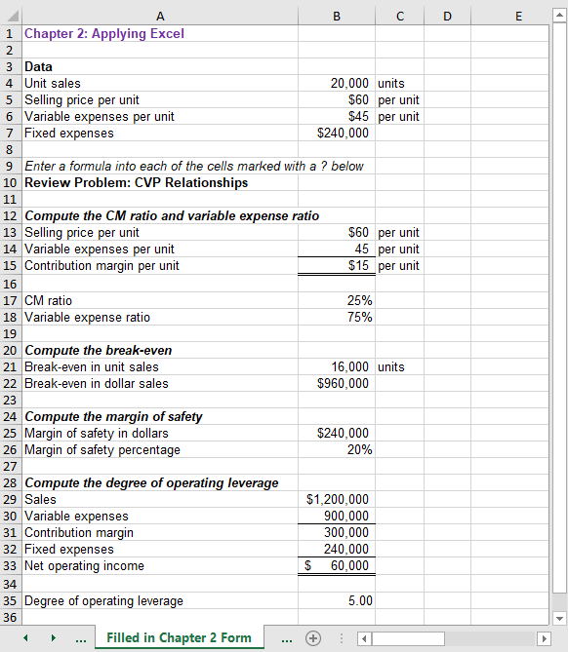

Chapter 2: Applying Excel (continued)

The completed worksheet, with formulas displayed, is shown below.

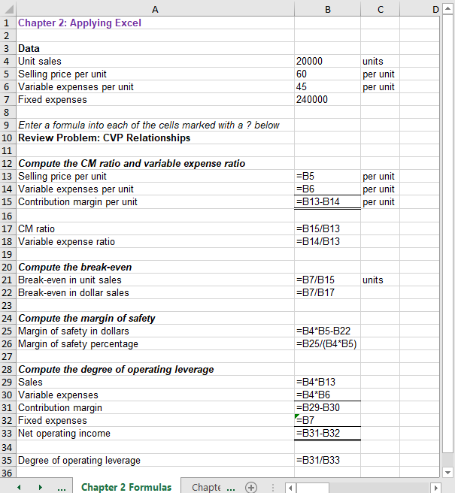

Chapter 2: Applying Excel (continued)

1. When the fixed expenses are changed to $270,000, the worksheet changes as shown below:

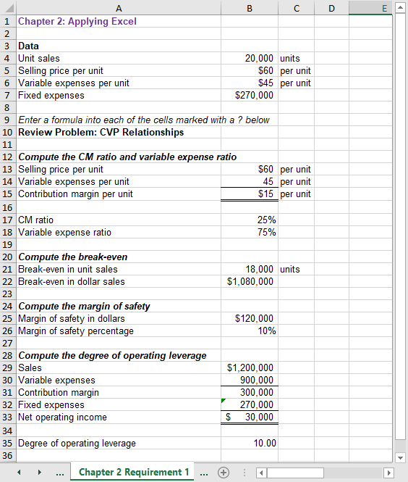

The margin of safety percentage is now 10%, whereas it was 20% before. This change occurred because the increase in fixed expenses increased the break-even point and hence reduced the margin of safety available for the current level of unit sales.

Chapter 2: Applying Excel (continued)

2. With the changes in the data, the worksheet should look like this:

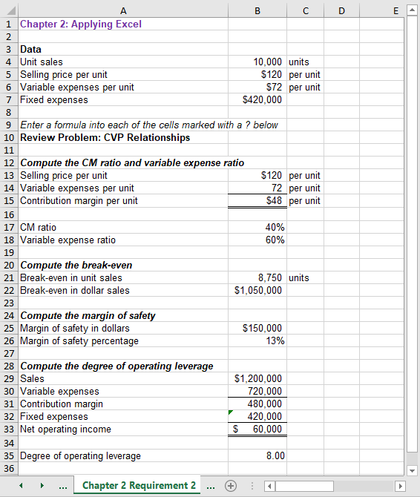

The margin of safety percentage is 13% and the degree of operating leverage is 8.

Chapter 2: Applying Excel (continued)

3. The degree of operating leverage can be used to estimate the expected percentage increase in net operating income from a 15% increase in unit sales as follows:

Percentage change in net operating income = Degree of operating leverage × Percentage change in sales = 8.00 × 15% = 120%

An increase of 120% over the current net operating income of $60,000 would result in net operating income of $132,000. This is verified in part (4) that follows.

Chapter 2: Applying Excel (continued)

4. Increasing the unit sales by 15% results in net operating income of $132,000—an increase of 120% over the previous net operating income of $60,000.

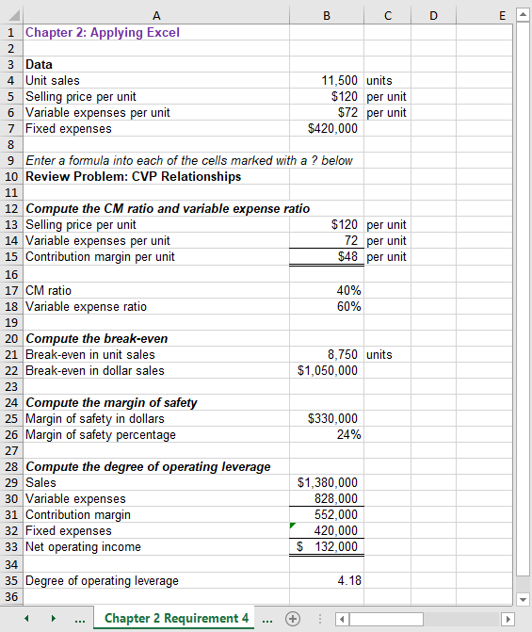

Chapter 2: Applying Excel (continued)

5. a. The initial plan for the Western Hombre motorcycle is summarized below:

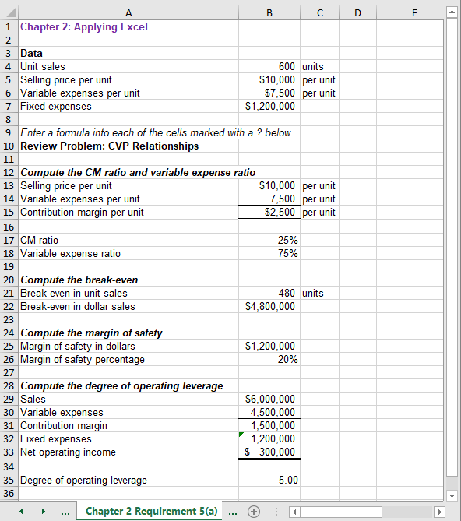

Chapter 2: Applying Excel (continued)

5. b. The modified plan for the Western Hombre motorcycle is summarized below:

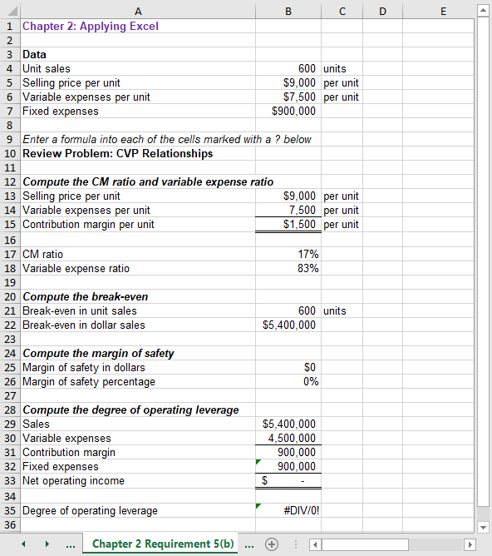

Chapter 2: Applying Excel (continued)

This does not appear to be a good plan. At best, Thad would only break even—and that assumes that 600 units would still be sold despite the drastic reduction in advertising expenses. The margin of safety is zero which means that any decrease in sales to below 600 units would result in a loss.

The degree of operating leverage is displayed in the worksheet as #DIV/0!. This means that Excel is unable to compute the degree of operating leverage because the divisor is 0. The divisor is 0 because the degree of operating leverage is the contribution margin divided by the net operating income and the net operating income is zero. Technically, the degree of operating leverage is undefined when net operating income is zero.

**The Foundational 15**

1. The contribution margin per unit is calculated as follows:

|  |  |  |
| --- | --- | --- |
| Total contribution margin (a) | $8,000 |  |
| Total units sold (b) | 1,000 | units |
| Contribution margin per unit (a) ÷ (b) | $8.00 | per unit |

The contribution margin per unit ($8) can also be derived by calculating the selling price per unit of $20 (= $20,000 ÷ 1,000 units) and deducting the variable expense per unit of $12 (= $12,000 ÷ 1,000 units).

2. The contribution margin ratio is calculated as follows:

|  |  |
| --- | --- |
| Total contribution margin (a) | $8,000 |
| Total sales (b) | $20,000 |
| Contribution margin ratio (a) ÷ (b) | 40% |

3. The variable expense ratio is calculated as follows:

|  |  |
| --- | --- |
| Total variable expenses (a) | $12,000 |
| Total sales (b) | $20,000 |
| Variable expense ratio (a) ÷ (b) | 60% |

4. The increase in net operating income is calculated as follows:

|  |  |  |
| --- | --- | --- |
| Contribution margin per unit (a) | $8.00 | per unit |
| Increase in unit sales (b) | 1 | unit |
| Increase in net operating income (a) × (b) | $8.00 |  |

5. If sales decline to 900 units, the net operating income would be computed as follows:

|  |  |  |
| --- | --- | --- |
|  | *Total* | *Per Unit* |
| Sales (900 units) | $18,000 | $20.00 |
| Variable expenses | 10,800 | 12.00 |
| Contribution margin | 7,200 | $  8.00 |
| Fixed expenses | 6,000 |  |
| Net operating income | $  1,200 |  |

**The Foundational 15** (continued)

6. The new net operating income would be computed as follows:

|  |  |  |
| --- | --- | --- |
|  | *Total* | *Per Unit* |
| Sales (900 units) | $19,800 | $22.00 |
| Variable expenses | 10,800 | 12.00 |
| Contribution margin | 9,000 | $10.00 |
| Fixed expenses | 6,000 |  |
| Net operating income | $  3,000 |  |

7. The new net operating income would be computed as follows:

|  |  |  |
| --- | --- | --- |
|  | *Total* | *Per Unit* |
| Sales (1,250 units) | $25,000 | $20.00 |
| Variable expenses | 16,250 | 13.00 |
| Contribution margin | 8,750 | $  7.00 |
| Fixed expenses | 7,500 |  |
| Net operating income | $  1,250 |  |

8. The equation method yields the break-even point in unit sales, Q, as follows:

|  |  |  |
| --- | --- | --- |
|  | Profit | = Unit CM × Q − Fixed expenses |
|  | $0 | = ($20 − $12) × Q − $6,000 |
|  | $0 | = ($8) × Q − $6,000 |
|  | $8Q | = $6,000 |
|  | Q | = $6,000 ÷ $8 |
|  | Q | = 750 units |

9. The equation method yields the dollar sales to break-even as follows:

|  |  |
| --- | --- |
| Profit | = CM ratio × Sales − Fixed expenses |
| $0 | = 0.40 × Sales − $6,000 |
| 0.40 × Sales | = $6,000 |
| Sales | = $6,000 ÷ 0.40 |
| Sales | = $15,000 |

The dollar sales to break-even ($15,000) can also be computed by multiplying the selling price per unit ($20) by the unit sales to break-even (750 units).

**The Foundational 15** (continued)

10. The equation method yields the target profit as follows:

|  |  |  |
| --- | --- | --- |
|  | Profit | = Unit CM × Q − Fixed expenses |
|  | $5,000 | = ($20 − $12) × Q − $6,000 |
|  | $5,000 | = ($8) × Q − $6,000 |
|  | $8Q | = $11,000 |
|  | Q | = $11,000 ÷ $8 |
|  | Q | = 1,375 units |

11. The margin of safety in dollars is calculated as follows:

|  |  |  |
| --- | --- | --- |
|  | Sales | $20,000 |
|  | Break-even sales (at 750 units) | 15,000 |
|  | Margin of safety (in dollars) | $  5,000 |
|  |  |  |

The margin of safety as a percentage of sales is calculated as follows:

|  |  |  |
| --- | --- | --- |
|  | Margin of safety (in dollars) (a) | $5,000 |
|  | Sales (b) | $20,000 |
|  | Margin of safety percentage (a) ÷ (b) | 25% |

12. The degree of operating leverage is calculated as follows:

|  |  |  |  |  |
| --- | --- | --- | --- | --- |
|  | Contribution margin (a) | | | $8,000 |
|  | Net operating income (b) | | | $2,000 |
|  | Degree of operating leverage (a) ÷ (b) | | | 4.0 |
|  |  |  |

13. A 5% increase in sales should result in a 20% increase in net operating income, computed as follows:

|  |  |  |
| --- | --- | --- |
|  | Degree of operating leverage (a) | 4.0 |
|  | Percent increase in sales (b) | 5% |
|  | Percent increase in net operating income (a) × (b) | 20% |

14. The degree of operating leverage is calculated as follows:

|  |  |
| --- | --- |
| Contribution margin ($20,000 – $6,000) (a) | $14,000 |
| Net operating income (b) | $2,000 |
| Degree of operating leverage (a) ÷ (b) | 7.0 |

**The Foundational 15** (continued)

15. A 5% increase in sales should result in a 35% increase in net operating income, computed as follows:

|  |  |
| --- | --- |
| Degree of operating leverage (a) | 7.0 |
| Percent increase in sales (b) | 5% |
| Percent increase in net operating income (a) × (b) | 35% |

**Exercise** **2-1** (20 minutes)

1. The revised net operating income would be:

|  |  |  |  |
| --- | --- | --- | --- |
|  |  | Total | Per Unit |
|  | Sales (10,100 units) | $353,500 | $35.00 |
|  | Variable expenses | 202,000 | 20.00 |
|  | Contribution margin | 151,500 | $15.00 |
|  | Fixed expenses | 135,000 |  |
|  | Net operating income | $ 16,500 |  |

You can get the same net operating income using the following approach:

|  |  |  |
| --- | --- | --- |
|  | Original net operating income | $15,000 |
|  | Change in contribution margin  (100 units × $15.00 per unit) | 1,500 |
|  | New net operating income | $16,500 |

2. The revised net operating income would be:

|  |  |  |  |
| --- | --- | --- | --- |
|  |  | Total | Per Unit |
|  | Sales (9,900 units) | $346,500 | $35.00 |
|  | Variable expenses | 198,000 | 20.00 |
|  | Contribution margin | 148,500 | $15.00 |
|  | Fixed expenses | 135,000 |  |
|  | Net operating income | $ 13,500 |  |

You can get the same net operating income using the following approach:

|  |  |  |
| --- | --- | --- |
|  | Original net operating income | $15,000 |
|  | Change in contribution margin  (-100 units × $15.00 per unit) | (1,500) |
|  | New net operating income | $13,500 |

**Exercise 2-1** (continued)

3. The revised net operating income would be:

|  |  |  |  |
| --- | --- | --- | --- |
|  |  | *Total* | *Per Unit* |
|  | Sales (9,000 units) | $315,000 | $35.00 |
|  | Variable expenses | 180,000 | 20.00 |
|  | Contribution margin | 135,000 | $15.00 |
|  | Fixed expenses | 135,000 |  |
|  | Net operating income | $         0 |  |

Note: This is the company’s break-even point.

**Exercise 2-2** (30 minutes)

1. The CVP graph can be plotted using the three steps outlined in the text. The graph appears on the next page.

Step 1. Draw a line parallel to the volume axis to represent the total fixed expense. For this company, the total fixed expense is $24,000.

Step 2. Choose some volume of sales and plot the point representing total expenses (fixed and variable) at the activity level you have selected. We’ll use the sales level of 8,000 units.

|  |  |  |
| --- | --- | --- |
|  | Fixed expenses | $ 24,000 |
|  | Variable expenses (8,000 units × $18 per unit) | 144,000 |
|  | Total expense | $168,000 |

Step 3. Choose some volume of sales and plot the point representing total sales dollars at the activity level you have selected. We’ll use the sales level of 8,000 units again.

|  |  |  |
| --- | --- | --- |
|  | Total sales revenue (8,000 units × $24 per unit) | $192,000 |

2. The break-even point is the point where the total sales revenue and the total expense lines intersect. This occurs at sales of 4,000 units. This can be verified as follows:

|  |  |  |
| --- | --- | --- |
|  | Profit | = Unit CM × Q − Fixed expenses |
|  |  | = ($24 − $18) × 4,000 − $24,000 |
|  |  | = $6 × 4,000 − $24,000 |
|  |  | = $24,000− $24,000 |
|  |  | = $0 |

**Exercise 2-2** (continued)

**Exercise 2-3** (15 minutes)

1. The profit graph is based on the following simple equation:

|  |  |  |
| --- | --- | --- |
|  | Profit | = Unit CM × Q − Fixed expenses |
|  | Profit | = ($16 − $11) × Q − $16,000 |
|  | Profit | = $5 × Q − $16,000 |

To plot the graph, select two different levels of sales such as Q=0 and Q=4,000. The profit at these two levels of sales are -$16,000 (=$5 × 0 − $16,000) and $4,000 (= $5 × 4,000 − $16,000).

**Exercise 2-3** (continued)

2. Looking at the graph, the break-even point appears to be 3,200 units. This can be verified as follows:

|  |  |  |
| --- | --- | --- |
|  | Profit | = Unit CM × Q − Fixed expenses |
|  |  | = $5 × Q − $16,000 |
|  |  | = $5 × 3,200 − $16,000 |
|  |  | = $16,000 − $16,000 |
|  |  | = $0 |

**Exercise 2-4** (10 minutes)

1. The company’s contribution margin (CM) ratio is:

|  |  |  |
| --- | --- | --- |
|  | Total sales | $200,000 |
|  | Total variable expenses | 120,000 |
|  | Total contribution margin (a) | $  80,000 |
|  |  |  |
|  | Total contribution margin (a) | $80,000 |
|  | Total sales (b) | $200,000 |
|  | CM ratio (a) ÷ (b) | 40% |

2. The change in net operating income from an increase in total sales of $1,000 can be estimated by using the CM ratio as follows:

|  |  |  |
| --- | --- | --- |
|  | Change in total sales (a) | $1,000 |
|  | CM ratio (b) | 40% |
|  | Estimated change in net operating income (a) × (b) | $400 |

This computation can be verified as follows:

|  |  |  |  |  |  |
| --- | --- | --- | --- | --- | --- |
|  | Total sales (a) | | | $200,000 |  |
|  | Total units sold (b) | | | 50,000 | units |
|  | Selling price per unit (a) ÷ (b) | | | $4.00 | per unit |
|  |  |  | | |  |
|  | Increase in total sales (a) | | $1,000 | |  |
|  | Selling price per unit (b) | | $4.00 | | per unit |
|  | Increase in unit sales (a) ÷ (b) | | 250 | | units |
|  |  | |  | |  |
|  | Increase in unit sales | | 250 | | units |
|  | Original total unit sales | | 50,000 | | units |
|  | New total unit sales | | 50,250 | | units |

|  |  |  |  |
| --- | --- | --- | --- |
|  |  | Original | New |
|  | Total unit sales | 50,000 | 50,250 |
|  | Sales | $200,000 | $201,000 |
|  | Variable expenses | 120,000 | 120,600 |
|  | Contribution margin | 80,000 | 80,400 |
|  | Fixed expenses | 65,000 | 65,000 |
|  | Net operating income | $ 15,000 | $ 15,400 |

**Exercise 2-5** (20 minutes)

1. The following table shows the effect of the proposed change in monthly advertising budget:

|  |  |  |  |  |
| --- | --- | --- | --- | --- |
|  |  |  | Sales With |  |
|  |  |  | Additional |  |
|  |  | Current | Advertising |  |
|  |  | Sales | Budget | Difference |
|  | Sales | $180,000 | $189,000 | $ 9,000 |
|  | Variable expenses | 126,000 | 132,300 | 6,300 |
|  | Contribution margin | 54,000 | 56,700 | 2,700 |
|  | Fixed expenses | 30,000 | 35,000 | 5,000 |
|  | Net operating income | $ 24,000 | $ 21,700 | $ (2,300) |

Assuming no other important factors need to be considered, the increase in the advertising budget should not be approved because it would lead to a decrease in net operating income of $2,300.

Alternative Solution 1

|  |  |  |
| --- | --- | --- |
|  | Expected total contribution margin: $189,000 × 30% CM ratio | $56,700 |
|  | Present total contribution margin: $180,000 × 30% CM ratio | 54,000 |
|  | Incremental contribution margin | 2,700 |
|  | Change in fixed expenses: Less incremental advertising expense | 5,000 |
|  | Change in net operating income | $ (2,300) |

Alternative Solution 2

|  |  |  |
| --- | --- | --- |
|  | Incremental contribution margin: $9,000 × 30% CM ratio | $2,700 |
|  | Less incremental advertising expense | 5,000 |
|  | Change in net operating income | $ (2,300) |

**Exercise 2-5** (continued)

2. The $2 increase in variable expense will cause the unit contribution margin to decrease from $27 to $25 with the following impact on net operating income:

|  |  |  |
| --- | --- | --- |
|  | Expected total contribution margin with the higher-quality components: 2,000 units × 1.1 × $25 per unit | $55,000 |
|  | Present total contribution margin: 2,000 units × $27 per unit | 54,000 |
|  | Change in total contribution margin | $ 1,000 |

Assuming no change in fixed expenses, the net operating income will also increase by $1,000. The higher-quality components should be used.

**Exercise 2-6** (20 minutes)

1. The break-even point in unit sales, Q, is computed as follows:

|  |  |  |
| --- | --- | --- |
|  | Profit | = Unit CM × Q − Fixed expenses |
|  | $0 | = ($15 − $12) × Q − $4,200 |
|  | $0 | = ($3) × Q − $4,200 |
|  | $3Q | = $4,200 |
|  | Q | = $4,200 ÷ $3 |
|  | Q | = 1,400 baskets |

2. The break-even point in dollar sales is computed as follows:

|  |  |
| --- | --- |
| Unit sales to break even (a) | 1,400 |
| Selling price per unit (b) | $15 |
| Dollar sales to break even (a) × (b) | $21,000 |

3. The new break-even point in unit sales, Q, is computed as follows:

|  |  |  |
| --- | --- | --- |
|  | Profit | = Unit CM × Q − Fixed expenses |
|  | $0 | = ($15 − $12) × Q − $4,800 |
|  | $0 | = ($3) × Q − $4,800 |
|  | $3Q | = $4,800 |
|  | Q | = $4,800 ÷ $3 |
|  | Q | = 1,600 baskets |

The break-even point in dollar sales is computed as follows:

|  |  |
| --- | --- |
| Unit sales to break even (a) | 1,600 |
| Selling price per unit (b) | $15 |
| Dollar sales to break even (a) × (b) | $24,000 |

**Exercise 2-7** (10 minutes)

1. The required unit sales, Q, to attain the target profit is computed as follows:

|  |  |  |
| --- | --- | --- |
|  | Profit | = Unit CM × Q − Fixed expenses |
|  | $10,000 | = ($120 − $80) × Q − $50,000 |
|  | $10,000 | = ($40) × Q − $50,000 |
|  | $40 × Q | = $10,000 + $50,000 |
|  | Q | = $60,000 ÷ $40 |
|  | Q | = 1,500 units |

2. One approach to solving this requirement is to compute the unit sales required to attain the target profit and then multiply this quantity by the selling price per unit:

|  |  |
| --- | --- |
| Profit | = Unit CM × Q − Fixed expenses |
| $15,000 | = ($120 − $80) × Q − $50,000 |
| $15,000 | = ($40) × Q − $50,000 |
| $40 × Q | = $15,000 + $50,000 |
| Q | = $65,000 ÷ $40 |
| Q | = 1,625 units |

|  |  |
| --- | --- |
| Unit sales to attain the target profit (a) | 1,625 |
| Selling price per unit (b) | $120 |
| Dollar sales to attain target profit (a) × (b) | $195,000 |

**Exercise 2-8** (10 minutes)

1. To compute the margin of safety, we must first compute the break-even unit sales.

|  |  |  |
| --- | --- | --- |
|  | Profit | = Unit CM × Q − Fixed expenses |
|  | $0 | = ($30 − $20) × Q − $7,500 |
|  | $0 | = ($10) × Q − $7,500 |
|  | $10Q | = $7,500 |
|  | Q | = $7,500 ÷ $10 |
|  | Q | = 750 units; or, at $30 per unit, $22,500 |

|  |  |  |
| --- | --- | --- |
|  | Sales (at the budgeted volume of 1,000 units) | $30,000 |
|  | Less break-even sales (at 750 units) | 22,500 |
|  | Margin of safety (in dollars) | $ 7,500 |

2. The margin of safety as a percentage of sales is as follows:

|  |  |  |
| --- | --- | --- |
|  | Margin of safety (in dollars) (a) | $7,500 |
|  | Sales (b) | $30,000 |
|  | Margin of safety percentage (a) ÷ (b) | 25% |

**Exercise 2-9** (20 minutes)

1. The company’s degree of operating leverage would be computed as follows:

|  |  |  |
| --- | --- | --- |
|  | Contribution margin (a) | $48,000 |
|  | Net operating income (b) | $10,000 |
|  | Degree of operating leverage (a) ÷ (b) | 4.8 |

2. A 5% increase in sales should result in a 24% increase in net operating income, computed as follows:

|  |  |  |
| --- | --- | --- |
|  | Degree of operating leverage (a) | 4.8 |
|  | Percent increase in sales (b) | 5% |
|  | Estimated percent increase in net operating income (a) × (b) | 24% |

3. The new income statement reflecting the change in sales is:

|  |  |  |  |
| --- | --- | --- | --- |
|  |  | Amount | Percent of Sales |
|  | Sales | $84,000 | 100% |
|  | Variable expenses | 33,600 | 40% |
|  | Contribution margin | 50,400 | 60% |
|  | Fixed expenses | 38,000 |  |
|  | Net operating income | $12,400 |  |

|  |  |  |
| --- | --- | --- |
|  | Net operating income reflecting change in sales | $12,400 |
|  | Original net operating income (a) | 10,000 |
|  | Change in net operating income (b) | $  2,400 |
|  | Percent change in net operating income (b) ÷ (a) | 24% |

**Exercise 2-10** (20 minutes)

1. The overall contribution margin ratio can be computed as follows:



2. The overall break-even point in dollar sales can be computed as follows:

Overall break-even 

 = $80,000

3. To construct the required income statement, we must first determine the relative sales mix for the two products:

|  |  |  |  |  |
| --- | --- | --- | --- | --- |
|  |  | Claimjumper | Makeover | Total |
|  | Original dollar sales | $30,000 | $70,000 | $100,000 |
|  | Percent of total | 30% | 70% | 100% |
|  | Sales at break-even | $24,000 | $56,000 | $80,000 |
|  |  |  |  |  |
|  |  | Claimjumper | Makeover | Total |
|  | Sales | $24,000 | $56,000 | $80,000 |
|  | Variable expenses* | 16,000 | 40,000 | 56,000 |
|  | Contribution margin | $ 8,000 | $16,000 | 24,000 |
|  | Fixed expenses |  |  | 24,000 |
|  | Net operating income |  |  | $       0 |

*Claimjumper variable expenses: ($24,000/$30,000) × $20,000 = $16,000

Makeover variable expenses: ($56,000/$70,000) × $50,000 = $40,000

**Exercise 2-11** (20 minutes)

|  |  |  |  |  |  |  |  |  |  |
| --- | --- | --- | --- | --- | --- | --- | --- | --- | --- |
| a. |  | Case #1 | | |  | Case #2 | | | |
|  | Number of units sold | 15,000 | * |  |  | 4,000 |  |  |  |
|  | Sales | $180,000 | * | $12 |  | $100,000 | * | $25 |  |
|  | Variable expenses | 120,000 | * | 8 |  | 60,000 |  | 15 |  |
|  | Contribution margin | 60,000 |  | $ 4 |  | 40,000 |  | $10 | * |
|  | Fixed expenses | 50,000 | * |  |  | 32,000 | * |  |  |
|  | Net operating income | $ 10,000 |  |  |  | $  8,000 | * |  |  |
|  |  |  |  |  |  |  |  |  |  |
|  |  | Case #3 | | |  | Case #4 | | | |
|  | Number of units sold | 10,000 | * |  |  | 6,000 | * |  |  |
|  | Sales | $200,000 |  | $20 |  | $300,000 | * | $50 |  |
|  | Variable expenses | 70,000 | * | 7 |  | 210,000 |  | 35 |  |
|  | Contribution margin | 130,000 |  | $13 | * | 90,000 |  | $15 |  |
|  | Fixed expenses | 118,000 |  |  |  | 100,000 | * |  |  |
|  | Net operating income (loss).. | $ 12,000 | * |  |  | $ (10,000) | * |  |  |

|  |  |  |  |  |  |  |  |  |  |  |  |  |  |  |
| --- | --- | --- | --- | --- | --- | --- | --- | --- | --- | --- | --- | --- | --- | --- |
| b. |  | | | Case #1 | | | |  | Case #2 | | | | | |
|  | Sales | | | $500,000 | * | 100% | |  | $400,000 | | | * | | 100% |
|  | Variable expenses | | | 400,000 |  | 80% | |  | 260,000 | | | * | | 65% |
|  | Contribution margin | | | 100,000 |  | 20% | | * | 140,000 | | |  | | 35% |
|  | Fixed expenses | | | 93,000 |  |  | |  | 100,000 | | | * | |  |
|  | Net operating income | | | $  7,000 | * |  | |  | $ 40,000 | | |  | |  |
|  | | |  |  | | | |  | |  | | | | |
|  | | |  | Case #3 | | | |  | | Case #4 | | | | |
|  | | Sales | | $250,000 |  | | 100% |  | | $600,000 | * | | 100% | |
|  | | Variable expenses | | 100,000 |  | | 40% |  | | 420,000 | * | | 70% | |
|  | | Contribution margin | | 150,000 |  | | 60% | * | | 180,000 |  | | 30% | |
|  | | Fixed expenses | | 130,000 | * | |  |  | | 185,000 |  | |  | |
|  | | Net operating income (loss). | | $ 20,000 | * | |  |  | | $  (5,000) | * | |  | |

*Given

**Exercise 2-12** (30 minutes)

1.

|  |  |  |  |  |  |  |  |  |
| --- | --- | --- | --- | --- | --- | --- | --- | --- |
|  | Flight Dynamic | |  | Sure Shot | |  | Total Company | |
|  | Amount | % |  | Amount | % |  | Amount | % |
| Sales | $150,000 | 100 |  | $250,000 | 100 |  | $400,000 | 100.0 |
| Variable expenses | 30,000 | 20 |  | 160,000 | 64 |  | 190,000 | 47.5 |
| Contribution margin | $120,000 | 80 |  | $ 90,000 | 36 |  | 210,000 | 52.5* |
| Fixed expenses |  |  |  |  |  |  | 183,750 |  |
| Net operating income |  |  |  |  |  |  | $ 26,250 |  |

*$210,000 ÷ $400,000 = 52.5%

2. The break-even point for the company as a whole is:



3. The additional contribution margin from the additional sales is computed as follows:

$100,000 × 52.5% CM ratio = $52,500

Assuming no change in fixed expenses, all of this additional contribution margin of $52,500 should drop to the bottom line as increased net operating income.

This answer assumes no change in selling prices, variable costs per unit, fixed expense, or sales mix.

**Exercise 2-13** (20 minutes)

|  |  |  |  |
| --- | --- | --- | --- |
|  |  | Total | Per Unit |
| 1. | Sales (20,000 units × 1.15 = 23,000 units) | $345,000 | $ 15.00 |
|  | Variable expenses | 207,000 | 9.00 |
|  | Contribution margin | 138,000 | $  6.00 |
|  | Fixed expenses | 70,000 |  |
|  | Net operating income | $ 68,000 |  |
|  |  |  |  |
| 2. | Sales (20,000 units × 1.25 = 25,000 units) | $337,500 | $13.50 |
|  | Variable expenses | 225,000 | 9.00 |
|  | Contribution margin | 112,500 | $ 4.50 |
|  | Fixed expenses | 70,000 |  |
|  | Net operating income | $ 42,500 |  |
|  |  |  |  |
| 3. | Sales (20,000 units × 0.95 = 19,000 units) | $313,500 | $16.50 |
|  | Variable expenses | 171,000 | 9.00 |
|  | Contribution margin | 142,500 | $ 7.50 |
|  | Fixed expenses | 90,000 |  |
|  | Net operating income | $ 52,500 |  |
|  |  |  |  |
| 4. | Sales (20,000 units × 0.90 = 18,000 units) | $302,400 | $16.80 |
|  | Variable expenses | 172,800 | 9.60 |
|  | Contribution margin | 129,600 | $ 7.20 |
|  | Fixed expenses | 70,000 |  |
|  | Net operating income | $ 59,600 |  |

**Exercise 2-14** (30 minutes)

1. Variable expenses: $40 × (100% – 30%) = $28

2. The break-even points in unit sales (Q) and dollar sales are computed as follows:

|  |  |  |  |  |
| --- | --- | --- | --- | --- |
|  |  | Selling price | $40 | 100% |
|  |  | Variable expenses | 28 | 70% |
|  |  | Contribution margin | $12 | 30% |

|  |  |
| --- | --- |
| Profit | = Unit CM × Q − Fixed expenses |
| $0 | = $12 × Q − $180,000 |
| $12Q | = $180,000 |
| Q | = $180,000 ÷ $12 |
| Q | = 15,000 units |

In dollar sales: 15,000 units × $40 per unit = $600,000

Alternative solution:

|  |  |
| --- | --- |
| Profit | = CM ratio × Sales − Fixed expenses |
| $0 | = 0.30 × Sales − $180,000 |
| 0.30 × Sales | = $180,000 |
| Sales | = $180,000 ÷ 0.30 |
| Sales | = $600,000 |

In unit sales: $600,000 ÷ $40 per unit = 15,000 units

3. The unit sales and dollar sales needed to attain the target profit are computed as follows:

|  |  |  |  |
| --- | --- | --- | --- |
|  |  | Profit | = Unit CM × Q − Fixed expenses |
|  |  | $60,000 | = $12 × Q − $180,000 |
|  |  | $12Q | = $60,000 + $180,000 |
|  |  | $12Q | = $240,000 |
|  |  | Q | = $240,000 ÷ $12 |
|  |  | Q | = 20,000 units |

In dollar sales: 20,000 units × $40 per unit = $800,000

**Exercise 2-14** (continued)

Alternative solution:

|  |  |
| --- | --- |
| Profit | = CM ratio × Sales − Fixed expenses |
| $60,000 | = 0.30 × Sales − $180,000 |
| 0.30 × Sales | = $240,000 |
| Sales | = $240,000 ÷ 0.30 |
| Sales | = $800,000 |

In unit sales: $800,000 ÷ $40 per unit = 20,000 units

4. The new break-even points in unit sales and dollar sales are computed as follows:

The company’s new cost/revenue relation will be:

|  |  |  |
| --- | --- | --- |
| Selling price | $40 | 100% |
| Variable expenses ($28 – $4) | 24 | 60% |
| Contribution margin | $16 | 40% |

|  |  |
| --- | --- |
| Profit | = Unit CM × Q − Fixed expenses |
| $0 | = ($40 − $24) × Q − $180,000 |
| $16Q | = $180,000 |
| Q | = $180,000 ÷ $16 per unit |
| Q | = 11,250 units |

In dollar sales: 11,250 units × $40 per unit = $450,000

Alternative solution:

|  |  |
| --- | --- |
| Profit | = CM ratio × Sales − Fixed expenses |
| $0 | = 0.40 × Sales − $180,000 |
| 0.40 × Sales | = $180,000 |
| Sales | = $180,000 ÷ 0.40 |
| Sales | = $450,000 |

In unit sales: $450,000 ÷ $40 per unit = 11,250 units

**Exercise 2-14** (continued)

4. The dollar sales required to attain the target profit is computed as follows:

|  |  |
| --- | --- |
| Profit | = CM ratio × Sales − Fixed expenses |
| $60,000 | = 0.40 × Sales − $180,000 |
| 0.40 × Sales | = $240,000 |
| Sales | = $240,000 ÷ 0.40 |
| Sales | = $600,000 |

**Exercise 2-15** (15 minutes)

|  |  |  |  |
| --- | --- | --- | --- |
| 1. |  |  |  |
|  |  | Total | Per Unit |
|  | Sales (15,000 games) | $300,000 | $20 |
|  | Variable expenses | 90,000 | 6 |
|  | Contribution margin | 210,000 | $14 |
|  | Fixed expenses | 182,000 |  |
|  | Net operating income | $ 28,000 |  |

The degree of operating leverage is:



2. a. Sales of 18,000 games represent a 20% increase over last year’s sales. Because the degree of operating leverage is 7.5, net operating income should increase by 7.5 times as much, or by 150% (7.5 × 20%).

b. The expected total dollar amount of net operating income for next year would be:

|  |  |
| --- | --- |
| Last year’s net operating income | $28,000 |
| Expected increase in net operating income next year (150% × $28,000) | 42,000 |
| Total expected net operating income | $70,000 |

**Exercise 2-16** (30 minutes)

1. The contribution margin per person would be:

|  |  |  |
| --- | --- | --- |
| Price per ticket |  | $35 |
| Variable expenses: |  |  |
| Dinner | $18 |  |
| Favors and program | 2 | 20 |
| Contribution margin per person |  | $15 |

The fixed expenses of the dinner-dance total $6,000 (= $2,800 + $900 + $1,000 + $1,300). The break-even point would be:

|  |  |  |
| --- | --- | --- |
|  | Profit | = Unit CM × Q − Fixed expenses |
|  | $0 | = ($35 − $20) × Q − $6,000 |
|  | $0 | = ($15) × Q − $6,000 |
|  | $15Q | = $6,000 |
|  | Q | = $6,000 ÷ $15 |
|  | Q | = 400 persons; or, at $35 per person, $14,000 |

Alternative solution:



or, at $35 per person, $14,000.

|  |  |  |
| --- | --- | --- |
| 2. | Variable cost per person ($18 + $2) | $20 |
|  | Fixed cost per person ($6,000 ÷ 300 persons) | 20 |
|  | Ticket price per person to break even | $40 |

**Exercise 2-16** (continued)

3. Cost-volume-profit graph:



**Exercise 2-17** (30 minutes)

|  |  |  |
| --- | --- | --- |
| 1. | Profit | = Unit CM × Q − Fixed expenses |
|  | $0 | = ($50 − $32) × Q − $108,000 |
|  | $0 | = ($18) × Q − $108,000 |
|  | $18Q | = $108,000 |
|  | Q | = $108,000 ÷ $18 |
|  | Q | = 6,000 stoves, or at $50 per stove, $300,000 in sales |

Alternative solution:



or at $50 per stove, $300,000 in sales.

2. An increase in variable expenses as a percentage of the selling price would result in a higher break-even point. If variable expenses increase as a percentage of sales, then the contribution margin will decrease as a percentage of sales. With a lower CM ratio, more stoves would have to be sold to generate enough contribution margin to cover the fixed costs.

|  |  |  |  |  |  |  |  |
| --- | --- | --- | --- | --- | --- | --- | --- |
| 3. |  | Present: 8,000 Stoves | |  | Proposed: 10,000 Stoves* | | |
|  |  | Total | Per Unit |  | Total | Per Unit |  |
|  | Sales | $400,000 | $50 |  | $450,000 | $45 | ** |
|  | Variable expenses | 256,000 | 32 |  | 320,000 | 32 |  |
|  | Contribution margin | 144,000 | $18 |  | 130,000 | $13 |  |
|  | Fixed expenses | 108,000 |  |  | 108,000 |  |  |
|  | Net operating income | $ 36,000 |  |  | $ 22,000 |  |  |

*8,000 stoves × 1.25 = 10,000 stoves

**$50 × 0.9 = $45

As shown above, a 25% increase in volume is not enough to offset a 10% reduction in the selling price; thus, net operating income decreases.

**Exercise 2-17** (continued)

|  |  |  |
| --- | --- | --- |
| 4. | Profit | = Unit CM × Q − Fixed expenses |
|  | $35,000 | = ($45 − $32) × Q − $108,000 |
|  | $35,000 | = ($13) × Q − $108,000 |
|  | $13 × Q | = $143,000 |
|  | Q | = $143,000 ÷ $13 |
|  | Q | = 11,000 stoves |

Alternative solution:



**Exercise 2-18** (30 minutes)

|  |  |  |
| --- | --- | --- |
| 1. | Profit | = Unit CM × Q − Fixed expenses |
|  | $0 | = ($30 − $12) × Q − $216,000 |
|  | $0 | = ($18) × Q − $216,000 |
|  | $18Q | = $216,000 |
|  | Q | = $216,000 ÷ $18 |
|  | Q | = 12,000 units, or at $30 per unit, $360,000 |

Alternative solution:





2. The contribution margin is $216,000 because the contribution margin is equal to the fixed expenses at the break-even point.

3. The unit sales to attain the target profit is computed as follows:

|  |  |
| --- | --- |
| 3. |  |

|  |  |  |  |
| --- | --- | --- | --- |
|  |  | Total | Unit |
|  | Sales (17,000 units × $30 per unit) | $510,000 | $30 |
|  | Variable expenses  (17,000 units × $12 per unit) | 204,000 | 12 |
|  | Contribution margin | 306,000 | $18 |
|  | Fixed expenses | 216,000 |  |
|  | Net operating income | $ 90,000 |  |

**Exercise 2-18** (continued)

4. Margin of safety in dollar terms:



Margin of safety in percentage terms:



5. The CM ratio is 60% [= ($30 – $12) ÷ $30].

|  |  |
| --- | --- |
| Expected total contribution margin: ($500,000 × 60%) | $300,000 |
| Present total contribution margin: ($450,000 × 60%) | 270,000 |
| Increased contribution margin | $ 30,000 |

Alternative solution:

$50,000 incremental sales × 60% CM ratio = $30,000

Given that the company’s fixed expenses will not change, monthly net operating income will also increase by $30,000.

**Problem 2-19** (45 minutes)

|  |  |  |
| --- | --- | --- |
| 1. | Sales (15,000 units × $70 per unit) | $1,050,000 |
|  | Variable expenses (15,000 units × $40 per unit) | 600,000 |
|  | Contribution margin | 450,000 |
|  | Fixed expenses | 540,000 |
|  | Net operating loss | $   (90,000) |

|  |  |
| --- | --- |
| 2. |  |

18,000 units × $70 per unit = $1,260,000 to break even

3. See the next page.

4. At a selling price of $58 per unit, the contribution margin is $18 per unit. Therefore:



30,000 units × $58 per unit = $1,740,000 to break even.

This break-even point is different from the break-even point in part (2) because of the change in selling price. With the change in selling price, the unit contribution margin drops from $30 to $18, resulting in an increase in the break-even point.

**Problem 2-19** (continued)

3.

|  |  |  |  |  |  |  |  |
| --- | --- | --- | --- | --- | --- | --- | --- |
|  | Unit Selling Price | Unit Variable Expense | Unit Contribution Margin | Volume (Units) | Total Contribution Margin | Fixed Expenses | Net operating income (loss) |
|  | $70 | $40 | $30 | 15,000 | $450,000 | $540,000 | $ (90,000) |
|  | $68 | $40 | $28 | 20,000 | $560,000 | $540,000 | $ 20,000 |
|  | $66 | $40 | $26 | 25,000 | $650,000 | $540,000 | $110,000 |
|  | $64 | $40 | $24 | 30,000 | $720,000 | $540,000 | $180,000 |
|  | $62 | $40 | $22 | 35,000 | $770,000 | $540,000 | $230,000 |
|  | $60 | $40 | $20 | 40,000 | $800,000 | $540,000 | $260,000 |
|  | $58 | $40 | $18 | 45,000 | $810,000 | $540,000 | $270,000 |
|  | $56 | $40 | $16 | 50,000 | $800,000 | $540,000 | $260,000 |

The maximum profit is $270,000. This level of profit can be earned by selling 45,000 units at a price of $58 each.

**Problem 2-20** (75 minutes)

|  |  |  |  |  |
| --- | --- | --- | --- | --- |
| 1. | a. | Selling price | $25 | 100% |
|  |  | Variable expenses | 15 | 60% |
|  |  | Contribution margin | $10 | 40% |

|  |  |  |
| --- | --- | --- |
|  | Profit | = Unit CM × Q − Fixed expenses |
|  | $0 | = $10 × Q − $210,000 |
|  | $10Q | = $210,000 |
|  | Q | = $210,000 ÷ $10 |
|  | Q | = 21,000 balls |

Alternative solution:



b. The degree of operating leverage is:



2. The new CM ratio will be:

|  |  |  |
| --- | --- | --- |
| Selling price | $25 | 100% |
| Variable expenses | 18 | 72% |
| Contribution margin | $ 7 | 28% |

The new break-even point will be:

|  |  |  |
| --- | --- | --- |
|  | Profit | = Unit CM × Q − Fixed expenses |
|  | $0 | = $7 × Q − $210,000 |
|  | $7Q | = $210,000 |
|  | Q | = $210,000 ÷ $7 |
|  | Q | = 30,000 balls |

**Problem 2-20** (continued)

Alternative solution:



|  |  |  |
| --- | --- | --- |
| 3. | Profit | = Unit CM × Q − Fixed expenses |
|  | $90,000 | = $7 × Q − $210,000 |
|  | $7Q | = $90,000 + $210,000 |
|  | Q | = $300,000 ÷ $7 |
|  | Q | = 42,857 balls (rounded) |

Alternative solution:



Thus, sales will have to increase by 12,857 balls (= 42,857 balls – 30,000 balls = 12,857 balls) to earn the same amount of net operating income as last year. The computations above and in part (2) show the dramatic effect that increases in variable costs can have on an organization. The effects on Northwood Company are summarized below:

|  |  |  |  |
| --- | --- | --- | --- |
|  | Present | Expected | |
| Break-even point (in balls) | 21,000 | 30,000 |
| Sales (in balls) needed to earn a $90,000 profit | 30,000 | 42,857 |

Note that if variable costs do increase next year, then the company will just break even if it sells the same number of balls (30,000) as it did last year.

**Problem 2-20** (continued)

4. The contribution margin ratio last year was 40%. If we let P equal the new selling price, then:

|  |  |
| --- | --- |
| P = | $18 + 0.40P |
| 0.60P = | $18 |
| P = | $18 ÷ 0.60 |
| P = | $30 |

To verify:

|  |  |  |  |
| --- | --- | --- | --- |
|  | Selling price | $30 | 100% |
|  | Variable expenses | 18 | 60% |
|  | Contribution margin | $12 | 40% |

Therefore, to maintain a 40% CM ratio, a $3 increase in variable costs would require a $5 increase in the selling price.

5. The new CM ratio would be:

|  |  |  |
| --- | --- | --- |
| Selling price | $25 | 100% |
| Variable expenses | 9* | 36% |
| Contribution margin | $16 | 64% |

*$15 – ($15 × 40%) = $9

The new break-even point would be:

|  |  |  |
| --- | --- | --- |
|  | Profit | = Unit CM × Q − Fixed expenses |
|  | $0 | = $16 × Q – ($210,000 × 2) |
|  | $16Q | = $420,000 |
|  | Q | = $420,000 ÷ $16 |
|  | Q | = 26,250 balls |

Alternative solution:



Although this new break-even point is greater than the company’s present break-even point of 21,000 balls [see Part (1) above], it is less than the break-even point will be if the company does not automate and variable labor costs rise next year [see Part (2) above].

**Problem 2-20** (continued)

|  |  |  |  |
| --- | --- | --- | --- |
| 6. | a. | Profit | = Unit CM × Q − Fixed expenses |
|  |  | $90,000 | = $16 × Q − $420,000 |
|  |  | $16Q | = $90,000 + $420,000 |
|  |  | Q | = $510,000 ÷ $16 |
|  |  | Q | = 31,875 balls |

Alternative solution:



Thus, the company will have to sell 1,875 more balls (31,875 – 30,000 = 1,875) than now being sold to earn a profit of $90,000 per year. However, this is still less than the 42,857 balls that would have to be sold to earn a $90,000 profit if the plant is not automated and variable labor costs rise next year [see Part (3) above].

b. The contribution income statement would be:

|  |  |
| --- | --- |
| Sales (30,000 balls × $25 per ball) | $750,000 |
| Variable expenses (30,000 balls × $9 per ball) | 270,000 |
| Contribution margin | 480,000 |
| Fixed expenses | 420,000 |
| Net operating income | $ 60,000 |



**Problem 2-20** (continued)

c. This problem illustrates the difficulty faced by some companies. When variable labor costs increase, it is often difficult to pass these cost increases along to customers in the form of higher prices. Thus, companies are forced to automate resulting in higher operating leverage, often a higher break-even point, and greater risk for the company.

There is no clear answer as to whether one should have been in favor of constructing the new plant.

**Problem 2-21** (30 minutes)

|  |  |  |  |  |  |  |  |  |  |  |  |  |  |  |  |
| --- | --- | --- | --- | --- | --- | --- | --- | --- | --- | --- | --- | --- | --- | --- | --- |
| 1. |  | Product | | | | | | | | | |  |  | | |
|  |  | White | |  | Fragrant | |  | Loonzain | | | |  | Total | | |
|  | Percentage of total sales | 40% |  |  | 24% |  |  | 36% | |  | |  | 100% |  |  |
|  | Sales | $300,000 | 100% |  | $180,000 | 100% |  | $270,000 | | 100% | |  | $750,000 | 100% |  |
|  | Variable expenses | 216,000 | 72% |  | 36,000 | 20% |  | 108,000 | | 40% | |  | 360,000 | 48% |  |
|  | Contribution margin | $ 84,000 | 28% |  | $144,000 | 80% |  | $162,000 | | | 60% |  | 390,000 | 52% | * |
|  | Fixed expenses |  |  |  |  |  |  | |  | |  |  | 449,280 |  |  |
|  | Net operating income (loss) |  |  |  |  |  |  | |  | |  |  | $ (59,280) |  |  |

*$390,000 ÷ $750,000 = 52%

2. Break-even sales would be:



**Problem 2-21** (continued)

3. Memo to the president:

Although the company met its sales budget of $750,000 for the month, the mix of products changed substantially from that budgeted. This is the reason the budgeted net operating income was not met, and the reason the break-even sales were greater than budgeted. The company’s sales mix was planned at 20% White, 52% Fragrant, and 28% Loonzain. The actual sales mix was 40% White, 24% Fragrant, and 36% Loonzain.

As shown by these data, sales shifted away from Fragrant Rice, which provides our greatest contribution per dollar of sales, and shifted toward White Rice, which provides our least contribution per dollar of sales. Although the company met its budgeted level of sales, these sales provided considerably less contribution margin than we had planned, with a resulting decrease in net operating income. Notice from the attached statements that the company’s overall CM ratio was only 52%, as compared to a planned CM ratio of 64%. This also explains why the break-even point was higher than planned. With less average contribution margin per dollar of sales, a greater level of sales had to be achieved to provide sufficient contribution margin to cover fixed costs.

**Problem 2-22** (60 minutes)

1. The CM ratio is 30%.

|  |  |  |  |
| --- | --- | --- | --- |
|  | Total | Per Unit | Percent of Sales |
| Sales (19,500 units) | $585,000 | $30.00 | 100% |
| Variable expenses | 409,500 | 21.00 | 70% |
| Contribution margin | $175,500 | $ 9.00 | 30% |

The break-even point is:

|  |  |  |
| --- | --- | --- |
|  | Profit | = Unit CM × Q − Fixed expenses |
|  | $0 | = ($30 − $21) × Q − $180,000 |
|  | $0 | = ($9) × Q − $180,000 |
|  | $9Q | = $180,000 |
|  | Q | = $180,000 ÷ $9 |
|  | Q | = 20,000 units |
|  |  |  |
|  | 20,000 units × $30 per unit = $600,000 in sales | |

Alternative solution:



|  |  |  |
| --- | --- | --- |
| 2. | Incremental contribution margin: |  |
|  | $80,000 increased sales × 0.30 CM ratio | $24,000 |
|  | Less increased advertising cost | 16,000 |
|  | Increase in monthly net operating income | $ 8,000 |

Since the company is now showing a loss of $4,500 per month, if the changes are adopted, the loss will turn into a profit of $3,500 each month ($8,000 – $4,500 = $3,500).

**Problem 2-22** (continued)

|  |  |  |
| --- | --- | --- |
| 3. | Sales (39,000 units @ $27.00 per unit*) | $1,053,000 |
|  | Variable expenses  (39,000 units @ $21.00 per unit) | 819,000 |
|  | Contribution margin | 234,000 |
|  | Fixed expenses ($180,000 + $60,000) | 240,000 |
|  | Net operating loss | $      (6,000) |

*$30.00 – ($30.00 × 0.10) = $27.00

|  |  |  |
| --- | --- | --- |
| 4. | Profit | = Unit CM × Q − Fixed expenses |
|  | $9,750 | = ($30.00 − $21.75) × Q − $180,000 |
|  | $9,750 | = ($8.25) × Q − $180,000 |
|  | $8.25Q | = $189,750 |
|  | Q | = $189,750 ÷ $8.25 |
|  | Q | = 23,000 units |

*$21.00 + $0.75 = $21.75

Alternative solution:



**$30.00 – $21.75 = $8.25

5. a. The new CM ratio would be:

|  |  |  |
| --- | --- | --- |
|  | Per Unit | Percent of Sales |
| Sales | $30.00 | 100% |
| Variable expenses | 18.00 | 60% |
| Contribution margin | $12.00 | 40% |

**Problem 2-22** (continued)

The new break-even point would be:



b. Comparative income statements follow:

|  |  |  |  |  |  |  |  |  |
| --- | --- | --- | --- | --- | --- | --- | --- | --- |
|  | Not Automated | | | |  | Automated | | |
|  | Total | | Per Unit | % |  | Total | Per Unit | % |
| Sales (26,000 units) | $780,000 | $30.00 | | 100 |  | $780,000 | $30.00 | 100 |
| Variable expenses | 546,000 | 21.00 | | 70 |  | 468,000 | 18.00 | 60 |
| Contribution margin | 234,000 | $ 9.00 | | 30 |  | 312,000 | $12.00 | 40 |
| Fixed expenses | 180,000 |  | |  |  | 252,000 |  |  |
| Net operating income | $ 54,000 |  | |  |  | $ 60,000 |  |  |

**Problem 2-22** (continued)

c. Whether or not the company should automate its operations depends on how much risk the company is willing to take and on prospects for future sales. The proposed changes would increase the company’s fixed costs and its break-even point. However, the changes would also increase the company’s CM ratio (from 0.30 to 0.40). The higher CM ratio means that once the break-even point is reached, profits will increase more rapidly than at present. If 26,000 units are sold next month, for example, the higher CM ratio will generate $6,000 (= $60,000 – $54,000) more in profits than if no changes are made.

The greatest risk of automating is that future sales may drop back down to present levels (only 19,500 units per month), and as a result, losses will be even larger than at present due to the company’s greater fixed costs. (Note the problem states that sales are erratic from month to month.) In sum, the proposed changes will help the company if sales continue to trend upward in future months; the changes will hurt the company if sales drop back down to or near present levels.

**Note to the Instructor:** Although it is not asked for in the problem, if time permits you may want to compute the point of indifference between the two alternatives in terms of units sold; i.e., the point where profits will be the same under either alternative. At this point, total revenue will be the same; hence, we include only costs in our equation:

|  |  |
| --- | --- |
| Let Q = | Point of indifference in units sold |
| $21.00Q + $180,000 = | $18.00Q + $252,000 |
| $3.00Q = | $72,000 |
| Q = | $72,000 ÷ $3.00 |
| Q = | 24,000 units |

If more than 24,000 units are sold in a month, the proposed plan will yield the greater profits; if less than 24,000 units are sold in a month, the present plan will yield the greater profits (or the least loss).

**Problem 2-23** (60 minutes)

1. The CM ratio is 60%:

|  |  |  |  |
| --- | --- | --- | --- |
|  | Sales price | $20.00 | 100% |
|  | Variable expenses | 8.00 | 40% |
|  | Contribution margin | $12.00 | 60% |

|  |  |
| --- | --- |
| 2. |  |

3. $75,000 increased sales × 0.60 CM ratio = $45,000 increased contribution margin. Because the fixed costs will not change, net operating income should also increase by $45,000.

4a. The degree of operating leverage is calculated as follows:

|  |  |  |
| --- | --- | --- |
| 4. |  |  |

4b. 4 × 20% = 80% increase in net operating income. In dollars, this increase would be 80% × $60,000 = $48,000.

**Problem 2-23** (continued)

5. This year’s net operating income is computed as follows:

|  |  |  |
| --- | --- | --- |
| Sales (25,000 units × $18 per unit) | $450,000 | |
| Variable expenses (25,000 units × $8 per unit) | 200,000 | |
| Contribution margin | 250,000 | |
| Fixed expenses ($180,000 + $30,000) | 210,000 | |
| Net operating income | $  40,000 |

The sales manager’s suggestions should not be implemented because they will lower net operating income by $20,000 (= $60,000 – $40,000).

|  |  |  |
| --- | --- | --- |
| 6. | Expected total contribution margin: 20,000 units × 1.25 × $11.00 per unit* | $275,000 |
|  | Present total contribution margin | 240,000 |
|  | Incremental contribution margin, and the amount by which advertising can be increased with net operating income remaining unchanged | $ 35,000 |
|  |  |  |
|  | *$20.00 – ($8.00 + $1.00) = $11.00 |  |

**Problem 2-24** (30 minutes)

The key to solving the requirements of this problem is understanding that the sweatshirts represent a step-fixed cost. They cannot be purchased at a cost of $8 each. They must be bought in batches of 75 sweatshirts at a cost of $600 per batch (75 sweatshirts × $8 per shirt = $600 per batch).

1. A good starting point for solving this problem is to compute the profit from buying and selling one batch of 75 sweatshirts:

|  |  |  |
| --- | --- | --- |
|  | Sales (75 shirts × $13.50) | $1,012.50 |
|  | Variable expenses (75 shirts × $1.50) | 112.50 |
|  | Contribution margin | 900.00 |
|  | Step-fixed expense ($600 × 1 batch) | 600.00 |
|  | Net operating income | $  300.00 |

If the profit from selling one batch of 75 sweatshirts is $300, then the profit from selling four batches of 75 sweatshirts, or 300 sweatshirts in total, will equal the target profit of $1,200 ($300 per batch × 4 batches = $1,200).

2. The contribution margin per sweatshirt is:

|  |  |
| --- | --- |
| Selling price | $13.50 |
| Variable expenses (commissions only) | 1.50 |
| Contribution margin | $12.00 |

The fixed cost associated with buying 75 sweatshirts is $600; therefore, the break-even point would be 50 sweatshirts computed as follows:



**Problem 2-25** (45 minutes)

1. The contribution margin per unit on the first 16,000 units is:

|  |  |
| --- | --- |
|  | Per Unit |
| Sales price | $3.00 |
| Variable expenses | 1.25 |
| Contribution margin | $1.75 |

The contribution margin per unit on anything over 16,000 units is:

|  |  |
| --- | --- |
|  | Per Unit |
| Sales price | $3.00 |
| Variable expenses | 1.40 |
| Contribution margin | $1.60 |

Thus, for the first 16,000 units sold, the total amount of contribution margin generated would be:

16,000 units × $1.75 per unit = $28,000

Since the fixed costs on the first 16,000 units total $35,000, the $28,000 contribution margin above is not enough to permit the company to break even. Therefore, in order to break even, more than 16,000 units would have to be sold. The fixed costs that will have to be covered by the additional sales are:

|  |  |
| --- | --- |
| Fixed costs on the first 16,000 units | $35,000 |
| Less contribution margin from the first 16,000 units | 28,000 |
| Remaining unrecovered fixed costs | 7,000 |
| Add monthly rental cost of the additional space needed to produce more than 16,000 units | 1,000 |
| Total fixed costs to be covered by remaining sales | $ 8,000 |

**Problem 2-25** (continued)

The additional sales of units required to cover these fixed costs would be:



Therefore, a total of 21,000 units (16,000 + 5,000) must be sold in order for the company to break even. This number of units would equal total sales of:

21,000 units × $3.00 per unit = $63,000 in total sales

|  |  |
| --- | --- |
| 2. |  |

Thus, the company must sell 7,500 units above the break-even point to earn a profit of $12,000 each month. These units, added to the 21,000 units required to break even, equal total sales of 28,500 units each month to reach the target profit.

3. If a bonus of $0.10 per unit is paid for each unit sold in excess of the break-even point, then the contribution margin on these units would drop from $1.60 to $1.50 per unit.

The desired monthly profit would be:

25% × ($35,000 + $1,000) = $9,000

Thus,



Therefore, the company must sell 6,000 units above the break-even point to earn a profit of $9,000 each month. These units, added to the 21,000 units required to break even, would equal total sales of 27,000 units each month.

**Problem 2-26** (60 minutes)

|  |  |  |
| --- | --- | --- |
| 1. | Profit | = Unit CM × Q − Fixed expenses |
|  | $0 | = ($30 − $18) × Q − $150,000 |
|  | $0 | = ($12) × Q − $150,000 |
|  | $12Q | = $150,000 |
|  | Q | = $150,000 ÷ $12 |
|  | Q | = 12,500 pairs |

12,500 pairs × $30 per pair = $375,000 in sales

Alternative solution:



2. See the graph on the following page.

3. The simplest approach is:

|  |  |
| --- | --- |
| Break-even sales | 12,500 pairs |
| Actual sales | 12,000 pairs |
| Sales short of break-even | 500 pairs |

500 pairs × $12 contribution margin per pair = $6,000 loss

Alternative solution:

|  |  |
| --- | --- |
| Sales (12,000 pairs × $30.00 per pair) | $360,000 |
| Variable expenses  (12,000 pairs × $18.00 per pair) | 216,000 |
| Contribution margin | 144,000 |
| Fixed expenses | 150,000 |
| Net operating loss | $  (6,000) |

**Problem 2-26** (continued)

2. Cost-volume-profit graph:



**Problem 2-26** (continued)

4. The variable expenses will now be $18.75 per pair, and the contribution margin will be $11.25 per pair.

|  |  |  |
| --- | --- | --- |
|  | Profit | = Unit CM × Q − Fixed expenses |
|  | $0 | = ($30.00 − $18.75) × Q − $150,000 |
|  | $0 | = ($11.25) × Q − $150,000 |
|  | $11.25Q | = $150,000 |
|  | Q | = $150,000 ÷ $11.25 |
|  | Q | = 13,333 pairs (rounded) |

13,333 pairs × $30.00 per pair = $400,000 in sales

Alternative solution:



5. The simplest approach is:

|  |  |
| --- | --- |
| Actual sales | 15,000 pairs |
| Break-even sales | 12,500 pairs |
| Excess over break-even sales | 2,500 pairs |
|  |  |
| 2,500 pairs × $11.50 per pair* = $28,750 profit | |
|  | |
| *$12.00 present contribution margin – $0.50 commission = $11.50 | |

**Problem 2-26** (continued)

6. The new variable expenses will be $13.50 per pair.

|  |  |  |  |
| --- | --- | --- | --- |
|  | Profit | = Unit CM × Q − Fixed expenses | |
|  | $0 | = ($30.00 − $13.50) × Q – ($150,000 + $31,500) | |
|  | $0 | = ($16.50) × Q − $181,500 | |
|  | $16.50Q | = $181,500 | |
|  | Q | = $181,500 ÷ $16.50 | |
|  | Q | = 11,000 pairs | |
|  |  |  | |
|  | 11,000 pairs × $30.00 per pair = $330,000 in sales | |

Although the change will lower the break-even point from 12,500 pairs to 11,000 pairs, the company must consider whether this reduction in the break-even point is more than offset by the possible loss in sales arising from having the sales staff on a salaried basis. Under a salary arrangement, the sales staff has less incentive to sell than under the present commission arrangement, resulting in a potential loss of sales and a reduction of profits. Although it is generally desirable to lower the break-even point, management must consider the other effects of a change in the cost structure. The break-even point could be reduced dramatically by doubling the selling price but it does not necessarily follow that this would improve the company’s profit.

**Problem 2-27** (45 minutes)

|  |  |  |  |  |  |  |  |  |  |  |
| --- | --- | --- | --- | --- | --- | --- | --- | --- | --- | --- |
| 1. | a. |  | Hawaiian  Fantasy  (20,000 units) | |  | Tahitian  Joy  (5,000 units) | |  | Total | |
|  |  |  | Amount | % |  | Amount | % |  | Amount | % |
|  |  | Sales | $300,000 | 100% |  | $500,000 | 100% |  | $800,000 | 100% |
|  |  | Variable expenses | 180,000 | 60% |  | 100,000 | 20% |  | 280,000 | 35% |
|  |  | Contribution margin | $120,000 | 40% |  | $400,000 | 80% |  | 520,000 | 65% |
|  |  | Fixed expenses |  |  |  |  |  |  | 475,800 |  |
|  |  | Net operating income |  |  |  |  |  |  | $ 44,200 |  |

|  |  |  |
| --- | --- | --- |
|  | b. |  |

**Problem 2-27** (continued)

|  |  |  |  |  |  |  |  |  |  |  |  |  |  |  |  |
| --- | --- | --- | --- | --- | --- | --- | --- | --- | --- | --- | --- | --- | --- | --- | --- |
| 2. | a. |  | Hawaiian  Fantasy  (20,000 units) | |  | | Tahitian  Joy  (5,000 units) | |  | Samoan  Delight  (10,000 units) | | |  | Total | |
|  |  |  | Amount | % |  | Amount | | % |  | | Amount | % |  | Amount | % |
|  |  | Sales | $300,000 | 100% |  | $500,000 | | 100% |  | | $450,000 | 100% |  | $1,250,000 | 100.0% |
|  |  | Variable expenses | 180,000 | 60% |  | 100,000 | | 20% |  | | 360,000 | 80% |  | 640,000 | 51.2% |
|  |  | Contribution  margin | $120,000 | 40% |  | $400,000 | | 80% |  | | $ 90,000 | 20% |  | 610,000 | 48.8% |
|  |  | Fixed expenses |  |  |  |  | |  |  | |  |  |  | 475,800 |  |
|  |  | Net operating  income |  |  |  |  | |  |  | |  |  |  | $  134,200 |  |

**Problem 2-27** (continued)

|  |  |  |
| --- | --- | --- |
|  | b. |  |

3. The reason for the increase in the break-even point can be traced to the decrease in the company’s overall contribution margin ratio when the third product is added. Note from the income statements above that this ratio drops from 65% to 48.8% with the addition of the third product. This product (the Samoan Delight) has a CM ratio of only 20%, which causes the average contribution margin per dollar of sales to shift downward.

This problem shows the somewhat tenuous nature of break-even analysis when the company has more than one product. The analyst must be very careful of his or her assumptions regarding sales mix, including the addition (or deletion) of new products.

It should be pointed out to the president that even though the break-even point is higher with the addition of the third product, the company’s margin of safety is also greater. Notice that the margin of safety increases from $68,000 to $275,000 or from 8.5% to 22%. Thus, the addition of the new product shifts the company much further from its break-even point, even though the break-even point is higher.

**Problem 2-28** (60 minutes)

1.

|  |  |  |  |  |  |  |  |  |  |
| --- | --- | --- | --- | --- | --- | --- | --- | --- | --- |
| Carbex, Inc. | | | | | | | | | |
| Income Statement For April | | | | | | | | | |
|  | | | | | | | | | |
|  | Standard | |  | Deluxe | | |  | Total | | |
|  | Amount | % |  | Amount | | % |  | Amount | % | |
| Sales | $240,000 | 100 |  | $150,000 | 100 | |  | $390,000 | 100.0 | |
| Variable expenses: |  |  |  |  |  | |  |  |  | |
| Production | 60,000 | 25 |  | 60,000 | 40 | |  | 120,000 | 30.8 | |
| Sales commission | 36,000 | 15 |  | 22,500 | 15 | |  | 58,500 | 15.0 | |
| Total variable expenses | 96,000 | 40 |  | 82,500 | 55 | |  | 178,500 | 45.8 | |
| Contribution margin | $144,000 | 60 |  | $ 67,500 | 45 | |  | $211,500 | 54.2 | |
| Fixed expenses: |  |  |  |  |  | |  |  |  | |
| Advertising |  |  |  |  |  | |  | 105,000 |  | |
| Depreciation |  |  |  |  |  | |  | 21,700 |  | |
| Administrative |  |  |  |  |  | |  | 63,000 |  | |
| Total fixed expenses |  |  |  |  |  | |  | 189,700 |  | |
| Net operating income |  |  |  |  |  | |  | $ 21,800 |  | |

|  |  |  |  |  |  |  |  |  |
| --- | --- | --- | --- | --- | --- | --- | --- | --- |
| Carbex, Inc. | | | | | | | | |
| Income Statement For May | | | | | | | | |
|  | | | | | | | | |
|  | Standard | |  | Deluxe | |  | Total | | |
|  | Amount | % |  | Amount | % |  | Amount | % | |
| Sales | $60,000 | 100 |  | $375,000 | 100 |  | $435,000 | 100.0 | |
| Variable expenses: |  |  |  |  |  |  |  |  | |
| Production | 15,000 | 25 |  | 150,000 | 40 |  | 165,000 | 37.9 | |
| Sales commission | 9,000 | 15 |  | 56,250 | 15 |  | 65,250 | 15.0 | |
| Total variable expenses | 24,000 | 40 |  | 206,250 | 55 |  | 230,250 | 52.9 | |
| Contribution margin | $36,000 | 60 |  | $168,750 | 45 |  | 204,750 | 47.1 | |
| Fixed expenses: |  |  |  |  |  |  |  |  | |
| Advertising |  |  |  |  |  |  | 105,000 |  | |
| Depreciation |  |  |  |  |  |  | 21,700 |  | |
| Administrative |  |  |  |  |  |  | 63,000 |  | |
| Total fixed expenses |  |  |  |  |  |  | 189,700 |  | |
| Net operating income |  |  |  |  |  |  | $ 15,050 |  | |

**Problem 2-28** (continued)

2. The sales mix has shifted over the last year from Standard sets to Deluxe sets. This shift has caused a decrease in the company’s overall CM ratio from 54.2% in April to 47.1% in May. For this reason, even though total sales (in dollars) are greater, net operating income is lower.

3. Sales commissions could be based on contribution margin rather than on sales price. A flat rate on total contribution margin, as the text suggests, might encourage the salespersons to emphasize the product with the greatest contribution to the profits.

a. The break-even in dollar sales can be computed as follows:



b. The break-even point in May would be higher than the break-even point in April. This occurs because the sales mix has shifted from the more profitable to the less profitable units, which in turn decreases the company’s overall CM ratio.

**Problem 2-29** (60 minutes)

1. The income statements would be:

|  |  |  |  |  |
| --- | --- | --- | --- | --- |
|  |  | Present | | |
|  |  | Amount | Per Unit | % |
|  | Sales | $450,000 | $30 | 100% |
|  | Variable expenses | 315,000 | 21 | 70% |
|  | Contribution margin | 135,000 | $  9 | 30% |
|  | Fixed expenses | 90,000 |  |  |
|  | Net operating income | $ 45,000 |  |  |

|  |  |  |  |  |
| --- | --- | --- | --- | --- |
|  |  | Proposed | | |
|  |  | Amount | Per Unit | % |
|  | Sales | $450,000 | $30 | 100% |
|  | Variable expenses* | 180,000 | 12 | 40% |
|  | Contribution margin | 270,000 | $18 | 60% |
|  | Fixed expenses | 225,000 |  |  |
|  | Net operating income | $ 45,000 |  |  |

*$21 – $9 = $12

2. a. Degree of operating leverage:

Present:



Proposed:



**Problem 2-29** (continued)

b. Dollar sales to break even:

Present:



Proposed:



c. Margin of safety:

Present:



Proposed:



**Problem 2-29** (continued)

3. The major factor would be the sensitivity of the company’s operations to cyclical movements in the economy. Because the new equipment will increase the CM ratio, in years of strong economic activity, the company will be better off with the new equipment. However, in economic recession, the company will be worse off with the new equipment. The fixed costs of the new equipment will cause losses to be deeper and sustained more quickly than at present. Thus, management must decide whether the potential for greater profits in good years is worth the risk of deeper losses in bad years.

4. No information is given in the problem concerning the new variable expenses or the new contribution margin ratio. Both of these items must be determined before the new break-even point can be computed. The computations are:

New variable expenses:

|  |  |
| --- | --- |
| Profit | = (Sales − Variable expenses) − Fixed expenses |
| $54,000** | = ($585,000* − Variable expenses) − $180,000 |
| Variable expenses | = $585,000 − $180,000 − $54,000 |
|  | = $351,000 |

|  |
| --- |
| *New level of sales: $450,000 × 1.30 = $585,000 |
| **New level of net operating income: $45,000 × 1.2 = $54,000 |

New CM ratio:

|  |  |  |
| --- | --- | --- |
| Sales | $585,000 | 100% |
| Variable expenses | 351,000 | 60% |
| Contribution margin | $234,000 | 40% |

With the above data, the new break-even point can be computed:



**Problem 2-29** (continued)

The greatest risk is that the increases in sales and net operating income predicted by the marketing manager will not happen and that sales will remain at their present level. Note that the present level of sales is $450,000, which is equal to the break-even level of sales under the new marketing method. Thus, if the new marketing strategy is adopted and sales remain unchanged, profits will drop from the current level of $45,000 per month to zero.

It would be a good idea to compare the new marketing strategy to the current situation more directly. What level of sales would be needed under the new method to generate at least the $45,000 in profits the company is currently earning each month? The computations are:



Thus, sales would have to increase by at least 25% ($562,500 is 25% higher than $450,000) in order to make the company better off with the new marketing strategy than with the current situation. This appears to be extremely risky.

**Problem 2-30** (60 minutes)

|  |  |  |
| --- | --- | --- |
| 1. | Profit | = Unit CM × Q − Fixed expenses |
|  | $0 | = ($40 − $16) × Q − $60,000 |
|  | $0 | = ($24) × Q − $60,000 |
|  | $24Q | = $60,000 |
|  | Q | = $60,000 ÷ $24 |
|  | Q | = 2,500 pairs, or at $40 per pair, $100,000 in sales |

Alternative solution:





2. See the graphs at the end of this solution.

|  |  |  |
| --- | --- | --- |
| 3. | Profit | = Unit CM × Q − Fixed expenses |
|  | $18,000 | = $24 × Q − $60,000 |
|  | $24Q | = $18,000 + $60,000 |
|  | Q | = $78,000 ÷ $24 |
|  | Q | = 3,250 pairs |

Alternative solution:



|  |  |  |
| --- | --- | --- |
| 4. | Incremental contribution margin: $25,000 increased sales × 60% CM ratio | $15,000 |
|  | Incremental fixed salary cost | 8,000 |
|  | Increased net income | $ 7,000 |

Yes, the position should be converted to a full-time basis.

**Problem 2-30** (continued)

|  |  |  |
| --- | --- | --- |
| 5. | a. |  |

b. 6 × 50% sales increase = 300% *increase* in net operating income. Thus, net operating income next year would be: $12,000 + ($12,000 × 300%) = $48,000.

2. Cost-volume-profit graph:



**Problem 2-30** (continued)

Profit graph:

Break-even point: 2,500 sandals

**Problem 2-31** (30 minutes)

|  |  |  |
| --- | --- | --- |
| 1. | (1) | Dollars |
|  | (2) | Volume of output, expressed in units, % of capacity, sales, or some other measure |
|  | (3) | Total expense line |
|  | (4) | Variable expense area |
|  | (5) | Fixed expense area |
|  | (6) | Break-even point |
|  | (7) | Loss area |
|  | (8) | Profit area |
|  | (9) | Sales line |

**Problem 2-31** (continued)

|  |  |  |  |  |
| --- | --- | --- | --- | --- |
| 2. | a. | Line 3: |  | Remain unchanged. |
|  |  | Line 9: |  | Have a steeper slope. |
|  |  | Break-even point: |  | Decrease. |
|  |  |  |  |  |
|  | b. | Line 3: |  | Have a flatter slope. |
|  |  | Line 9: |  | Remain unchanged. |
|  |  | Break-even point: |  | Decrease. |
|  |  |  |  |  |
|  | c. | Line 3: |  | Shift upward. |
|  |  | Line 9: |  | Remain unchanged. |
|  |  | Break-even point: |  | Increase. |
|  |  |  |  |  |
|  | d. | Line 3: |  | Remain unchanged. |
|  |  | Line 9: |  | Remain unchanged. |
|  |  | Break-even point: |  | Remain unchanged. |
|  |  |  |  |  |
|  | e. | Line 3: |  | Shift downward and have a steeper slope. |
|  |  | Line 9: |  | Remain unchanged. |
|  |  | Break-even point: |  | Probably change, but the direction is uncertain. |
|  |  |  |  |  |
|  | f. | Line 3: |  | Have a steeper slope. |
|  |  | Line 9: |  | Have a steeper slope. |
|  |  | Break-even point: |  | Remain unchanged in terms of units; increase in terms of total dollars of sales. |
|  |  |  |  |  |
|  | g. | Line 3: |  | Shift upward. |
|  |  | Line 9: |  | Remain unchanged. |
|  |  | Break-even point: |  | Increase. |
|  |  |  |  |  |
|  | h. | Line 3: |  | Shift upward and have a flatter slope. |
|  |  | Line 9: |  | Remain unchanged. |
|  |  | Break-even point: |  | Probably change, but the direction is uncertain. |

**Case 2-32** (60 minutes)

Note: This is a problem that will challenge the very best students’ conceptual and analytical skills. However, working through this case will yield substantial dividends in terms of a much deeper understanding of critical management accounting concepts.

1. The overall break-even sales can be determined using the CM ratio.

|  |  |  |  |  |  |
| --- | --- | --- | --- | --- | --- |
|  |  | Velcro | Metal | Nylon | Total |
|  | Sales | $165,000 | $300,000 | $340,000 | $805,000 |
|  | Variable expenses | 125,000 | 140,000 | 100,000 | 365,000 |
|  | Contribution margin | $ 40,000 | $160,000 | $240,000 | 440,000 |
|  | Fixed expenses |  |  |  | 400,000 |
|  | Net operating income |  |  |  | $ 40,000 |





2. The issue is what to do with the common fixed cost when computing the break-evens for the individual products. The correct approach is to ignore the common fixed costs. If the common fixed costs are included in the computations, the break-even points will be overstated for individual products and managers may drop products that in fact are profitable.

a. The break-even points for each product can be computed using the contribution margin approach as follows:

|  |  |  |  |  |
| --- | --- | --- | --- | --- |
|  |  | Velcro | Metal | Nylon |
|  | Unit selling price | $1.65 | $1.50 | $0.85 |
|  | Variable cost per unit | 1.25 | 0.70 | 0.25 |
|  | Unit contribution margin (a) | $0.40 | $0.80 | $0.60 |
|  | Product fixed expenses (b) | $20,000 | $80,000 | $60,000 |
|  | Unit sales to break even (b) ÷ (a) | 50,000 | 100,000 | 100,000 |

**Case 2-32** (continued)

b. If the company were to sell exactly the break-even quantities computed above, the company would lose $240,000—the amount of the common fixed cost. This can be verified as follows:

|  |  |  |  |  |  |
| --- | --- | --- | --- | --- | --- |
|  |  | Velcro | Metal | Nylon | Total |
|  | Unit sales | 50,000 | 100,000 | 100,000 |  |
|  | Sales | $82,500 | $150,000 | $85,000 | $317,500 |
|  | Variable expenses | 62,500 | 70,000 | 25,000 | 157,500 |
|  | Contribution margin | $20,000 | $ 80,000 | $60,000 | 160,000 |
|  | Fixed expenses |  |  |  | 400,000 |
|  | Net operating loss |  |  |  | $(240,000) |

At this point, many students conclude that something is wrong with their answer to part (a) because a result in which the company loses money operating at the break-evens for the individual products does not seem to make sense. They also worry that managers may be lulled into a false sense of security if they are given the break-evens computed in part (a). Total sales at the individual product break-evens is only $317,500, whereas the total sales at the overall break-even computed in part (1) is $731,797.

Many students (and managers, for that matter) attempt to resolve this apparent paradox by allocating the common fixed costs among the products prior to computing the break-evens for individual products. Any of a number of allocation bases could be used for this purpose—sales, variable expenses, product-specific fixed expenses, contribution margins, etc. (We usually take a tally of how many students allocated the common fixed costs using each possible allocation base before proceeding.) For example, the common fixed costs are allocated on the next page based on sales.

**Case 2-32** (continued)

Allocation of common fixed expenses on the basis of sales revenue:

|  |  |  |  |  |
| --- | --- | --- | --- | --- |
|  | Velcro | Metal | Nylon | Total |
| Sales | $165,000 | $300,000 | $340,000 | $805,000 |
| Percentage of total sales | 20.497% | 37.267% | 42.236% | 100.0% |
| Allocated common fixed expense* | $49,193 | $ 89,441 | $101,366 | $240,000 |
| Product fixed expenses | 20,000 | 80,000 | 60,000 | 160,000 |
| Allocated common and product fixed expenses (a) | $69,193 | $169,441 | $161,366 | $400,000 |
| Unit contribution margin (b) | $0.40 | $0.80 | $0.60 |  |
| “Break-even” point in units sold (a) ÷ (b) | 172,983 | 211,801 | 268,943 |  |

*Total common fixed expense × percentage of total sales

If the company sells 172,983 units of the Velcro product, 211,801 units of the Metal product, and 268,943 units of the Nylon product, the company will indeed break even overall. However, the apparent break-evens for two of the products are higher than their normal annual sales.

|  |  |  |  |
| --- | --- | --- | --- |
|  | Velcro | Metal | Nylon |
| Normal annual sales volume | 100,000 | 200,000 | 400,000 |
| “Break-even” annual sales | 172,983 | 211,801 | 268,943 |
| “Strategic” decision | drop | drop | retain |

It would be natural for managers to interpret a break-even for a product as the level of sales below which the company would be financially better off dropping the product. Therefore, we should not be surprised if managers, based on the above erroneous break-even calculation, would decide to drop the Velcro and Metal products and concentrate on the company’s “core competency,” which appears to be the Nylon product.

**Case 2-32** (continued)

If the managers drop the Velcro and Metal products, the company would face a loss of $60,000 computed as follows:

|  |  |  |  |  |
| --- | --- | --- | --- | --- |
|  | Velcro | Metal | Nylon | Total |
| Sales | dropped | dropped | $340,000 | $340,000 |
| Variable expenses |  |  | 100,000 | 100,000 |
| Contribution margin |  |  | $240,000 | 240,000 |
| Fixed expenses* |  |  |  | 300,000 |
| Net operating loss |  |  |  | $ (60,000) |

* By dropping the two products, the company reduces its fixed expenses by only $100,000 ($20,000 + $80,000). Therefore, the total fixed expenses are $300,000 rather than $400,000.

By dropping the two products, the company would go from making a profit of $40,000 to suffering a loss of $60,000. The reason is that the two dropped products were contributing $100,000 toward covering common fixed expenses and toward profits. This can be verified by looking at a segmented income statement like the one that will be introduced in a later chapter.

|  |  |  |  |  |
| --- | --- | --- | --- | --- |
|  | Velcro | Metal | Nylon | Total |
| Sales | $165,000 | $300,000 | $340,000 | $805,000 |
| Variable expenses | 125,000 | 140,000 | 100,000 | 365,000 |
| Contribution margin | 40,000 | 160,000 | 240,000 | 440,000 |
| Product fixed expenses | 20,000 | 80,000 | 60,000 | 160,000 |
| Product segment margin | $ 20,000 | $ 80,000 | $180,000 | 280,000 |
| Common fixed expenses |  |  |  | 240,000 |
| Net operating income |  |  |  | $ 40,000 |
|  | $100,000 | |  |  |

**Case 2-33** (75 minutes)

Before proceeding with the solution, it is helpful first to restructure the data into contribution format for each of the three alternatives. (The data in the statements below are in thousands.)

|  |  |  |  |  |  |  |  |  |  |  |
| --- | --- | --- | --- | --- | --- | --- | --- | --- | --- | --- |
|  |  | 15% Commission | |  | 20% Commission | |  | Own Sales Force | | |
| Sales |  | $16,000 | 100% |  | $16,000 | 100% |  | $16,000.00 |  | 100.0% |
| Variable expenses: |  |  |  |  |  |  |  |  |  |  |
| Manufacturing |  | 7,200 |  |  | 7,200 |  |  | 7,200.00 |  |  |
| Commissions (15%, 20%, 7.5%) |  | 2,400 |  |  | 3,200 |  |  | 1,200.00 |  |  |
| Total variable expenses |  | 9,600 | 60% |  | 10,400 | 65% |  | 8,400.00 |  | 52.5% |
| Contribution margin |  | 6,400 | 40% |  | 5,600 | 35% |  | 7,600.00 |  | 47.5% |
| Fixed expenses: |  |  |  |  |  |  |  |  |  |  |
| Manufacturing overhead |  | 2,340 |  |  | 2,340 |  |  | 2,340.00 |  |  |
| Marketing |  | 120 |  |  | 120 |  |  | 2,520.00 | * |  |
| Administrative |  | 1,800 |  |  | 1,800 |  |  | 1,725.00 | ** |  |
| Interest |  | 540 |  |  | 540 |  |  | 540.00 |  |  |
| Total fixed expenses |  | 4,800 |  |  | 4,800 |  |  | 7,125.00 |  |  |
| Income before income taxes |  | 1,600 |  |  | 800 |  |  | 475.00 |  |  |
| Income taxes (30%) |  | 480 |  |  | 240 |  |  | 142.50 |  |  |
| Net income |  | $ 1,120 |  |  | $   560 |  |  | $    332.50 |  |  |

|  |
| --- |
| *$120,000 + $2,400,000 = $2,520,000 |
| **$1,800,000 – $75,000 = $1,725,000 |

**Case 2-33** (continued)

1. When the income before taxes is zero, income taxes will also be zero and net income will be zero. Therefore, the break-even calculations can be based on the income before taxes.

a. Break-even point in dollar sales if the commission remains 15%:



b. Break-even point in dollar sales if the commission increases to 20%:



c. Break-even point in dollar sales if the company employs its own sales force:



2. In order to generate a $1,120,000 net income, the company must generate $1,600,000 in income before taxes. Therefore,



3. To determine the volume of sales at which net income would be equal under either the 20% commission plan or the company sales force plan, we find the volume of sales where costs before income taxes under the two plans are equal. See the next page for the solution.

**Case 2-33** (continued)

|  |  |  |
| --- | --- | --- |
|  | X = | Total sales revenue |
|  | 0.65X + $4,800,000 = | 0.525X + $7,125,000 |
|  | 0.125X = | $2,325,000 |
|  | X = | $2,325,000 ÷ 0.125 |
|  | X = | $18,600,000 |

Thus, at a sales level of $18,600,000 either plan would yield the same income before taxes and net income. Below this sales level, the commission plan would yield the largest net income; above this sales level, the sales force plan would yield the largest net income.

4. a., b., and c.

|  |  |  |  |
| --- | --- | --- | --- |
|  | 15%  Commission | 20%  Commission | Own  Sales Force |
| Contribution margin (Part 1) (a) | $6,400,000 | $5,600,000 | $7,600,000 |
| Income before taxes (Part 1) (b) | $1,600,000 | $800,000 | $475,000 |
| Degree of operating leverage:  (a) ÷ (b) | 4 | 7 | 16 |

5. We would continue to use the sales agents for at least one more year, and possibly for two more years. The reasons are as follows:

**First,** use of the sales agents would have a less dramatic effect on net income.

**Second**, use of the sales agents for at least one more year would give the company more time to hire competent people and get the sales group organized.

**Third,** the sales force plan doesn’t become more desirable than the use of sales agents until the company reaches sales of $18,600,000 a year. This level probably won’t be reached for at least one more year, and possibly two years.

**Fourth,** the sales force plan will be highly leveraged since it will increase fixed costs (and decrease variable costs). One or two years from now, when sales have reached the $18,600,000 level, the company can benefit greatly from this leverage. For the moment, profits will be greater and risks will be less by staying with the agents, even at the higher 20% commission rate.

Appendix 2A

Analyzing Mixed Costs

**Exercise 2A-1** (20 minutes)

|  |  |  |  |
| --- | --- | --- | --- |
| 1. |  | Occupancy-Days | Electrical Costs |
|  | High activity level (August) | 2,406 | $5,148 |
|  | Low activity level (October) | 124 | 1,588 |
|  | Change | 2,282 | $3,560 |

Variable cost = Change in cost ÷ Change in activity

= $3,560 ÷ 2,282 occupancy-days

= $1.56 per occupancy-day

|  |  |  |
| --- | --- | --- |
|  | Total cost (August) | $5,148 |
|  | Variable cost element  ($1.56 per occupancy-day × 2,406 occupancy-days) | 3,753 |
|  | Fixed cost element | $1,395 |

2. Electrical costs may reflect seasonal factors other than just the variation in occupancy days. For example, common areas such as the reception area must be lighted for longer periods during the winter than in the summer. This will result in seasonal fluctuations in the fixed electrical costs.  
 Additionally, fixed costs will be affected by the number of days in a month. In other words, costs like the costs of lighting common areas are variable with respect to the number of days in the month, but are fixed with respect to how many rooms are occupied during the month.  
 Other, less systematic, factors may also affect electrical costs such as the frugality of individual guests. Some guests will turn off lights when they leave a room. Others will not.

**Exercise 2A-2** (20 minutes)

1. and 2.

The scattergraph plot and least-squares regression estimates of fixed and variable costs using Microsoft Excel are shown below:

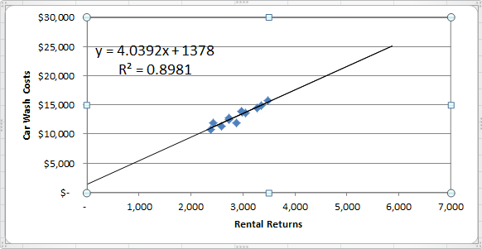

The intercept provides the estimate of the fixed cost element, $1,378 per month, and the slope provides the estimate of the variable cost element, $4.04 per rental return. Expressed as an equation in the form *Y* = *a* + *bX*, the relation between car wash costs and rental returns is

Y = $1,378 + $4.04X

where X is the number of rental returns.

Note that the R2 is approximately 0.90, which is quite high, and indicates a strong linear relationship between car wash costs and rental returns.

**Exercise 2A-3** (20 minutes)

|  |  |  |  |
| --- | --- | --- | --- |
| 1. |  | Kilometers Driven | Total Annual Cost* |
|  | High level of activity | 105,000 | $11,970 |
|  | Low level of activity | 70,000 | 9,380 |
|  | Change | 35,000 | $ 2,590 |

|  |  |
| --- | --- |
| * | 105,000 kilometers × $0.114 per kilometer = $11,970 |
|  | 70,000 kilometers × $0.134 per kilometer = $9,380 |

Variable cost per kilometer:



Fixed cost per year:

|  |  |
| --- | --- |
| Total cost at 105,000 kilometers | $11,970 |
| Less variable portion:  105,000 kilometers × $0.074 per kilometer | 7,770 |
| Fixed cost per year | $ 4,200 |

2. Y = $4,200 + $0.074X

|  |  |  |
| --- | --- | --- |
| 3. | Fixed cost | $ 4,200 |
|  | Variable cost:  80,000 kilometers × $0.074 per kilometer | 5,920 |
|  | Total annual cost | $10,120 |

**Exercise 2A-4** (45 minutes)

1. The scattergraph appears below:

Yes, there is an approximately linear relationship between the number of units shipped and the total shipping expense.

**Exercise 2A-4** (continued)

2. The high-low estimates and cost formula are computed as follows:

|  |  |  |  |
| --- | --- | --- | --- |
|  |  | Units Shipped | Shipping Expense |
|  |  |  |  |
|  | High activity level (June) | 8 | $2,700 |
|  | Low activity level (July) | 2 | 1,200 |
|  | Change | 6 | $1,500 |

Variable cost element:



Fixed cost element:

|  |  |
| --- | --- |
| Shipping expense at high activity level | $2,700 |
| Less variable cost element ($250 per unit × 8 units) | 2,000 |
| Total fixed cost | $ 700 |

The cost formula is $700 per month plus $250 per unit shipped or

Y = $700 + $250X,

where X is the number of units shipped.

The scattergraph on the following page shows the straight line drawn through the high and low data points.

**Exercise 2A-4** (continued)

3. The high-low estimate of fixed costs is $210.71 (= $910.71 – $700.00) lower than the estimate provided by least-squares regression. The high-low estimate of the variable cost per unit is $32.14 (= $250.00 – $217.86) higher than the estimate provided by least-squares regression. A straight line that minimized the sum of the squared errors would intersect the Y-axis at $910.71 instead of $700. It would also have a flatter slope because the estimated variable cost per unit is lower than the high-low method.

4. The cost of shipping units is likely to depend on the weight and volume of the units shipped and the distance traveled as well as on the number of units shipped. In addition, higher cost shipping might be necessary to meet a deadline.

**Exercise 2A-5** (20 minutes)

1. and 2.

The scattergraph plot and regression estimates of fixed and variable costs using Microsoft Excel are shown below:

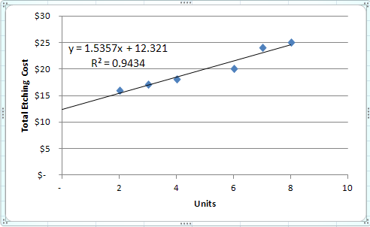

Note that the R2 is approximately 0.94, which means that 94% of the variation in etching costs is explained by the number of units etched. This is a very high R2 which indicates a very good fit.

The regression equation, in the form *Y* = *a* + *bX,* is as follows (where *a* is rounded to nearest dollar and *b* is rounded to the nearest cent):

Y = $12.32 + $1.54X

3. Total expected etching cost if 5 units are processed:

|  |  |
| --- | --- |
| Variable cost: 5 units × $1.54 per unit | $ 7.70 |
| Fixed cost | 12.32 |
| Total expected cost | $20.02 |

**Problem 2A-6** (30 minutes)

1. The scattergraph plot and regression estimates of fixed and variable costs using Microsoft Excel are shown below:

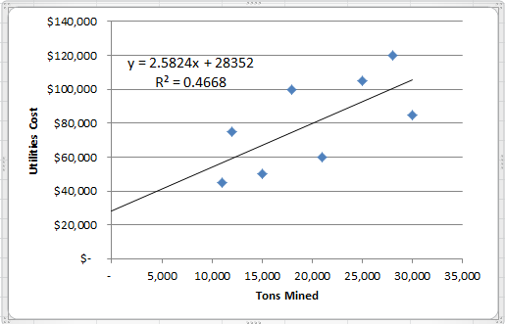

The cost formula, in the form *Y* = *a* + *bX*, using tons mined as the activity base is $28,352 per quarter plus $2.58 per ton mined, or

Y = $28,352 + $2.58X.

Note that the R2 is approximately 0.47, which means that only 47% of the variation in utility costs is explained by the number of tons mined.

**Problem 2A-6** (continued)

2. The scattergraph plot and regression estimates of fixed and variable costs using Microsoft Excel are shown below:

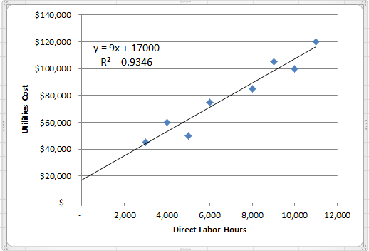

The cost formula, in the form *Y* = *a* + *bX*, using direct labor-hours as the activity base is $17,000 per quarter plus $9.00 per direct labor-hour, or:

Y = $17,000 + $9.00X.

Note that the R2 is approximately 0.93, which means that 93% of the variation in utility costs is explained by direct labor-hours. This is a very high R2 which is an indication of a very good fit.

3. The company should probably use direct labor-hours as the activity base, since the fit of the regression line to the data is much tighter than it is with tons mined. The R2 for the regression using direct labor-hours as the activity base is twice as large as for the regression using tons mined as the activity base. However, managers should look more closely at the costs and try to determine why utilities costs are more closely tied to direct labor-hours than to the number of tons mined.

**Problem 2A-7** (45 minutes)

|  |  |  |
| --- | --- | --- |
| 1. | Cost of goods sold | Variable |
|  | Advertising expense | Fixed |
|  | Shipping expense | Mixed |
|  | Salaries and commissions | Mixed |
|  | Insurance expense | Fixed |
|  | Depreciation expense | Fixed |

2. Analysis of the mixed expenses:

|  |  |  |  |
| --- | --- | --- | --- |
|  | Units | Shipping Expense | Salaries and Commissions Expense |
| High level of activity | | 5,000 | $38,000 | $90,000 |
| Low level of activity | | 4,000 | 34,000 | 78,000 |
| Change | | 1,000 | $  4,000 | $12,000 |

Variable cost element:



Fixed cost element:

|  |  |  |
| --- | --- | --- |
|  | Shipping Expense | Salaries and Commissions Expense |
| Cost at high level of activity | $38,000 | $90,000 |
| Less variable cost element: |  |  |
| 5,000 units × $4 per unit | 20,000 |  |
| 5,000 units × $12 per unit |  | 60,000 |
| Fixed cost element | $18,000 | $30,000 |

**Problem 2A-7** (continued)

The cost formulas are:

Shipping expense:

$18,000 per month plus $4 per unit

or

Y = $18,000 + $4X

Salaries and commissions expense:

$30,000 per month plus $12 per unit

or

Y = $30,000 + $12X

3.

|  |  |  |  |
| --- | --- | --- | --- |
|  | Morrisey & Brown, Ltd. | | |
|  | Income Statement | | |
|  | For the Month Ended September 30 | | |
|  | Sales (5,000 units × $100 per unit) |  | $500,000 |
|  | Variable expenses: |  |  |
|  | Cost of goods sold  (5,000 units × $60 per unit) | $300,000 |  |
|  | Shipping expense  (5,000 units × $4 per unit) | 20,000 |  |
|  | Salaries and commissions expense  (5,000 units × $12 per unit) | 60,000 | 380,000 |
|  | Contribution margin |  | 120,000 |
|  | Fixed expenses: |  |  |
|  | Advertising expense | 21,000 |  |
|  | Shipping expense | 18,000 |  |
|  | Salaries and commissions expense | 30,000 |  |
|  | Insurance expense | 6,000 |  |
|  | Depreciation expense | 15,000 | 90,000 |
|  | Net operating income |  | $ 30,000 |

**Problem 2A-8** (20 minutes)

1. Maintenance cost at the 90,000 machine-hour level of activity can be isolated as follows:

|  |  |  |
| --- | --- | --- |
|  | Level of Activity | |
|  | 60,000 MHs | 90,000 MHs |
| Total factory overhead cost | $174,000 | $246,000 |
| Deduct: |  |  |
| Utilities cost @ $0.80 per MH* | 48,000 | 72,000 |
| Supervisory salaries | 21,000 | 21,000 |
| Maintenance cost | $105,000 | $153,000 |

*$48,000 ÷ 60,000 MHs = $0.80 per MH

2. High-low analysis of maintenance cost:

|  |  |  |
| --- | --- | --- |
|  | Machine-Hours | Maintenance Cost |
| High activity level | 90,000 | $153,000 |
| Low activity level | 60,000 | 105,000 |
| Change | 30,000 | $  48,000 |

Variable rate:



Total fixed cost:

|  |  |
| --- | --- |
| Total maintenance cost at the high activity level | $153,000 |
| Less variable cost element  (90,000 MHs × $1.60 per MH) | 144,000 |
| Fixed cost element | $   9,000 |

Therefore, the cost formula for maintenance is $9,000 per month plus $1.60 per machine-hour or

Y = $9,000 + $1.60X

**Problem 2A-8** (continued)

|  |  |  |  |
| --- | --- | --- | --- |
| 3. |  | Variable Cost per Machine-Hour | Fixed Cost |
|  | Utilities cost | $0.80 |  |
|  | Supervisory salaries cost |  | $21,000 |
|  | Maintenance cost | 1.60 | 9,000 |
|  | Total overhead cost | $2.40 | $30,000 |

Thus, the cost formula would be: Y = $30,000 + $2.40X.

4. Total overhead cost at an activity level of 75,000 machine-hours:

|  |  |
| --- | --- |
| Fixed costs | $ 30,000 |
| Variable costs: 75,000 MHs × $2.40 per MH | 180,000 |
| Total overhead costs | $210,000 |

**Problem 2A-9** (30 minutes)

1. High-low method:

|  |  |  |
| --- | --- | --- |
|  | Units  Sold | Shipping Expense |
| High activity level | 20,000 | $210,000 |
| Low activity level | 10,000 | 119,000 |
| Change | 10,000 | $91,000 |
|  |  |  |



Fixed cost element:

|  |  |  |
| --- | --- | --- |
|  | Total shipping expense at high activity level | $210,000 |
|  | Less variable element: |  |
|  | 20,000 units × $9.10 per unit | 182,000 |
|  | Fixed cost element | $ 28,000 |
|  |  |  |

Therefore, the cost formula is: Y = $28,000 + $9.10X.

**Problem 2A-9** (continued)

|  |  |  |  |
| --- | --- | --- | --- |
| 2. | Milden Company Budgeted Contribution Format Income Statement For the First Quarter, Year 3 | | |
|  | Sales (12,000 units × $100 per unit) |  | $1,200,000 |
|  | Variable expenses: |  |  |
|  | Cost of goods sold  (12,000 units × $35 unit) | $420,000 |  |
|  | Sales commission (6% × $1,200,000) | 72,000 |  |
|  | Shipping expense  (12,000 units × $9.10 per unit) | 109,200 |  |
|  | Total variable expenses |  | 601,200 |
|  | Contribution margin |  | 598,800 |
|  | Fixed expenses: |  |  |
|  | Advertising expense | 210,000 |  |
|  | Shipping expense | 28,000 |  |
|  | Administrative salaries | 145,000 |  |
|  | Insurance expense | 9,000 |  |
|  | Depreciation expense | 76,000 |  |
|  | Total fixed expenses |  | 468,000 |
|  | Net operating income |  | $  130,800 |

**Problem 2A-10** (30 minutes)

1. and 2.

The scattergraph plot and regression estimates of fixed and variable costs using Microsoft Excel are shown below:

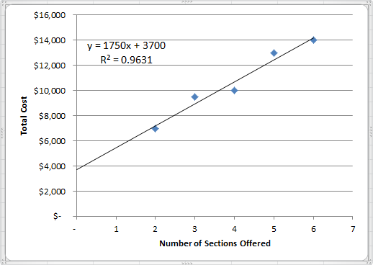

The cost formula, in the form *Y* = *a* + *bX*, using number of sections offered as the activity base is $3,700 per quarter plus $1,750 per section offered, or:

Y = $3,700 + $1,750X

Note that the R2 is approximately 0.96, which means that 96% of the variation in cost is explained by the number of sections. This is a very high R2 which indicates a very good fit.

**Problem 2A-10** (continued)

3. Expected total cost would be:

|  |  |
| --- | --- |
| Fixed cost | $ 3,700 |
| Variable cost (8 sections × $1,750 per section) | 14,000 |
| Total cost | $17,700 |

The problem with using the cost formula from (2) to derive total cost is that an activity level of 8 sections may lie outside the relevant range—the range of activity within which the fixed cost is approximately $3,700 per term and the variable cost is approximately $1,750 per section offered. These approximations appear to be reasonably accurate within the range of 2 to 6 sections, but they may be invalid outside this range.

**Case 2A-11** (60 minutes)

1. High-low method:

|  |  |  |  |
| --- | --- | --- | --- |
|  | Hours | Cost | |
| High level of activity | 25,000 | | $99,000 | |
| Low level of activity | 10,000 | | 64,500 | |
| Change | 15,000 | | $34,500 | |
|  |  | |  | |

Variable element: $34,500 ÷ 15,000 DLH = $2.30 per MH

Fixed element:

|  |  |
| --- | --- |
| Total cost—25,000 MH | $99,000 |
| Less variable element: 25,000 MH × $2.30 per MH | 57,500 |
| Fixed element | $41,500 |
|  |  |

Therefore, the cost formula is: Y = $41,500 + $2.30X

2. The scattergraph is shown below:

Overhead

Costs

$60,000

$65,000

$70,000

$75,000

$80,000

$85,000

$90,000

$95,000

$100,000

8,000

10,000

12,000

14,000

16,000

18,000

20,000

22,000

24,000

26,000

Machine-Hours

Y

X

**Case 2A-11** (continued)

2. The scattergraph shows that there are two relevant ranges—one below 19,500 MH and one above 19,500 MH. The change in equipment lease cost from a fixed fee to an hourly rate causes the slope of the regression line to be steeper above 19,500 MH, and to be discontinuous between the fixed fee and hourly rate points.

3. The cost formulas computed with the high-low and regression methods are faulty since they are based on the assumption that a single straight line provides the best fit to the data. Creating two data sets related to the two relevant ranges will enable more accurate cost estimates.

4. High-low method:

|  |  |  |  |
| --- | --- | --- | --- |
|  | Hours | Cost | |
| High level of activity | 25,000 | | $99,000 | |
| Low level of activity | 20,000 | | 80,000 | |
| Change | 5,000 | | $19,000 | |
|  |  | |  | |

Variable element: $19,000 ÷ 5,000 MH = $3.80 per MH

Fixed element:

|  |  |
| --- | --- |
| Total cost—25,000 MH | $99,000 |
| Less variable element: 25,000 MH × $3.80 per MH | 95,000 |
| Fixed element | $4,000 |
|  |  |

Expected overhead costs when 22,500 machine-hours are used:

|  |  |
| --- | --- |
| Variable cost: 22,500 hours × $3.80 per hour | $85,500 |
| Fixed cost | 4,000 |
| Total cost | $89,500 |
|  |  |

5. The high-low estimate of fixed costs is $6,090 (= $10,090 – $4,000) lower than the estimate provided by least-squares regression. The high-low estimate of the variable cost per machine hour is $0.27 (= $3.80 –$3.53) higher than the estimate provided by least-squares regression. A straight line that minimized the sum of the squared errors would intersect the Y-axis at $10,090 instead of $4,000. It would also have a flatter slope because the estimated variable cost per unit is lower than the high-low method.

**Case 2A-12** (45 minutes)

1. and 2.

The scattergraph plot and regression estimates of fixed and variable costs using Microsoft Excel are shown below:

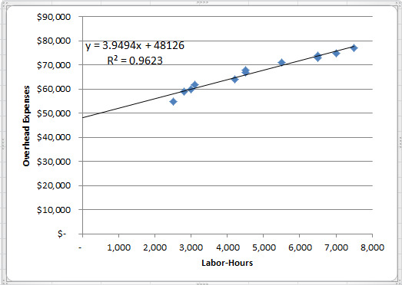

The scattergraph reveals three interesting findings. First, it indicates the relation between overhead expense and labor hours is approximated reasonably well by a straight line. (However, there appears to be a slight downward bend in the plot as the labor-hours increase—evidence of increasing returns to scale. This is a common occurrence in practice. See Noreen & Soderstrom, “Are overhead costs strictly proportional to activity?” *Journal of Accounting and Economics*, vol. 17, 1994, pp. 255-278.)

Second, the data points are all fairly close to the straight line. This indicates that most of the variation in overhead expenses is explained by labor hours. As a consequence, there probably wouldn’t be much benefit to investigating other possible cost drivers for the overhead expenses.

Third, most of the overhead expense appears to be fixed. Maria should ask herself if this is reasonable. Does the company have large fixed expenses such as rent, depreciation, and salaries?

**CASE 2A-12** (continued)

The cost formula, in the form *Y* = *a* + *bX*, using labor-hours as the activity base is $48,126 per month plus $3.95 per labor-hour, or:

Y = $48,126 + $3.95X

Note that the R2 is approximately 0.96, which means that 96% of the variation in cost is explained by labor-hours. This is a very high R2 which indicates a very good fit.

3. Using the least-squares regression estimate of the variable overhead cost, the total variable cost per guest is computed as follows:

|  |  |
| --- | --- |
| Food and beverages | $15.00 |
| Labor (0.5 hour @ $10 per hour) | 5.00 |
| Overhead (0.5 hour @ $3.95 per hour) | 1.98 |
| Total variable cost per guest | $21.98 |
|  |  |

The total contribution from 180 guests paying $31 each is computed as follows:

|  |  |
| --- | --- |
| Sales (180 guests @ $31.00 per guest) | $5,580.00 |
| Variable cost (180 guests @ $21.98 per guest) | 3,956.40 |
| Contribution to profit | $1,623.60 |
|  |  |

Fixed costs are not included in the above computation because there is no indication that any additional fixed costs would be incurred as a consequence of catering the cocktail party. If additional fixed costs were incurred, they should also be subtracted from revenue.

4. Assuming that no additional fixed costs are incurred as a result of catering the charity event, any price greater than the variable cost per guest of roughly $22 would contribute to profits.

**CASE 2A-12** (continued)

5. We would favor bidding slightly less than $30 to get the contract. Any bid above $22 would contribute to profits and a bid at the normal price of $31 is unlikely to land the contract. And apart from the contribution to profit, catering the event would show off the company’s capabilities to potential clients. The danger is that a price that is lower than the normal bid of $31 might set a precedent for the future or it might initiate a price war among caterers. However, the price need not be publicized and the lower price could be justified to future clients because this is a charity event. Another possibility would be for Maria to maintain her normal price but throw in additional services at no cost to the customer. Whether to compete on price or service is a delicate issue that Maria will have to decide after getting to know the personality and preferences of the customer.