CHAPTER 2 | Trade-offs, Comparative Advantage, and the
Market System
Brief Chapter Summary and Learning Objectives
2.1 Production Possibilities Frontiers and Opportunity Costs (pages 42–47)
Use a production possibilities frontier to analyze opportunity costs and trade-offs.
▪ The model of the production possibilities frontier is used to analyze the opportunity costs and trade-offs that individuals, firms, and countries face.
2.2 Comparative Advantage and Trade (pages 48–54)
Describe comparative advantage and explain how it serves as the basis for trade.
▪ Comparative advantage is the ability of an individual, firm, or country to produce a good or service at a lower opportunity cost than other producers.
2.3 The Market System (pages 54–63)
Explain the basics of how a market system works.
▪ Markets enable buyers and sellers of goods and services to come together to trade.
Key Terms

Absolute advantage, p. 50. The ability of an individual, a firm, or a country to produce more of a good or service than competitors, using the same amount of resources.
Circular-flow diagram, p. 55. A model that illustrates how participants in markets are linked.
Comparative advantage, p. 51. The ability of an individual, a firm, or a country to produce a good or service at a lower opportunity cost than competitors.
Economic growth, p. 47. The ability of the economy to increase the production of goods and services.
Entrepreneur, p. 59. Someone who operates a business, bringing together the factors of production—labor, capital, and natural resources—to produce goods and services.
Factor market, p. 54. A market for the factors of production, such as labor, capital, natural resources, and entrepreneurial ability.
Factors of production, p. 54. Labor, capital, natural resources, and other inputs used to make goods and services.
Free Market, p. 56. A market with few government restrictions on how a good or service can be produced or sold or on how a factor of production can be employed.
Market, p. 54. A group of buyers and sellers of a good or service and the institution or arrangement by which they come together to trade.
Opportunity cost, p. 43. The highest-valued alternative that must be given up to engage in an activity.
Product market, p. 54. A market for goods—such as computers—or services—such as medical treatment.
Production possibilities frontier (PPF),
p. 42. A curve showing the maximum attainable combinations of two goods that can be produced with available resources and current technology.
Property rights, p. 61. The rights individuals or firms have to the exclusive use of their property, including the right to buy or sell it.
Scarcity, p. 42. A situation in which unlimited wants exceed the limited resources available to fulfill those wants.
Trade, p. 48. The act of buying and selling.

Chapter Outline
Managers at Tesla Motors Face Trade-Offs
Electric cars have struggled in the marketplace because the batteries that power them are costly. Furthermore, the batteries have to be recharged every 100 to 300 miles. But in early 2013, Tesla Motors announced higher than expected sales of its electric cars. Tesla sells all of its cars online and relies on company-owned service centers to provide maintenance. Tesla’s managers face a number of decisions; for example, to reach its goal of producing 1 million vehicles annually will require it to build one additional factory to assemble cars and other factories to make the battery cells used to power the cars. Using more resources to build factories would leave fewer resources to expand production of its two existing product lines.
2.1 | Production Possibilities Frontiers and Opportunity Costs (pages 42–47)  Learning Objective: Use a production possibilities frontier to analyze opportunity costs and trade-offs.

Scarcity is a situation in which unlimited wants exceed the limited resources available to fulfill those wants. A production possibilities frontier is a simple model that economists can use to analyze trade-offs, such as the trade-off Tesla faces in deciding how many of each type of automobile (in the textbook example, either original models or Model 3s) it should produce at its plant in Fremont, California, given its limited resources.
A production possibilities frontier (PPF) is a curve showing the maximum attainable combinations of two goods that may be produced with available resources and current technology.
A. Graphing the Production Possibilities Frontier
All combinations of products on the frontier are efficient because all available resources are being used. Combinations inside the frontier are inefficient because maximum output is not obtained from available resources. Points outside the frontier are unattainable given the firm’s current resources. Opportunity cost is the highest-valued alternative that must be given up to engage in an activity.
B. Increasing Marginal Opportunity Costs
A production possibilities frontier that is bowed outward illustrates increasing marginal opportunity costs, which occur because some workers, machines, and other resources are better suited to one use than to another. Increasing marginal opportunity costs illustrate an important concept: The more resources already devoted to any activity, the smaller the payoff to devoting additional resources to that activity.
C. Economic Growth
Economic growth is the ability of the economy to increase the production of goods and services. Economic growth can occur if more resources become available or if a technological advance makes resources more productive. Growth may lead to greater increases in production for one good than another.
Extra  Apply the Concept | Facing Trade-offs in Health Care Spending

Households have limited incomes. If the price of health care rises, households have to choose whether to buy less health care or spend less on other goods and services. The same is true of the federal government’s spending on health care. The government provides health insurance to about 30 percent of the population through programs such as Medicare for people age 65 and older and Medicaid for low-income people. If the price of health care rises, the government has to either cut back on the services provided through Medicare and Medicaid or cut spending in another part of the government’s budget. (Of course, both households and the government can borrow to pay for some of their spending, but ultimately the funds they can borrow are also limited.)
About 54 percent of the population has private health insurance, often provided by employers. When the fees doctors charge, the cost of prescription drugs, and the cost of hospital stays rise, the cost to employers of providing health insurance increases too. As a result, employers will typically increase the amount they withhold from employees’ paychecks to pay for the insurance. Some employers—particularly small firms—will even stop offering health insurance to their employees. In either case, the price employees pay for health care will rise. How do people respond to rising health care costs? Isn’t health care a necessity that people continue to consume the same amount of, no matter how much its price increases? In fact, studies have shown that rising health care costs cause people to cut back their spending on medical services, just as people cut back their spending on other goods and services when their prices rise. One research study indicates that for every 1 percent increase in the amount employers charge employees for insurance, 164,000 people become uninsured. Of course, people without health insurance can still visit the doctor and obtain prescriptions, but they have to pay higher prices than people with insurance pay. Although the consequences of being uninsured can be severe, particularly if someone develops a serious illness, economists are not surprised that higher prices for health insurance lead to less health insurance being purchased: Faced with limited incomes, people have to make choices among the goods and services they buy.
The Congressional Budget Office estimates that as the U.S. population ages and medical costs continue to rise, federal government spending on Medicare will more than double over between 2016 and 2027. Many policymakers are concerned that this rapid increase in Medicare spending will force a reduction in spending on other government programs. Daniel Callahan, a researcher at the Hastings Center for Bioethics, has argued that policymakers should consider taking some dramatic steps, such as having Medicare stop paying for open-heart surgery and other expensive treatments for people over 80 years of age. Callahan argues that the costs of open-heart surgery and similar treatments for the very old exceed the benefits, and the funds would be better spent on treatments for younger patients, where the benefits would exceed the costs. Spending less on prolonging the lives of the very old in order to save resources that can be used for other purposes is a very painful trade-off to consider. But in a world of scarcity, trade-offs of some kind are inevitable.

Sources: Daniel Callahan, “The Economic Woes of Medicare,” The New York Times, November 13, 2008; Ezekiel J. Emanuel, “The Cost–Coverage Trade-off,” Journal of the American Medical Association, Vol. 299, No. 8, February 27, 2008, pp. 947–949; and Congressional Budget Office, A Preliminary Analysis of the President’s Budget and an Update of CBO’s Budget and Economic Outlook, March 2009.
Question: Suppose the U.S. president is attempting to decide if the federal government should spend more on research to find a cure for heart disease. He asks you, one of his economic advisors, to prepare a report discussing the relevant factors he should consider. Use the concepts of opportunity cost and trade-offs to discuss some of the main issues you would deal with in your report.

Answer: If the federal government has a fixed budget for medical research, then the opportunity cost of funding more research on heart disease is the reduction in funding for research on other diseases. The decision should be made at the margin: to maximize the benefits from government spending on medical research, the last dollar devoted to research on heart disease should result in the same marginal benefit—less disease and fewer deaths—as the last dollar spent on research for other diseases. If the additional funding for research on heart disease comes at the expense of other nonmedical research expenditures, then the opportunity cost will be different, but a similar analysis should be conducted.

2.2 | Comparative Advantage and Trade (pages 48–54)  Learning Objective: Describe comparative advantage and explain how it serves as the basis for trade.

Trade is the act of buying and selling. Trade makes it possible for people to become better off by increasing both their production and their consumption.
A. Specialization and Gains from Trade
PPFs show the combinations of two goods that can be produced if no trade occurs. We can also use PPFs to show how someone can benefit from trade even if she is better than someone else at producing both goods.
B. Absolute Advantage versus Comparative Advantage
Absolute advantage is the ability of an individual, a firm, or a country to produce more of a good or service than competitors, using the same amount of resources. If the two individuals have different opportunity costs for producing two goods, each individual will have a comparative advantage in the production of one of the goods. Comparative advantage is the ability of an individual, a firm, or a country to produce a good or service at a lower opportunity cost than competitors. Comparing the possible combinations of production and consumption before and after specialization and trade occur proves that trade is mutually beneficial.
C. Comparative Advantage and the Gains from Trade
The basis for trade is comparative advantage, not absolute advantage. Individuals, firms, and countries are better off if they specialize in producing the goods and services for which they have a comparative advantage and obtain the other goods and services they need by trading.
Teaching Tips
Even good students have difficulty understanding comparative advantage. A good example of comparative advantage is the career of baseball legend Babe Ruth. Before he achieved his greatest fame as a home run hitter and outfielder with the New York Yankees, Ruth was a star pitcher with the Boston Red Sox. Ruth may have been the best left-handed pitcher in the American League during his years with Boston (1914–1919), but he was used more as an outfielder in his last two years with the team. In fact, he established a record for home runs in a season (29) in 1919. The Yankees acquired Ruth in 1920 and made him a full-time outfielder. The opportunity cost of this decision for the Yankees was the wins he could have earned as a pitcher. But because New York already had skilled pitchers, the opportunity cost of replacing him as a pitcher was lower than the cost of replacing Ruth as a hitter. No one else on the Yankees could have hit 54 home runs, Ruth’s total in 1920; the next highest total on the Yankees was 11. It can be argued that Ruth had an absolute advantage as both a hitter and pitcher for the Yankees in 1920, but a comparative advantage only as a hitter.

2.3 | The Market System (pages 54–63)  Learning Objective: Explain the basics of how a market system works.
In the United States and most other countries, trade is carried out in markets. A market is a group of buyers and sellers of a good or service and the institution or arrangement by which they come together to trade.
A product market is a market for goods—such as computers—or services—such as medical treatment. A factor market is a market for the factors of production, such as labor, capital, natural resources, and entrepreneurial ability. Factors of production are the inputs used to make goods and services.
A. The Circular Flow of Income
A circular-flow diagram is a model that illustrates how participants in markets are linked. The diagram demonstrates the interaction between firms and households in both product and factor markets.
B. The Gains from Free Markets
A free market is a market with few government restrictions on how a good or service can be produced or sold or on how a factor of production can be employed. Adam Smith is considered the father of modern economics. His book, An Inquiry into the Nature and Causes of the Wealth of Nations, published in 1776, was an influential argument for the free market system.
C. The Market Mechanism
A key to understanding Adam Smith’s argument is the assumption that individuals usually act in a rational, self-interested way. This assumption underlies nearly all economic analysis.
D. The Role of the Entrepreneur in the Market System
Entrepreneurs are an essential part of a market economy. An entrepreneur is someone who operates a business, bringing together the factors of production—labor, capital, and natural resources—to produce goods and services. Entrepreneurs often risk their own funds to start businesses and organize factors of production to produce those goods and services that consumers want.
E. The Legal Basis of a Successful Market System
The absence of government intervention is not enough for a market economy to work well. Government has to provide a legal environment that allows markets to operate efficiently. Property rights are the rights individuals or firms have to the exclusive use of their property, including the right to buy or sell it. To protect intellectual property rights, the federal government grants inventors patents. A patent grants the exclusive right to produce and sell a new product for 20 years from the date the patent is filed. Books, films, and software receive copyright protection. Under U.S. law, the creator of a book, film, or piece of music has the exclusive right to use the creation during the creator’s lifetime. The creator’s heirs retain this right for 50 years after the death of the creator.
Teaching Tips
To initiate class discussion regarding intellectual property rights, ask students these questions:
1. How many of you have downloaded music from the Internet?
2. Should the government have the right to grant exclusive rights to musicians and other artists to produce and sell their creative works?
3. Should the government fine or prosecute people who illegally obtain music, books, movies, and other creative works in violation of property rights laws?
Extra Solved Problem 2.3
Adam Smith’s “Invisible Hand”
Alan Krueger, an economist at Princeton University, has argued that Adam Smith was concerned that the invisible hand would not function properly if merchants and manufacturers convinced the government to issue regulations to help them.
Source: Alan B. Krueger, “Rediscovering the Wealth of Nations,” New York Times, August 16, 2001.
a. What types of regulations might merchants and manufacturers seek from the government?
b. How might these regulations prevent the invisible hand from working?
Solving the Problem
Step 1: Review the chapter material.
This problem is about how goods and services are produced and sold and how factors of production are employed in a free market economic system as described by Adam Smith in An Inquiry into the Nature and Causes of the Wealth of Nations, so you may want to review the section “The Gains from Free Markets,” on page 56.
Step 2: Answer (a) by describing the economic system in place in Europe in 1776.
At the time, governments gave guilds—associations of producers—the authority to control production. The production controls limited the output of goods such as shoes and clothing, as well as the number of producers of these items. Limiting production and competition led to higher prices and fewer choices for consumers. Instead of catering to the wants of consumers, producers sought favors from government officials.
Step 3: Answer (b) by contrasting the behavior of merchants and manufacturers under a guild system and in a market system.
Because governments in a guild system gave producers the power to control production, producers did not have to respond to consumers’ demands for better quality, greater variety, and lower prices. In a market system, producers who sell poor quality goods at high prices suffer economic losses; producers who provide better quality goods at low prices are rewarded with profits. Therefore, it is in the self-interest of producers to address consumer wants. This is how the invisible hand works in a free market economy but not in most of Europe in the eighteenth century.

Extra  Apply the Concept | An Elementary Case of Copyright

The U.S. Congress provides copyright protection to authors to give them an economic incentive to invest the time and effort required to write books. While a book is under copyright, only the author—or whoever the author sells the copyright to—can legally publish a paper or digital copy of the book. Once the copyright expires, however, the book enters the public domain, and anyone is free to publish the book. Copies of classic books written in the 1800s, such as Mark Twain’s Huckleberry Finn and Charles Dickens’s Oliver Twist, are available from many publishers that do not have to pay a fee to the authors’ heirs.
Arthur Conan Doyle was a doctor in England when he published his first story featuring the detective Sherlock Holmes in 1887. Anyone who wants to publish any of the Sherlock Holmes stories that Doyle wrote from 1887 through the end of 1922 is free do so. But the last 10 Sherlock Holmes stories that Doyle wrote from 1923 to 1927 remain under copyright protection. Doyle’s heirs argue that because the author continued to develop the personalities of Sherlock Holmes and his companion Dr. John Watson in the 10 stories that remain under copyright protection, the characters cannot be used in new books, films, or television shows without payment. Doyle’s heirs have asked anyone who wants to include Holmes in a new work to pay them a fee of $5,000 per use.
The producers of two recent Sherlock Holmes films starring Robert Downey, Jr., and the producers of the television series Sherlock, starring Benedict Cumberbatch, and Elementary, starring Jonny Lee Miller, agreed to pay the fee, as have most authors of books using Holmes as a character. In 2011, when Leslie S. Klinger published A Study in Sherlock, a collection of new stories involving Sherlock Holmes, his publisher insisted that he pay the usual fee to Doyle’s descendants. But two years later, when Klinger decided to publish another collection, In the Company of Sherlock Holmes, he decided that rather than pay the fee he would sue Doyle’s descendants, hoping the federal courts would rule against their copyright claims.
Federal Appeals Judge Richard Posner—who is also an economist—eventually ruled in favor of Klinger. He argued that copyright law did not allow authors or their heirs to require fees for the use of characters from stories in the public domain. He also noted that, “the longer the copyright term is, the less public-domain material there will be and so the greater will be the cost of authorship, because authors will have to obtain licenses from copyright holders for more material.” As a result of this ruling, for the first time since 1887, anyone can use Sherlock Holmes as a character in a book, television show, or movie without having to pay a fee.
Sources: Jennifer Schuessler, “Appeals Court Affirms Sherlock Holmes Is in Public Domain,” New York Times, June 17, 2014; Jennifer Schuessler, “Conan Doyle Estate Told to Pay Legal Fees,” New York Times, August 5, 2014; Eriq Gardner, “Conan Doyle Estate Loses Appeal Over ‘Sherlock Holmes’ Rights,” Hollywood Reporter, June 16, 2014; and Leslie S. Kling v. Conan Doyle Estate, Ltd. (7th Cir. 2014), media.ca7.uscourts.gov.
Extra Economics in Your Life & Career:
Economists Express Their Agreement on Free Trade
During the summer of 2017, fifteen former leaders of the White House Council of Economic Advisors signed a letter to President Trump urging him not to place tariffs on imports of steel into the United States. The letter notes that “Among us are Republicans and Democrats alike, and we have disagreements on a number of policy issues. But on some policies there is near universal agreement. One such issue is the harm of imposing tariffs on steel imports.” Tariffs are taxes imposed by government on imports. Those who endorse tariffs and other barriers to free international trade believe that such barriers protect domestic industries and the jobs of their employees.
Questions: (a) Why do many economists, including those who have served for both Republican and Democratic administrations, support free trade policies and oppose tariffs and trade barriers even if these barriers are designed to protect domestic workers from losing their jobs? (b) What types of jobs would be most vulnerable to job losses due to competition from imports?

Answers: (a) As you learned in this chapter, countries are better off if they specialize in producing goods and services in which they have a comparative advantage and trading with other countries for other goods and services. Tariffs prevent countries from taking full advantage of the benefits from free trade. The argument that economists who have worked for both Democratic and Republican governments made is based on positive economic analysis (analysis concerned with what is) rather than normative analysis (analysis concerned with what ought to be). Ben Bernanke, former chairman of the Federal Reserve Board, has cited a study that examined the effect of international trade on income in the United States since World War II: “. . . the increase in trade . . . has boosted U.S. annual incomes on the order of $10,000 per household. The same study found that removing all remaining barriers to trade would raise incomes anywhere from $4,000 to $12,000 per household.”
(b) Another study cited by Bernanke found that the 21 occupations in the United States that were most vulnerable to imports from foreign firms were primarily for relatively low-wage positions. In general, the greater the skill requirements for the job you hold, the less vulnerable you will be to losing your job due to competition from imports.
Sources: Nick Timiraos, “Former White House Economists to Donald Trump: Don’t Impose Steel Tariffs,” Wall Street Journal, July 12, 2017; Ben Bernanke, “Embracing the Challenge of Free Trade: Competing and Prospering in a Global Economy,” The Federal Reserve Board, May 1, 2007. http://www.federalreserve.gov/boarddocs/speeches/2007/20070501/default.htm; and “Why Open Markets Matter,” oecd.org/trade/whyopenmarketsmatter.htm.
Solutions to End-of-Chapter Exercises
Answers to Thinking Critically Questions to accompany the Inside Look newspaper feature
1. In 2018, maximum production is 600 thousand Model 3 sedan batteries or 600 thousand Powerwall batteries. In 2022, maximum production is 600 thousand Model 3 sedan batteries or 900 thousand Powerwall batteries. Therefore:
• The opportunity cost of one Model 3 sedan battery in 2018 is one Powerwall battery.
• The opportunity cost of one Model 3 sedan battery in 2022 is 1 ½ Powerwall batteries.

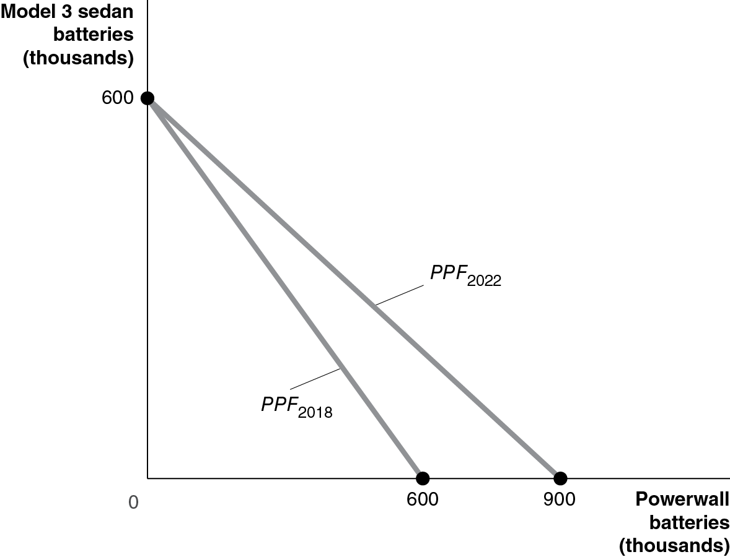
2. Tesla can’t fill all these orders. This point is unattainable because it is beyond the 2022 PPF. Tesla can produce a maximum of 900 thousand Model 3 sedan batteries or Powerwall batteries. The slope of the PPF is 1, so the opportunity cost of making one more Model 3 sedan battery is one less Powerwall battery. If Tesla produces 750 thousand Model 3 sedan batteries, it won’t be able to produce 350 thousand Powerwall batteries as well.

2.1 | Production Possibilities Frontiers and Opportunity Costs  Learning Objective: Use a production possibilities frontier to analyze opportunity costs and trade-offs.
Review Questions
1.1 Scarcity is the situation in which wants exceed the limited resources available to fulfill those wants. There are some things that are available in such abundance that they exceed our wants. For example, for most people there is enough oxygen in the atmosphere that the amount they want to inhale would not exceed the available amount—so oxygen isn’t scarce for them. Another example might be something undesirable, such as weeds in your garden—unlike tomato plants, the number of weeds available exceeds the number you desire.
1.2 The production possibilities frontier (PPF) is a curve showing all the attainable combinations of two products that can be produced with available resources and existing technology. Combinations of goods that are on the frontier are efficient because all available resources are being fully used, and the fewest possible resources are being used to produce a given amount of output. Points inside the production possibilities frontier are inefficient because the maximum output is not being obtained from the available resources. A production possibilities frontier will shift outward (to the right) if more resources become available for making the products or if technology improves so that firms can produce more output with the same amount of inputs.
1.3 Increasing marginal opportunity costs means that as more and more of a product is made, the opportunity cost of making each additional unit rises. It occurs because the first units of a good are produced with the resources that are best suited for making it, but as more and more of the good is produced, resources must be used that are better suited for producing something else. Increasing marginal opportunity costs imply that the production possibilities frontier (PPF) is bowed out—the slope of the PPF gets steeper and steeper as you move down the frontier.
Problems and Applications
1.4 a. The production possibilities frontiers in the figure are bowed to the right from the origin because of increasing marginal opportunity costs. The drought causes the production possibilities frontier to shift to the left (see the graph part (b)).
b. The genetic modifications would shift to the right the maximum soybean production (doubling it), but not the maximum cotton production.
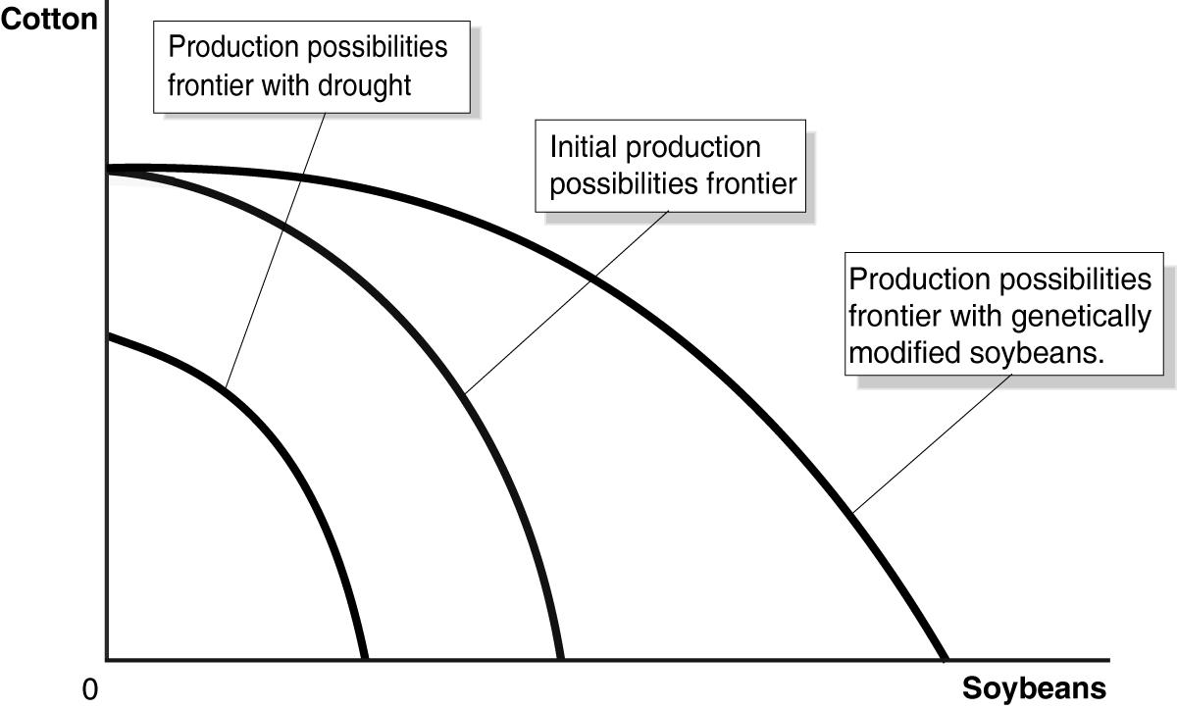
1.5 Increased safety will decrease maximum range, as shown in the following figure. Trade-offs can be between physical goods, such as cotton and soybeans in problem 1.4, or between the features of a product, like the maximum range and the safety of an electric car.
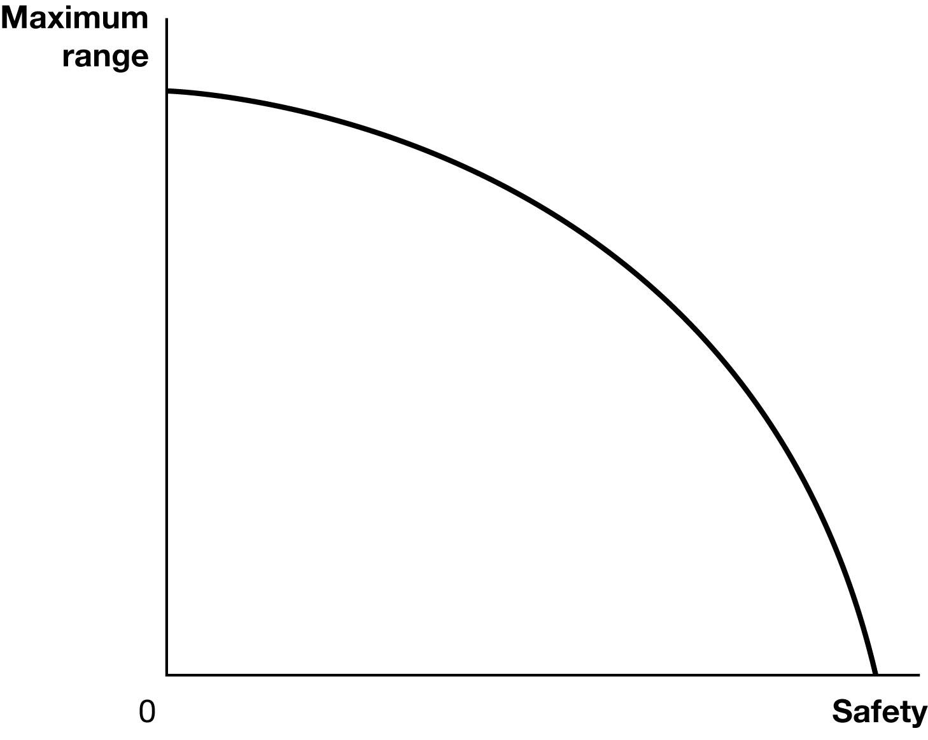
1.6 If a Staples retail store has surplus space that has no other use than as a Workbar office workspace, then the opportunity cost would be zero. If there is a positive opportunity cost to use the surplus space it would be the best foregone alternative to using it as an office workspace; for example, as a storage for Staples’ inventory.
1.7 One could argue that the price paid for a book is a close approximation to the opportunity cost of buying a book, but consuming—that is, reading—the book could require many hours of leisure time that could be spent on some other activity. The time spent reading a book always has an opportunity cost.
1.8 a. The production possibilities frontier will be bowed out like Figure 2.2 because some economic inputs are likely to be more productive when making capital goods, and others are likely to be more productive when making consumption goods.
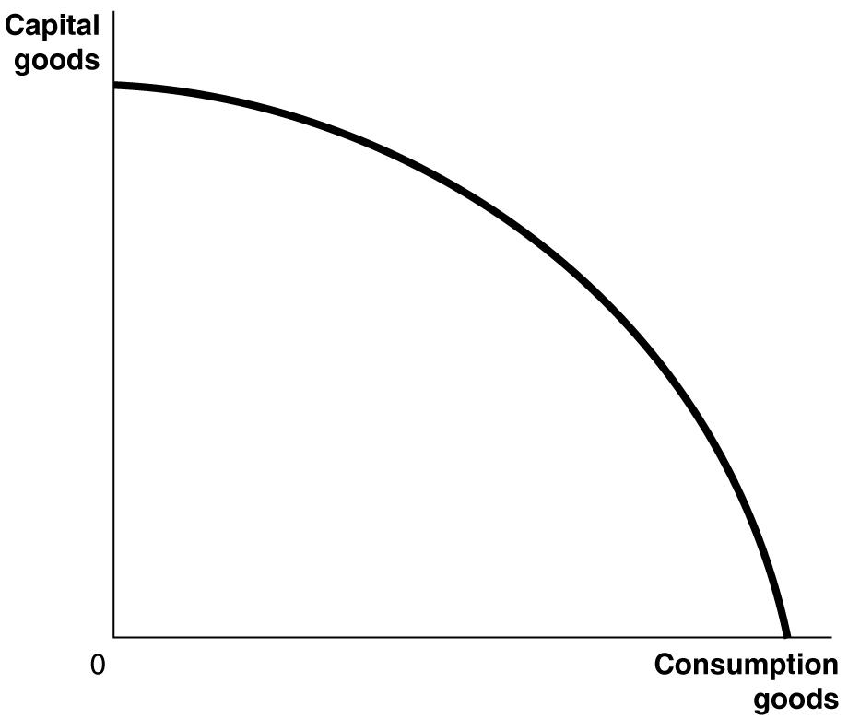
b.
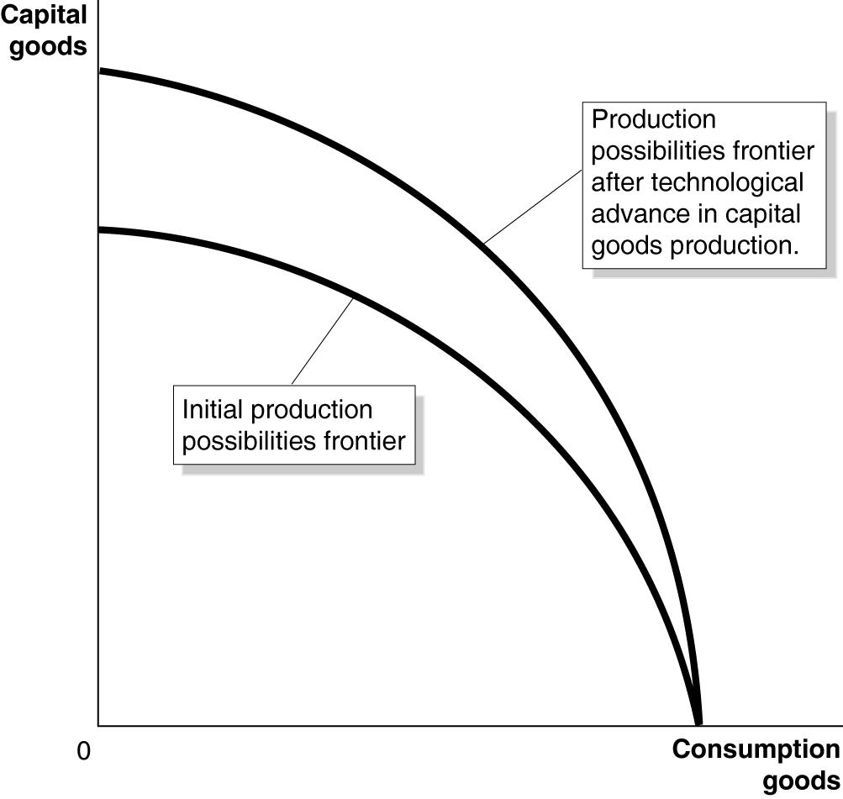
c. Because it will have more machinery and equipment, Luxembourg is likely to experience more rapid growth in the future.

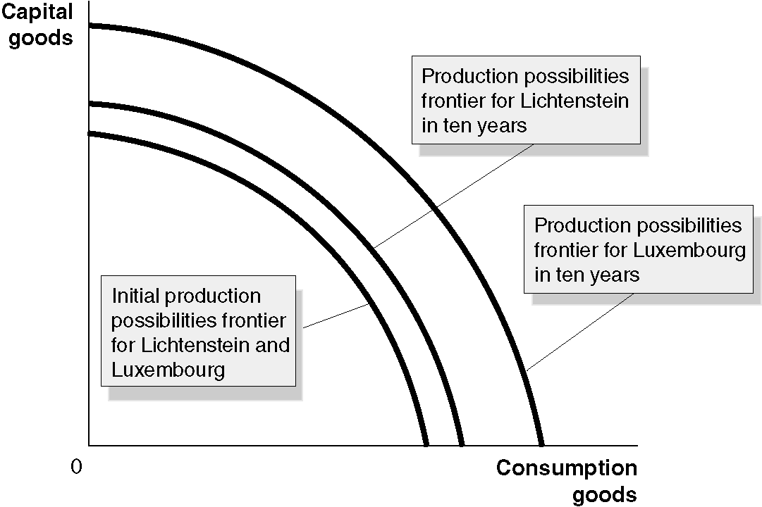
1.9 a. Point E is outside the production possibilities frontier, so it is unattainable.
b. Points B, C, and D are on the production possibilities frontier, so they are efficient.
c. Point A is inside the production possibilities frontier, so it is inefficient.
d. At point B, the country is devoting the most resources to producing capital goods, so production at this point is most likely to lead to the highest growth rate. The more capital goods the country produces, the greater the capacity of the country to produce goods and services in the future.
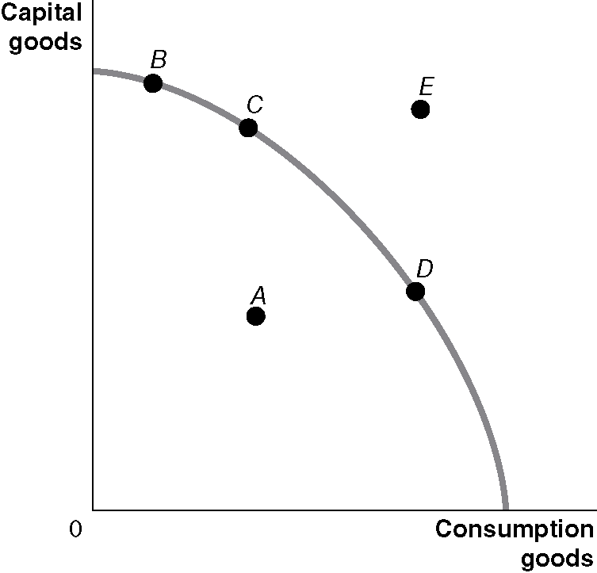
1.10 a.
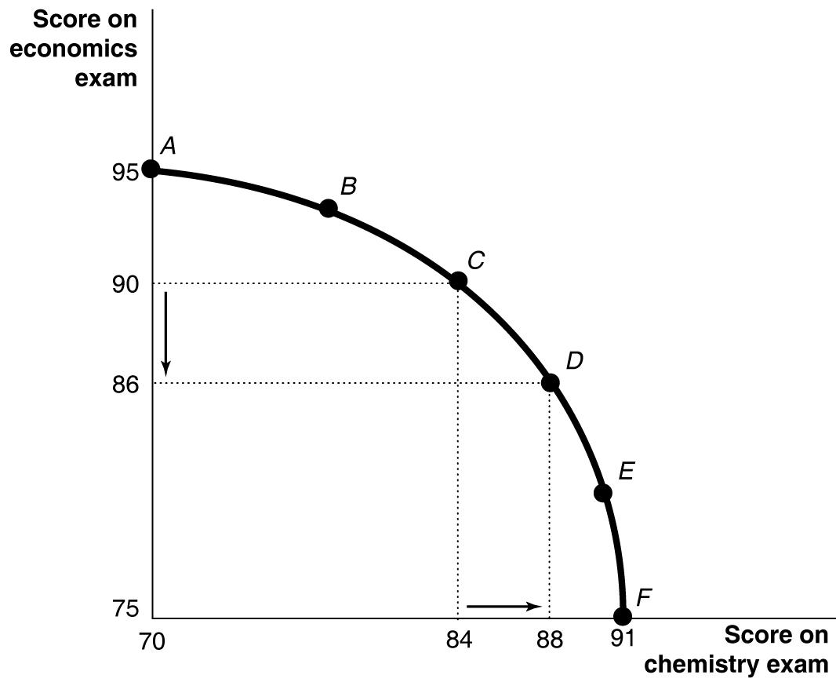
If you spend all five hours studying for your economics exam, you will score a 95 on the exam; therefore, your production possibilities frontier will intersect the vertical axis at 95. If you devote all five hours studying for your chemistry exam, you will score a 91 on the exam; therefore, your production possibilities frontier will intersect the horizontal axis at 91.
b. The points for choices C and D can be plotted using information from the table. Moving from choice C to choice D increases your chemistry score by four points but lowers your economics score by four points. Therefore, the opportunity cost of increasing your chemistry score by four points is the decline of four points in your economics score.
c. Choice A might be sensible if the marginal benefits of doing well on the chemistry exam are low relative to the marginal benefits from doing well on the economics exam; for example, the chemistry exam is only a small portion of your grade, but the economics exam is a large portion of your grade; or if you are majoring in economics and don’t care much about chemistry; or if you already have an A sewn up in chemistry, but the economics professor will replace a low exam grade with this exam grade.
1.11 If the federal government has a fixed budget for medical research, then the opportunity cost of funding more research on heart disease is the reduction in funding for research on other diseases. The decision should be made at the margin: To maximize the benefits from government spending on medical research, the last dollar devoted to research on heart disease should result in the same marginal benefit—less disease and fewer deaths—as the last dollar spent on research for other diseases. If the additional funding for research on heart disease comes at the expense of other nonmedical research expenditures, then the opportunity cost will be different, but a similar analysis should be conducted.
1.12 State governments have limited budgets. Subsidies paid by governments for prescription drugs use revenue from taxpayers that could be used to pay for other valuable goods and services. Nearly all state governments are required to balance their budgets. Therefore, increases in spending on one worthwhile program require either a reduction in spending on another worthwhile program or an increase in taxes. One can agree or disagree with a state’s decision to provide expensive drugs only to patients with the most serious illnesses. This is a normative issue and your response to the program depends on how you evaluate the trade-offs involved.
1.13 Resources used to reduce pollution are not available for other uses, such as saving lives through medical research, so it is more ethical to take into account the opportunity cost of reducing pollution.
1.14 Economic systems that do not allow people to keep most of the output they produce do not provide much incentive for people to work hard. Unfortunately, experience has shown that people are more self-interested and less altruistic than would be necessary for the system used in Oz to work in the real world.

2.2 | Comparative Advantage and Trade  Learning Objective: Describe comparative advantage and explain how it serves as the basis for trade.
Review Questions
2.1 Absolute advantage is the ability to produce more of a good or service than competitors using the same amount of resources. Comparative advantage is the ability to produce a good or service at a lower opportunity cost than competitors. It is possible to have a comparative advantage in producing a good even if someone else has an absolute advantage in producing that good (and every other good). Unless the two producers have exactly the same opportunity costs of producing two goods—the same trade-off between the two goods—one producer will have a comparative advantage in making one of the goods and the other producer will have a comparative advantage in making the other good.
2.2 The basis for trade is comparative advantage. If each party specializes in making the product for which it has a comparative advantage, they can arrange a trade that makes both of them better off. Each party will be able to obtain the product made by its trading partner at a lower opportunity cost than without trade.
Problems and Applications
2.3 In the example in Figure 2.4 the opportunity cost of 1 pound of apples is 1 pound of cherries to you and 2 pounds of cherries to your neighbor. Any price of apples between 1 and 2 pounds of cherries will be a fair trading price, and because 10 pounds of apples for 15 pounds of cherries is the same as 1 pound of apples for 1.5 pounds of cherries, it falls within this range. We could take any other value in this range to complete the table. Let’s take, for example, 1.25 pounds of cherries per pound of apples. We will keep the pounds of apples traded as before at 10. The completed table will now be:
TABLE 2.1: A Summary of the Gains from Trade
 | You |  | Your Neighbor
 | Apples (pounds) | Cherries  (pounds) | Apples (pounds) | Cherries  (pounds)
Production and consumption without trade | 8 | 12 | 9 | 42
Production with trade | 20 | 0 | 0 | 60
Consumption with trade | 10 | 10 × 1.25 = 12.5 | 10 | 60 − 12.5 = 47.5
Gains from trade (increased consumption) | 2 | 12.5 − 12 = 0.5 | 1 | 47.5 − 42 = 5.5
Note that both you and your neighbor are better off after trade than before trade. Note also that this rate of trading cherries for apples is better for your neighbor than the original rate of trading and worse for you.
2.4 a. Canada has a comparative advantage in making boots. Canada’s opportunity cost of making
1 boot is giving up 1 shirt. In the United States, the opportunity cost of making 1 boot is giving up 3 shirts. The United States has a comparative advantage in making shirts. In the United States, the opportunity cost of making one shirt is giving up 1/3 boot, but Canada’s opportunity cost of making 1 shirt is 1 boot.
b. Neither country has an absolute advantage in making both goods. The United States has an absolute advantage in making shirts, but Canada has an absolute advantage in making boots. Remember, both countries have the same amount of resources. If each country puts all of its resources into making shirts, then the United States makes 12 shirts, but Canada makes only 6 shirts. If each country puts all of its resources into making boots, then Canada makes 6 boots, but the United States makes only 4 boots.
c. If each country specializes in the production of the good in which it has a comparative advantage and then trades with the other country, both will be better off. Let’s use the case in which each country trades half of what it makes for half of what the other makes. The United States will specialize by making 12 shirts and Canada will specialize by making 6 boots. Because each gets half of the other’s production, they both end up with 6 shirts and 3 boots. They are better off than before trading because they end up with the same number of boots, but twice as many shirts. Other trades will also make them better off.
2.5 a. By writing “China is always better than Spain” at producing textiles, the columnist means that China has an absolute advantage in producing textiles.
b. Assuming that Spain has a comparative advantage in producing textiles (that is, it can produce textiles at a lower opportunity cost than China can), it can sell textiles to Chinese firms and consumers at a lower price than Chinese textile producers can charge even if China has an absolute advantage in producing textiles.

2.6 a. When the United Kingdom produces 1 more barrel of fish oil, it produces 1 less barrel of crude oil. When Norway produces 1 more barrel of fish oil, it produces 1 less barrel of crude oil. Therefore, neither country has a comparative advantage in either good. In both countries, the opportunity cost of 1 barrel of crude oil is 1 barrel of fish oil. Comparative advantage arises only if someone has a lower opportunity cost of producing a good, but these two countries have the same opportunity cost. (Note, though, that the United Kingdom has an absolute advantage in producing goods because it can produce more of each than can Norway using the same amounts of capital and labor.)
b. No, the countries can’t gain from trade. Trading across the border would result in the same trade-offs that can be made within each country.
2.7 a. When France produces 1 more bottle of wine, it produces 2 fewer pounds of schnitzel. When Germany produces 1 more bottle of wine, it produces 3 fewer pounds of schnitzel. Therefore, France’s opportunity cost of producing wine—2 pounds of schnitzel—is less than Germany’s—3 pounds of schnitzel. When Germany produces 1 more pound of schnitzel, it produces 0.33 fewer bottles of wine. When France produces 1 more pound of schnitzel, it produces 0.50 fewer bottles of wine. Therefore, Germany’s opportunity cost of producing schnitzel—0.33 bottles of wine—is less than that of France—0.50 bottles of wine. We can conclude that France has a comparative advantage in making wine and that Germany has a comparative advantage in making schnitzel.
b. We know that France should specialize where it has a comparative advantage and Germany should specialize where it has a comparative advantage. If both countries specialize, France will make 4 bottles of wine and 0 pounds of schnitzel, and Germany will make 0 bottles of wine and 15 pounds of schnitzel. After both countries specialize, France could then trade 3 bottles of wine to Germany in exchange for 7 pounds of schnitzel. France will have the same amount of wine as they initially had, but 1 more pound of schnitzel. Germany will have 3 bottles of wine and 8 pounds of schnitzel—that is, the same amount of wine, but 2 more pounds of schnitzel. Other mutually beneficial trades are possible.
2.8 An individual or a country cannot produce beyond its production possibilities frontier. The production possibilities frontier shows the most that an individual or a country can produce for a given amount of resources and technology. Without trade, an individual or a country cannot consume beyond its production possibilities frontier, but with specialization and trade an individual or a country can consume beyond its production possibilities frontier. In Figure 2.5, both you and your neighbor were able to consume beyond your production possibilities frontiers, and in Solved Problem 2.2, both Canada and the United States were able to consume beyond their production possibilities frontiers.
2.9 Colombia could have a comparative advantage in producing coffee if Nicaragua has an even larger absolute advantage relative to Colombia at producing another product. Say Nicaragua can produce four times more cashews than Colombia can using the same resources, then Colombia will have a comparative advantage in producing coffee.
2.10 Tom and you are using absolute advantage, not comparative advantage, to decide what to do. Tom Brady has a comparative advantage at playing quarterback because even though he is five times better at selling Patriots memorabilia than any other employee or player, he has an even larger absolute advantage at playing quarterback. You, as a creative and effective leader, have a comparative advantage at leading the organization. Your absolute advantage at leading is even larger than your absolute advantage in cleaning offices.
2.11 Countries benefit when they import goods and services that other countries produce at a lower cost, and export goods and services that they can produce at a lower cost than other countries can. Assuming that the sanctions “push Russia onto a path of greater self-reliance” means that Russia will have to produce some goods and services at a higher cost than its trading partners can. Therefore, the sanctions will decrease, not increase, the economic well-being of the average Russian in the long run.
2.12 Falling transportation costs allowed people to trade more easily and to specialize on the basis of comparative advantage. If people were able to specialize, they would be more productive and, in turn, earn more income.
2.13 Importing only products that could not be produced here would result in the United States producing—rather than importing—many goods for which it does not have a comparative advantage. These products would be produced at a higher opportunity cost than if they had been imported. The policy would result in a lower standard of living in the United States.
2.14 Even though you are better at unloading the dishwasher, you might be even better relative to the other members of the household at other household chores. You have an absolute advantage in unloading the dishwasher, but you might have an even larger absolute advantage at other household chores. Having an absolute advantage does not mean that you have a comparative advantage in unloading the dishwasher. Household production will be accomplished in fewer hours if each member of the household performs chores in which he or she has a comparative advantage.
2.15 The amount of time that family members spend on household chores has changed over the years for a number of reasons, including changes in the average number of children per household and the average age that couples marry. But the most important reason why the number of hours of housework has fallen since 1965 is probably due to technological change. It takes the average household less time to do laundry, wash dishes, and perform other household chores. This reduction has allowed men and women more time to spend working outside the home or engaging in leisure activities without having to put up with messier homes.

2.3 | The Market System  Learning Objective: Explain the basics of how a market system works.
Review Questions
3.1 The circular-flow diagram illustrates how participants in markets are linked. It shows that in factor markets, households supply labor and other factors of production in exchange for wages and other payments from firms. In product markets, households use the payments they earn in factor markets to purchase the goods and services produced by firms.
3.2 The two main categories of market participants are households and firms. Households as consumers are of greatest importance in determining what goods and services are produced. Firms make a profit only when they produce goods and services valued by consumers. Therefore, only the goods and services that consumers are willing and able to purchase are produced.
3.3 A free market is one with few government restrictions on how goods or services can be produced or sold, or on how factors of production can be employed. In a free market economy, buyers and sellers in the marketplace make economic decisions. In a centrally planned economy, the government—rather than households and firms—makes almost all the economic decisions. Free market economies have a much better track record of providing people with rising standards of living.
3.4 An entrepreneur operates a business. Entrepreneurs play a key role in the economy by bringing together the factors of production—labor, capital, and natural resources—to produce goods and services for sale. Entrepreneurs decide what to produce and how to produce it. They put their own funds or borrowed funds at risk when they start a business.
3.5 Firms are likely to produce more of a good or service if consumers want more of it. As consumer demand rises, price will rise, which will lead firms to produce more. If demand falls, price will fall, which will lead firms to produce less.
3.6 Private property rights are the rights individuals or firms have to the exclusive use of their property, including the right to buy or sell it. If individuals and firms believe that property rights are not well enforced, they will be reluctant to risk their wealth by opening new businesses. Therefore, the enforcement of property rights and contracts is vital for the functioning of the economy. Independent courts are crucial because property rights and contracts will be enforced only if judges make impartial decisions based on the law, rather than decisions that favor powerful or politically connected individuals.
Problems and Applications
3.7 a. An auto purchase takes place in the product market. The household (Tariq) demands the good, and the firm (Tesla Motors) supplies the good.
b. The labor market is a factor market. Households supply labor, and the firm demands labor.
c. The labor market is a factor market. The household (Tariq) supplies a factor of production (labor), while the firm (McDonald’s) demands it.
d. The land market is a factor market. The household (Tariq) supplies a factor of production (land), and the firm (McDonald’s) demands it.
3.8 Firms typically are trying to make the most profit possible, while consumers are trying to spend their incomes in a way that gives them the greatest satisfaction. Neither firms nor consumers are directly interested in increasing economic efficiency or the standard of living of the average person. But the interaction of firms and consumers in markets produces outcomes that are economically efficient and that promote the economic growth that results in rising living standards. This idea is an important intellectual contribution for two reasons: 1) It is not obvious that an outcome can result even though the people involved don’t intend for that outcome to occur and 2) this idea forms the basis for understanding the favorable economic outcomes that result from a market system.
3.9 It was not necessary for the managers of any of the firms that participated in the making of the pencils described in Leonard Read’s story to know how the components they produced were used to make pencils. Nor was it necessary for the chief executive officer of the Eberhard Faber Company to have this knowledge. All of the companies were motivated by their own self-interest in providing the materials and services used to make pencils. This account is an illustration of Adam Smith’s “invisible hand” metaphor.
3.10 Adam Smith realized—as economists today realize—that people’s motives can be complex. But in analyzing people in the act of buying and selling, economists have concluded that in most instances, the motivation of financial reward provides the best explanation for the actions people take. Moreover, being self-interested—looking out for your own well-being and happiness—and being selfish—caring only about yourself—are not the same thing. Many successful business people are, in fact, generous: Donating to charity, volunteering for activities, and otherwise acting in a generous way. These actions are not inconsistent with making business decisions that maximize profits for their companies.
3.11 Whether self-interest is an “ignoble human trait” is a matter of opinion. There are certainly more noble traits than self-interest, but without at least some self-interest, a person wouldn’t survive. A market system encourages self-interest in the sense that it paradoxically allows people to enrich themselves by fulfilling the needs of others; that is, by producing goods and services that fulfill the wants of consumers.
3.12 a. “Psychic rewards” refer to the psychological benefits of, in this case, buying lottery tickets, which provide the excitement of playing the lottery and the chance of winning big.
b. An entrepreneur might receive the psychic rewards of creating and running his or her own business along with the chance of making large profits.
c. Answers will vary here. Elements of being an entrepreneur do appear to be similar to buying a lottery ticket with the psychic rewards of playing the game along with the possibly of large returns. Other elements may differ, such as the probability of success. Although a purchaser of a lottery ticket may know at least roughly the probability that she will win the lottery, the probability that an entrepreneur will earn a high return is much more difficult for her to calculate.
3.13 a. Strong, innovative markets are markets in which entrepreneurs are willing to risk investing in new goods and services with the knowledge that the government will protect their property rights. Property rights–including intellectual rights to new products and the processes used to produce goods and services—refer to the rights of firms and individuals to have exclusive use of their property. It is the responsibility of government to ensure that such rights are protected. Property rights provide incentives for people to maintain and increase the value of the property they own.
b. By protecting private property rights, governments make it more likely that investments will be made in businesses that provide jobs and income for workers. This activity results in an increase in a country’s standard of living.
3.14 a. The farmers responded to the skyrocketing price of chemical fertilizers by switching to the organic pig manure fertilizer.
b. It appears that under Pennsylvania’s Right to Farm Act, farmers have the property right to the smell of the air around their farms as long as they use practices common to agriculture.
3.15 Copyrights give the creator of a book (or film or piece of music) the exclusive right to use his or her creation, which restricts the reproduction and supply of the copyrighted material. The restriction in supply raises the price of the copyrighted material, which the British historian Macaulay likens to a tax. Governments enact copyrights to encourage authors and firms to spend time and money on the creation, research, and development necessary to create new books (or films or pieces of music).
3.16 a. The “shares” each program receives to bid on food is similar to the way money (income) is used by consumers to bid on goods and services in markets.
b. The role played by the number of shares a program needs to obtain certain types of food is similar to the role that prices play in the marketplace for goods and services.
c. It would be difficult for food donors located far from a food bank’s clients to know where their food items would be best distributed to match the needs of food recipients. A market mechanism is better suited to match donations of different food items to locations where they have the highest benefit to recipients. The market mechanism works to process information scattered among sellers and buyers—in this case, those donating food and those receiving it. No one person, or small group of people, will have all of this information available to them. Therefore, they would be unable to allocate the food as efficiently as a market can.

Suggestions for the Thinking Critically Exercises

CT2.1 You might want to respond to your relative that comparative advantage is about producing an item at the lowest opportunity cost. It likely would be best to use an analogy rather than a chart to explain this to someone with no economic training.

CT2.2 It likely will be difficult for a group to come up with a product made entirely by one company as few are completely vertically integrated (oil companies are one example, however). Thus, this question is exploring specialization. The text explores this by looking at the production of iPads.

CT2.3 While an economist would likely be impressed with all the varied skills of this individual, ultimately they would argue that specialization leads to more production.

