Microeconomics 2019, 7e (Hubbard/O'Brien)
Chapter 2 Trade-offs, Comparative Advantage, and the Market System

2.1 Production Possibilities Frontiers and Opportunity Costs

1) Scarcity
A) stems from the incompatibility between limited resources and unlimited wants.
B) can be overcome by discovering new resources.
C) can be eliminated by rationing products.
D) is a bigger problem in market economies than in socialist economies.
Answer: A
Diff: 2 Page Ref: 42
Topic: Scarcity
*: Recurring
Learning Outcome: Micro-1: Identify the basic principles of economics and explain how to think like an economist
AACSB: Analytical thinking

2) Tesla Motors manufactures its cars at a plant in Fremont, California. At this plant, Tesla is able to take advantage of the high level of technical training possessed by its American workers, but it also sacrifices the ability to pay lower wages had it chosen to open its plant in a low-wage country such as Mexico, India, or China. In deciding to open the Fremont plant, Tesla
A) faced no trade-offs because employing more technically-skilled workers increased efficiency.
B) faced a trade-off between higher cost and less technical skill.
C) adopted a negative technological change because it chose high-skilled workers over low-paid workers.
D) eroded some of its competitiveness in the luxury electric car market because of its increased cost of production.
Answer: B
Diff: 2 Page Ref: 40
Topic: Opportunity Cost
Learning Outcome: Micro-3: Discuss different types of market systems and the gains that can be made from trade
AACSB: Analytical thinking
Special Feature: Chapter Opener: Managers at Tesla Motors Face Trade-Offs

3) The concept of opportunity cost is that
A) in a market economy, taking advantage of profitable opportunities involves some money cost.
B) the economic cost of using a factor of production is the alternative use of that factor that is given up.
C) taking advantage of investment opportunities involves costs.
D) the cost of production varies depending on the opportunity for technological application.
Answer: B
Diff: 2 Page Ref: 43
Topic: Opportunity Cost
*: Recurring
Learning Outcome: Micro-1: Identify the basic principles of economics and explain how to think like an economist
AACSB: Analytical thinking
4) The production possibilities frontier shows the ________ combinations of two products that can be produced in a particular time period with available resources.
A) minimum attainable
B) maximum attainable
C) only
D) equitable
Answer: B
Diff: 2 Page Ref: 42
Topic: Production Possibilities Frontiers
*: Recurring
Learning Outcome: Micro-3: Discuss different types of market systems and the gains that can be made from trade
AACSB: Analytical thinking

5) The production possibilities frontier model shows that
A) if consumers decide to buy more of a product, its price will increase.
B) a market economy is more efficient in producing goods and services than is a centrally planned economy.
C) economic growth can only be achieved by free market economies.
D) if all resources are fully and efficiently utilized, more of one good can be produced only by producing less of another good.
Answer: D
Diff: 2 Page Ref: 42
Topic: Production Possibilities Frontiers
*: Recurring
Learning Outcome: Micro-3: Discuss different types of market systems and the gains that can be made from trade
AACSB: Analytical thinking

6) The production possibilities frontier model assumes which of the following?
A) Labor, capital, land, and natural resources are unlimited in quantity.
B) The economy produces only two products.
C) Production of any level of the two products that the economy produces is currently possible.
D) The level of technology is variable.
Answer: B
Diff: 2 Page Ref: 42
Topic: Production Possibilities Frontiers
*: Recurring
Learning Outcome: Micro-3: Discuss different types of market systems and the gains that can be made from trade
AACSB: Analytical thinking
7) The attainable production points on a production possibilities frontier are
A) the horizontal and vertical intercepts.
B) the points along the production possibilities frontier.
C) the points outside the area enclosed by the production possibilities frontier.
D) the points along and inside the production possibility frontier.
Answer: D
Diff: 2 Page Ref: 42
Topic: Production Possibilities Frontiers
*: Recurring
Learning Outcome: Micro-3: Discuss different types of market systems and the gains that can be made from trade
AACSB: Analytical thinking

8) The points outside the production possibilities frontier are
A) efficient.
B) attainable.
C) inefficient.
D) unattainable.
Answer: D
Diff: 2 Page Ref: 43
Topic: Production Possibilities Frontiers
*: Recurring
Learning Outcome: Micro-3: Discuss different types of market systems and the gains that can be made from trade
AACSB: Analytical thinking
Figure 2-1

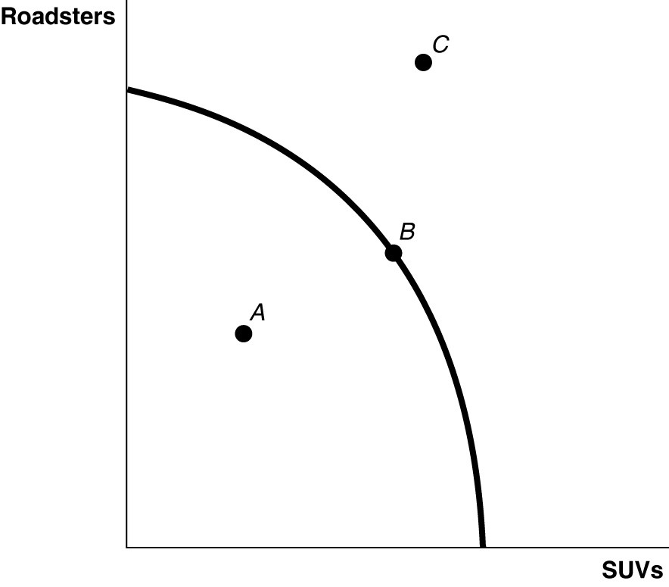

9) Refer to Figure 2-1. Point A is
A) technically efficient.
B) unattainable with current resources.
C) inefficient in that not all resources are being used.
D) the equilibrium output combination.
Answer: C
Diff: 1 Page Ref: 43
Topic: Production Possibilities Frontiers
*: Recurring
Learning Outcome: Micro-2: Interpret and analyze information presented in different types of graphs
AACSB: Analytical thinking

10) Refer to Figure 2-1. Point B is
A) technically efficient.
B) unattainable with current resources.
C) inefficient in that not all resources are being used.
D) the equilibrium output combination.
Answer: A
Diff: 1 Page Ref: 43
Topic: Production Possibilities Frontiers
*: Recurring
Learning Outcome: Micro-2: Interpret and analyze information presented in different types of graphs
AACSB: Analytical thinking
11) Refer to Figure 2-1. Point C is
A) technically efficient.
B) unattainable with current resources.
C) inefficient in that not all resources are being used.
D) is the equilibrium output combination.
Answer: B
Diff: 1 Page Ref: 43
Topic: Production Possibilities Frontiers
*: Recurring
Learning Outcome: Micro-2: Interpret and analyze information presented in different types of graphs
AACSB: Analytical thinking

12) In a production possibilities frontier, a point ________ the frontier is productively inefficient.
A) along
B) inside
C) outside
D) at either intercept of
Answer: B
Diff: 1 Page Ref: 43
Topic: Production Possibilities Frontiers
*: Recurring
Learning Outcome: Micro-3: Discuss different types of market systems and the gains that can be made from trade
AACSB: Analytical thinking

13) Bella can produce either a combination of 60 silk roses and 80 silk leaves or a combination of 70 silk roses and 55 silk leaves. If she now produces 60 silk roses and 80 silk leaves, what is the opportunity cost of producing an additional 10 silk roses?
A) 2.5 silk leaves
B) 10 silk leaves
C) 25 silk leaves
D) 55 silk leaves
Answer: C
Diff: 2 Page Ref: 43
Topic: Opportunity Cost
*: Recurring
Learning Outcome: Micro-3: Discuss different types of market systems and the gains that can be made from trade
AACSB: Analytical thinking
14) Pierre can produce either a combination of 20 bow ties and 30 neckties or a combination of 35 bow ties and 15 neckties. If he now produces 35 bow ties and 15 neckties, what is the opportunity cost of producing an additional 15 neckties?
A) 2 bow ties
B) 15 bow ties
C) 20 bow ties
D) 35 bow ties
Answer: B
Diff: 2 Page Ref: 43
Topic: Opportunity Cost
*: Recurring
Learning Outcome: Micro-3: Discuss different types of market systems and the gains that can be made from trade
AACSB: Analytical thinking

15) If the production possibilities frontier is ________, then opportunity costs are constant as more of one good is produced.
A) bowed out
B) bowed in
C) non-linear
D) linear
Answer: D
Diff: 2 Page Ref: 43
Topic: Opportunity Cost
*: Recurring
Learning Outcome: Micro-3: Discuss different types of market systems and the gains that can be made from trade
AACSB: Analytical thinking
Figure 2-2

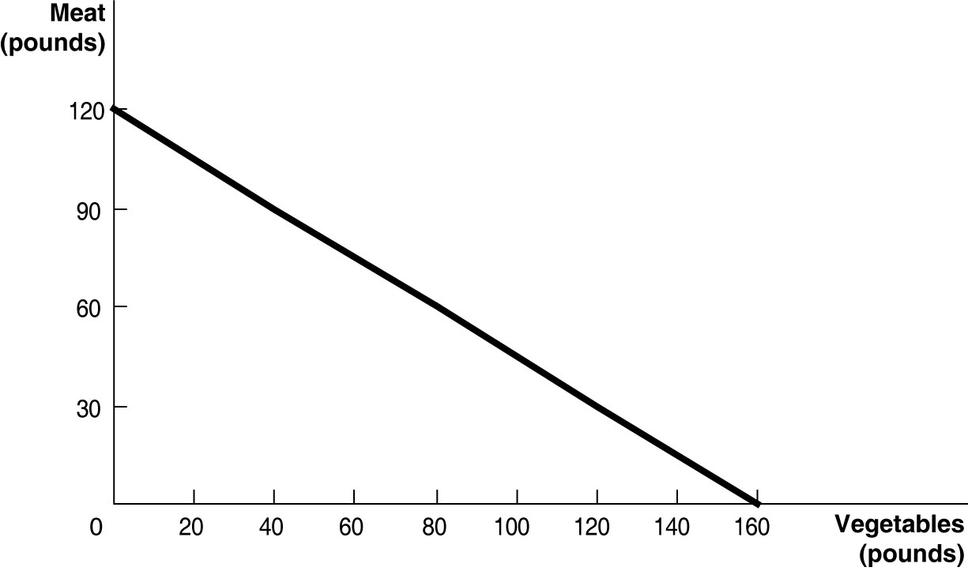

Figure 2-2 above shows the production possibilities frontier for Mendonca, an agrarian nation that produces two goods, meat and vegetables.

16) Refer to Figure 2-2. What is the opportunity cost of one pound of vegetables?
A) 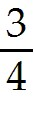 pound of meat
B) 1.2 pounds of meat
C) 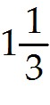 pounds of meat
D) 12 pounds of meat
Answer: A
Diff: 2 Page Ref: 44-45
Topic: Opportunity Cost
Learning Outcome: Micro-2: Interpret and analyze information presented in different types of graphs
AACSB: Analytical thinking
Special Feature: Solved Problem: Drawing a Production Possibilities Frontier for Tesla Motors

17) Refer to Figure 2-2. What is the opportunity cost of one pound of meat?
A) pound of vegetables
B) pounds of vegetables
C) 1.6 pounds of vegetables
D) 16 pounds of vegetables
Answer: B
Diff: 2 Page Ref: 44-45
Topic: Opportunity Cost
Learning Outcome: Micro-2: Interpret and analyze information presented in different types of graphs
AACSB: Analytical thinking
Special Feature: Solved Problem: Drawing a Production Possibilities Frontier for Tesla Motors
18) Refer to Figure 2-2. Suppose Mendonca is currently producing 60 pounds of vegetables per period. How much meat is it also producing, assuming that resources are fully utilized?
A) 45 pounds of meat
B) 75 pounds of meat
C) 80 pounds of meat
D) 100 pounds of meat
Answer: B
Diff: 2 Page Ref: 44-45
Topic: Opportunity Cost
Learning Outcome: Micro-2: Interpret and analyze information presented in different types of graphs
AACSB: Analytical thinking
Special Feature: Solved Problem: Drawing a Production Possibilities Frontier for Tesla Motors

19) Refer to Figure 2-2. If Mendonca chooses to produce 160 pounds of vegetables, how much meat can it produce to maximize production?
A) 0 pounds of meat
B) 30 pounds of meat
C) 60 pounds of meat
D) 120 pounds of meat
Answer: A
Diff: 2 Page Ref: 44-45
Topic: Opportunity Cost
Learning Outcome: Micro-2: Interpret and analyze information presented in different types of graphs
AACSB: Analytical thinking
Special Feature: Solved Problem: Drawing a Production Possibilities Frontier for Tesla Motors

20) Refer to Figure 2-2. If Mendonca chooses to produce 120 pounds of meat, how much vegetables can it produce to maximize production?
A) 0 pounds of vegetables
B) 60 pounds of vegetables
C) 100 pounds of vegetables
D) 160 pounds of vegetables
Answer: A
Diff: 2 Page Ref: 44-45
Topic: Opportunity Cost
Learning Outcome: Micro-2: Interpret and analyze information presented in different types of graphs
AACSB: Analytical thinking
Special Feature: Solved Problem: Drawing a Production Possibilities Frontier for Tesla Motors

21) Refer to Figure 2-2. The linear production possibilities frontier in the figure indicates that
A) Mendonca has a comparative advantage in the production of vegetables.
B) Mendonca has a comparative disadvantage in the production of meat.
C) the trade-off between meat and vegetables is constant.
D) it is progressively more expensive to produce meat.
Answer: C
Diff: 2 Page Ref: 44-45
Topic: Opportunity Cost
Learning Outcome: Micro-2: Interpret and analyze information presented in different types of graphs
AACSB: Analytical thinking
Special Feature: Solved Problem: Drawing a Production Possibilities Frontier for Tesla Motors
22) A production possibilities frontier with a bowed-outward shape indicates
A) the possibility of inefficient production.
B) constant opportunity costs as more and more of one good is produced.
C) increasing opportunity costs as more and more of one good is produced.
D) decreasing opportunity costs as more and more of one good is produced.
Answer: C
Diff: 2 Page Ref: 46
Topic: Opportunity Cost
*: Recurring
Learning Outcome: Micro-3: Discuss different types of market systems and the gains that can be made from trade
AACSB: Analytical thinking

23) Increasing opportunity cost is represented by a ________ production possibilities frontier.
A) linear
B) bowed in
C) bowed out
D) vertical
Answer: C
Diff: 2 Page Ref: 46
Topic: Opportunity Cost
*: Recurring
Learning Outcome: Micro-3: Discuss different types of market systems and the gains that can be made from trade
AACSB: Analytical thinking

24) The slope of a production possibilities frontier
A) has no economic relevance or meaning.
B) is always constant.
C) is always varying.
D) measures the opportunity cost of producing one more unit of a good.
Answer: D
Diff: 1 Page Ref: 46
Topic: Opportunity Cost
*: Recurring
Learning Outcome: Micro-3: Discuss different types of market systems and the gains that can be made from trade
AACSB: Analytical thinking

25) ________ marginal opportunity cost implies that the more resources already devoted to any activity, the payoff from allocating yet more resources to that activity increases by progressively smaller amounts.
A) Increasing
B) Decreasing
C) Constant
D) Negative
Answer: A
Diff: 2 Page Ref: 46
Topic: Opportunity Cost
*: Recurring
Learning Outcome: Micro-20: Apply the concepts of opportunity cost, marginal analysis, and present value to make decisions
AACSB: Analytical thinking
26) If opportunity costs are constant, the production possibilities frontier would be graphed as
A) a ray from the origin.
B) a positively sloped straight line.
C) a negatively sloped curve bowed in toward the origin.
D) a negatively sloped straight line.
Answer: D
Diff: 1 Page Ref: 46
Topic: Opportunity Cost
*: Recurring
Learning Outcome: Micro-3: Discuss different types of market systems and the gains that can be made from trade
AACSB: Analytical thinking

Figure 2-3

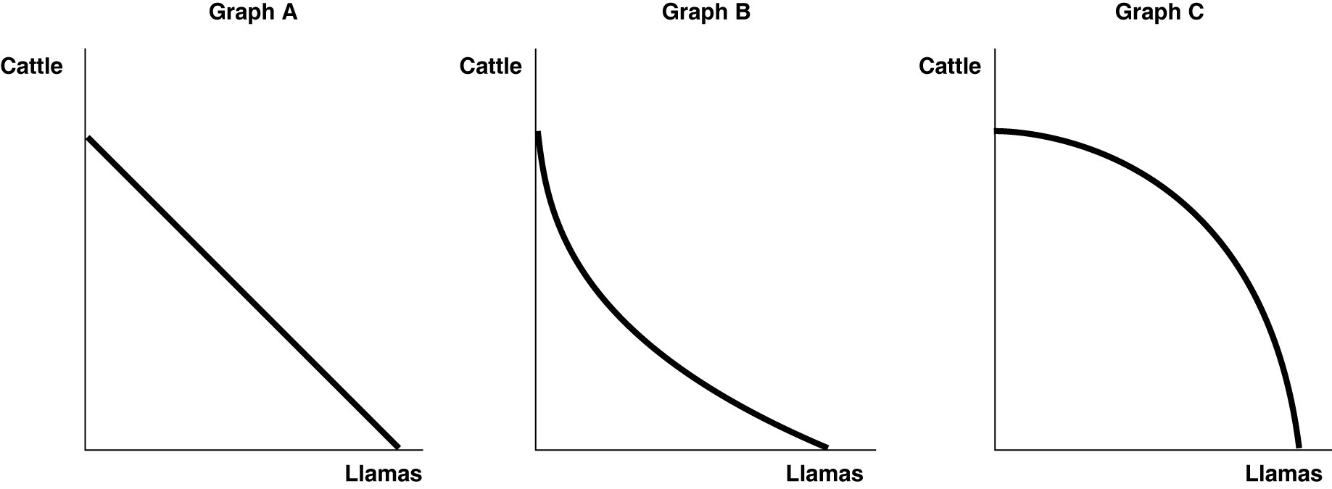

27) Refer to Figure 2-3. Sergio Vignetto raises cattle and llamas on his land. His land is equally suitable for raising either animal. Which of the graphs in Figure 2-3 represent his production possibilities frontier?
A) Graph A
B) Graph B
C) Graph C
D) either Graph A or Graph C
E) either Graph B or Graph C
Answer: A
Diff: 2 Page Ref: 46
Topic: Opportunity Cost
*: Recurring
Learning Outcome: Micro-2: Interpret and analyze information presented in different types of graphs
AACSB: Analytical thinking
28) Refer to Figure 2-3. Sergio Vignetto raises cattle and llamas on his land. A portion of his land is more suitable for raising cattle, and the other portion is better suited for raising llamas. Which of the graphs in Figure 2-3 represent his production possibilities frontier that displays increasing opportunity costs?
A) Graph A
B) Graph B
C) Graph C
D) either Graph A or Graph C
E) either Graph B or Graph C
Answer: C
Diff: 2 Page Ref: 46
Topic: Opportunity Cost
*: Recurring
Learning Outcome: Micro-2: Interpret and analyze information presented in different types of graphs
AACSB: Analytical thinking

Table 2-1

Production choices for Tomaso's Trattoria
Choice | Quantity of Pizzas Produced | Quantity of Calzones Produced
A | 48 | 0
B | 36 | 15
C | 24 | 30
D | 12 | 45
E | 0 | 60

29) Refer to Table 2-1. Assume that Tomaso's Trattoria only produces pizzas and calzones. A combination of 24 pizzas and 30 calzones would appear
A) along Tomaso's production possibilities frontier.
B) inside Tomaso's production possibilities frontier.
C) outside Tomaso's production possibilities frontier.
D) at the horizontal intercept of Tomaso's production possibilities frontier.
Answer: A
Diff: 2 Page Ref: 43
Topic: Production Possibilities Frontiers
*: Recurring
Learning Outcome: Micro-3: Discuss different types of market systems and the gains that can be made from trade
AACSB: Analytical thinking
30) Refer to Table 2-1. Assume that Tomaso's Trattoria only produces pizzas and calzones. A combination of 36 pizzas and 30 calzones would appear
A) along Tomaso's production possibilities frontier.
B) inside Tomaso's production possibilities frontier.
C) outside Tomaso's production possibilities frontier.
D) at the horizontal intercept of Tomaso's production possibilities frontier.
Answer: C
Diff: 2 Page Ref: 43
Topic: Production Possibilities Frontiers
*: Recurring
Learning Outcome: Micro-3: Discuss different types of market systems and the gains that can be made from trade
AACSB: Analytical thinking

31) Refer to Table 2-1. Assume that Tomaso's Trattoria only produces pizzas and calzones. A combination of 24 pizzas and 15 calzones would appear
A) along Tomaso's production possibilities frontier.
B) inside Tomaso's production possibilities frontier.
C) outside Tomaso's production possibilities frontier.
D) at the horizontal intercept of Tomaso's production possibilities frontier.
Answer: B
Diff: 2 Page Ref: 43
Topic: Production Possibilities Frontiers
*: Recurring
Learning Outcome: Micro-3: Discuss different types of market systems and the gains that can be made from trade
AACSB: Analytical thinking

32) Refer to Table 2-1. Assume that Tomaso's Trattoria only produces pizzas and calzones. Tomaso faces ________ opportunity costs in the production of pizzas and calzones.
A) increasing
B) decreasing
C) constant
D) negative
Answer: C
Diff: 2 Page Ref: 43
Topic: Opportunity Cost
*: Recurring
Learning Outcome: Micro-3: Discuss different types of market systems and the gains that can be made from trade
AACSB: Analytical thinking
Table 2-2

Production choices for Billie's Bedroom Shop
Choice | Quantity of Pillows Produced | Quantity of Blankets Produced
A | 36 | 0
B | 27 | 7
C | 18 | 14
D | 9 | 21
E | 0 | 28

33) Refer to Table 2-2. Assume that Billie's Bedroom Shop only produces pillows and blankets. A combination of 9 pillows and 21 blankets would appear
A) along Billie's production possibilities frontier.
B) inside Billie's production possibilities frontier.
C) outside Billie's production possibilities frontier.
D) at the vertical intercept of Billie's production possibilities frontier.
Answer: A
Diff: 2 Page Ref: 43
Topic: Production Possibilities Frontiers
*: Recurring
Learning Outcome: Micro-3: Discuss different types of market systems and the gains that can be made from trade
AACSB: Analytical thinking

34) Refer to Table 2-2. Assume that Billie's Bedroom Shop only produces pillows and blankets. A combination of 27 pillows and 14 blankets would appear
A) along Billie's production possibilities frontier.
B) inside Billie's production possibilities frontier.
C) outside Billie's production possibilities frontier.
D) at the vertical intercept of Billie's production possibilities frontier.
Answer: C
Diff: 2 Page Ref: 43
Topic: Production Possibilities Frontiers
*: Recurring
Learning Outcome: Micro-3: Discuss different types of market systems and the gains that can be made from trade
AACSB: Analytical thinking

35) Refer to Table 2-2. Assume that Billie's Bedroom Shop only produces pillows and blankets. A combination of 5 pillows and 21 blankets would appear
A) along Billie's production possibilities frontier.
B) inside Billie's production possibilities frontier.
C) outside Billie's production possibilities frontier.
D) at the vertical intercept of Billie's production possibilities frontier.
Answer: B
Diff: 2 Page Ref: 43
Topic: Production Possibilities Frontiers
*: Recurring
Learning Outcome: Micro-3: Discuss different types of market systems and the gains that can be made from trade
AACSB: Analytical thinking
36) Refer to Table 2-2. Assume that Billie's Bedroom Shop only produces pillows and blankets. Billie faces ________ opportunity costs in the production of pillows and blankets.
A) increasing
B) constant
C) decreasing
D) negative
Answer: B
Diff: 2 Page Ref: 43
Topic: Production Possibilities Frontiers
*: Recurring
Learning Outcome: Micro-3: Discuss different types of market systems and the gains that can be made from trade
AACSB: Analytical thinking

37) An inward shift of a nation's production possibilities frontier can occur due to
A) a reduction in unemployment.
B) a natural disaster like a hurricane or bad earthquake.
C) a change in the amounts of one good desired.
D) an increase in the labor force.
Answer: B
Diff: 2 Page Ref: 47
Topic: Economic Growth
*: Recurring
Learning Outcome: Micro-3: Discuss different types of market systems and the gains that can be made from trade
AACSB: Analytical thinking

38) An outward shift of a nation's production possibilities frontier represents
A) economic growth.
B) rising prices of the two goods on the production possibilities frontier model.
C) an impossible situation.
D) a situation in which a country produces more of one good and less of another.
Answer: A
Diff: 1 Page Ref: 47
Topic: Economic Growth
*: Recurring
Learning Outcome: Micro-3: Discuss different types of market systems and the gains that can be made from trade
AACSB: Analytical thinking

39) Economic decline (negative growth) is represented on a production possibilities frontier model by the production possibility frontier
A) shifting outward.
B) shifting inward.
C) becoming steeper.
D) becoming flatter.
Answer: B
Diff: 1 Page Ref: 47
Topic: Economic Growth
*: Recurring
Learning Outcome: Micro-3: Discuss different types of market systems and the gains that can be made from trade
AACSB: Analytical thinking
40) Without an increase in the supply of the factors of production, how can a nation achieve economic growth?
A) by producing more high-value goods and fewer low-value goods
B) through technological advancement which enables more output with the same quantity of resources
C) by lowering the prices of factors of production
D) by increasing the prices of factors of production
Answer: B
Diff: 2 Page Ref: 47
Topic: Economic Growth
*: Recurring
Learning Outcome: Micro-17: Explain the effects of the factors of production, factor demand, and factor supply and labor in factor markets
AACSB: Analytical thinking

41) Which of the following would shift a nation's production possibilities frontier outward?
A) discovering a cheaper way to convert sunshine into electricity
B) an increase in demand for the nation's products
C) a decrease in the unemployment rate
D) a law requiring workers to retire at age 50
Answer: A
Diff: 2 Page Ref: 47
Topic: Economic Growth
*: Recurring
Learning Outcome: Micro-3: Discuss different types of market systems and the gains that can be made from trade
AACSB: Analytical thinking
Figure 2-4

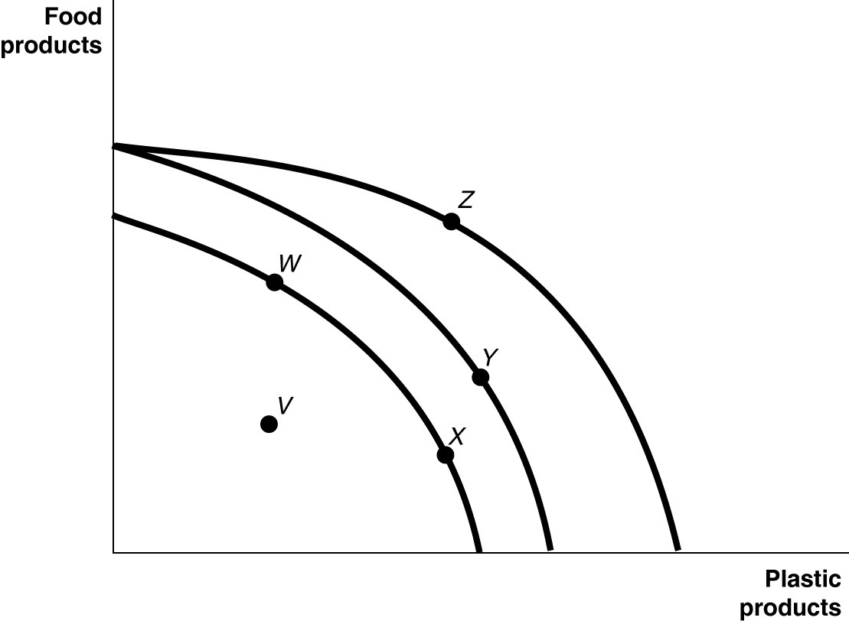
Figure 2-4 shows various points on three different production possibilities frontiers for a nation.

42) Refer to Figure 2-4. A movement from X to Y
A) could be due to a change in consumers' tastes and preferences.
B) could occur because of an influx of immigrant labor.
C) is the result of advancements in food production technology only, with no change in the technology for plastic production.
D) is the result of advancements in plastic production technology only, with no change in food production technology.
Answer: B
Diff: 2 Page Ref: 47
Topic: Economic Growth
*: Recurring
Learning Outcome: Micro-2: Interpret and analyze information presented in different types of graphs
AACSB: Analytical thinking

43) Refer to Figure 2-4. A movement from Y to Z
A) represents an increase in the demand for plastic products.
B) is the result of a decrease in preference for food products.
C) is the result of advancements in food production technology.
D) is the result of advancements in plastic production technology.
Answer: D
Diff: 2 Page Ref: 47
Topic: Economic Growth
*: Recurring
Learning Outcome: Micro-2: Interpret and analyze information presented in different types of graphs
AACSB: Analytical thinking
44) Refer to Figure 2-4. Consider the following events:
a. an increase in the unemployment rate
b. a decrease in a nation's money supply
c. a war that kills a significant portion of a nation's population

Which of the events listed above could cause a movement from Y to W?
A) a, b, and c
B) a and b only
C) a and c only
D) a only
E) c only
Answer: E
Diff: 2 Page Ref: 47
Topic: Economic Growth
*: Recurring
Learning Outcome: Micro-2: Interpret and analyze information presented in different types of graphs
AACSB: Analytical thinking

45) Refer to Figure 2-4. Consider the following movements:
a. from point V to point W
b. from point W to point Y
c. from point Y to point Z

Which of the movements listed above represents economic growth?
A) a, b, and c
B) b and c only
C) a only
D) b only
Answer: B
Diff: 2 Page Ref: 47
Topic: Economic Growth
*: Recurring
Learning Outcome: Micro-2: Interpret and analyze information presented in different types of graphs
AACSB: Analytical thinking

46) Refer to Figure 2-4. Consider the following events:
a. a decrease in the unemployment rate
b. general technological advancement
c. an increase in consumer wealth

Which of the events listed above could cause a movement from V to W?
A) a only
B) a and b only
C) b and c only
D) a, b, and c
Answer: A
Diff: 2 Page Ref: 47
Topic: Economic Growth
*: Recurring
Learning Outcome: Micro-2: Interpret and analyze information presented in different types of graphs
AACSB: Analytical thinking
47) Refer to Figure 2-4. Consider the following events:
a. a reduction in the patent protection period to no more than 2 years
b. a war that destroys a substantial portion of a nation's capital stock
c. the lack of a secure and enforceable property rights system

Which of the events listed above could cause a movement from W to V?
A) a only
B) a and b only
C) a and c only
D) b and c only
E) a, b, and c
Answer: C
Diff: 2 Page Ref: 47
Topic: Economic Growth
*: Recurring
Learning Outcome: Micro-2: Interpret and analyze information presented in different types of graphs
AACSB: Analytical thinking

48) Refer to Figure 2-4. A movement from ________ could occur because of an influx of immigrant labor.
A) W to V
B) X to W
C) W to Z
D) Y to W
Answer: C
Diff: 2 Page Ref: 47
Topic: Economic Growth
*: Recurring
Learning Outcome: Micro-2: Interpret and analyze information presented in different types of graphs
AACSB: Analytical thinking

49) Refer to Figure 2-4. A movement from ________ is the result of negative technological change in plastic production.
A) V to X
B) X to W
C) W to Z
D) Z to Y
Answer: D
Diff: 2 Page Ref: 47
Topic: Economic Growth
*: Recurring
Learning Outcome: Micro-2: Interpret and analyze information presented in different types of graphs
AACSB: Analytical thinking

50) Refer to Figure 2-4. Consider the following events:
a. a decrease in the unemployment rate
b. an increase in a nation's money supply
c. an influx of immigrant workers

Which of the events listed above could cause a movement from X to Z?
A) a, b, and c
B) a and b only
C) a and c only
D) a only
E) c only
Answer: E
Diff: 2 Page Ref: 47
Topic: Economic Growth
*: Recurring
Learning Outcome: Micro-2: Interpret and analyze information presented in different types of graphs
AACSB: Analytical thinking

51) Refer to Figure 2-4. Consider the following movements:
a. from point V to point W
b. from point W to point Y
c. from point Y to point Z

Which of the movements listed above represents advancements in technology with respect to only plastic production?
A) a, b, and c
B) b and c only
C) b only
D) c only
Answer: D
Diff: 2 Page Ref: 47
Topic: Economic Growth
*: Recurring
Learning Outcome: Micro-2: Interpret and analyze information presented in different types of graphs
AACSB: Analytical thinking

52) Refer to Figure 2-4. Consider the following events:
a. an increase in the unemployment rate
b. general technological advancement
c. a decrease in consumer wealth

Which of the events listed above could cause a movement from X to V?
A) a only
B) a and b only
C) b and c only
D) a, b, and c
Answer: A
Diff: 2 Page Ref: 47
Topic: Economic Growth
*: Recurring
Learning Outcome: Micro-2: Interpret and analyze information presented in different types of graphs
AACSB: Analytical thinking
53) Refer to Figure 2-4. Consider the following events:
a. an increase in the patent protection period to 30 years
b. an increase of a nation's capital stock
c. an improved property rights system

Which of the events listed above could cause a movement from V to W?
A) a only
B) a and b only
C) a and c only
D) b and c only
E) a, b, and c
Answer: C
Diff: 2 Page Ref: 47
Topic: Economic Growth
*: Recurring
Learning Outcome: Micro-2: Interpret and analyze information presented in different types of graphs
AACSB: Analytical thinking

54) The Great Depression of the 1930s, with a large number of workers and factories unemployed, would be represented in a production possibilities frontier by
A) a point inside the frontier.
B) a point outside the frontier.
C) a point on the frontier.
D) an intercept on either the vertical or the horizontal axis.
Answer: A
Diff: 2 Page Ref: 43
Topic: Production Possibilities Frontiers
*: Recurring
Learning Outcome: Micro-3: Discuss different types of market systems and the gains that can be made from trade
AACSB: Analytical thinking

55) Suppose there is no unemployment in the economy and society decides that it wants more of one good. Which of the following statements is true?
A) It can only achieve this with an advance in technology.
B) It can increase output without giving up another good.
C) It can only achieve this with an increase in resource supplies.
D) It will have to give up production and consumption of some other good.
Answer: D
Diff: 2 Page Ref: 43
Topic: Opportunity Cost
*: Recurring
Learning Outcome: Micro-3: Discuss different types of market systems and the gains that can be made from trade
AACSB: Analytical thinking
56) If society decides it wants more of one good and all resources are fully utilized, then
A) it is unable to do this unless technology advances.
B) additional resource supplies will have to be found.
C) it has to give up some of another good and incur some opportunity costs.
D) more unemployment will occur.
Answer: C
Diff: 2 Page Ref: 43
Topic: Opportunity Cost
*: Recurring
Learning Outcome: Micro-20: Apply the concepts of opportunity cost, marginal analysis, and present value to make decisions
AACSB: Analytical thinking

57) According to the production possibilities model, if more resources are allocated to the production of physical and human capital, then which of the following is likely to happen?
A) Fewer goods will be produced for consumption today.
B) The production possibilities frontier will shift inward in the future.
C) Future economic growth will decline.
D) The country's total production will fall.
Answer: A
Diff: 2 Page Ref: 43
Topic: Opportunity Cost
*: Recurring
Learning Outcome: Micro-3: Discuss different types of market systems and the gains that can be made from trade
AACSB: Analytical thinking
Figure 2-5

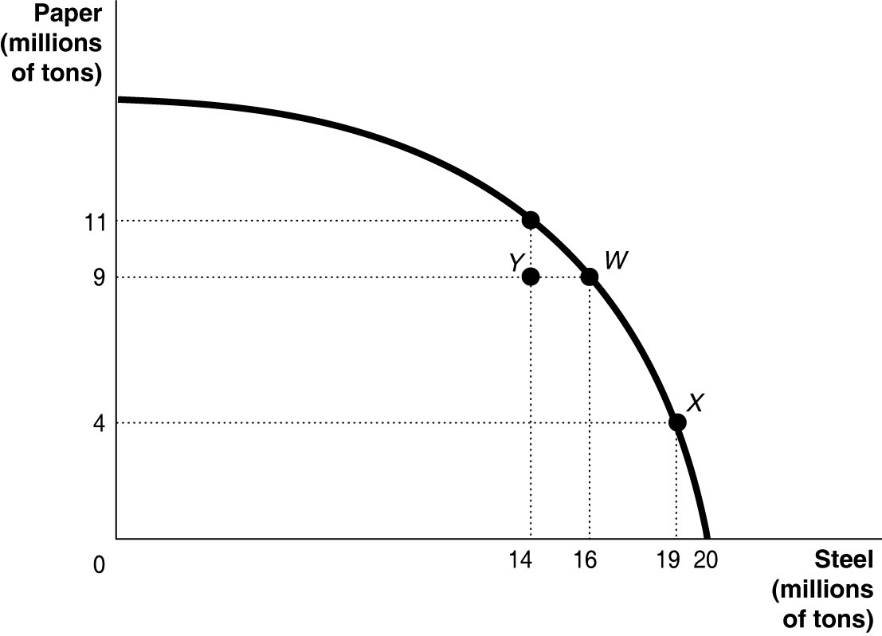

58) Refer to Figure 2-5. If the economy is currently producing at point Y, what is the opportunity cost of moving to point W?
A) 2 million tons of steel
B) zero
C) 9 million tons of paper
D) 16 million tons of paper
Answer: B
Diff: 2 Page Ref: 43
Topic: Opportunity Cost
*: Recurring
Learning Outcome: Micro-2: Interpret and analyze information presented in different types of graphs
AACSB: Analytical thinking

59) Refer to Figure 2-5. If the economy is currently producing at point W, what is the opportunity cost of moving to point X?
A) 3 million tons of steel
B) 19 million tons of steel
C) 5 million tons of paper
D) 9 million tons of paper
Answer: C
Diff: 1 Page Ref: 43
Topic: Opportunity Cost
*: Recurring
Learning Outcome: Micro-2: Interpret and analyze information presented in different types of graphs
AACSB: Analytical thinking
60) Refer to Figure 2-5. If the economy is currently producing at point X, what is the gain in production if the economy moves to point Y?
A) 5 million tons of steel
B) 9 million tons of paper
C) 5 million tons of paper
D) 14 million tons of steel
Answer: C
Diff: 2 Page Ref: 43
Topic: Opportunity Cost
*: Recurring
Learning Outcome: Micro-2: Interpret and analyze information presented in different types of graphs
AACSB: Analytical thinking

Figure 2-6

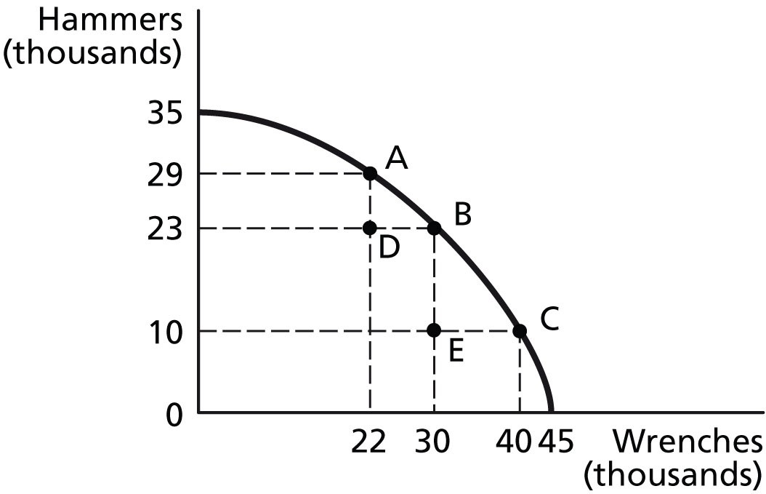

61) Refer to Figure 2-6. If the economy is currently producing at point A, what is the opportunity cost of moving to point B?
A) 8 thousand wrenches
B) 6 thousand hammers
C) 30 thousand wrenches
D) 23 thousand hammers
Answer: B
Diff: 1 Page Ref: 43
Topic: Opportunity Cost
*: Recurring
Learning Outcome: Micro-2: Interpret and analyze information presented in different types of graphs
AACSB: Analytical thinking
62) Refer to Figure 2-6. If the economy is currently producing at point C, what is the opportunity cost of moving to point B?
A) 10 thousand wrenches
B) 13 thousand hammers
C) 30 thousand wrenches
D) 23 thousand hammers
Answer: A
Diff: 1 Page Ref: 43
Topic: Opportunity Cost
*: Recurring
Learning Outcome: Micro-2: Interpret and analyze information presented in different types of graphs
AACSB: Analytical thinking

63) Refer to Figure 2-6. If the economy is currently producing at point D, what is the opportunity cost of moving to point B?
A) 8 thousand wrenches
B) 23 thousand hammers
C) 30 thousand wrenches
D) 0 hammers
Answer: D
Diff: 1 Page Ref: 43
Topic: Opportunity Cost
*: Recurring
Learning Outcome: Micro-2: Interpret and analyze information presented in different types of graphs
AACSB: Analytical thinking

64) Refer to Figure 2-6. If the economy is currently producing at point E, what is the opportunity cost of moving to point B?
A) 13 thousand hammers
B) 10 thousand hammers
C) 30 thousand wrenches
D) 0 wrenches
Answer: D
Diff: 1 Page Ref: 43
Topic: Opportunity Cost
*: Recurring
Learning Outcome: Micro-2: Interpret and analyze information presented in different types of graphs
AACSB: Analytical thinking

65) Refer to Figure 2-6. If the economy is currently producing at point E, what is the gain in production if the economy moves to point D?
A) 13 thousand hammers
B) 10 thousand hammers
C) 8 thousand wrenches
D) 0 wrenches
Answer: A
Diff: 1 Page Ref: 43
Topic: Opportunity Cost
*: Recurring
Learning Outcome: Micro-2: Interpret and analyze information presented in different types of graphs
AACSB: Analytical thinking
66) In a report made to the U.S. Congress in 2001, the National Academy of Sciences cautioned that if fuel economy encourages the production of smaller and lighter cars, "Some additional traffic fatalities would be expected." This statement suggests that
A) U.S. auto manufacturers are more concerned about producing fuel efficient cars to compete with their Japanese and South Korean rivals than about consumer safety.
B) there is a trade-off between safety and fuel economy.
C) society should value safety more highly than fuel economy.
D) society should value fuel economy more highly than consumer safety because of the long-term environmental benefits generated by less gasoline use.
Answer: B
Diff: 2 Page Ref: 43
Topic: Opportunity Cost
*: Recurring
Learning Outcome: Micro-3: Discuss different types of market systems and the gains that can be made from trade
AACSB: Analytical thinking

67) Suppose your expenses for this term are as follows: tuition: $12,000, room and board: $6,500, books and other educational supplies: $1,500. Further, during the term, you can only work part-time and earn $3,500 instead of your full-time salary of $14,000. What is the opportunity cost of going to college this term, assuming that your room and board expenses would be the same even if you did not go to college?
A) $13,500
B) $20,000
C) $24,000
D) $30,500
Answer: C
Diff: 3 Page Ref: 43
Topic: Opportunity Cost
*: Recurring
Learning Outcome: Micro-20: Apply the concepts of opportunity cost, marginal analysis, and present value to make decisions
AACSB: Analytical thinking

68) Suppose your expenses for this term are as follows: tuition: $28,000, room and board: $9,000, books and other educational supplies: $2,500. Further, during the term, you can only work part-time and earn $16,000 instead of your full-time salary of $42,000. What is the opportunity cost of going to college this term, assuming that your room and board expenses would be the same even if you did not go to college?
A) $36,500
B) $56,500
C) $65,500
D) $72,500
Answer: B
Diff: 3 Page Ref: 43
Topic: Opportunity Cost
*: Recurring
Learning Outcome: Micro-20: Apply the concepts of opportunity cost, marginal analysis, and present value to make decisions
AACSB: Analytical thinking
69) The opportunity cost of taking a semester-long economics class is
A) the cost of tuition and fees only.
B) the value of the time spent in the classroom.
C) zero because there is no admission charged if you are enrolled in the course.
D) equal to the highest value of an alternative use of the time and money spent on the class.
E) the knowledge and enjoyment you receive from attending the class.
Answer: D
Diff: 2 Page Ref: 43
Topic: Opportunity Cost
*: Recurring
Learning Outcome: Micro-20: Apply the concepts of opportunity cost, marginal analysis, and present value to make decisions
AACSB: Analytical thinking

Figure 2-7

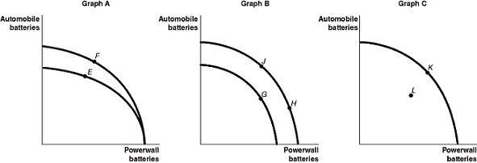

Tesla opened its Gigafactory near Sparks, Nevada to produce lithium-ion batteries for both its automobiles and its Powerwall energy storage products. Figure 2-7 shows changes to its production possibilities frontier at the Gigafactory in response to new developments and different strategic production decisions.

70) Refer to Figure 2-7. Assume a technological advancement greatly reduces the cost to produce batteries for its automobiles. This is best represented by the
A) movement from E to F in Graph A.
B) movement from G to H in Graph B.
C) movement from K to L in Graph C.
D) movement from H to J in Graph B.
Answer: A
Diff: 2 Page Ref: 47
Topic: Economic Growth
Learning Outcome: Micro-2: Interpret and analyze information presented in different types of graphs
AACSB: Analytical thinking
Special Feature: An Inside Look: Tesla Bets Big on Nevada Battery Plant
71) Refer to Figure 2-7. Assume that in response to changing consumer demands, Tesla cuts back on the production of Powerwall batteries and increases its production of automobile batteries. This strategy is best represented by the
A) movement from E to F in Graph A.
B) movement from J to G in Graph B.
C) movement from L to K in Graph C.
D) movement from H to J in Graph B.
Answer: D
Diff: 2 Page Ref: 43
Topic: Opportunity Cost
Learning Outcome: Micro-2: Interpret and analyze information presented in different types of graphs
AACSB: Analytical thinking
Special Feature: An Inside Look: Tesla Bets Big on Nevada Battery Plant

72) Refer to Figure 2-7. Assume that in 2024, Tesla temporarily shuts down part of the Gigafactory for an extensive renovation, and this reduces the amount of production capacity available for both types of batteries. This is best represented by the
A) movement from E to F in Graph A.
B) movement from H to J in Graph B.
C) movement from K to L in Graph C.
D) movement from J to G in Graph B.
Answer: C
Diff: 2 Page Ref: 47
Topic: Economic Growth
Learning Outcome: Micro-2: Interpret and analyze information presented in different types of graphs
AACSB: Analytical thinking
Special Feature: An Inside Look: Tesla Bets Big on Nevada Battery Plant

73) Sarita can bake either a combination of 25 cakes and 15 pies or a combination of 10 cakes and 20 pies. If she now bakes 10 cakes and 20 pies, what is the opportunity cost of baking an additional 15 cakes?
A) 5 pies
B) 10 pies
C) 15 pies
D) 20 pies
Answer: A
Diff: 2 Page Ref: 43
Topic: Opportunity Cost
*: Recurring
Learning Outcome: Micro-3: Discuss different types of market systems and the gains that can be made from trade
AACSB: Analytical thinking
Figure 2-8

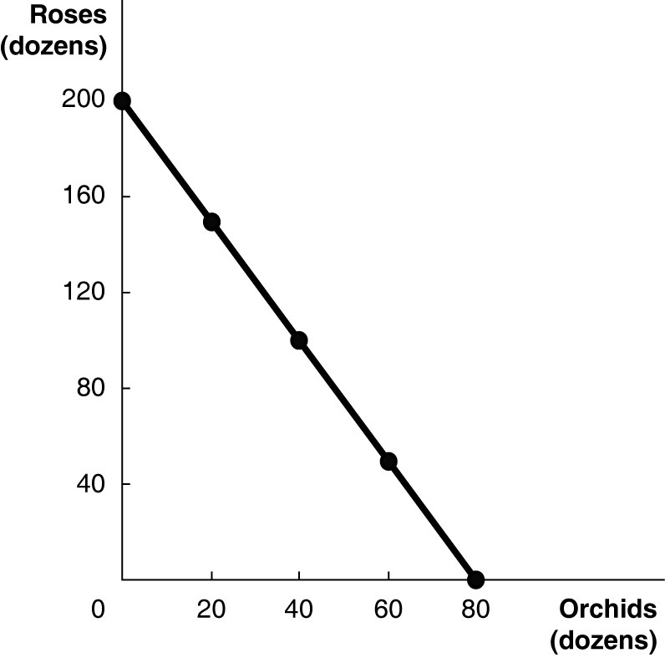

Figure 2-8 above shows the production possibilities frontier for Vidalia, a nation that produces two goods, roses and orchids.

74) Refer to Figure 2-8. What is the opportunity cost of 80 dozen orchids?
A) 0 roses
B) 2.5 dozen roses
C) 40 dozen roses
D) 200 dozen roses
Answer: D
Diff: 2 Page Ref: 44-45
Topic: Opportunity Cost
Learning Outcome: Micro-2: Interpret and analyze information presented in different types of graphs
AACSB: Analytical thinking
Special Feature: Solved Problem: Drawing a Production Possibilities Frontier for Tesla Motors

75) Refer to Figure 2-8. What is the opportunity cost of 100 dozen roses?
A) 0.8 dozen orchids
B) 5 dozen orchids
C) 40 dozen orchids
D) 80 dozen orchids
Answer: C
Diff: 2 Page Ref: 44-45
Topic: Opportunity Cost
Learning Outcome: Micro-2: Interpret and analyze information presented in different types of graphs
AACSB: Analytical thinking
Special Feature: Solved Problem: Drawing a Production Possibilities Frontier for Tesla Motors
76) Refer to Figure 2-8. Suppose Vidalia is currently producing 60 dozen orchids per period. How many roses is it also producing, assuming that resources are fully utilized?
A) 40 dozen roses
B) 50 dozen roses
C) 60 dozen roses
D) 100 dozen roses
Answer: B
Diff: 2 Page Ref: 44-45
Topic: Opportunity Cost
Learning Outcome: Micro-2: Interpret and analyze information presented in different types of graphs
AACSB: Analytical thinking
Special Feature: Solved Problem: Drawing a Production Possibilities Frontier for Tesla Motors

77) Refer to Figure 2-8. Suppose Vidalia is currently producing 120 dozen roses per period. How many orchids is it also producing, assuming that resources are fully utilized?
A) 20 dozen orchids
B) 32 dozen orchids
C) 44 dozen orchids
D) 68 dozen orchids
Answer: B
Diff: 2 Page Ref: 44-45
Topic: Opportunity Cost
Learning Outcome: Micro-2: Interpret and analyze information presented in different types of graphs
AACSB: Analytical thinking
Special Feature: Solved Problem: Drawing a Production Possibilities Frontier for Tesla Motors

Table 2-3

Production Choices for Dina's Diner
Choice | Quantity of Sliders Produced | Quantity of Hot Wings Produced
A | 160 | 0
B | 120 | 50
C | 80 | 100
D | 40 | 150
E | 0 | 200

78) Refer to Table 2-3. Assume Dina's Diner only produces sliders and hot wings. A combination of 80 sliders and 100 hot wings would appear
A) along Dina's production possibilities frontier.
B) inside Dina's production possibilities frontier.
C) outside Dina's production possibilities frontier.
D) at the vertical intercept of Dina's production possibilities frontier.
Answer: A
Diff: 2 Page Ref: 43
Topic: Production Possibilities Frontiers
*: Recurring
Learning Outcome: Micro-3: Discuss different types of market systems and the gains that can be made from trade
AACSB: Analytical thinking
79) Refer to Table 2-3. Assume Dina's Diner only produces sliders and hot wings. A combination of 80 sliders and 50 hot wings would appear
A) along Dina's production possibilities frontier.
B) inside Dina's production possibilities frontier.
C) outside Dina's production possibilities frontier.
D) at the vertical intercept of Dina's production possibilities frontier.
Answer: B
Diff: 2 Page Ref: 43
Topic: Production Possibilities Frontiers
*: Recurring
Learning Outcome: Micro-3: Discuss different types of market systems and the gains that can be made from trade
AACSB: Analytical thinking

80) Refer to Table 2-3. Assume Dina's Diner only produces sliders and hot wings. A combination of 120 sliders and 100 hot wings would appear
A) along Dina's production possibilities frontier.
B) inside Dina's production possibilities frontier.
C) outside Dina's production possibilities frontier.
D) at the vertical intercept of Dina's production possibilities frontier.
Answer: C
Diff: 2 Page Ref: 43
Topic: Production Possibilities Frontiers
*: Recurring
Learning Outcome: Micro-3: Discuss different types of market systems and the gains that can be made from trade
AACSB: Analytical thinking

81) Refer to Table 2-3. Dina faces ________ opportunity costs in the production of sliders and hot wings.
A) increasing
B) decreasing
C) constant
D) negative
Answer: C
Diff: 2 Page Ref: 43
Topic: Opportunity Cost
*: Recurring
Learning Outcome: Micro-3: Discuss different types of market systems and the gains that can be made from trade
AACSB: Analytical thinking
82) Suppose your expenses for this term are as follows: tuition: $10,000, room and board: $6,000, books and other educational supplies: $1,000. Further, during the term, you can only work part-time and earn $8,000 instead of your full-time salary of $20,000. What is the opportunity cost of going to college this term, assuming that your room and board expenses would be the same even if you did not go to college?
A) $11,000
B) $17,000
C) $23,000
D) $29,000
Answer: C
Diff: 3 Page Ref: 43
Topic: Opportunity Cost
*: Recurring
Learning Outcome: Micro-20: Apply the concepts of opportunity cost, marginal analysis, and present value to make decisions
AACSB: Analytical thinking

83) The opportunity cost of going to an outdoor music festival is
A) the enjoyment you receive from going to the festival.
B) the value of the time spent at the festival.
C) equal to the highest value of an alternative use of the time and money spent on the festival.
D) zero because there are no overhead costs for an outdoor festival.
E) the cost of the festival ticket only.
Answer: C
Diff: 2 Page Ref: 43
Topic: Opportunity Cost
*: Recurring
Learning Outcome: Micro-20: Apply the concepts of opportunity cost, marginal analysis, and present value to make decisions
AACSB: Analytical thinking

84) A decrease in the unemployment rate may be represented as a movement from a point on the production possibilities frontier to a point outside the frontier.
Answer: FALSE
Diff: 2 Page Ref: 47
Topic: Economic Growth
*: Recurring
Learning Outcome: Micro-3: Discuss different types of market systems and the gains that can be made from trade
AACSB: Analytical thinking

85) If a country is producing efficiently and is on the production possibilities frontier, the only way to produce more of one good is to produce less of the other.
Answer: TRUE
Diff: 2 Page Ref: 43
Topic: Opportunity Cost
*: Recurring
Learning Outcome: Micro-3: Discuss different types of market systems and the gains that can be made from trade
AACSB: Analytical thinking
86) Consider a country that produces only two goods: kayaks and coconuts. Suppose it is possible for this country to increase its production of kayaks without producing fewer coconuts. In this case, its current output combination is efficient.
Answer: FALSE
Diff: 2 Page Ref: 42
Topic: Production Possibilities Frontiers
*: Recurring
Learning Outcome: Micro-3: Discuss different types of market systems and the gains that can be made from trade
AACSB: Analytical thinking

87) Any output combination outside a production possibilities frontier is associated with unused or
underutilized resources.
Answer: FALSE
Diff: 2 Page Ref: 43
Topic: Production Possibilities Frontiers
*: Recurring
Learning Outcome: Micro-3: Discuss different types of market systems and the gains that can be made from trade
AACSB: Analytical thinking

88) An increase in the labor force shifts the production possibilities frontier inwards over time.
Answer: FALSE
Diff: 2 Page Ref: 47
Topic: Economic Growth
*: Recurring
Learning Outcome: Micro-3: Discuss different types of market systems and the gains that can be made from trade
AACSB: Analytical thinking

89) If additional units of a good could be produced at a constant opportunity cost, the production possibilities frontier would be bowed outward (concave).
Answer: FALSE
Diff: 2 Page Ref: 46
Topic: Opportunity Cost
*: Recurring
Learning Outcome: Micro-3: Discuss different types of market systems and the gains that can be made from trade
AACSB: Analytical thinking

90) On a diagram of a production possibilities frontier, opportunity cost is represented by the production possibilities frontier shifting outward.
Answer: FALSE
Diff: 2 Page Ref: 46
Topic: Opportunity Cost
*: Recurring
Learning Outcome: Micro-3: Discuss different types of market systems and the gains that can be made from trade
AACSB: Analytical thinking
91) To increase gas mileage, automobile manufacturers make cars small and light. Large cars absorb more of the impact of an accident than small cars but yield lower gas mileage. These facts suggest that a negative relationship exists between safety and gas mileage.
Answer: TRUE
Diff: 2 Page Ref: 46
Topic: Production Possibilities Frontiers
Learning Outcome: Micro-3: Discuss different types of market systems and the gains that can be made from trade
AACSB: Analytical thinking
Special Feature: Economics in Your Life & Career: The Trade-offs When You Buy a Car

92) An increase in the unemployment rate may be represented as a movement from a point on the production possibilities frontier to a different point on the frontier.
Answer: FALSE
Diff: 2 Page Ref: 47
Topic: Economic Growth
*: Recurring
Learning Outcome: Micro-3: Discuss different types of market systems and the gains that can be made from trade
AACSB: Analytical thinking

93) If a country is producing efficiently and is on the production possibilities frontier, the country can produce more of one good without producing less of the other good.
Answer: FALSE
Diff: 2 Page Ref: 47
Topic: Economic Growth
*: Recurring
Learning Outcome: Micro-3: Discuss different types of market systems and the gains that can be made from trade
AACSB: Analytical thinking

94) Consider a country that produces only two goods: parrots and iguanas. Suppose it is impossible for this country to increase its production of parrots without producing fewer iguanas. In this case, its current output combination is efficient.
Answer: TRUE
Diff: 2 Page Ref: 43
Topic: Production Possibilities Frontiers
*: Recurring
Learning Outcome: Micro-3: Discuss different types of market systems and the gains that can be made from trade
AACSB: Analytical thinking

95) Any output combination along a production possibilities frontier is associated with fully utilized resources.
Answer: TRUE
Diff: 2 Page Ref: 43
Topic: Production Possibilities Frontiers
*: Recurring
Learning Outcome: Micro-3: Discuss different types of market systems and the gains that can be made from trade
AACSB: Analytical thinking
96) A decrease in population shifts the production possibilities frontier outwards over time.
Answer: FALSE
Diff: 2 Page Ref: 47
Topic: Economic Growth
*: Recurring
Learning Outcome: Micro-3: Discuss different types of market systems and the gains that can be made from trade
AACSB: Analytical thinking

97) If additional units of a good could be produced at an increasing opportunity cost, the production possibilities frontier would be linear.
Answer: FALSE
Diff: 2 Page Ref: 46
Topic: Opportunity Cost
*: Recurring
Learning Outcome: Micro-3: Discuss different types of market systems and the gains that can be made from trade
AACSB: Analytical thinking

98) On a diagram of a production possibilities frontier, economic growth is represented by the slope of the production possibilities frontier.
Answer: FALSE
Diff: 2 Page Ref: 43
Topic: Opportunity Cost
*: Recurring
Learning Outcome: Micro-3: Discuss different types of market systems and the gains that can be made from trade
AACSB: Analytical thinking

99) What is meant by the term "opportunity cost"?
Answer: Opportunity cost is the highest-valued alternative that must be given up to engage in an activity.
Diff: 2 Page Ref: 43
Topic: Opportunity Cost
*: Recurring
Learning Outcome: Micro-3: Discuss different types of market systems and the gains that can be made from trade
AACSB: Analytical thinking

100) What is economic growth?
Answer: Economic growth refers to the ability of the economy to increase the production of goods and services.
Diff: 2 Page Ref: 47
Topic: Economic Growth
*: Recurring
Learning Outcome: Micro-3: Discuss different types of market systems and the gains that can be made from trade
AACSB: Analytical thinking
101) What is a production possibilities frontier? What do points along the frontier represent? What do points inside and outside the frontier represent?
Answer: A production possibilities frontier is a curve showing the maximum attainable combinations of two products that may be produced with available resources and current technology. Points along a production possibilities frontier are attainable with the resources available and are efficient. Points inside the frontier are attainable but inefficient. Points outside the frontier are unattainable.
Diff: 2 Page Ref: 42-43
Topic: Production Possibilities Frontiers
*: Recurring
Learning Outcome: Micro-3: Discuss different types of market systems and the gains that can be made from trade
AACSB: Analytical thinking

102) What shape does a production possibilities frontier take if it displays increasing opportunity costs? What shape does a production possibilities frontier take if it displays constant opportunity costs? Which shape is most common in production situations?
Answer: A production possibilities frontier which displays increasing opportunity costs is bowed outward. A production possibilities frontier which displays constant opportunity costs is linear. A bowed-out production possibilities frontier is most common in production situations.
Diff: 2 Page Ref: 46
Topic: Opportunity Cost
*: Recurring
Learning Outcome: Micro-3: Discuss different types of market systems and the gains that can be made from trade
AACSB: Analytical thinking
103) a. Draw a production possibilities frontier for a country that produces two goods, beer and pretzels. Assume that resources are equally suited to both tasks.
b. Define opportunity costs.
c. Use your production possibilities frontier graph to demonstrate the concept of opportunity costs.
Answer:
a. The PPF is linear to reflect the fact that resources are equally suited to both tasks.

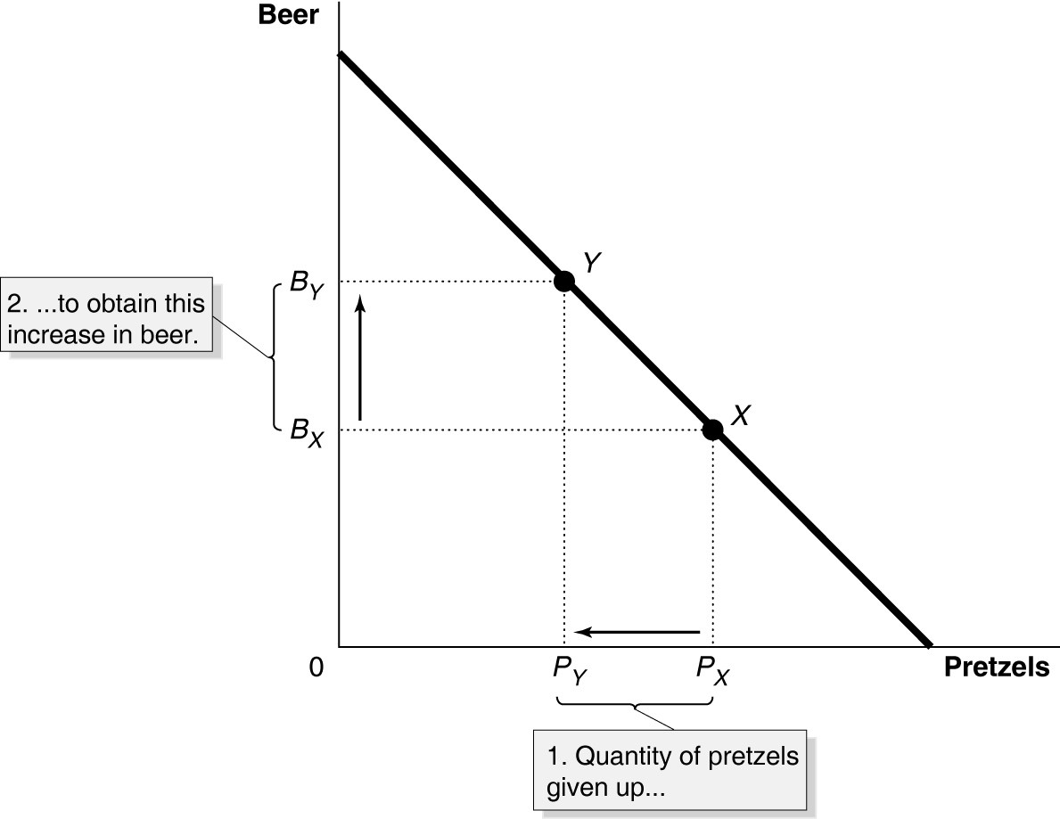

b. Opportunity cost is defined as the highest-valued alternative that must be forgone by taking an action.
c. In the PPF graph in part (a), suppose the country is currently producing at point X and wishes to move to point Y so that it can produce more beer. The only way it can obtain more beer is to give up some amount of pretzels.
Diff: 2 Page Ref: 43
Topic: Production Possibilities Frontiers
*: Recurring
Learning Outcome: Micro-2: Interpret and analyze information presented in different types of graphs
AACSB: Analytical thinking

Table 2-4

Possible Output Combinations | Apples  (thousands of pounds) | Pears  (thousands of pounds)
A | 70 | 0
B | 60 | 20
C | 50 | 36
D | 40 | 48
E | 30 | 56
F | 20 | 60
G | 10 | 63
H | 0 | 65

104) Refer to Table 2-4. The Fruit Farm produces only apples and pears. The table above shows the maximum possible output combinations of the two fruits using all resources and currently available technology.

a. Graph the Fruit Farm's production possibilities frontier. Put apples on the horizontal axis and pears on the vertical axis. Be sure to identify the output combination points on your diagram.
b. Suppose the Fruit Farm is currently producing at point D. What is the opportunity cost of producing an additional 8,000 pounds of pears?
c. Suppose the Fruit Farm is currently producing at point D. What happens to the opportunity cost of producing more and more pears? Does it increase, decrease, or remain constant? Explain your answer.
d. Suppose the Fruit Farm is currently producing at point G. What happens to the opportunity cost of producing more and more apples? Does it increase, decrease, or remain constant? Explain your answer.
e. Suppose the Fruit Farm is plagued by the apple maggot infestation which destroys apple trees but not pear trees. Show in a graph what happens to its PPF.
Answer:
a.
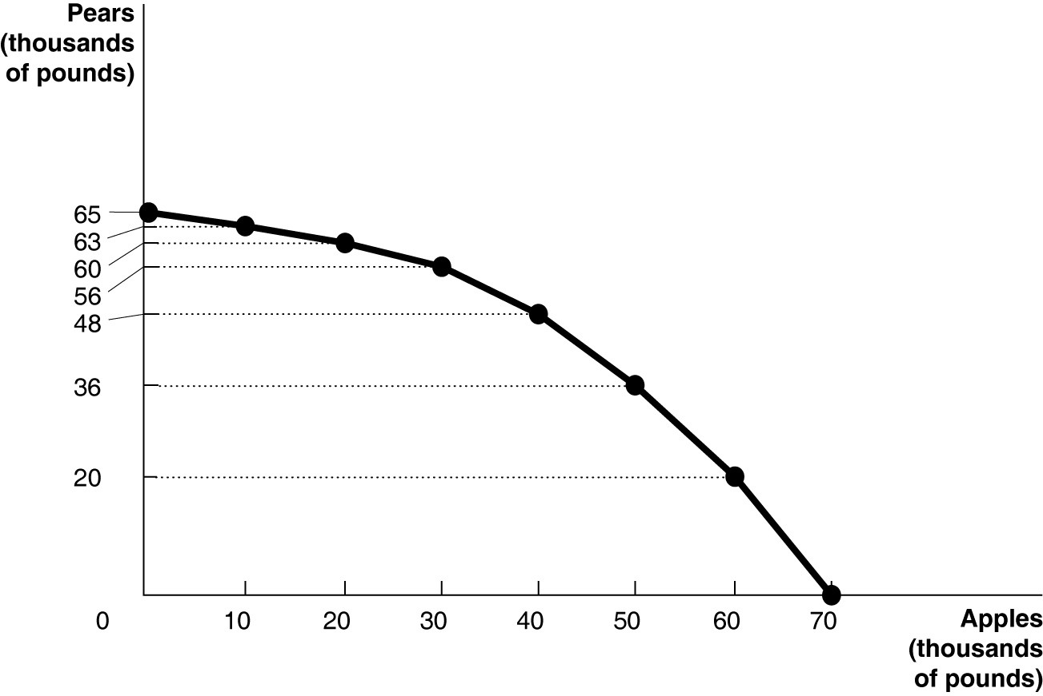
b. 10,000 pounds of apples
c. It increases. For example to move to E, the Fruit Farm has to give up 10,000 pounds of apples to produce an additional 8,000 pounds of pears. For each additional 10,000 pounds of apples foregone, the payoff in terms of pears gets progressively smaller.
d. It increases. Each time it wants to produce an additional 10,000 pounds of apples, more and more pears must be given up.
e.
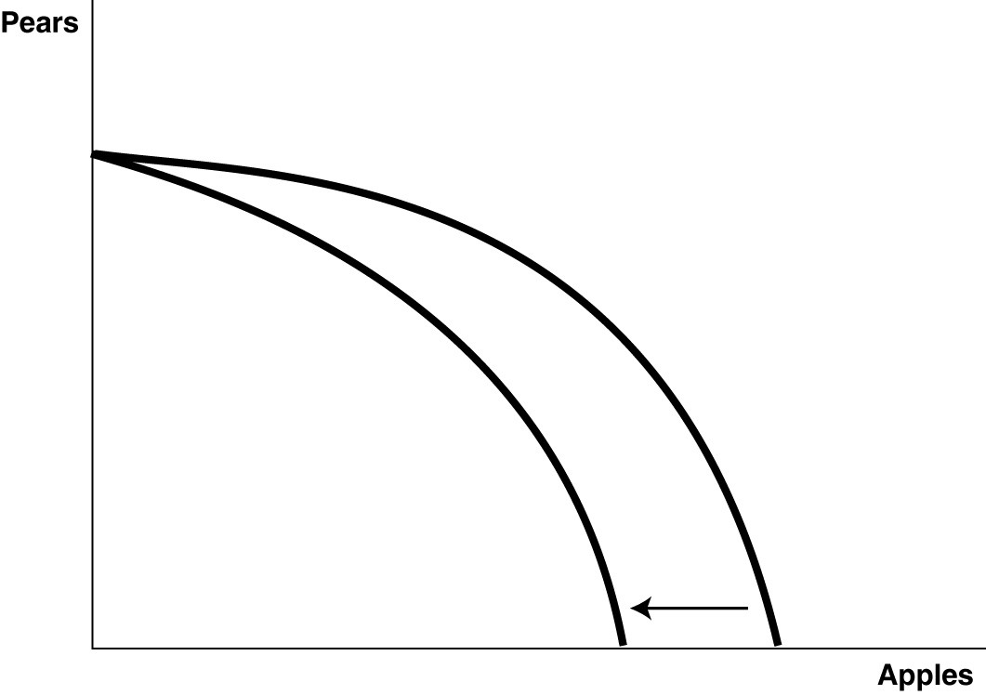
Diff: 3 Page Ref: 44-45
Topic: Production Possibilities Frontiers
Learning Outcome: Micro-3: Discuss different types of market systems and the gains that can be made from trade
AACSB: Analytical thinking
Special Feature: Solved Problem: Drawing a Production Possibilities Frontier for Tesla Motors
Table 2-5
Possible Output Combinations | Shrimp  (thousands of pounds) | Oysters  (thousands of pounds)
A | 35 | 0
B | 30 | 20
C | 25 | 35
D | 20 | 47
E | 15 | 57
F | 10 | 64
G | 5 | 68
H | 0 | 70

105) Refer to Table 2-5. The Shellfish Shack produces only shrimp and oysters. The table above shows the maximum possible output combinations of the two types of shellfish using all resources and currently available technology.

a. Suppose The Shellfish Shack is currently producing at point E. What is the opportunity cost of producing an additional 11,000 pounds of oysters?
b. Suppose The Shellfish Shack is currently producing at point E. What happens to the opportunity cost of producing more and more shrimp? Does it increase, decrease, or remain constant? Explain your answer.
c. Suppose The Shellfish Shack is currently producing at point B. What happens to the opportunity cost of producing more and more oysters? Does it increase, decrease, or remain constant? Explain your answer.
d. Suppose The Shellfish Shack is plagued by a disease which destroys oyster beds but not shrimp habitats. What would happen to its PPF?
Answer:
a. 10,000 pounds of shrimp
b. It increases. For example to move to D, The Shellfish Shack has to give up 10,000 pounds of oysters to produce an additional 5,000 pounds of shrimp. For each additional 5,000 pounds of shrimp produced, more and more oysters must be given up.
c. It increases. Each time it gives up 5,000 pounds of shrimp, fewer and fewer oysters can be produced.
d. Its PPF would rotate inward, with maximum shrimp production staying the same but maximum oyster production being reduced.
Diff: 3 Page Ref: 44-45
Topic: Production Possibilities Frontiers
Learning Outcome: Micro-3: Discuss different types of market systems and the gains that can be made from trade
AACSB: Analytical thinking
Special Feature: Solved Problem: Drawing a Production Possibilities Frontier for Tesla Motors

2.2 Comparative Advantage and Trade

1) You have an absolute advantage whenever you
A) are better educated than someone else.
B) can produce more of something than others with the same resources.
C) prefer to do one particular activity.
D) can produce something at a lower opportunity cost than others.
Answer: B
Diff: 1 Page Ref: 50
Topic: Absolute Advantage
*: Recurring
Learning Outcome: Micro-3: Discuss different types of market systems and the gains that can be made from trade
AACSB: Analytical thinking

Table 2-6

 | Serena | Haley
Bracelets | 8 | 9
Necklaces | 16 | 12

Table 2-6 shows the output per week of two jewelers, Serena and Haley. They can either devote their time to making bracelets or making necklaces.

2) Refer to Table 2-6. Which of the following statements is true?
A) Haley has an absolute advantage in making both products.
B) Serena has an absolute advantage in making both products.
C) Haley has an absolute advantage in making bracelets and Serena in making necklaces.
D) Haley has an absolute advantage in making necklaces and Serena in making bracelets.
Answer: C
Diff: 1 Page Ref: 50
Topic: Absolute Advantage
*: Recurring
Learning Outcome: Micro-3: Discuss different types of market systems and the gains that can be made from trade
AACSB: Analytical thinking

3) Refer to Table 2-6. What is Haley's opportunity cost of making a bracelet?
A) 3/4 of a bracelet
B) 3 bracelets
C) 1 1/3 necklaces
D) 2 necklaces
Answer: C
Diff: 2 Page Ref: 50
Topic: Opportunity Cost
*: Recurring
Learning Outcome: Micro-20: Apply the concepts of opportunity cost, marginal analysis, and present value to make decisions
AACSB: Analytical thinking
4) Refer to Table 2-6. What is Haley's opportunity cost of making a necklace?
A) 3/4 of a bracelet
B) 3 bracelets
C) 1 1/3 necklaces
D) 2 necklaces
Answer: A
Diff: 2 Page Ref: 50
Topic: Opportunity Cost
*: Recurring
Learning Outcome: Micro-20: Apply the concepts of opportunity cost, marginal analysis, and present value to make decisions
AACSB: Analytical thinking

5) Refer to Table 2-6. What is Serena's opportunity cost of making a bracelet?
A) 2 necklaces
B) 1/2 of a bracelet
C) 1/2 of a necklace
D) 3/4 of a bracelet
Answer: A
Diff: 2 Page Ref: 50
Topic: Opportunity Cost
*: Recurring
Learning Outcome: Micro-20: Apply the concepts of opportunity cost, marginal analysis, and present value to make decisions
AACSB: Analytical thinking

6) Refer to Table 2-6. What is Serena's opportunity cost of making a necklace?
A) 2 necklaces
B) 1/2 of a bracelet
C) 1/2 of a necklace
D) 3/4 of a bracelet
Answer: B
Diff: 2 Page Ref: 50
Topic: Opportunity Cost
*: Recurring
Learning Outcome: Micro-20: Apply the concepts of opportunity cost, marginal analysis, and present value to make decisions
AACSB: Analytical thinking

7) Refer to Table 2-6. Which of the following statements is true?
A) Haley has a comparative advantage in making both products.
B) Serena has a comparative advantage in making both products.
C) Haley has a comparative advantage in making bracelets and Serena in making necklaces.
D) Haley has a comparative advantage in making necklaces and Serena in making bracelets.
Answer: C
Diff: 3 Page Ref: 50
Topic: Comparative Advantage
*: Recurring
Learning Outcome: Micro-3: Discuss different types of market systems and the gains that can be made from trade
AACSB: Analytical thinking
Table 2-7

 | Fred | Barney
Pogo Sticks | 24 | 28
Unicycles | 8 | 14

Table 2-7 shows the output per month of two people, Fred and Barney. They can either devote their time to making pogo sticks or making unicycles.

8) Refer to Table 2-7. Which of the following statements is true?
A) Fred has an absolute advantage in making both products.
B) Barney has an absolute advantage in making both products.
C) Barney has an absolute advantage in making pogo sticks and Fred in making unicycles.
D) Barney has an absolute advantage in making unicycles and Fred in making pogo sticks.
Answer: B
Diff: 1 Page Ref: 50
Topic: Absolute Advantage
*: Recurring
Learning Outcome: Micro-3: Discuss different types of market systems and the gains that can be made from trade
AACSB: Analytical thinking

9) Refer to Table 2-7. What is Fred's opportunity cost of making a pogo stick?
A) 1/3 of a unicycle
B) 3 unicycles
C) 6/7 of a pogo stick
D) 1/2 of a unicycle
Answer: A
Diff: 2 Page Ref: 50
Topic: Opportunity Cost
*: Recurring
Learning Outcome: Micro-3: Discuss different types of market systems and the gains that can be made from trade
AACSB: Analytical thinking

10) Refer to Table 2-7. What is Fred's opportunity cost of making a unicycle?
A) 1/3 of a pogo stick
B) 3 pogo sticks
C) 1/2 of a unicycle
D) 1.3 pogo sticks
Answer: B
Diff: 2 Page Ref: 50
Topic: Opportunity Cost
*: Recurring
Learning Outcome: Micro-3: Discuss different types of market systems and the gains that can be made from trade
AACSB: Analytical thinking
11) Refer to Table 2-7. What is Barney's opportunity cost of making a pogo stick?
A) 1/2 of a unicycle
B) 2 unicycles
C) 1/3 of a unicycle
D) 1.4 pogo sticks
Answer: A
Diff: 2 Page Ref: 50
Topic: Opportunity Cost
*: Recurring
Learning Outcome: Micro-3: Discuss different types of market systems and the gains that can be made from trade
AACSB: Analytical thinking

12) Refer to Table 2-7. What is Barney's opportunity cost of making a unicycle?
A) 1/2 of a pogo stick
B) 2 pogo sticks
C) 1.75 unicycles
D) 2.8 pogo sticks
Answer: B
Diff: 2 Page Ref: 50
Topic: Opportunity Cost
*: Recurring
Learning Outcome: Micro-3: Discuss different types of market systems and the gains that can be made from trade
AACSB: Analytical thinking

13) Refer to Table 2-7. Which of the following statements is true?
A) Fred has a comparative advantage in making both products.
B) Barney has a comparative advantage in making both products.
C) Barney has a comparative advantage in making pogo sticks and Fred in making unicycles.
D) Barney has a comparative advantage in making unicycles and Fred in making pogo sticks.
Answer: D
Diff: 3 Page Ref: 50
Topic: Comparative Advantage
*: Recurring
Learning Outcome: Micro-3: Discuss different types of market systems and the gains that can be made from trade
AACSB: Analytical thinking

14) Comparative advantage means the ability to produce a good or service
A) at a lower selling price than any other producer.
B) at a lower opportunity cost than any other producer.
C) of a higher quality than any other producer.
D) at a higher profit level than any other producer.
Answer: B
Diff: 1 Page Ref: 50
Topic: Comparative Advantage
*: Recurring
Learning Outcome: Micro-3: Discuss different types of market systems and the gains that can be made from trade
AACSB: Analytical thinking
15) Specializing in the production of a good or service in which one has a comparative advantage enables a country to do all of the following except
A) engage in mutually beneficial trade with other nations.
B) increase the variety of products that it can consume with no increase in resources.
C) consume a combination of goods that lies outside its own production possibilities frontier.
D) produce a combination of goods that lies outside its own production possibilities frontier.
Answer: D
Diff: 3 Page Ref: 50
Topic: Comparative Advantage
*: Recurring
Learning Outcome: Micro-3: Discuss different types of market systems and the gains that can be made from trade
AACSB: Analytical thinking

16) For each bottle of wine that Italy produces, it gives up the opportunity to make 10 pounds of cheese. France gives up the opportunity to produce of 1 bottle of wine for every 25 pounds of cheese it produces. Which of the following is true about the comparative advantage between the two countries?
A) Italy has the comparative advantage in cheese.
B) Italy has the comparative advantage in wine.
C) France has the comparative advantage in wine and cheese.
D) France has the comparative advantage in wine.
Answer: B
Diff: 2 Page Ref: 50
Topic: Comparative Advantage
*: Recurring
Learning Outcome: Micro-3: Discuss different types of market systems and the gains that can be made from trade
AACSB: Analytical thinking
Figure 2-9

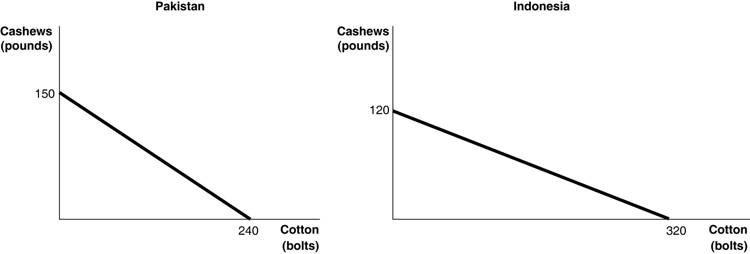

Figure 2-9 shows the production possibilities frontiers for Pakistan and Indonesia. Each country produces two goods, cotton and cashews.

17) Refer to Figure 2-9. What is the opportunity cost of producing 1 bolt of cotton in Pakistan?
A) 3/8 of a pound of cashews
B) 5/8 of a pound of cashews
C) 1 3/5 pounds of cashews
D) 150 pounds of cashews
Answer: B
Diff: 2 Page Ref: 50
Topic: Opportunity Cost
*: Recurring
Learning Outcome: Micro-20: Apply the concepts of opportunity cost, marginal analysis, and present value to make decisions
AACSB: Analytical thinking

18) Refer to Figure 2-9. What is the opportunity cost of producing 1 bolt of cotton in Indonesia?
A) 3/8 of a pound of cashews
B) 5/8 of a pound of cashews
C) 2 2/3 pounds of cashews
D) 120 pounds of cashews
Answer: A
Diff: 2 Page Ref: 50
Topic: Opportunity Cost
*: Recurring
Learning Outcome: Micro-20: Apply the concepts of opportunity cost, marginal analysis, and present value to make decisions
AACSB: Analytical thinking
19) Refer to Figure 2-9. What is the opportunity cost of producing 1 pound of cashews in Pakistan?
A) 3/8 of a bolt of cotton
B) 5/8 of a bolt of cotton
C) 1 3/5 bolts of cotton
D) 240 bolts of cotton
Answer: C
Diff: 2 Page Ref: 50
Topic: Opportunity Cost
*: Recurring
Learning Outcome: Micro-20: Apply the concepts of opportunity cost, marginal analysis, and present value to make decisions
AACSB: Analytical thinking

20) Refer to Figure 2-9. What is the opportunity cost of producing 1 pound of cashews in Indonesia?
A) 3/8 of a bolt of cotton
B) 5/8 of a bolt of cotton
C) 2 2/3 bolts of cotton
D) 320 bolts of cotton
Answer: C
Diff: 2 Page Ref: 50
Topic: Opportunity Cost
*: Recurring
Learning Outcome: Micro-20: Apply the concepts of opportunity cost, marginal analysis, and present value to make decisions
AACSB: Analytical thinking

21) Refer to Figure 2-9. Which country has a comparative advantage in the production of cotton?
A) Indonesia
B) They have equal productive abilities.
C) Pakistan
D) neither country
Answer: A
Diff: 2 Page Ref: 50
Topic: Comparative Advantage
*: Recurring
Learning Outcome: Micro-3: Discuss different types of market systems and the gains that can be made from trade
AACSB: Analytical thinking

22) Refer to Figure 2-9. Which country has a comparative advantage in the production of cashews?
A) Indonesia
B) They have equal productive abilities.
C) Pakistan
D) neither country
Answer: C
Diff: 2 Page Ref: 50
Topic: Comparative Advantage
*: Recurring
Learning Outcome: Micro-3: Discuss different types of market systems and the gains that can be made from trade
AACSB: Analytical thinking
23) Refer to Figure 2-9. If the two countries have the same amount of resources and the same technological knowledge, which country has an absolute advantage in the production of cotton?
A) Indonesia
B) They have the same advantage.
C) Pakistan
D) cannot be determined
Answer: A
Diff: 2 Page Ref: 50
Topic: Absolute Advantage
*: Recurring
Learning Outcome: Micro-3: Discuss different types of market systems and the gains that can be made from trade
AACSB: Analytical thinking

Figure 2-10

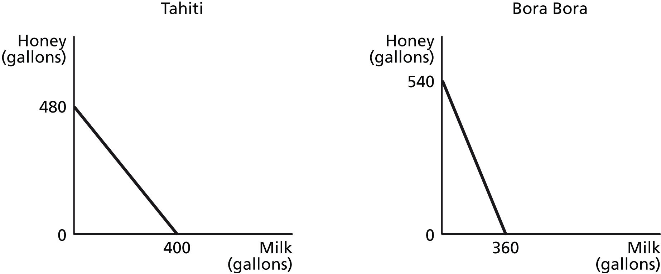

Figure 2-10 shows the production possibilities frontiers for Tahiti and Bora Bora. Each country produces two goods, milk and honey.

24) Refer to Figure 2-10. What is the opportunity cost of producing one gallon of milk in Tahiti?
A) 1/2 of a gallon of honey
B) 5/6 of a gallon of honey
C) 1.2 gallons of honey
D) 1.5 gallons of honey
Answer: C
Diff: 2 Page Ref: 50
Topic: Opportunity Cost
*: Recurring
Learning Outcome: Micro-3: Discuss different types of market systems and the gains that can be made from trade
AACSB: Analytical thinking
25) Refer to Figure 2-10. What is the opportunity cost of producing one gallon of milk in Bora Bora?
A) 2/3 of a gallon of honey
B) 0.8 gallons of honey
C) 1.125 gallons of honey
D) 1.5 gallons of honey
Answer: D
Diff: 2 Page Ref: 50
Topic: Opportunity Cost
*: Recurring
Learning Outcome: Micro-3: Discuss different types of market systems and the gains that can be made from trade
AACSB: Analytical thinking

26) Refer to Figure 2-10. What is the opportunity cost of producing one gallon of honey in Tahiti?
A) 5/6 of a gallon of milk
B) 0.9 gallons of milk
C) 1.2 gallons of milk
D) 1 1/3 gallons of milk
Answer: A
Diff: 2 Page Ref: 50
Topic: Opportunity Cost
*: Recurring
Learning Outcome: Micro-3: Discuss different types of market systems and the gains that can be made from trade
AACSB: Analytical thinking

27) Refer to Figure 2-10. What is the opportunity cost of producing one gallon of honey in Bora Bora?
A) 2/3 of a gallon of milk
B) 0.9 gallons of milk
C) 1 1/3 gallons of milk
D) 1.5 gallons of milk
Answer: A
Diff: 2 Page Ref: 50
Topic: Opportunity Cost
*: Recurring
Learning Outcome: Micro-3: Discuss different types of market systems and the gains that can be made from trade
AACSB: Analytical thinking

28) Refer to Figure 2-10. Which country has a comparative advantage in the production of milk?
A) Bora Bora
B) They have equal productive abilities.
C) Tahiti
D) neither country
Answer: C
Diff: 2 Page Ref: 50
Topic: Comparative Advantage
*: Recurring
Learning Outcome: Micro-3: Discuss different types of market systems and the gains that can be made from trade
AACSB: Analytical thinking
29) Refer to Figure 2-10. Which country has a comparative advantage in the production of honey?
A) Bora Bora
B) They have equal productive abilities.
C) Tahiti
D) neither country
Answer: A
Diff: 2 Page Ref: 50
Topic: Comparative Advantage
*: Recurring
Learning Outcome: Micro-3: Discuss different types of market systems and the gains that can be made from trade
AACSB: Analytical thinking

30) Refer to Figure 2-10. If the two countries have the same amount of resources and the same technological knowledge, which country has an absolute advantage in the production of milk?
A) Bora Bora
B) They have the same advantage.
C) Tahiti
D) cannot be determined
Answer: C
Diff: 2 Page Ref: 50
Topic: Absolute Advantage
*: Recurring
Learning Outcome: Micro-3: Discuss different types of market systems and the gains that can be made from trade
AACSB: Analytical thinking

31) Which of the following statements is true?
A) Individuals who have never been the best at doing anything cannot have a comparative advantage in producing any product.
B) Individuals who have never been the best at doing anything can still have a comparative advantage in producing some product.
C) Individuals who have never been the best at doing anything perform all tasks at a higher opportunity cost than others.
D) Individuals who have never been the best at doing anything must have an absolute advantage in at least ones task.
Answer: B
Diff: 2 Page Ref: 50
Topic: Comparative Advantage
*: Recurring
Learning Outcome: Micro-3: Discuss different types of market systems and the gains that can be made from trade
AACSB: Analytical thinking
Table 2-8

 | One Digital Camera | Wheat  (per pound)
China | 100 hours | 4 hours
South Korea | 60 hours | 3 hours

Table 2-8 shows the number of labor hours required to produce a digital camera and a pound of wheat in China and South Korea.

32) Refer to Table 2-8. Does either China or South Korea have an absolute advantage and if so, in what product?
A) South Korea only has an absolute advantage in wheat.
B) China only has an absolute advantage in wheat.
C) South Korea has an absolute advantage in both products.
D) China only has an absolute advantage in digital cameras.
Answer: C
Diff: 2 Page Ref: 52-53
Topic: Absolute Advantage
Learning Outcome: Micro-3: Discuss different types of market systems and the gains that can be made from trade
AACSB: Analytical thinking
Special Feature: Solved Problem: Comparative Advantage and the Gains from Trade

33) Refer to Table 2-8. What is China's opportunity cost of producing one digital camera?
A) 0.04 pounds of wheat
B) 4 pounds of wheat
C) 25 pounds of wheat
D) 40 pounds of wheat
Answer: C
Diff: 2 Page Ref: 52-53
Topic: Opportunity Cost
Learning Outcome: Micro-20: Apply the concepts of opportunity cost, marginal analysis, and present value to make decisions
AACSB: Analytical thinking
Special Feature: Solved Problem: Comparative Advantage and the Gains from Trade

34) Refer to Table 2-8. What is South Korea's opportunity cost of producing one digital camera?
A) 0.05 pounds of wheat
B) 20 pounds of wheat
C) 25 pounds of wheat
D) 60 pounds of wheat
Answer: B
Diff: 2 Page Ref: 52-53
Topic: Opportunity Cost
Learning Outcome: Micro-20: Apply the concepts of opportunity cost, marginal analysis, and present value to make decisions
AACSB: Analytical thinking
Special Feature: Solved Problem: Comparative Advantage and the Gains from Trade
35) Refer to Table 2-8. What is China's opportunity cost of producing one pound of wheat?
A) 0.04 units of a digital camera
B) 4 digital cameras
C) 25 digital cameras
D) 40 digital cameras
Answer: A
Diff: 2 Page Ref: 52-53
Topic: Opportunity Cost
Learning Outcome: Micro-20: Apply the concepts of opportunity cost, marginal analysis, and present value to make decisions
AACSB: Analytical thinking
Special Feature: Solved Problem: Comparative Advantage and the Gains from Trade

36) Refer to Table 2-8. What is South Korea's opportunity cost of producing one pound of wheat?
A) 60 digital cameras
B) 20 digital cameras
C) 5 digital cameras
D) 0.05 units of a digital camera
Answer: D
Diff: 2 Page Ref: 52-53
Topic: Opportunity Cost
Learning Outcome: Micro-20: Apply the concepts of opportunity cost, marginal analysis, and present value to make decisions
AACSB: Analytical thinking
Special Feature: Solved Problem: Comparative Advantage and the Gains from Trade

37) Refer to Table 2-8. China has a comparative advantage in the production of
A) wheat.
B) digital cameras.
C) both products.
D) neither product.
Answer: A
Diff: 2 Page Ref: 52-53
Topic: Comparative Advantage
Learning Outcome: Micro-3: Discuss different types of market systems and the gains that can be made from trade
AACSB: Analytical thinking
Special Feature: Solved Problem: Comparative Advantage and the Gains from Trade

38) Refer to Table 2-8. South Korea has a comparative advantage in the production of
A) wheat.
B) digital cameras.
C) both products.
D) neither product.
Answer: B
Diff: 2 Page Ref: 52-53
Topic: Comparative Advantage
Learning Outcome: Micro-3: Discuss different types of market systems and the gains that can be made from trade
AACSB: Analytical thinking
Special Feature: Solved Problem: Comparative Advantage and the Gains from Trade
39) Refer to Table 2-8. If the two countries specialize and trade, who should export wheat?
A) There is no basis for trade between the two countries.
B) China
C) South Korea
D) They should both be exporting wheat.
Answer: B
Diff: 2 Page Ref: 52-53
Topic: Specialization
Learning Outcome: Micro-3: Discuss different types of market systems and the gains that can be made from trade
AACSB: Analytical thinking
Special Feature: Solved Problem: Comparative Advantage and the Gains from Trade

40) Refer to Table 2-8. If the two countries specialize and trade, who should export digital cameras?
A) There is no basis for trade between the two countries.
B) China
C) South Korea
D) They should both be importing digital cameras.
Answer: C
Diff: 2 Page Ref: 52-53
Topic: Specialization
Learning Outcome: Micro-3: Discuss different types of market systems and the gains that can be made from trade
AACSB: Analytical thinking
Special Feature: Solved Problem: Comparative Advantage and the Gains from Trade

Table 2-9

 | One Canoe | One Sailboat
Guatemala | 10 hours | 60 hours
Honduras | 15 hours | 75 hours

Table 2-9 shows the number of labor hours required to produce a canoe and a sailboat in Guatemala and Honduras.

41) Refer to Table 2-9. Does either Guatemala or Honduras have an absolute advantage and if so, in what product?
A) Guatemala only has an absolute advantage in producing canoes.
B) Honduras only has an absolute advantage in producing canoes.
C) Guatemala has an absolute advantage in producing both products.
D) Honduras only has an absolute advantage in producing sailboats.
Answer: C
Diff: 2 Page Ref: 52-53
Topic: Absolute Advantage
Learning Outcome: Micro-3: Discuss different types of market systems and the gains that can be made from trade
AACSB: Analytical thinking
Special Feature: Solved Problem: Comparative Advantage and the Gains from Trade
42) Refer to Table 2-9. What is Honduras's opportunity cost of producing one sailboat?
A) 1/5 of a canoe
B) 1.5 canoes
C) 4 canoes
D) 5 canoes
Answer: D
Diff: 2 Page Ref: 52-53
Topic: Opportunity Cost
Learning Outcome: Micro-3: Discuss different types of market systems and the gains that can be made from trade
AACSB: Analytical thinking
Special Feature: Solved Problem: Comparative Advantage and the Gains from Trade

43) Refer to Table 2-9. What is Guatemala's opportunity cost of producing one sailboat?
A) 1/6 of a canoe
B) 2/3 of a canoe
C) 3 canoes
D) 6 canoes
Answer: D
Diff: 2 Page Ref: 52-53
Topic: Opportunity Cost
Learning Outcome: Micro-3: Discuss different types of market systems and the gains that can be made from trade
AACSB: Analytical thinking
Special Feature: Solved Problem: Comparative Advantage and the Gains from Trade

44) Refer to Table 2-9. What is Honduras's opportunity cost of producing one canoe?
A) 1/5 of a sailboat
B) 1.5 sailboats
C) 5 sailboats
D) 6 sailboats
Answer: A
Diff: 2 Page Ref: 52-53
Topic: Opportunity Cost
Learning Outcome: Micro-3: Discuss different types of market systems and the gains that can be made from trade
AACSB: Analytical thinking
Special Feature: Solved Problem: Comparative Advantage and the Gains from Trade

45) Refer to Table 2-9. What is Guatemala's opportunity cost of producing one canoe?
A) 1/6 of a sailboat
B) 2/3 of a sailboat
C) 6 sailboats
D) 7.5 sailboats
Answer: A
Diff: 2 Page Ref: 52-53
Topic: Opportunity Cost
Learning Outcome: Micro-3: Discuss different types of market systems and the gains that can be made from trade
AACSB: Analytical thinking
Special Feature: Solved Problem: Comparative Advantage and the Gains from Trade
46) Refer to Table 2-9. Honduras has a comparative advantage in the production of
A) canoes.
B) sailboats.
C) both products.
D) neither product.
Answer: B
Diff: 2 Page Ref: 52-53
Topic: Comparative Advantage
Learning Outcome: Micro-3: Discuss different types of market systems and the gains that can be made from trade
AACSB: Analytical thinking
Special Feature: Solved Problem: Comparative Advantage and the Gains from Trade

47) Refer to Table 2-9. Guatemala has a comparative advantage in the production of
A) canoes.
B) sailboats.
C) both products.
D) neither product.
Answer: A
Diff: 2 Page Ref: 52-53
Topic: Comparative Advantage
Learning Outcome: Micro-3: Discuss different types of market systems and the gains that can be made from trade
AACSB: Analytical thinking
Special Feature: Solved Problem: Comparative Advantage and the Gains from Trade

48) Refer to Table 2-9. If the two countries specialize and trade, who should export sailboats?
A) There is no basis for trade between the two countries.
B) Guatemala
C) Honduras
D) They should both be importing sailboats.
Answer: C
Diff: 2 Page Ref: 52-53
Topic: Specialization
Learning Outcome: Micro-3: Discuss different types of market systems and the gains that can be made from trade
AACSB: Analytical thinking
Special Feature: Solved Problem: Comparative Advantage and the Gains from Trade

49) Refer to Table 2-9. If the two countries specialize and trade, who should export canoes?
A) There is no basis for trade between the two countries.
B) Guatemala
C) Honduras
D) They should both be exporting canoes.
Answer: B
Diff: 2 Page Ref: 52-53
Topic: Specialization
Learning Outcome: Micro-3: Discuss different types of market systems and the gains that can be made from trade
AACSB: Analytical thinking
Special Feature: Solved Problem: Comparative Advantage and the Gains from Trade
50) If the best surgeon in town is also the best at cleaning swimming pools, then according to the theory of comparative advantage, this person should
A) pursue the activity he enjoys more.
B) specialize in cleaning swimming pools because it is more labor-intensive.
C) split his time evenly between being a surgeon and cleaning swimming pools.
D) specialize in being a surgeon because its opportunity cost is lower.
Answer: D
Diff: 1 Page Ref: 50
Topic: Specialization
*: Recurring
Learning Outcome: Micro-20: Apply the concepts of opportunity cost, marginal analysis, and present value to make decisions
AACSB: Analytical thinking

51) Rayburn Reed is a highly talented photographer. He has chosen to specialize in photography because of all of the following except
A) he obviously has a comparative advantage in photography.
B) his opportunity cost of pursuing another career is very low.
C) for him, this is the most lucrative way to purchase the products that he wants to consume.
D) his photographs are highly esteemed by art lovers who are willing to pay very high prices.
Answer: B
Diff: 3 Page Ref: 50
Topic: Specialization
*: Recurring
Learning Outcome: Micro-20: Apply the concepts of opportunity cost, marginal analysis, and present value to make decisions
AACSB: Analytical thinking

Table 2-10

 | Tammi | Horace
Dogs Groomed | 20 | 12
Cats Bathed | 10 | 8

Table 2-10 shows the output per day of two pet groomers, Tammi and Horace. They can either devote their time to grooming dogs or bathing cats.

52) Refer to Table 2-10. Which of the following statements is true?
A) Horace has an absolute advantage in both tasks.
B) Tammi has an absolute advantage in both tasks.
C) Horace has an absolute advantage in dog grooming and Tammi in cat bathing.
D) Horace has an absolute advantage in cat bathing and Tammi in dog grooming.
Answer: B
Diff: 2 Page Ref: 50
Topic: Absolute Advantage
*: Recurring
Learning Outcome: Micro-3: Discuss different types of market systems and the gains that can be made from trade
AACSB: Analytical thinking
53) Refer to Table 2-10. What is Horace's opportunity cost of grooming a dog?
A) half a bathed cat
B) two bathed cats
C) two-thirds of a bathed cat
D) one and a half bathed cats
Answer: C
Diff: 2 Page Ref: 50
Topic: Opportunity Cost
*: Recurring
Learning Outcome: Micro-20: Apply the concepts of opportunity cost, marginal analysis, and present value to make decisions
AACSB: Analytical thinking

54) Refer to Table 2-10. What is Horace's opportunity cost of bathing a cat?
A) half a groomed dog
B) two groomed dogs
C) two-thirds of a groomed dog
D) one and a half groomed dogs
Answer: D
Diff: 2 Page Ref: 50
Topic: Opportunity Cost
*: Recurring
Learning Outcome: Micro-20: Apply the concepts of opportunity cost, marginal analysis, and present value to make decisions
AACSB: Analytical thinking

55) Refer to Table 2-10. What is Tammi's opportunity cost of grooming a dog?
A) half a bathed cat
B) two bathed cats
C) two-thirds of a bathed cat
D) one and a half bathed cats
Answer: A
Diff: 2 Page Ref: 50
Topic: Opportunity Cost
*: Recurring
Learning Outcome: Micro-20: Apply the concepts of opportunity cost, marginal analysis, and present value to make decisions
AACSB: Analytical thinking

56) Refer to Table 2-10. What is Tammi's opportunity cost of bathing a cat?
A) half a groomed dog
B) two groomed dogs
C) two-thirds of a groomed dog
D) one and a half groomed dogs
Answer: B
Diff: 2 Page Ref: 50
Topic: Opportunity Cost
*: Recurring
Learning Outcome: Micro-20: Apply the concepts of opportunity cost, marginal analysis, and present value to make decisions
AACSB: Analytical thinking
57) Refer to Table 2-10. Which of the following statements is true?
A) Horace has a comparative advantage in both tasks.
B) Tammi has a comparative advantage in both tasks.
C) Horace has a comparative advantage in grooming dogs and Tammi in bathing cats.
D) Horace has a comparative advantage in bathing cats and Tammi in grooming dogs.
Answer: D
Diff: 3 Page Ref: 50
Topic: Comparative Advantage
*: Recurring
Learning Outcome: Micro-3: Discuss different types of market systems and the gains that can be made from trade
AACSB: Analytical thinking

58) For each surfboard that Australia produces, it gives up the opportunity to make 25 boomerangs. New Zealand can produce 1 surfboard for every 15 boomerangs it produces. Which of the following is true about the comparative advantage between the two countries?
A) Australia has the comparative advantage in producing surfboards.
B) Australia has the comparative advantage in producing boomerangs.
C) New Zealand has the comparative advantage in producing surfboards and boomerangs.
D) New Zealand has the comparative advantage in producing boomerangs.
Answer: B
Diff: 2 Page Ref: 50
Topic: Comparative Advantage
*: Recurring
Learning Outcome: Micro-3: Discuss different types of market systems and the gains that can be made from trade
AACSB: Analytical thinking

Table 2-11

 | One Motorcycle | One Guitar
Ireland | 20 hours | 4 hours
Scotland | 8 hours | 2 hours

Table 2-11 shows the number of labor hours required to produce a motorcycle and a guitar in Ireland and Scotland.

59) Refer to Table 2-11. Does either Ireland or Scotland have an absolute advantage and if so, in what product?
A) Scotland only has an absolute advantage in producing guitars.
B) Ireland only has an absolute advantage in producing guitars.
C) Scotland has an absolute advantage in producing both products.
D) Ireland only has an absolute advantage in producing motorcycles.
Answer: C
Diff: 2 Page Ref: 50
Topic: Absolute Advantage
*: Recurring
Learning Outcome: Micro-3: Discuss different types of market systems and the gains that can be made from trade
AACSB: Analytical thinking
60) Refer to Table 2-11. What is Ireland's opportunity cost of producing one motorcycle?
A) 0.2 guitar
B) 5 guitars
C) 8 guitars
D) 32 guitars
Answer: B
Diff: 2 Page Ref: 50
Topic: Opportunity Cost
*: Recurring
Learning Outcome: Micro-20: Apply the concepts of opportunity cost, marginal analysis, and present value to make decisions
AACSB: Analytical thinking

61) Refer to Table 2-11. What is Scotland's opportunity cost of producing one motorcycle?
A) 0.25 guitar
B) 4 guitars
C) 12 guitars
D) 16 guitars
Answer: B
Diff: 2 Page Ref: 50
Topic: Opportunity Cost
*: Recurring
Learning Outcome: Micro-20: Apply the concepts of opportunity cost, marginal analysis, and present value to make decisions
AACSB: Analytical thinking

62) Refer to Table 2-11. What is Ireland's opportunity cost of producing one guitar?
A) 0.2 motorcycles
B) 5 motorcycles
C) 8 motorcycles
D) 32 motorcycles
Answer: A
Diff: 2 Page Ref: 50
Topic: Opportunity Cost
*: Recurring
Learning Outcome: Micro-20: Apply the concepts of opportunity cost, marginal analysis, and present value to make decisions
AACSB: Analytical thinking

63) Refer to Table 2-11. What is Scotland's opportunity cost of producing one guitar?
A) 0.25 motorcycles
B) 4 motorcycles
C) 12 motorcycles
D) 16 motorcycles
Answer: A
Diff: 2 Page Ref: 50
Topic: Opportunity Cost
*: Recurring
Learning Outcome: Micro-20: Apply the concepts of opportunity cost, marginal analysis, and present value to make decisions
AACSB: Analytical thinking
64) Refer to Table 2-11. Ireland has a comparative advantage in the production of
A) both products.
B) guitars.
C) motorcycles.
D) neither product.
Answer: B
Diff: 2 Page Ref: 50
Topic: Comparative Advantage
*: Recurring
Learning Outcome: Micro-3: Discuss different types of market systems and the gains that can be made from trade
AACSB: Analytical thinking

65) Refer to Table 2-11. Scotland has a comparative advantage in the production of
A) both products.
B) guitars.
C) motorcycles.
D) neither product.
Answer: C
Diff: 2 Page Ref: 50
Topic: Comparative Advantage
*: Recurring
Learning Outcome: Micro-3: Discuss different types of market systems and the gains that can be made from trade
AACSB: Analytical thinking

66) Refer to Table 2-11. If the two countries specialize and trade, who should export guitars?
A) There is no basis for trade between the two countries.
B) Ireland
C) Scotland
D) They should both be exporting guitars.
Answer: B
Diff: 2 Page Ref: 50
Topic: Specialization
*: Recurring
Learning Outcome: Micro-3: Discuss different types of market systems and the gains that can be made from trade
AACSB: Analytical thinking

67) Refer to Table 2-11. If the two countries specialize and trade, who should export motorcycles?
A) There is no basis for trade between the two countries.
B) Ireland
C) Scotland
D) They should both be importing motorcycles.
Answer: C
Diff: 2 Page Ref: 50
Topic: Specialization
*: Recurring
Learning Outcome: Micro-3: Discuss different types of market systems and the gains that can be made from trade
AACSB: Analytical thinking
68) As women's wages have risen relative to men's wages, the opportunity cost to women of doing housework has ________ than has the opportunity cost to men.
A) increased less
B) increased more
C) decreased more
D) decreased less
Answer: B
Diff: 2 Page Ref: 53-54
Topic: Opportunity Cost
Learning Outcome: Micro-20: Apply the concepts of opportunity cost, marginal analysis, and present value to make decisions
AACSB: Analytical thinking
Special Feature: Apply the Concept: Comparative Advantage, Opportunity Cost, and Housework

69) If Sanjaya can shuck more oysters in one hour than Tatiana, then Sanjaya has a comparative advantage in shucking oysters.
Answer: FALSE
Diff: 2 Page Ref: 50
Topic: Absolute Advantage
*: Recurring
Learning Outcome: Micro-3: Discuss different types of market systems and the gains that can be made from trade
AACSB: Analytical thinking

70) The basis for trade is comparative advantage, not absolute advantage.
Answer: TRUE
Diff: 1 Page Ref: 50
Topic: Comparative Advantage
*: Recurring
Learning Outcome: Micro-3: Discuss different types of market systems and the gains that can be made from trade
AACSB: Analytical thinking

71) If a country produces only two goods, it is possible to have a comparative advantage in the production of both those goods.
Answer: FALSE
Diff: 2 Page Ref: 50
Topic: Comparative Advantage
*: Recurring
Learning Outcome: Micro-3: Discuss different types of market systems and the gains that can be made from trade
AACSB: Analytical thinking

72) In a two-good, two country world, if one country has an absolute advantage in the production of both goods, it cannot benefit by trading with the other country.
Answer: FALSE
Diff: 2 Page Ref: 50
Topic: Absolute Advantage
*: Recurring
Learning Outcome: Micro-3: Discuss different types of market systems and the gains that can be made from trade
AACSB: Analytical thinking
73) For a person to have a comparative advantage in producing a product, she must be able to produce that product at a lower opportunity cost than her competitors.
Answer: TRUE
Diff: 2 Page Ref: 50
Topic: Comparative Advantage
*: Recurring
Learning Outcome: Micro-3: Discuss different types of market systems and the gains that can be made from trade
AACSB: Analytical thinking

74) It is possible to have a comparative advantage in producing a good or service without having an absolute advantage.
Answer: TRUE
Diff: 2 Page Ref: 51
Topic: Comparative Advantage
Learning Outcome: Micro-3: Discuss different types of market systems and the gains that can be made from trade
AACSB: Analytical thinking
Special Feature: Don't Let This Happen to You: Don't Confuse Absolute Advantage and Comparative Advantage

75) If Tanisha can audit more tax returns in one hour than Libby, then Tanisha has an absolute advantage in auditing tax returns.
Answer: TRUE
Diff: 2 Page Ref: 50
Topic: Comparative Advantage
*: Recurring
Learning Outcome: Micro-3: Discuss different types of market systems and the gains that can be made from trade
AACSB: Analytical thinking

76) If a country produces only two goods, then it is not possible to have an absolute advantage in the production of both goods.
Answer: FALSE
Diff: 1 Page Ref: 50
Topic: Comparative Advantage
*: Recurring
Learning Outcome: Micro-3: Discuss different types of market systems and the gains that can be made from trade
AACSB: Analytical thinking

77) In a two-good, two country world, if one country has an absolute advantage in the production of both goods, it must also have a comparative advantage in the production of both goods.
Answer: FALSE
Diff: 2 Page Ref: 50
Topic: Absolute Advantage
*: Recurring
Learning Outcome: Micro-3: Discuss different types of market systems and the gains that can be made from trade
AACSB: Analytical thinking
78) If the opportunity cost of producing more of one good remains the same as more of that good is produced, then the production method is inefficient.
Answer: FALSE
Diff: 2 Page Ref: 50
Topic: Opportunity Cost
*: Recurring
Learning Outcome: Micro-3: Discuss different types of market systems and the gains that can be made from trade
AACSB: Analytical thinking

79) It is possible to have an absolute advantage in producing a good or service without having a comparative advantage.
Answer: TRUE
Diff: 2 Page Ref: 51
Topic: Comparative Advantage
Learning Outcome: Micro-3: Discuss different types of market systems and the gains that can be made from trade
AACSB: Analytical thinking
Special Feature: Don't Let This Happen to You: Don't Confuse Absolute Advantage and Comparative Advantage

80) What is comparative advantage? What is absolute advantage?
Answer: Comparative advantage is the ability of an individual, firm, or country to produce a good or service at a lower opportunity cost than competitors. Absolute advantage is the ability of an individual, firm, or country to produce more of a good or service than competitors, using the same amount of resources.
Diff: 1 Page Ref: 49-50
Topic: Comparative Advantage
*: Recurring
Learning Outcome: Micro-3: Discuss different types of market systems and the gains that can be made from trade
AACSB: Analytical thinking

81) Is it possible for a firm to have an absolute advantage in producing something without having a comparative advantage? Why or why not?
Answer: Yes, a firm can have an absolute advantage without having a comparative advantage. A firm may be able to produce more of a good or service than its competitors, but that does not necessarily mean it can produce the good or service at a lower opportunity cost than its competitors.
Diff: 2 Page Ref: 49-50
Topic: Absolute Advantage
*: Recurring
Learning Outcome: Micro-3: Discuss different types of market systems and the gains that can be made from trade
AACSB: Analytical thinking
82) Suppose that in Belize, the opportunity cost of producing a sailboat is 5 hang gliders. In Honduras, the opportunity cost of producing a sailboat is 8 hang gliders.
a. What is the opportunity cost of producing a hang glider for Belize?
b. What is the opportunity cost of producing a hang glider for Honduras?
c. Which country has a comparative advantage in the production of hang gliders?
d. Which country has a comparative advantage in the production of sailboats?
Answer:
a. For Belize, the opportunity cost of producing a hang glider is 1/5 of a sailboat.
b. For Honduras, the opportunity cost of producing a hang glider is 1/8 of a sailboat.
c. Honduras has a comparative advantage in the production of hang gliders.
d. Belize has a comparative advantage in the production of sailboats.
Diff: 3 Page Ref: 50
Topic: Opportunity Cost
*: Recurring
Learning Outcome: Micro-20: Apply the concepts of opportunity cost, marginal analysis, and present value to make decisions
AACSB: Analytical thinking

83) Suppose that in Germany, the opportunity cost of producing a gallon of beer is 5 gallons of wine. In Italy, the opportunity cost of producing a gallon of beer is 3 gallons of wine.
a. What is the opportunity cost of producing a gallon of wine for Germany?
b. What is the opportunity cost of producing a gallon of wine for Italy?
c. Which country has a comparative advantage in the production of beer?
d. Which country has a comparative advantage in the production of wine?
Answer:
a. For Germany, the opportunity cost of producing a gallon of wine is 1/5 of a gallon of beer.
b. For Italy, the opportunity cost of producing a gallon of wine is 1/3 of a gallon of beer.
c. Germany has a comparative advantage in the production of wine.
d. Italy has a comparative advantage in the production of beer.
Diff: 3 Page Ref: 50
Topic: Opportunity Cost
*: Recurring
Learning Outcome: Micro-20: Apply the concepts of opportunity cost, marginal analysis, and present value to make decisions
AACSB: Analytical thinking
Table 2-12

 | Digital Camera | Wheat (bushel)
China | 100 hours | 5 hours
South Korea | 90 hours | 3 hours

84) Refer to Table 2-12. This table shows the number of labor hours required to produce a digital camera and a bushel of wheat in China and South Korea.
a. Which country has an absolute advantage in the production of digital cameras?
b. Which country has an absolute advantage in the production of wheat?
c. What is China's opportunity cost of producing one digital camera?
d. What is South Korea's opportunity cost of producing one digital camera?
e. What is China's opportunity cost of producing one bushel of wheat?
f. What is South Korea's opportunity cost of producing one pound of wheat?
g. If each country specializes in the production of the product in which it has a comparative advantage, who should produce digital cameras?
h. If each country specializes in the production of the product in which it has a comparative advantage, who should produce wheat?
Answer:
a. South Korea has an absolute advantage in the production of digital cameras.
b. South Korea has an absolute advantage in wheat production.
c. China's opportunity cost of producing one digital camera is 20 bushels of wheat.
d. South Korea's opportunity cost of producing one digital camera is 30 bushels of wheat
e. China's opportunity cost of one bushel of wheat is 0.05 units of a digital camera.
f. South Korea's opportunity cost of one bushel of wheat is 0.03 units of a digital camera.
g. China should specialize in producing digital cameras.
h. South Korea should specialize in producing wheat.
Diff: 3 Page Ref: 48-50
Topic: Specialization
*: Recurring
Learning Outcome: Micro-20: Apply the concepts of opportunity cost, marginal analysis, and present value to make decisions
AACSB: Analytical thinking

85) Refer to Table 2-12. This table shows the number of labor hours required to produce a digital camera and a bushel of wheat in China and South Korea.
a. Assume each country has a total of 9,000 labor hours to devote to the production of the two goods and draw the production possibilities frontier for each country. Put "Digital Camera" on the horizontal axis and "Wheat" on the vertical axis. Be sure to identify the intercept values on your graphs.
b. Suppose each country allocates 60% of its labor hours to wheat production and 40% to the production of digital cameras. Complete Table 2-13 below to show each country's output of the two products.

Table 2-13: Production and Consumption with no Trade
 | Digital Camera Output | Wheat Output (bushels)
China
South Korea
Total

c. If the two countries do not trade and consume whatever they produce, identify the current production and consumption point for each country on their respective production possibilities frontiers. Label China's consumption point "C" and South Korea's consumption point "K."
d. Suppose the two countries specialize and trade. Which country should produce digital cameras and which should produce wheat? Explain your answer.
e. Complete Table 2-14 below to show each country's output with specialization.

Table 2-14: Output with Specialization
 | Digital Camera Output | Wheat Output (bushels)
China
South Korea
Total

f. Did specialization increase the combined output for the two countries without any increase in resources? If so, by how much?
g. Suppose China and South Korea agree to trade so that in exchange for 1,200 bushels of wheat, the exporter of wheat receives 48 digital cameras. Complete Table 2-15 below to show each country's consumption bundle after trade.

Table 2-15: Consumption with Trade
 | Digital Cameras | Wheat (bushels)
China
South Korea
Total

h. Show the consumption points after trade on each country's production possibilities frontier. Label these points "B" for China and "J" for South Korea.
i. Has trade made the two countries better off? Explain your answer.
Answer:
a.
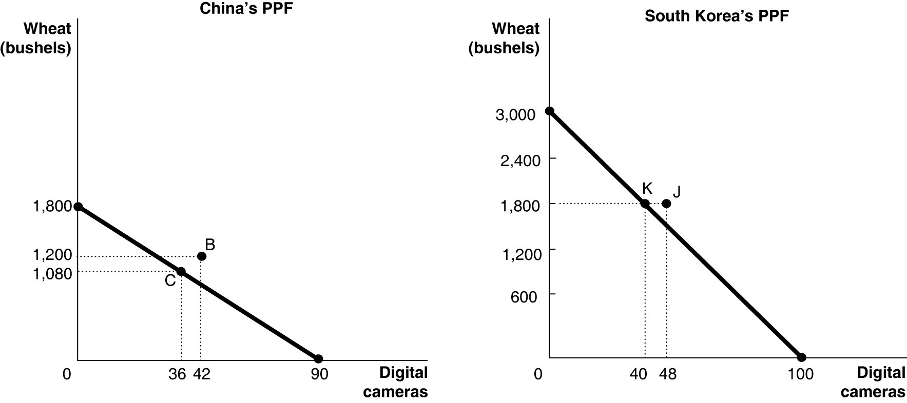
b.

Table 2-13: Production and Consumption with no Trade
 | Digital Camera Output | Wheat Output (bushels)
China | 36 | 1,080
South Korea | 40 | 1,800
Total | 76 | 2,880

c. See graph in part (a)
d. China should specialize in producing digital cameras because it has a lower opportunity cost of 20 bushels of wheat as opposed to South Korea's 30 bushels of wheat. South Korea should specialize in producing wheat because it has a lower opportunity cost of 0.03 units of a digital camera as opposed to China's 0.05 units of a digital camera.
e.

Table 2-14: Output with Specialization
 | Digital Camera Output | Wheat Output (bushels)
China | 90 | 0
South Korea | 0 | 3,000
Total | 90 | 3,000

f. Yes, digital camera output increased by 14 units (from 76 to 90) and wheat output increased by 120 bushels (from 2,880 to 3,000).
g.
Table 2-15: Consumption with Trade
 | Digital Cameras | Wheat (bushels)
China | 42 | 1,200
South Korea | 48 | 1,800

h. See graph in part (a).
i. Yes, trade has enabled the two countries to consume outside their PPFs.
Diff: 3 Page Ref: 50
Topic: Opportunity Cost
*: Recurring
Learning Outcome: Micro-20: Apply the concepts of opportunity cost, marginal analysis, and present value to make decisions
AACSB: Analytical thinking
Table 2-16
 | One Motorcycle | One Guitar
Ireland | 10 hours | 2.5 hours
Scotland | 9 hours | 2 hours

86) Refer to Table 2-16. This table shows the number of labor hours required to produce a motorcycle and a guitar in Ireland and Scotland.
a. Which country has an absolute advantage in the production of motorcycles?
b. Which country has an absolute advantage in the production of guitars?
c. What is Ireland's opportunity cost of producing one motorcycle?
d. What is Scotland's opportunity cost of producing one motorcycle?
e. What is Ireland's opportunity cost of producing one guitar?
f. What is Scotland's opportunity cost of producing one guitar?
g. If each country specializes in the production of the product in which it has a comparative advantage, which country should produce motorcycles?
h. If each country specializes in the production of the product in which it has a comparative advantage, which country should produce guitars?
Answer:
a. Scotland has an absolute advantage in the production of motorcycles.
b. Scotland has an absolute advantage in the production of guitars.
c. Ireland's opportunity cost of producing one motorcycle is 4 guitars.
d. Scotland's opportunity cost of producing one motorcycle is 4.5 guitars
e. Ireland's opportunity cost of one guitar is 0.25 motorcycles.
f. Scotland's opportunity cost of one guitar is 0.22 motorcycles.
g. Ireland should specialize in producing motorcycles.
h. Scotland should specialize in producing guitars.
Diff: 3 Page Ref: 48-50
Topic: Specialization
*: Recurring
Learning Outcome: Micro-20: Apply the concepts of opportunity cost, marginal analysis, and present value to make decisions
AACSB: Analytical thinking

Table 2-17

 | One Motorcycle | One Guitar
Ireland | 10 hours | 2.5 hours
Scotland | 9 hours | 2 hours

87) Refer to Table 2-17. This table shows the number of labor hours required to produce a motorcycle and a guitar in Ireland and Scotland.
a. Assume each country has a total of 2,700 labor hours to devote to the production of the two goods and draw the production possibilities frontier for each country. Put "Motorcycle" on the horizontal axis and "Guitar" on the vertical axis. Be sure to identify the intercept values on your graphs.
b. Suppose each country allocates 55% of its labor hours to guitar production and 45% to the production of motorcycles. Complete Table 2-18 below to show each country's output of the two products.

Table 2-18: Production and Consumption with no Trade
 | Motorcycle Output | Guitar Output
Ireland
Scotland
Total

c. If the two countries do not trade and consume whatever they produce, identify the current production and consumption point for each country on their respective production possibilities frontiers. Label Ireland's consumption point "I" and Scotland's consumption point "S."
d. Suppose the two countries specialize and trade. Which country should produce motorcycles and which should produce guitars? Explain your answer.
e. Complete Table 2-19 below to show each country's output with specialization.

Table 2-19: Output with Specialization
 | Motorcycle Output | Guitar Output
Ireland
Scotland
Total

f. Did specialization increase the combined output for the two countries without any increase in resources? If so, by how much?
g. Suppose Ireland and Scotland agree to trade so that in exchange for 600 guitars, the exporter of guitars receives 140 motorcycles. Complete Table 2-20 below to show each country's consumption bundle after trade.

Table 2-20: Consumption with Trade
 | Motorcycles | Guitars
Ireland
Scotland

h. Show the consumption points after trade on each country's production possibilities frontier. Label these points "X" for Ireland and "Y" for Scotland.
i. Has trade made the two countries better off? Explain your answer.
Answer:
a.
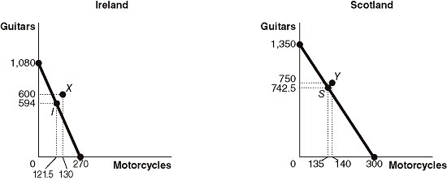

b.
Table 2-18: Production and Consumption with no Trade
 | Motorcycle Output | Guitar Output
Ireland | 121.5 | 594
Scotland | 135 | 742.5
Total | 256.5 | 1,336.5

c. See graph in part (a)
d. Ireland should specialize in producing motorcycles because it has a lower opportunity cost of 4 guitars as opposed to Scotland's 4.5 guitars. Scotland should specialize in producing guitars because it has a lower opportunity cost of 0.22 units of a motorcycle as opposed to Ireland's 0.25 units of a motorcycle.
e.
Table 2-19: Output with Specialization
 | Motorcycle Output | Guitar Output
Ireland | 270 | 0
Scotland | 0 | 1,350
Total | 270 | 1,350

f. Yes, motorcycle output increased by 13.5 units (from 256.5 to 270) and guitar output increased by 13.5 units (from 1,336.5 to 1,350).
g.
Table 2-20: Consumption with Trade
 | Motorcycles | Guitars
Ireland | 130 | 600
Scotland | 140 | 750

h. See graph in part (a).
i. Yes, trade has enabled the two countries to consume outside their PPFs. (Compare Table 2-20 with Table 2-18)
Diff: 3 Page Ref: 50
Topic: Opportunity Cost
*: Recurring
Learning Outcome: Micro-20: Apply the concepts of opportunity cost, marginal analysis, and present value to make decisions
AACSB: Analytical thinking
2.3 The Market System

1) Which of the following is not a factor of production?
A) an acre of farmland
B) a drill press in a machine shop
C) the manager of the local tire shop
D) $1,000 in cash
Answer: D
Diff: 2 Page Ref: 54
Topic: Factors of Production
*: Recurring
Learning Outcome: Micro-3: Discuss different types of market systems and the gains that can be made from trade
AACSB: Analytical thinking

2) Which of the following is a factor of production?
A) an oven in a bakery
B) a share of General Motors' stock
C) a credit card
D) a $500 Treasury bond
Answer: A
Diff: 2 Page Ref: 54
Topic: Factors of Production
*: Recurring
Learning Outcome: Micro-3: Discuss different types of market systems and the gains that can be made from trade
AACSB: Analytical thinking

3) An example of a factor of production for Dell is
A) stock issued by Dell.
B) the computers exported by Dell.
C) corporate bonds sold by Dell.
D) a worker hired by Dell.
Answer: D
Diff: 2 Page Ref: 54
Topic: Factors of Production
*: Recurring
Learning Outcome: Micro-3: Discuss different types of market systems and the gains that can be made from trade
AACSB: Analytical thinking

4) If a commercial dairy farm wants to raise funds to purchase feeding troughs, it does so in the
A) output market.
B) product market.
C) factor market.
D) dairy products market.
Answer: C
Diff: 1 Page Ref: 55
Topic: Markets
*: Recurring
Learning Outcome: Micro-3: Discuss different types of market systems and the gains that can be made from trade
AACSB: Analytical thinking
5) The natural resources used in production are made available in the
A) goods and services market.
B) product market.
C) government market.
D) factor market.
Answer: D
Diff: 1 Page Ref: 55
Topic: Markets
*: Recurring
Learning Outcome: Micro-3: Discuss different types of market systems and the gains that can be made from trade
AACSB: Analytical thinking

6) When you purchase a new pair of jeans you do so in the
A) factor market.
B) input market.
C) product market.
D) resource market.
Answer: C
Diff: 1 Page Ref: 55
Topic: Markets
*: Recurring
Learning Outcome: Micro-3: Discuss different types of market systems and the gains that can be made from trade
AACSB: Analytical thinking

7) The resource income earned by those who supply ________ is called wages.
A) labor
B) capital
C) natural resources
D) entrepreneurship
Answer: A
Diff: 1 Page Ref: 55
Topic: Factors of Production
*: Recurring
Learning Outcome: Micro-3: Discuss different types of market systems and the gains that can be made from trade
AACSB: Analytical thinking

8) Which of the following statements about an entrepreneur is false?
A) An entrepreneur organizes the other factors of production into a working unit.
B) An entrepreneur develops the vision for the firm and funds the producing unit.
C) An entrepreneur sells his entrepreneurial services in the output market.
D) An entrepreneur risks the personal funds provided.
Answer: C
Diff: 2 Page Ref: 55
Topic: Factors of Production
*: Recurring
Learning Outcome: Micro-3: Discuss different types of market systems and the gains that can be made from trade
AACSB: Analytical thinking
9) The ________ demonstrates the roles played by households and firms in the market system.
A) production possibilities frontier
B) circular flow model
C) theory of comparative advantage
D) business cycle
Answer: B
Diff: 2 Page Ref: 56
Topic: The Circular Flow of Income
*: Recurring
Learning Outcome: Micro-3: Discuss different types of market systems and the gains that can be made from trade
AACSB: Analytical thinking

10) Households
A) have no involvement in the circular flow in a market economy.
B) purchase resources in the factor market.
C) sell goods in the product market.
D) sell resources in the factor market.
Answer: D
Diff: 1 Page Ref: 55
Topic: The Circular Flow of Income
*: Recurring
Learning Outcome: Micro-3: Discuss different types of market systems and the gains that can be made from trade
AACSB: Analytical thinking

11) Households ________ final goods and services in the ________ market.
A) purchase; factor
B) purchase; product
C) sell; factor
D) sell; product
Answer: B
Diff: 1 Page Ref: 55
Topic: The Circular Flow of Income
*: Recurring
Learning Outcome: Micro-3: Discuss different types of market systems and the gains that can be made from trade
AACSB: Analytical thinking

12) In the circular flow model, producers
A) sell goods and services in the input market.
B) and households spend earnings from resource sales on goods and services in the factor market.
C) hire resources sold by households in the factor market.
D) spend earnings from resource sales on goods and services in the product market.
Answer: C
Diff: 1 Page Ref: 55
Topic: The Circular Flow of Income
*: Recurring
Learning Outcome: Micro-20: Apply the concepts of opportunity cost, marginal analysis, and present value to make decisions
AACSB: Analytical thinking
13) Which of the following is a flow in the circular flow model?
A) the flow of goods and services from households to firms
B) the flow of profit and the flow of revenue
C) the flow of income earned by firms and the flow of expenditures earned by households
D) the flow of revenue received by firms and the flow of payments to resource owners
Answer: D
Diff: 2 Page Ref: 56
Topic: The Circular Flow of Income
*: Recurring
Learning Outcome: Micro-3: Discuss different types of market systems and the gains that can be made from trade
AACSB: Analytical thinking

Figure 2-11

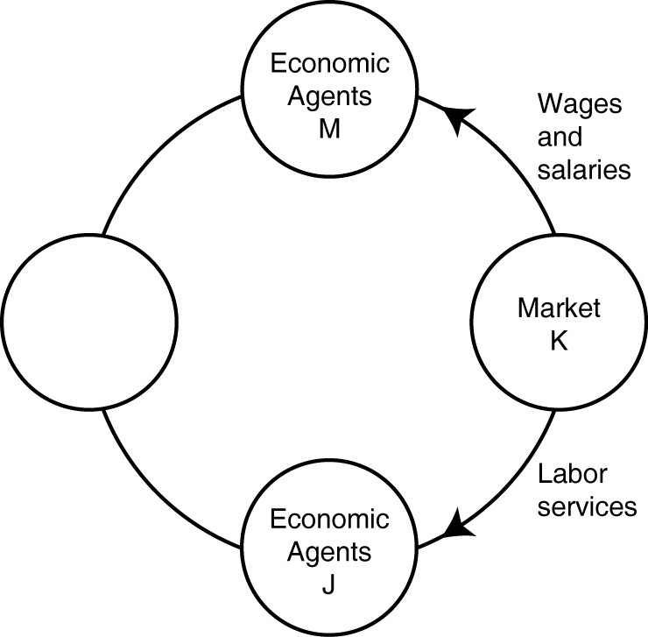

14) Refer to Figure 2-11. One segment of the circular flow diagram in the figure shows the flow of labor services from market K to economic agents J. What is market K and who are economic agents J?
A) K = factor markets; J = households
B) K = product markets; J = households
C) K = factor markets; J = firms
D) K = product markets; J = firms
Answer: C
Diff: 2 Page Ref: 55
Topic: The Circular Flow of Income
*: Recurring
Learning Outcome: Micro-2: Interpret and analyze information presented in different types of graphs
AACSB: Analytical thinking
15) Refer to Figure 2-11. One segment of the circular flow diagram in the figure shows the flow of wages and salaries from market K to economic agents M. What is market K and who are economic agents M?
A) K = factor markets; M = households
B) K = product markets; M = households
C) K = factor markets; M = firms
D) K = product markets; M = firms
Answer: A
Diff: 2 Page Ref: 55
Topic: The Circular Flow of Income
*: Recurring
Learning Outcome: Micro-2: Interpret and analyze information presented in different types of graphs
AACSB: Analytical thinking

16) Which of the following are separate flows in the circular flow model?
A) the flow of goods and the flow of services
B) the flow of costs and the flow of revenue
C) the flow of income earned from the sale of resources and the flow of expenditures on goods and services
D) the flow of income received by households and the flow of tax revenues paid by households
Answer: C
Diff: 2 Page Ref: 55
Topic: The Circular Flow of Income
*: Recurring
Learning Outcome: Micro-3: Discuss different types of market systems and the gains that can be made from trade
AACSB: Analytical thinking

17) Which of the following statements about a circular flow model is false?
A) Producers are buyers in the factor market and sellers in the product market.
B) Households are neither buyers nor sellers in the input market.
C) Producers are buyers in the factor market.
D) Households are buyers in the product market.
Answer: B
Diff: 2 Page Ref: 55
Topic: The Circular Flow of Income
*: Recurring
Learning Outcome: Micro-3: Discuss different types of market systems and the gains that can be made from trade
AACSB: Analytical thinking
Figure 2-12

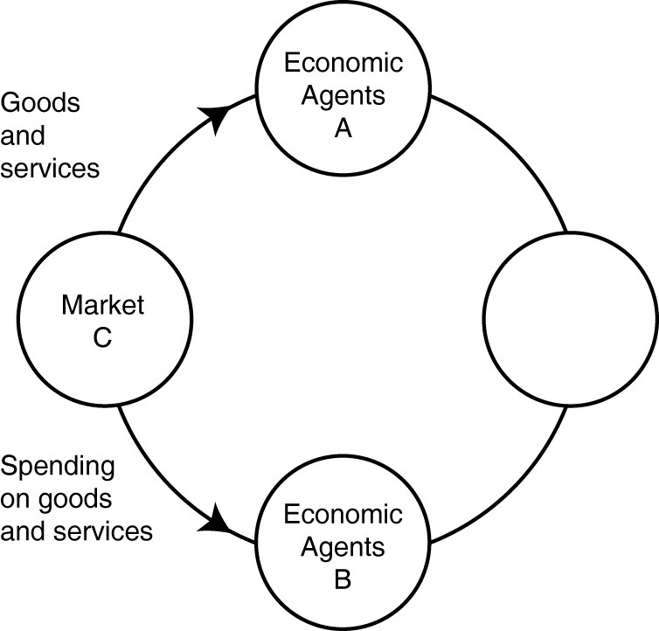

18) Refer to Figure 2-12. One segment of the circular flow diagram in the figure shows the flow of goods and services from market C to economic agents A. What is market C and who are economic agents A?
A) C = factor markets; A = households
B) C = product markets; A = households
C) C = factor markets; A = firms
D) C= product markets; A = firms
Answer: B
Diff: 2 Page Ref: 55
Topic: The Circular Flow of Income
*: Recurring
Learning Outcome: Micro-2: Interpret and analyze information presented in different types of graphs
AACSB: Analytical thinking
Figure 2-13

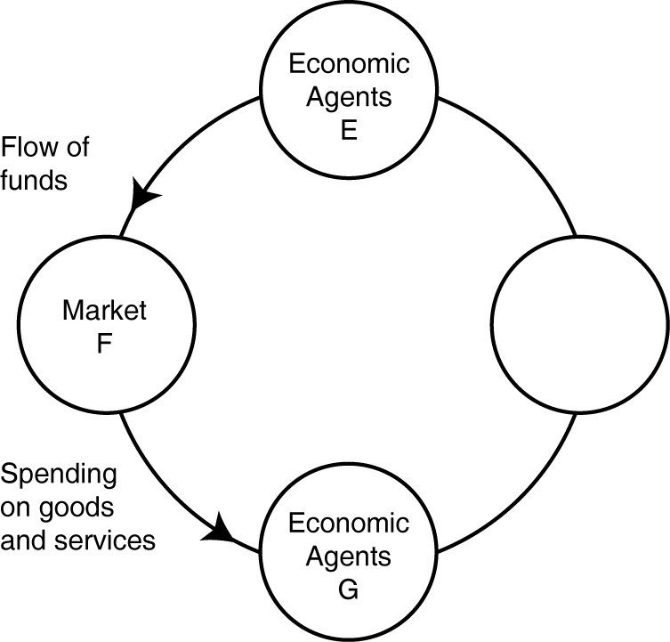

19) Refer to Figure 2-13. One segment of the circular flow diagram in the figure shows the flow of funds from economic agents E to market F. Who are economic agents E and what is market F?
A) E = households; F = product markets
B) E = firms; F = product markets
C) E = households; F = factor markets
D) none of the above
Answer: A
Diff: 2 Page Ref: 55
Topic: The Circular Flow of Income
*: Recurring
Learning Outcome: Micro-3: Discuss different types of market systems and the gains that can be made from trade
AACSB: Analytical thinking

20) All of the following are examples of spending on factors of production in the circular flow model except
A) Bima hires two students to work at his ice-cream store.
B) "Get Fit Together" purchases 3 new treadmills for its gym.
C) Iris buys a dozen roses for her mother's birthday.
D) The Banyan Tree rents a much larger property so that it can add a restaurant to its facilities.
Answer: C
Diff: 2 Page Ref: 55
Topic: The Circular Flow of Income
*: Recurring
Learning Outcome: Micro-3: Discuss different types of market systems and the gains that can be made from trade
AACSB: Analytical thinking

21) Which of the following is an example of spending on factors of production in the circular flow model?
A) Carolina has her nails done before her 20th high school class reunion.
B) Giorgio buys snow cones for his youth soccer team after each game.
C) Stevie trades in his old cell phone for a newer model.
D) Arlisha purchases a cotton candy machine for her concession stand at the state fair.
Answer: D
Diff: 2 Page Ref: 56
Topic: The Circular Flow of Income
*: Recurring
Learning Outcome: Micro-3: Discuss different types of market systems and the gains that can be made from trade
AACSB: Analytical thinking

22) Which of the following is an example of spending on goods and services in the circular flow model?
A) Belinda purchases a new computer for her tax-preparation business.
B) Javier buys 800 square feet of wood flooring for his vacation home.
C) Celeste buys fresh herbs at the farmers' market to use in her restaurant.
D) Timmy purchases a new examination table for use in his veterinary clinic.
Answer: B
Diff: 2 Page Ref: 56
Topic: The Circular Flow of Income
*: Recurring
Learning Outcome: Micro-3: Discuss different types of market systems and the gains that can be made from trade
AACSB: Analytical thinking

23) "An Inquiry into the Nature and Causes of the Wealth of Nations" published in 1776 was written by
A) John Maynard Keynes.
B) Karl Marx.
C) Alfred Marshall.
D) Adam Smith.
Answer: D
Diff: 1 Page Ref: 56
Topic: Markets
*: Recurring
Learning Outcome: Micro-1: Identify the basic principles of economics and explain how to think like an economist
Figure 2-14

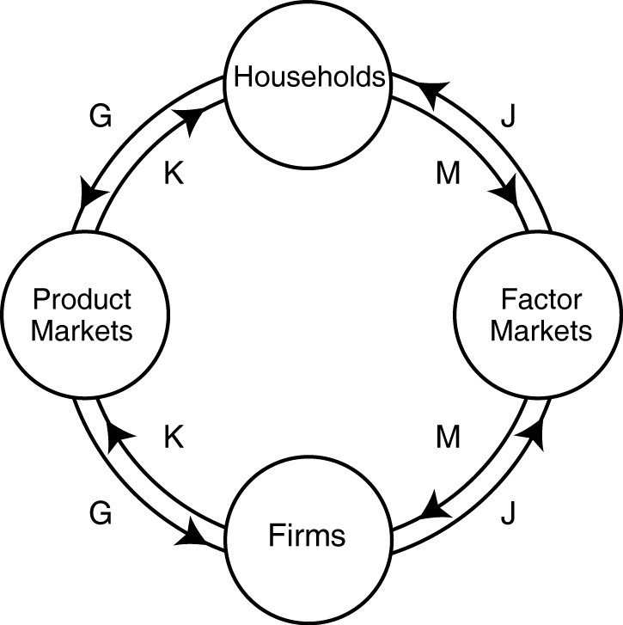

24) Refer to Figure 2-14. Identify the two arrows in the diagram that depict the following transaction: LaDonna sells 20 pairs of sunglasses at the Oakley store.
A) J and M
B) J and G
C) K and M
D) K and G
Answer: D
Diff: 2 Page Ref: 55
Topic: The Circular Flow of Income
*: Recurring
Learning Outcome: Micro-2: Interpret and analyze information presented in different types of graphs
AACSB: Analytical thinking

25) Refer to Figure 2-14. Identify the two arrows in the diagram that depict the following transaction: Dorian Gray hires "Wild Oscar," a professional portrait artist, to paint his picture.
A) J and M
B) K and G
C) K and M
D) J and G
Answer: B
Diff: 2 Page Ref: 55
Topic: The Circular Flow of Income
*: Recurring
Learning Outcome: Micro-2: Interpret and analyze information presented in different types of graphs
AACSB: Analytical thinking
26) Refer to Figure 2-14. Identify the two arrows in the diagram that depict the following transaction: Barney earns $250 for selling scissors and razors to Floyd's Barber Shop.
A) J and M
B) K and G
C) K and M
D) J and G
Answer: A
Diff: 2 Page Ref: 55
Topic: The Circular Flow of Income
*: Recurring
Learning Outcome: Micro-2: Interpret and analyze information presented in different types of graphs
AACSB: Analytical thinking

27) Refer to Figure 2-14. Identify the two arrows in the diagram that depict the following transaction: Myrna earns $450 for working at HempHill's Drug Store.
A) J and M
B) K and G
C) K and M
D) J and G
Answer: A
Diff: 2 Page Ref: 55
Topic: The Circular Flow of Income
*: Recurring
Learning Outcome: Micro-2: Interpret and analyze information presented in different types of graphs
AACSB: Analytical thinking

28) Adam Smith's behavioral assumption about humans was that people
A) typically act irrationally.
B) usually act in a rational, self-interested way.
C) are consistently greedy.
D) typically act randomly.
Answer: B
Diff: 1 Page Ref: 56
Topic: Markets
*: Recurring
Learning Outcome: Micro-1: Identify the basic principles of economics and explain how to think like an economist
AACSB: Analytical thinking

29) All of the following countries come close to the free market benchmark except
A) Canada.
B) North Korea.
C) Germany.
D) Singapore.
Answer: B
Diff: 1 Page Ref: 57
Topic: Markets
*: Recurring
Learning Outcome: Micro-3: Discuss different types of market systems and the gains that can be made from trade
AACSB: Analytical thinking
30) Adam Smith's invisible hand refers to
A) the government's unobtrusive role in ensuring that the economy functions efficiently.
B) property ownership laws and the rule of the court system.
C) the process by which individuals acting in their own self-interest bring about a market outcome that benefits society as a whole.
D) the laws of nature that influence economics decisions.
Answer: C
Diff: 2 Page Ref: 57
Topic: Markets
*: Recurring
Learning Outcome: Micro-1: Identify the basic principles of economics and explain how to think like an economist
AACSB: Analytical thinking

31) All of the following are critical functions of the government in facilitating the operation of a market economy except
A) protecting private property.
B) enforcing property rights.
C) ensuring an equal distribution of income to all citizens.
D) enforcing contracts.
Answer: C
Diff: 2 Page Ref: 59-61
Topic: Markets
*: Recurring
Learning Outcome: Micro-3: Discuss different types of market systems and the gains that can be made from trade
AACSB: Analytical thinking

32) The term "property rights" refers to
A) the physical possession of a house or any other property which the owner legally purchased.
B) the ability to exercise control over one's own resources within the confines of the law.
C) the government's right to appropriate land from wealthy land owners to redistribute to peasants.
D) the right of a business not to have its assets confiscated by the government in the event that the business is accused of committing fraud.
Answer: B
Diff: 2 Page Ref: 61
Topic: Property Rights
*: Recurring
Learning Outcome: Micro-3: Discuss different types of market systems and the gains that can be made from trade
AACSB: Analytical thinking
33) The primary purpose of ________ is to encourage the expenditure of funds on research and development to create new products.
A) centrally planned economies
B) government-run health care
C) nationalizing oil companies
D) patents and copyrights
Answer: D
Diff: 1 Page Ref: 61
Topic: Property Rights
*: Recurring
Learning Outcome: Micro-3: Discuss different types of market systems and the gains that can be made from trade
AACSB: Analytical thinking

34) A major factor contributing to the slow growth rate of less-developed economies is
A) the lack of well-defined and enforceable property rights.
B) the lack of natural resources.
C) the lack of workers.
D) the high rate of illiteracy.
Answer: A
Diff: 2 Page Ref: 61
Topic: Property Rights
*: Recurring
Learning Outcome: Micro-3: Discuss different types of market systems and the gains that can be made from trade
AACSB: Analytical thinking

35) A successful market economy requires
A) a government-controlled banking system and government price controls.
B) well-defined property rights and an independent court system to adjudicate disputes based on the law.
C) generous unemployment benefits and paid medical leave for everyone in the labor force.
D) an equitable distribution of income and limits on immigration.
Answer: B
Diff: 1 Page Ref: 61
Topic: Property Rights
*: Recurring
Learning Outcome: Micro-3: Discuss different types of market systems and the gains that can be made from trade
AACSB: Analytical thinking
36) Consider the following items:
a. the novel "A Gentleman in Moscow" by Amor Towles
b. the "The Spirited Shipper," an innovative wine shipping box
c. a Swiss chef's award-winning recipe
d. an original fabric design, for example, the fabric used for "Coach" bags and luggage

Which of the items listed is an example of intellectual property?
A) a and b only
B) a, b, and c
C) a and d only
D) all of the items listed
Answer: D
Diff: 2 Page Ref: 61
Topic: Property Rights
*: Recurring
Learning Outcome: Micro-3: Discuss different types of market systems and the gains that can be made from trade
AACSB: Analytical thinking

37) Consider the following items:
a. the album "Divide" by Ed Sheeran
b. a Dutch horticulturalist's new method for cultivating hybrid tulips
c. Rolls Royce's "Spirit of Ecstasy" hood ornament design
d. the fine china department at a Macy's department store

Which of the items listed is an example of intellectual property?
A) a and b only
B) a, b, and c
C) a and d only
D) all of the items listed
Answer: B
Diff: 2 Page Ref: 61
Topic: Property Rights
*: Recurring
Learning Outcome: Micro-3: Discuss different types of market systems and the gains that can be made from trade
AACSB: Analytical thinking

38) An organization of producers that limits the amount of a good produced is known as a
A) free market organization.
B) guild.
C) collective.
D) co-op.
Answer: B
Diff: 1 Page Ref: 56
Topic: Markets
*: Recurring
Learning Outcome: Micro-3: Discuss different types of market systems and the gains that can be made from trade
AACSB: Analytical thinking
39) In 18th century Europe, governments gave guilds legal authority to limit production of goods. How did this authority either obstruct or improve the market mechanism?
A) It improved the market mechanism by making it more efficient because the guilds were able to quickly identify and rectify any market shortages and surpluses.
B) It improved the market mechanism because the government's actions provided the correct set of signals to the market so that producers can adjust their output to better meet the needs of consumers.
C) It obstructed the market mechanism because the guild's actions prevented the forces of demand and supply from coordinating the self-interested decisions of producers and consumers.
D) It obstructed the market mechanism because with one more party having to coordinate activities (the guilds) there were delays in getting the products to consumers.
Answer: C
Diff: 2 Page Ref: 56
Topic: Markets
*: Recurring
Learning Outcome: Micro-3: Discuss different types of market systems and the gains that can be made from trade
AACSB: Analytical thinking

40) Stricter laws and regulations to protect intellectual property rights
A) will help to create a more successful market system.
B) will only benefit those companies whose intellectual property rights have in the past been ignored.
C) will tend to have little impact on an economy since intellectual property is not tangible.
D) will create a stronger and more successful black market for intellectual property.
Answer: A
Diff: 1 Page Ref: 61
Topic: Property Rights
*: Recurring
Learning Outcome: Micro-5: List ways in which governments intervene in markets and explain the consequences of such intervention
AACSB: Analytical thinking

41) If a nation changes its laws to more actively enforce intellectual property rights, all of the following will most likely take place except
A) more software companies will choose to export their products to that country.
B) more film makers will choose to do business in that country.
C) the black market for intellectual property will become more prosperous in that country.
D) foreign investment in that country will increase.
Answer: C
Diff: 2 Page Ref: 61
Topic: Property Rights
*: Recurring
Learning Outcome: Micro-5: List ways in which governments intervene in markets and explain the consequences of such intervention
AACSB: Analytical thinking

42) Which of the following is a factor of production?
A) a necklace produced by a jewelry manufacturer
B) 50 shares of Google stock
C) the security guard at the local bank
D) $1,000 in casino chips
Answer: C
Diff: 2 Page Ref: 54
Topic: Factors of Production
*: Recurring
Learning Outcome: Micro-3: Discuss different types of market systems and the gains that can be made from trade
AACSB: Analytical thinking

43) An example of a factor of production is
A) a bottle of wine produced by a vineyard.
B) a vintner hired by a vineyard.
C) a loan granted to a vineyard.
D) the wine exported by a vineyard.
Answer: B
Diff: 2 Page Ref: 54
Topic: Factors of Production
*: Recurring
Learning Outcome: Micro-3: Discuss different types of market systems and the gains that can be made from trade
AACSB: Analytical thinking

44) If a brewery wants to raise funds to purchase a new fermenting vat, it does so in the
A) factor market.
B) output market.
C) product market.
D) alcoholic beverages market.
Answer: A
Diff: 2 Page Ref: 54
Topic: Markets
*: Recurring
Learning Outcome: Micro-3: Discuss different types of market systems and the gains that can be made from trade
AACSB: Analytical thinking

45) When you purchase a new set of spurs you do so in the
A) resource market.
B) product market.
C) input market.
D) factor market.
Answer: B
Diff: 1 Page Ref: 54
Topic: Markets
*: Recurring
Learning Outcome: Micro-3: Discuss different types of market systems and the gains that can be made from trade
AACSB: Analytical thinking
46) Which of the following is an example of spending on factors of production in the circular flow model?
A) Orson buys a package of beef jerky at a convenience store.
B) Bernadette gets a manicure and pedicure before attending her parents' anniversary party.
C) Landon pays $100 for a season pass to a water park.
D) The "Suds Bucket" car wash buys new squeegees for all its employees.
Answer: D
Diff: 2 Page Ref: 55
Topic: The Circular Flow of Income
*: Recurring
Learning Outcome: Micro-3: Discuss different types of market systems and the gains that can be made from trade
AACSB: Analytical thinking

47) All of the following are examples of spending on goods and services in the circular flow model except
A) Giovani buys a new cell phone to replace the one he flushed down the toilet.
B) Amir buys a new humidor for his cigar shop.
C) Isabella buys the sushi plate for lunch at the Turning Japanese Sushi Bar.
D) Vijay buys a new minivan for his family's cross-country vacation.
Answer: B
Diff: 2 Page Ref: 55
Topic: The Circular Flow of Income
*: Recurring
Learning Outcome: Micro-3: Discuss different types of market systems and the gains that can be made from trade
AACSB: Analytical thinking
Article Summary
Two U.S. Senators have introduced a bipartisan bill to strengthen patent protection in the United States. The STRONGER Patents Act, designed to improve the patent system, includes provisions which would permit injunctions to protect patent owners against infringement both during and after court cases and guarantee fairness in administrative proceedings by limiting repetitive and harassing challenges against inventors. Changes over the last decade have lessened some U.S. patent rights, while countries such as China and Germany have moved to strengthen their own patent protections. In 2016, the United States fell to 10th place in the U.S. Chamber of Commerce's international ranking of patent system strength.
Source: Brian Pomper, "Senators Coons and Cotton Introduce STRONGER Patents Act of 2017," ipwatchdog.com, June 21, 2017.

48) Refer to the Article Summary. If the STRONGER patents Act of 2017 becomes law, all of the following would most likely occur except
A) companies would increase investment in the development of more innovative products.
B) innovating companies would consider expanding their research and development departments.
C) more patents would be issued to innovators and inventors.
D) fewer dollars would be spent on the development of new technology.
Answer: D
Diff: 2 Page Ref: 61
Topic: Property Rights
Learning Outcome: Micro-5: List ways in which governments intervene in markets and explain the consequences of such intervention
AACSB: Analytical thinking
Special Feature: Apply the Concept: Senators Coons and Cotton Introduce STRONGER Patents Act of 2017

49) When Feeding America changed its food allocation system to one that resembled a market, each food program was given a number of "shares" that they could use in bidding against other food programs for the types of food that best met the needs of the people using their programs. Using these "shares" helped answer which of the following fundamental economic questions?
A) What goods and services will be produced?
B) How will the goods and services be produced?
C) Who will receive the goods and services produced?
D) When will the goods and services be produced?
Answer: C
Diff: 2 Page Ref: 62-63
Topic: Property Rights
Learning Outcome: Micro-1: Identify the basic principles of economics and explain how to think like an economist
AACSB: Analytical thinking
Special Feature: Apply the Concept: Managers at Feeding America Use the Market Mechanism to Reduce Hunger

50) The payment received by suppliers of entrepreneurial skills is called interest.
Answer: FALSE
Diff: 1 Page Ref: 54
Topic: Factors of Production
*: Recurring
Learning Outcome: Micro-3: Discuss different types of market systems and the gains that can be made from trade
AACSB: Analytical thinking
51) In the circular flow model, households supply resources such as labor services in the factor market.
Answer: TRUE
Diff: 1 Page Ref: 55
Topic: The Circular Flow of Income
*: Recurring
Learning Outcome: Micro-3: Discuss different types of market systems and the gains that can be made from trade
AACSB: Analytical thinking

52) Entrepreneurs bring together the factors of production to produce goods and services.
Answer: TRUE
Diff: 1 Page Ref: 54
Topic: Factors of Production
*: Recurring
Learning Outcome: Micro-3: Discuss different types of market systems and the gains that can be made from trade
AACSB: Analytical thinking

53) In a free market there are virtually no restrictions, or at best few restrictions, on how factors of production can be employed.
Answer: TRUE
Diff: 1 Page Ref: 55
Topic: Markets
*: Recurring
Learning Outcome: Micro-3: Discuss different types of market systems and the gains that can be made from trade
AACSB: Analytical thinking

54) Crude oil is not an example of a factor of production, but when crude oil is processed into gasoline, it is a factor of production.
Answer: FALSE
Diff: 2 Page Ref: 54
Topic: Factors of Production
*: Recurring
Learning Outcome: Micro-3: Discuss different types of market systems and the gains that can be made from trade
AACSB: Analytical thinking

55) Each person goes about her daily business seeking to maximize her own self interests. In doing so, she contributes to the welfare of society at large. This is the idea underlying Adam Smith's "invisible hand."
Answer: TRUE
Diff: 2 Page Ref: 57
Topic: Markets
*: Recurring
Learning Outcome: Micro-3: Discuss different types of market systems and the gains that can be made from trade
AACSB: Analytical thinking
56) The payment received by suppliers of entrepreneurial skills is called wages.
Answer: FALSE
Diff: 1 Page Ref: 54
Topic: Factors of Production
*: Recurring
Learning Outcome: Micro-3: Discuss different types of market systems and the gains that can be made from trade
AACSB: Analytical thinking

57) In the circular flow model, households demand resources such as labor services in the factor market.
Answer: FALSE
Diff: 2 Page Ref: 55
Topic: The Circular Flow of Income
*: Recurring
Learning Outcome: Micro-3: Discuss different types of market systems and the gains that can be made from trade
AACSB: Analytical thinking

58) In economics, the term "free market" refers to a market where products are traded but not sold.
Answer: FALSE
Diff: 1 Page Ref: 56
Topic: Markets
*: Recurring
Learning Outcome: Micro-3: Discuss different types of market systems and the gains that can be made from trade
AACSB: Analytical thinking

59) In a free market there are significant restrictions on how a good or service can be produced or sold.
Answer: FALSE
Diff: 1 Page Ref: 56
Topic: Markets
*: Recurring
Learning Outcome: Micro-3: Discuss different types of market systems and the gains that can be made from trade
AACSB: Analytical thinking

60) A bed of oysters is not an example of a factor of production but the shucked oysters used to make oyster stew are a factor of production.
Answer: FALSE
Diff: 2 Page Ref: 55
Topic: Factors of Production
*: Recurring
Learning Outcome: Micro-3: Discuss different types of market systems and the gains that can be made from trade
AACSB: Analytical thinking
61) What is the difference between product markets and factor markets?
Answer: Product markets are markets for goods and services. Factor markets are markets for the factors of production, which are the inputs used to make goods and services.
Diff: 1 Page Ref: 54
Topic: Markets
*: Recurring
Learning Outcome: Micro-3: Discuss different types of market systems and the gains that can be made from trade
AACSB: Analytical thinking

62) How do firms and households interact in markets?
Answer: Firms supply goods and services to households, and buy factors of production from households. Households supply factors of production to firms, and buy goods and services from firms.
Diff: 1 Page Ref: 55
Topic: The Circular Flow of Income
*: Recurring
Learning Outcome: Micro-3: Discuss different types of market systems and the gains that can be made from trade
AACSB: Analytical thinking

63) What is meant by the term "free market"?
Answer: A free market is a market with few government restrictions on how a good or service can be produced or sold or on how factors of production can be employed.
Diff: 1 Page Ref: 56
Topic: Markets
*: Recurring
Learning Outcome: Micro-3: Discuss different types of market systems and the gains that can be made from trade
AACSB: Analytical thinking

64) What is a circular flow diagram and what does it demonstrate?
Answer: A circular flow diagram is a model that illustrates how participants in markets are linked. It shows who supplies and purchases factors of production and who supplies and purchases goods and services.
Diff: 2 Page Ref: 55
Topic: The Circular Flow of Income
*: Recurring
Learning Outcome: Micro-3: Discuss different types of market systems and the gains that can be made from trade
AACSB: Analytical thinking

65) What is an entrepreneur?
Answer: An entrepreneur is someone who operates a business, bringing together the factors of production to produce goods and services.
Diff: 2 Page Ref: 59
Topic: Elasticity and Economic Issues
*: Recurring
Learning Outcome: Micro-3: Discuss different types of market systems and the gains that can be made from trade
AACSB: Analytical thinking
66) Identify whether each of the following transactions will take place in the factor market or in the product market.
a. Graciela buys a Tesla Motors Model X.
b. Lashan works 60 hours a week at a law firm.
c. Tito sells his family's farmland to a housing developer.
d. Tesla Motors increases employment at its Fremont, California plant.
Answer:
a takes place in the product market.
b, c, and d take place in the factor market.
Diff: 2 Page Ref: 54
Topic: Markets
*: Recurring
Learning Outcome: Micro-3: Discuss different types of market systems and the gains that can be made from trade
AACSB: Analytical thinking

