**Chapter 2: The Study of Learning and Behavior**

Multiple Choice

1. The person who suggested that to learn how nature works, we must “sit down before fact as a little child,” and “be prepared to give up every preconceived notion” was ______.

a. Charles Darwin

b. T. H. Huxley

c. E. L. Thorndike

d. John B. Watson

Ans: B Ref: 34

2. Harry teaches an advanced painting class. His goal is to teach students to paint more creatively. Harry will probably measure learning as a change in response _________.

a. topography

b. intensity

c. speed

d. rate

Ans: A Ref: 37

3. Marjorie drives a school bus. Sometimes the kids get rather noisy. She decides to play music the kids like through speakers on the bus, but whenever the kids get too noisy she turns the music off. When they quiet down, she turns the music back on. In this way, she hopes to get the kids to make less noise. Marjorie is probably going to measure learning as a change in response _________.

a. topography

b. intensity

c. speed

d. rate

Ans: B Ref: 37

4. The figure below shows learning as a change in ___________.

a. intensity

b. frequency

c. topography

d. redundancy

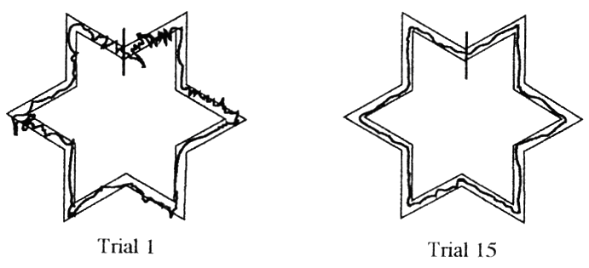

Ans: C Ref: 38 Note: Another possible answer is a change in the number of errors, but that option is not given.

5. The figure below shows learning as a change in __________.

a. intensity

b. frequency

c. topography

d. speed

Ans: A Ref: 38

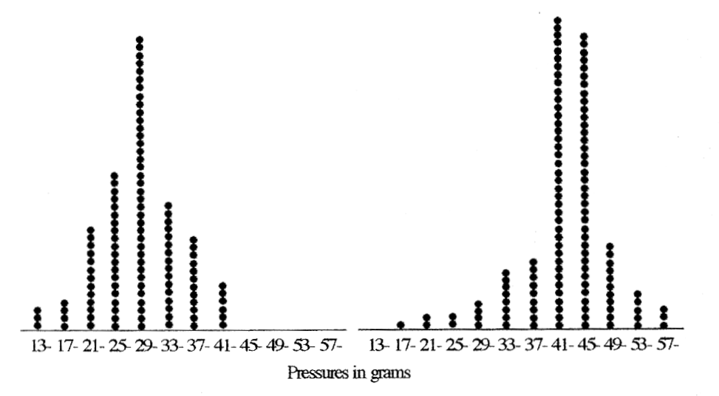

6. In a cumulative record, learning is indicated by a change in response _______.

a. topography

b. amplitude

c. speed

d. rate

Ans: D Ref:40

7. A teacher who looks for an increase in the number of correct performances per minute is using _______ as a measure of learning.

a. topography

b. speed

c. rate

d. fluency

Ans: D Ref: 41

8. In the cumulative record below, the rate of behavior is ________.

a. increasing

b. decreasing

c. stable

d. fluctuating wildly

Ans: B Ref: 41

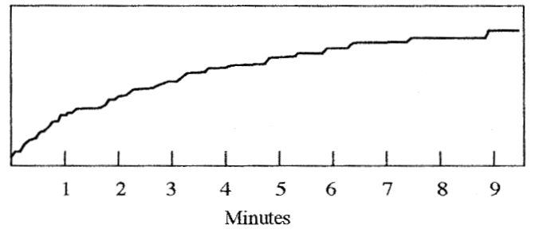

9. A person who says, “Everyone knows that....” is referring to _______.

a. anecdotal evidence

b. case study evidence

c. descriptive research evidence

d. experimental research evidence

Ans: A Ref: 42

10. The figure below shows the results of an experiment comparing the effects of two teaching methods. Phyllis was taught by method A; Gertrude was taught by method B. This study is an example of _______.

a. a between-subjects design

b. a within-subject design

c. random assignment

d. yoked control

Ans: A Ref:44

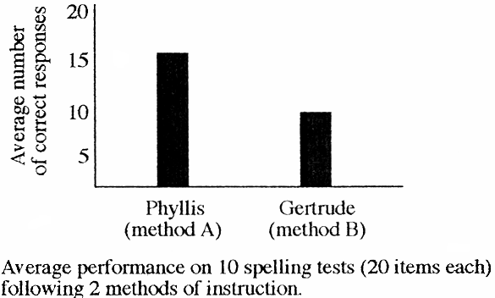

11. Any variable an experimenter manipulates is a(n) ________ variable.

a. autonomous

b. dependent

c. independent

d. synchronous

Ans: C Ref: 44

12. Any variable that is allowed to vary freely is a(n) __________ variable.

a. autonomous

b. dependent

c. independent

d. synchronous

Ans: B Ref: 44

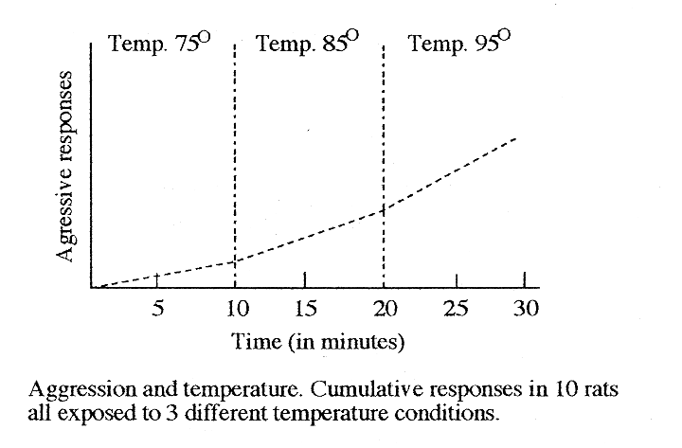13. The figure below shows the results of an experiment on the effects of heat on aggressive social behavior. Each rat experienced three temperatures. There was a sharp increase in the rate of aggressive behavior in all rats when the temperature went above 90. This study is best described as ________.

a. a between-subjects experiment

b. a within-subject experiment

c. a case study

d. anecdotal evidence

Ans: B Ref: 46

Note: The above item is likely to lead to debate since the data presented are group data. However, data can be presented in any number of ways, but this does not change the research procedures taken. In this case the researcher exposed each rat to the same conditions. The graph merely shows the average effects of these three conditions. Other data graphs could compare the rate of aggression in individual rats under the different conditions.

14. The kind of experiment that is most likely to require statistical analysis is a(n) _______.

a. between-subjects experiment

b. within-subject experiment

c. ABA experiment

d. descriptive study

Ans: A Ref: 46

15. In within-subject experiments, each subject's performance is compared with his or her performance during a ______.

a. control period

b. random sampling period

c. baseline period

d. benchmark session

Ans: C Ref: 46

16. In group-design experiments, researchers often use _________ to reduce differences among participants.

a. clones

b. statistics

c. DNA matching

d. matched sampling

Ans: D Ref: 46

17. The kind of study that is most likely to involve a large number of subjects is one with a ________.

a. between-subjects design

b. within-subject design

c. ABA design

d. matched sample

Ans: A Ref: 46

18. Using an ABA reversal design is rather like using a ______.

a. dust mop

b. fountain pen

c. light switch

d. barber’s chair

Ans: C Ref: 47

19. The first person to use a single-subject reversal design was probably ____________.

a. Aardvark

b. Darwin

c. Galen

d. Malthus

Ans: C Ref: 48 (marginal note)

20. Experiments done in natural settings are called _______.

a. natural experiments

b. spontaneous experiments

c. unplanned experiments

d. field experiments

Ans: D Ref: 49

21. Experimental research on behavior is often said to be artificial. To compensate for this problem, researchers do ________ .

a. field experiments

b. open-ended research

c. follow-up studies

d. free sampling research

Ans: A Ref: 49

22. An ­­­­_____________ is something an organism tries to escape or avoid.

a. adenoid

b. adhesive

c. adversive

d. aversive

Ans: D Ref: 52

23. One problem with computer simulations as a substitute for animal research is that ___________.

a. they are terribly expensive

b. they take years to develop

c. “bugs” in the software distort the findings

d. no one knows what behavior to program until the research has been done

Ans: D Ref: 52

24. Balster suggests that inhumane treatment of research animals is __________.

a. not good PR

b. expensive, in the long run

c. bad science

d. likely to result in litigation

Ans: C Ref: 52

25. A computer simulation that is useful for teaching certain principles of learning is called _________.

a. MacAnimal

b. Animal Trainer

c. Sniffy the Virtual Rat

d. Howard the Holographic Hog

Ans: C Ref: 52

26. One highly readable little book on research methods mentioned in your text is called _________.

a. The Idiot’s Guide to Behavioral Research

b. Research Made Simple

c. Psychological Research: An Introduction

d. Random Designs

Ans: C Ref: 53

Note: Items of this sort are included to induce students to at least scan the recommended readings list.

True/False

27. The natural science approach assumes that things are caused only by natural events. T (35)

28. *Speed* and *rate* are different terms for the same measure of learning. F (39)

29. A cumulative record shows the total number of responses that have occurred in a given period of time as well as the rate at which they occurred. T (40)

30. B. F. Skinner was the first person to record data cumulatively. F (41)

31. Research results with humans usually parallel those with animals. T (50)

Completion

32. A change in the form that behavior takes is called a change in ________.

Ans: topography (37)

33. Response _______ refers to the time that passes before a response occurs. Ans: latency (39)

34. Your text describes four basic sources of evidence: anecdotal, case study, descriptive study, experimental study. The least reliable of these is ______. Ans: anecdotal (42)

35. A flat cumulative record indicates that the behavior is ________. Ans: not occurring (40)

36. One thing researchers can control better with animal subjects than with human subjects is _________. Ans: genetic history/environmental history/learning experiences (49)

Short Essay

37. Discuss the various ways of measuring learning. (37-41)

*Answers should name and describe topography, errors, intensity, speed, latency, rate, and perhaps fluency.*

38. Explain how a cumulative recorder works. (40)

*An inked pen leaves a line on a moving sheet of paper. Each response causes the pen to move at right angles to the direction of the paper, so that the rate of responding is reflected in the slope of the line. Some students might mention that today’s cumulative recorders are software programs running on computers.*

39. Explain the difference between within-subject and between-subjects experiments. (44-48)

*In between-subjects experiments, two or more groups of subjects perform under different conditions and the performance of the groups is compared. In within-subject experiments, each subject performs under different conditions; the performance of a subject in one condition is compared with the performance of that subject in another condition.*

40. Explain why random assignment of subjects is unnecessary in ABA experiments. (46-47)

*Random assignment is meant to control for inter-subject variability. In ABA designs, each subject is compared against himself or herself, so inter-subject variability is eliminated as a source of differences in data.*

41. Discuss the ethics of using animals for research on learning. (51-52)

*Answers may note that some people argue that humans have no more right to use animals for research than animals have to use humans. This argument implies that it is wrong to use animals for farm work, for entertainment, and even for household pets. If those uses are allowed, why not research? Another argument says that animal research is unethical because computer simulations render it unnecessary. But computers can be programmed to simulate behavior only after we know how the organism behaves.*