Part Two

Solutions to
End-of-Chapter Problems

Chapter 3
Understanding Financial Statements

3-1. To find net income, we must subtract all relevant expenses from revenues: cost of goods sold, operating expenses, interest expense, and taxes. Following the template from Checkpoint 3.1, we find the following for GMT Transport Company.

GMT Transport Company was able to generate $1,105,000 in net income from its sales of $18 million. The $1,105,000 is now available to pay out to shareholders (dividends), and/or to reinvest in the business (retained earnings).

3-2. We just learned in Problem 3-1that GMT Transport Company has $1,105,000to allocate to dividends and reinvestment. If it chooses to reinvest $1 million, then it will have ($1,105,000 - $1,000,000) = $105,000 to pay out as dividends (a [$105,000/$1,105,000= 9.5% payout ratio).

3-3. Marifield Steel Fabrication earned net income of $500,000, then paid out a dividend of $300,000. This left ($500,000 − $300,000) = $200,000 to be retained by the firm to finance growth.

However, earnings per share is based on net income, not reinvested earnings. Thus, the firm’s EPS is:

3-4. Merry Soundtracks, Inc. earned $4 million in taxable income. Using the corporate tax rates given in Section 3.3 of the chapter, we find the following:

Merry Soundtracks, Inc.’s total tax liability is $1,360,000, for an average tax rate of ($1,360,000/$4,000,000) = 34%.

The chart above is very close to that in Section 3.3. However, we will explain the entries, using the calculations for bracket #3 (highlighted in the chart) as an example:

Bracket #3 is shown in the text to apply to taxable income between $75,001 through $100,000. Thus, the bracket applies to $25,000, which is what we have entered in the “marginal taxable income” column. The “cumulative income taxed” column shows $100,000, meaning that when
we have moved through this third bracket, we will have taxed our first $100,000 of taxable income.

Since we move all the way through the third bracket, we generate ($25,000 taxable income in bracket) ∗ (34% marginal tax rate) = $8500 in tax liability from that bracket. Added to the tax we owed for the first two brackets, this implies a total liability so far of ($13,750 + $8500) = $22,250. This tax liability is a weighted average of the rates whose brackets we’ve passed through: 15%, 25%, and 34%. This average tax rate equals [($22,250 tax liability so far)/($100,000 taxed so far)] = 22.25%, a value between 15% and 34%.

Note that the final average tax rate for the firm is 34%. Our average tax rate equals our marginal rate, even though our first dollars were taxed at 15% and 25%! What’s going on?

The chart below shows how the fourth bracket’s 5% surcharge (to 39%) takes away the benefits of the lower tax rates of the first two brackets. Column D shows how each bracket’s taxable income increment would be taxed if exposed to a flat rate of 34%. Column E then shows the difference between this hypothetical flat 34% tax and the actual, progressive rates. The first two brackets save the company $11,750 relative to the flat 34%. However, this is exactly the amount recouped by the 5% surcharge as the company moves all the way though the fourth bracket. Companies that have more than $335,000 in taxable income, but less than $10 million, are indifferent between the actual progressive system and a flat rate of 34%.

As noted in the text, firms with taxable income greater than $18.33 million, the top of the 7th bracket, are indifferent between the progressive scheme and a flat rate of 35%.

3-5. Sanderson, Inc.’s situation before the dividends is:

However, before we can determine the firm’s tax liability, we must consider the tax due on its dividends received. The firm received $50,000 from a company in which it owned less than 20%. Because of the dividends-received deduction, Sanderson only needs to pay taxes on (100% − 70%) = 30% of these dividends. This will add (30%) ∗ ($50,000) = $15,000 to the firm’s taxable income. Dividends paid to the firm’s own shareholders are made after taxes are paid. They therefore will not affect the firm’s tax liability.

Thus, we have:

Sanderson has $365,000 in taxable income, so it will end up in the 5th tax bracket. Thus, as we saw in Problem 3-4, this means that Sanderson’s average tax rate equals its marginal rate of 34%.

3-6. The statement below outlines the situation of the Robbins Corporation.

Because Robbins owns between 20% and 79% of a firm’s shares, the dividend it receives from
that firm are subject to a 75% dividends-received deduction. Thus, Robbins is only taxed on
(100% − 75%) = 25% of its dividends received, or (25%) ∗ ($40,000) = $10,000.

Adding Robbins’ $10,000 in taxable dividends to its $50,000 in taxable income from operations gives the firm a total of $60,000 in taxable income. We can now compute its tax liability as follows:

Robbins finishes in the middle of the second bracket, so its marginal tax rate (the rate on its next dollar of income, which will still be in the second bracket) is 25%. Its average tax rate is the weighted average of the $50,000 taxed in the first bracket at 15%, and the ($60,000 − $50,000) = $10,000 taxed at 25% in the second bracket: [($50,000/$60,000) ∗ (15%)] + [($10,000/$60,000) ∗ (25%)] = [(0.8333) ∗ (15%)] + [(0.1667) ∗ (25%)] = 16.67%.

As for additional action: Robbins made $1 million in sales, but generated only ($50,000 − $10,000 tax liability) = $40,000 in after-tax (net) income (ignoring the dividends it received). It may want to search for operating efficiencies to improve its profit margins. Its interest expense, in particular, seem high.

Note that we did not consider Robbins’ dividend payments to its own stockholders here as those payments are made after taxes are paid.

3-7. For J.P. Hulett, Inc. we have the following statement calculating taxable income:

Since Hulett owns more than 80% of the shares of the firm from which it received dividends, none of the dividends are taxable to Hulett, and we can ignore them.

Given Hulett’s taxable income of $150,000, we can find its tax liability as follows:
Hulett’s taxable income of $150,000 takes it up to the fourth bracket, where its marginal tax rate (the tax rate on next dollar of income) is 39%. Its average tax rate is a weighted average of the tax rates from the first through fourth bracket: 15%, 25%, 34%, and 39%. For Hulett, this average is ($41,750/$150,000) = 27.83%. If Hulett had made it all the way through the fourth bracket, its average tax rate would have been 34%, as we discussed in Problem 3-4.
3-8. The statement below shows how we can compute the taxable income for G.R. Edwin, Inc.:

Edwin therefore has taxable income of $370,000. Using the corporate tax tables from the chapter, we can therefore determine the tax liability as:
Since the firm’s taxable income moved it beyond the fourth bracket and into the fifth bracket, Edwin’s average tax rate is 34% ($125,800 tax liability/$370,000 taxable income), the same as its marginal tax rate. Remember that the fourth bracket has a surcharge that gradually takes away the benefits of initially moving through the 1st (15%) and 2nd (25%) brackets. Moving all the way through the fourth bracket, as Edwin did, means that all of those low-rate benefits are taken away, and the firm is left as if it had paid a flat rate of 34% from the beginning.

3-9. Meyer, Inc. has taxable income of $300,000, which is in the fourth tax bracket. Since Meyer won’t move all the way through this bracket (its upper limit is $335,000, higher than Meyer’s EBT), its marginal tax rate will be the 4th bracket’s rate, 39%. Also, since Meyer will not have moved all the way through the 4th bracket, it will not have all of the benefits of the low-rate 1st and 2nd brackets taken away; its average tax rate will therefore be less than 34%. We can find its tax liability and average tax rate as follows:

of $300,000. Its average tax rate is therefore = 33.42%.

3-10. Kelly and Co., Inc. has $19 million of taxable income. This puts the firm into the very highest tax bracket, the eighth, in which the marginal tax rate is 35%. In earlier problems (e.g., 3-4 and 3-8), we saw that firms whose taxable income fell into the 5th bracket had their low-rate brackets’ benefits taken away, leaving them with a flat 34% tax rate. Firms like Kelly and Co., Inc. that make it all the way into the 8th bracket have a similar but more severe situation: They have all of their low-rate benefits taken away, leaving them with a flat 35% rate.

How does this happen? We can track the benefits from the lower-rate brackets and the costs of the higher-rate brackets as shown below:

Column D in the chart above calculates the tax liability for a bracket, assuming that the rate for that bracket is 35%. Column E then compares that hypothetical 35% tax liability with the actual liability for the bracket. For brackets whose rates are less than 35%, column E therefore shows a savings—a benefit from paying the actual, lower rate rather than 35%. However, in brackets #4 and #7, column E is negative. In these brackets, the marginal rates are greater than 35%. These brackets are taking back the benefits of the lower-rate brackets. If a taxpayer passes all the way through the 7th bracket, as Kelly and Co., Inc., does, then all of the low-rate benefits are taken away. The taxpayer whose taxable income is greater than $18.33 million pays a flat 35%.

3-11. Caraway Seed Co.’s balance sheet is shown below:

a. Caraway’s total assets are the sum of its current (short-term) assets of $50,000 and its fixed (long-term) assets of $250,000, i.e., $300,000. Since this is what Caraway has, this is the amount for which it has received funding. Caraway uses two types of funding: debt and equity. It therefore must be true that its debt funding plus its equity funding equals the total, $300,000.

We are told that Caraway has $30,000 in current (short-term) debt, plus $100,000 in long-term debt. It therefore has received a total of ($30,000 + $100,000) = $130,000 in debt funding. Since it has $300,000 in assets, it must be that ($300,000 − $130,000) = $170,000 in funding has come from equity. (Once we know total assets and total liabilities, then, total equity is just a plug figure.)

b. If we focus on current assets and liabilities, we can find net working capital, which is defined in equation 3-5 as:
net working capital = current assets − current liabilities

= $50,000 − $30,000 = $20,000.

This is the amount of liquid assets that Caraway has, above and beyond what it needs to make payments over the next year. Given that its current liabilities are $30,000, a cushion of $20,000 seems to imply that Caraway is very liquid.

c. Knowing that the firm’s $30,000 in current liabilities is comprised of $20,000 in accounts payable and $10,000 in notes payable does not affect working capital, which is based on total current liabilities and assets. (See Figure 3.1, where working capital is defined graphically; current liabilities there include A/P and N/P.)

3-12. First, let’s categorize the accounts we were given:

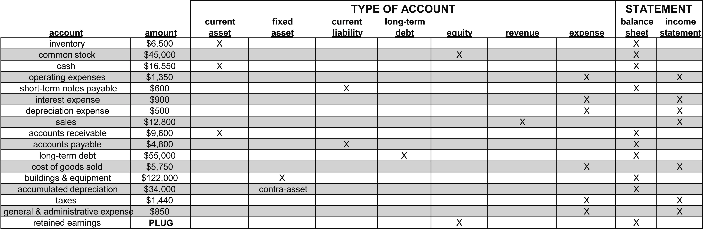

Note that expenses and revenues go on the income statement, while assets, liabilities, and equity go on the balance sheet.

As shown on the next page, we will find retained earnings as the plug figure that will equate total assets with total liabilities and owners’ equity. We use the following 2-step process:

a. Now that we know which accounts belong to which statement, we can create the statements as follows:

b. Now that we’ve identified Belmond’s current assets and current liabilities, we can find the firm’s net working capital as the difference between them:
current assets = $32,650
current liabilities = ($5,400)
net working capital = $27,250

c. If I were asked to assess Belmond’s financial position, I’d say:

• It has adequate liquidity, given that its current assets are $32,650 while current liabilities are only $5,400—resulting in a strong net working capital position of $27,250.

• It is managing its costs well: COGS is only 45% of sales; operating expenses are 21% of sales; interest expense is 7% of sales; net income is almost 16% of sales.

• Its retained earnings seem relatively low, which is odd, given the rest of the results. However, this could occur if Belmond is a relatively new company or if a significant amount of dividends had been paid in previous years.

• Its cash seems extremely high, given its sales (annual sales < cash!).

Overall, Belmond seems to be well-managed and in good financial shape.

3-13. We first classify TNT, Inc.’s accounts as follows:

Expenses and revenues belong on the income statement; assets, debt, and equity belong on the balance sheet. Note that accrued expenses are a current liability—this represents the accumulation of expenses taken on the periodic income statements, and are the amount the firm must pay (thus, a liability). The same situation applies to taxes payable as well.
- and b. Given these assignments, we can create the firm’s balance sheet and income statement as shown on the next page.

- TNT, Inc.’s financials reveal no glaring, severe problems. The firm seems to be doing well managing its expenses. Its COGS is about 52% of sales; operating expenses are 25% of sales; net income is 13% of sales. It is adequately liquid: Its net working capital is $380,850 (current assets of $737,700 are over 2 times current liabilities of $356,850
- In fact, the firm may be too liquid: Cash is 20%of total assets, which seems high, especially since all of the current liabilities total just over 21% of total assets. The firm is running lean on inventory (9% of assets), which is positive. Long-term debt is only 3% of assets and interest expense is less than 1% of sales. Given that the firm’s tax bill was almost 9% of sales, it could probably benefit from more leverage.

3-14. The values from Google’s cash flow statement are graphed below:

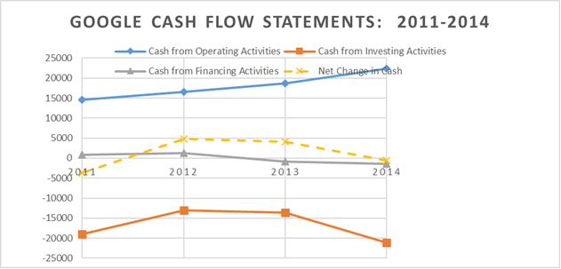
- Yes. Google’s operating cash flow was between $14.6 billion and $22.4 billion each year between 2011 and 2014. The sum of operating cash flows for all four years is $72.2 billion.
- The sum of new capital expenditures over these four years is ($3,438 + $3,273 + $7,358 + $10,959) million = $25,028 million, or $25.0 billion.
- Google did not issue any stock between 2011 and 2014. It issued a relatively small amount of debt in 2011 and 2012 ($726 million and $1.3 billion, respectively) and retired a modest amount of debt in 2013 and 2014. Operating cash flow was very strong and more than sufficient to finance all capital expenditures, resulting in limited financing from financial markets in recent years.
- Google generated significant net income over the four years from 2011 to 2014, reporting a total of $47.8 billion in net income for these years. Depreciation and non-cash items also contributed to a strong positive cash flow from operations. Operating cash flow was more than sufficient to finance all capital expenditures during this period. As a result, the firm did not issue any additional equity during this period. The company also moved from being a net issuer of debt in 2011 to retiring some existing debt in 2013 and 2014. The strong cash flow from operations also enabled Google to make significant investments in marketable securities. Over these four years, Google purchased a total of $196.8 billion of marketable securities, nearly 8 times the amount invested in capital expenditures over this period. The company appears to have transitioned from a start-up company to a cash cow relatively quickly.

3-15. BigBox’s cash flows are graphed below:

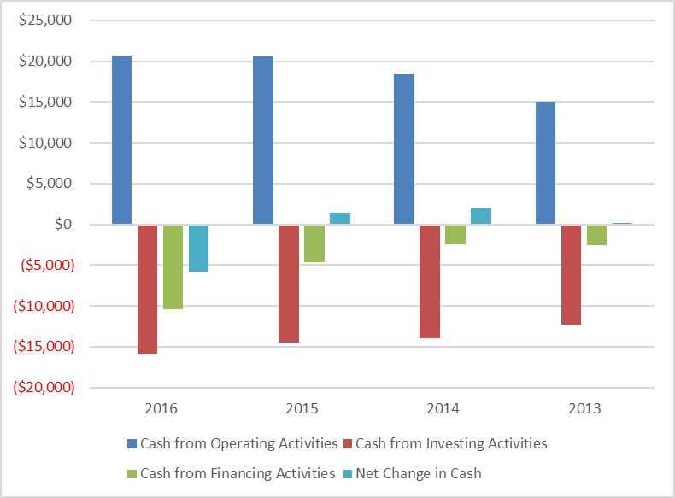

a. BigBox has generated positive cash flows from operations in each of the past four years. Cash flow from operations grew from $15.0 billion in 2013 to $20.7 billion in 2016.

b. The company has made significant capital investments during each of the four years, increasing the amount every year. The total over the full period is $56,800 million.

c. Big Box financed its capital expenditures from its strong cash flow from operations, resulting in minimal need for accessing capital in the financial markets. There was a modest amount of debt issued during these four years providing a net cash inflow of $9,500 million. This is in contrast to the $74,700 million provided from operations over the four-year period. The strong operating cash flow allowed Big Box to pay a large dividend each year (with a four-year total of $11,100 million) and repurchase a significant amount of equity ($17,600 million) over the four-year period.

d. Thus it appears that over the last four years, the firm has:

• Generated steady growth in net income, and some growth in depreciation cash flow

• Received positive cash flow from reductions in working capital investments

• Made significant and growing expenditures on capital assets between 123% and 127% of net income each year

• Paid steadily growing dividends between 22% and 28% of net income

• Retired stock each year, with the largest retirement in the most recent year, while issuing modest amounts of debt (the debt amounts issued were less than the stock amounts retired)

This firm appears to be in a mature, steady state.

3-16. a. The quality of earnings ratio for Mitchell Electric Company is as follows:

Quality of earnings ratio = (cash flow from operations / net income)

= $575,000 / $750,000 = .7667 = 76.67%

Without further detail, as given in the Boswell example of the text, we can only say that the firm received approximately 77% of its cash flow from its operating income stream and about 23% from non-operating sources.

Capital acquisitions ratio =
3-yr avg. cash flow from operations / 3-yr avg. cash paid for capital expenditures =

[($478 + $403 + $470) thousand/ 3] / [($459 + $447 + $456) thousand/ 3] = 0.9919 = 99.19%

This means that for the last 3 years, Mitchell Electric Company, on average, was able to finance 99.19% of its capital expenditures with its operating cash flow.

3-17. Using the link to Yahoo Finance http://finance.yahoo.com/ the following statement of cash flows were found for Home Depot and Lowe’s:

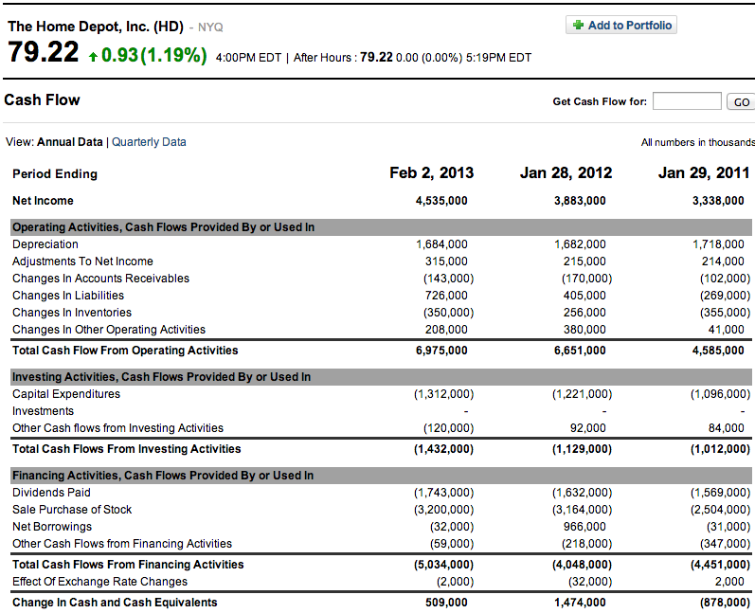

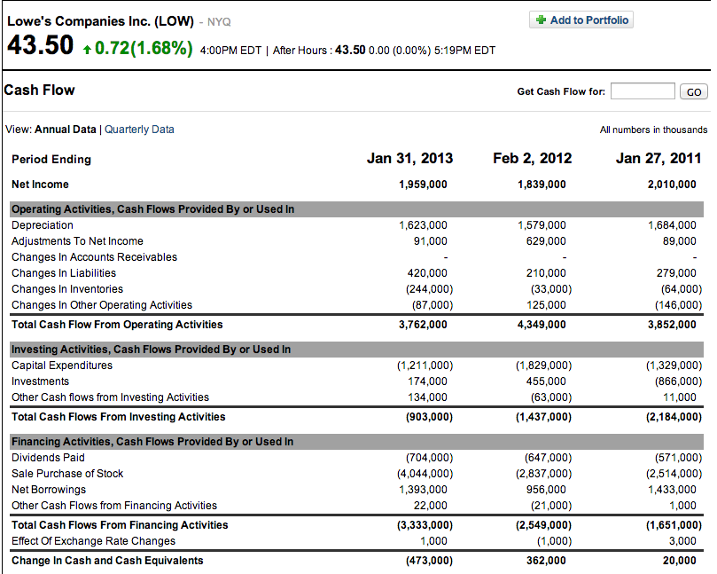

 |  | 2013 |  | 2012 |  | 2011
Home Depot
 | Net Income | 4,535,000 |  | 3,883,000 |  | 3,338,000
 | CF from Operating Activities | 6,975,000 |  | 6,651,000 |  | 4,585,000
 | CAPEX | 1,312,000 |  | 1,221,000 |  | 1,096,000
 | Quality of Earnings Ratio =
 | CF from Oper/Net Income | 153.80% |  | 171.29% |  | 137.36%
 | Capital Acquisitions Ratio =
 | CF From Oper/Cash Paid
 | for CAPEX | 531.63% |  | 544.72% |  | 418.34%

 |  | 2013 |  | 2012 |  | 2011
Lowe’s
 | Net Income | 1,959,000 |  | 1,839,000 |  | 2,010,000
 | CF from Operating Activities | 3,762,000 |  | 4,349,000 |  | 3,852,000
 | CAPEX | 1,211,000 |  | 1,829,000 |  | 1,329,000
 | Quality of Earnings Ratio =
 | CF from Oper/Net Income | 192.04% |  | 236.49% |  | 191.64%
 | Capital Acquisitions Ratio =
 | CF From Oper/Cash Paid
 | for CAPEX | 310.65% |  | 237.78% |  | 289.84%
- As calculated above, the quality of earnings ratio for both Home Depot and Lowe’s is high and above 100%. For Home Depot, the values are 153.80%, 171.29%, and 137.26%, respectively. For Lowe’s the values are 192.04%, 236.49%, and 191.64%, respectively. These numbers suggest that the quality of earnings for both firms is very high.
- Home Depot has a much larger amount for the entry “adjustments to net income,” as well as a positive and large entry for “changes in other operating activities.” While either of these adjustments may be innocuous, a serious investor would need to understand both of the items. Checking both firms’ annual reports or 10-K statements filed with the SEC will provide more details than the summaries posted to Yahoo Finance.
- As calculated above, the capital acquisitions ratio for both Home Depot and Lowe’s is high and above 100%. For Home Depot, the values are 531.63%, 544.72%, and 418.34%, respectively. For Lowe’s the values are 310.65%, 237.78%, and 289.84%, respectively. This indicates that both firms can finance capital expenditures internally without accessing the financial markets.
- Home Depot is able to cover its CAPEX through its operating cash flow a greater number of times, but both firms have the means to expand their CAPEX significantly. Lowe’s issued debt in 2013 (some of which was used to finance the repurchase of a significant amount of stock) and would therefore have been more active in the capital markets than Home Depot.

