CHAPTER 2

Strategic marketing planning

Asos founder turns to online homeware

One of the founders of Asos, the fast-growing online fashion retailer, has launched a website focusing on the competitive homewares market.

Quentin Griffiths, who left Asos as it turned its first profit in 2005, started Achica this year along with co-founder Will Cooper and it now has 20,000 members, they say.

The site holds 48-hour sales of sought after homeware brands, including Royal Crown Derby china and Yves Delorme bed linen, at up to 70 per cent off. The UK market for homeware is about £10.7bn ($16.1bn), according to research by Verdict. Mr Griffiths expects that Achica could take up to 5 per cent in the next five years.

He said homeware was lagging behind fashion because initially people had been cautious about making high-ticket purchases on the internet. Online homeware is already a competitive market with stores such as John Lewis and Marks and Spencer seeing strong sales. Fashion retailers H&M and Zara have also launched homeware businesses online.

Mr Griffiths says an advantage to selling homeware brands online is that the company avoids paying storage costs as it only stores products for the brief period before they are sent to a consumer. Achica would not hold stock that has not already been sold.

Unlike many sites that focus on one-off sales, the retailer does not just sell last season’s stock.

Retailers anticipate pressure on disposable income from the government’s harsh austerity measures may help discount sale sites. In western Europe, Forrester Research expects 11 per cent growth rate for online retail sales during the next five years, going from $93bn in 2009 to $156bn (£62bn to £104bn) in 2014.

*Source*: Hannah Kuchler, ‘Asos founder turns to online homeware’, [*www.ft.com*](http://www.ft.com/), 28 June 2010

Discussion questions

1. Why did Quentin Griffiths enter the competitive homewares market?

This is strategic marketing planning. Quentin Griffiths would have evaluated the market needs   
ad conditions for online homeware in parallel with its company’s resources. The market needs   
exist and the conditions appear favourable due to the government’s austerity measures and   
according to Forrester Research. Quentin Griffiths is already a successful online marketer.

13

© Pearson Education Limited 2017

Brigitte Nicoulaud, *Marketing Strategy & Competitive Positioning*, 6th edition,   
 Instructor’s Manual on the web

2. How is he trying to compete?

Quentin Griffiths is following on the footsteps of other fashion retailers who have proven the concept. He is also adopting a prudent business model and is developing a competitive advantage by not just selling ‘last season’s stock’.

Amazon eyes online sales boost through ‘Fire’ smartphone

Amazon has a decent shot at shaking up a smartphone market controlled by Samsung and Apple as well as selling more of everything to its customers with its new Fire smartphone, unveiled on Wednesday in Seattle.

But first, it has to find a way to convince consumers to buy the phone.

‘Is it a good product and a neat idea? Yup. Will it be a success? Question mark’, says Mohan Sawhney, a management professor at Northwestern University who has studied Amazon.

Another question is just what constitutes success: muscle in on the smartphone market or driving more sales of the multitude of products sold via Amazon.

The phone is likely to funnel users towards buying more from Amazon, says Michael Graham, an internet analyst at Canaccord Genuity. Getting users of its hardware to buy more goods from its online store is how Amazon profited from the Kindle line of tablet and e-readers, in spite of selling many of those at or below cost.

The phone also comes with a free year of Amazon Prime membership, worth $99, allowing   
unlimited free shipping and a catalogue of digital music, movies and television shows. Users   
can store in Amazon’s cloud an unlimited number of photos that they take with the device.

Prime users are more lucrative for Amazon than regular customers, says Mr Graham and Firefly could encourage phone owners to use Amazon, rather than use search engine Google, as their main place to search for purchases.

But the challenge, says James McQuivey, an analyst with Forrester, is that entry into the phone market is tough to crack. Buying a phone typically means locking into a two-year contract, or paying more for a faster upgrade. The difficulty convincing consumers to wager on whether they will like a new device in two years had stymied many purchases - some early phones from Microsoft sold fewer than 20,000, he says.

Bringing more users into Prime and trying to sell more Amazon goods ‘are shrewd and calculated moves and the phone in theory could be a tremendous extension of that strategy, but you’ve got to get people to want one’, he says. ‘I’m not sure [the Fire] will impress consumers to the tune of millions of them running out to buy it’.

The Fire starts with a 32GB model that sells for $199 on a two-year contract through AT&T, the only US carrier offering the device. Without a contract, it costs $649.

That places the Fire on par with Apple’s iPhone and Samsung’s high-end Galaxy line of devices

- a part of the market that is increasingly competitive as sales slow and users are reluctant to

14

© Pearson Education Limited 2017

Brigitte Nicoulaud, *Marketing Strategy & Competitive Positioning*, 6th edition,   
 Instructor’s Manual on the web

switch from familiar brands and operating systems. Many other would-be contenders, including HTC, Motorola and Nokia have struggled to gain market share.

To help Amazon succeed where others failed, Jeff Bezos, Amazon’s chief executive, brought to   
the launch in a Seattle warehouse a device that mixes content, customer services and hardware.

Best known for its online shopping mall, Amazon also controls a global network of warehouses, one of the world’s largest commercial cloud storage operations and has access to a growing catalogue of digital music, movies and films - expanded week with the launch of a Spotify-like music streaming service.

The Fire sports a 3D display that uses four infrared cameras to track users’ head motion and pivot games or maps in line with how the viewer is looking at them. It also has a visual search tool named Firefly.

With Firefly, a user can point the phone’s camera at anything from a book to a shaker of salt or a poster and either extract and save information - such as an e-mail address - or navigate directly to a product page on Amazon to buy it.

‘What we saw was an opportunity to prove some new capabilities that really hadn’t been done before in premium smartphones’, says Ian Freed, Amazon’s vice-president for the Fire phone. ‘We’ve seen innovation stagnate a bit over the past two to three years’.

Analysts with Jefferies, the brokerage, estimate that Foxconn, the phone’s manufacturer, will produce roughly 200,000 phones a month in the coming months.

Amazon decline to comment on plans to launch the phone in Europe, but people familiar with   
the company say it is holding discussions with Vodafone and O2 in the UK about possibly   
launching there.

By December or January - after the big back to school and holiday sales - it should be clear how well the phone is doing in the US, says Mr McQuivey. If Amazon reduces the price or adds more benefits, such as an additional year of Prime membership, it would be a sign that the initial launch underwhelmed the market and a rethink was needed.

‘There are levers that Amazon could still pull if it needs to’, he says. Copyright The Financial Times Limited 2014

Please do not cut and paste FT articles and redistribute by email or post to the web.

Discussion questions

1. What is driving Amazon’s entry into the smartphone market? Is it an ego trip?

The information in the case suggests that launching a mobile phone presents a good strategic fit for Amazon, i.e. there is a good match between the company’s capabilities, the market needs and the marketing strategy.

15

© Pearson Education Limited 2017

Brigitte Nicoulaud, *Marketing Strategy & Competitive Positioning*, 6th edition,   
 Instructor’s Manual on the web

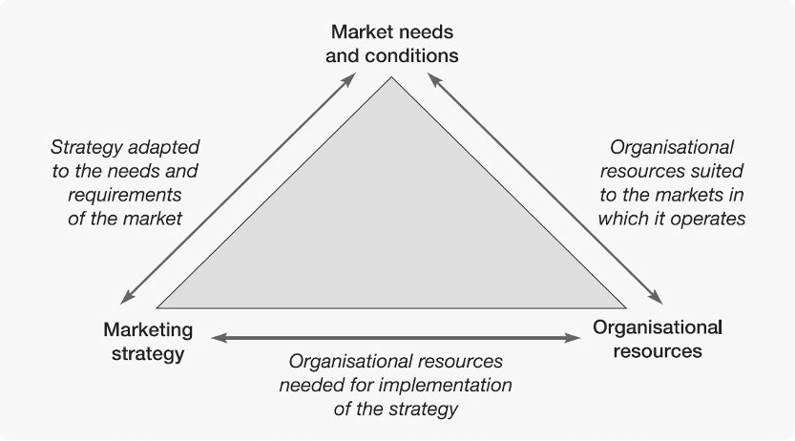

2. How does it fit in Amazon’s vision ‘to be earth's most customer centric company; to   
 build a place where people can come to find and discover anything they might want to

buy online’?

Fundamental to deciding upon where a company is to go is defining its purpose or mission, i.e.:

i. What business are we in?

ii. What business do we want to be in?

Amazon intends ‘to be earth's most customer centric company; to build a place where people can come to find and discover anything they might want to buy online’, therefore the move is highly consistent, particularly with Firefly. It is also consistent with the success of the Kindle line of tablet and e-readers.

It is, however, important to be aware that even with the convergence of access to shopping and   
devices the new Fire smartphone is another departure from Amazon original core business. It   
will be competing against already strongly established brands that are offering familiar   
operating systems.

It is important that the mission should be defined rigorously and the question of ‘what business do we want to be in?’ be clearly and unequivocally answered.

16

© Pearson Education Limited 2017

Brigitte Nicoulaud, *Marketing Strategy & Competitive Positioning*, 6th edition,   
 Instructor’s Manual on the web

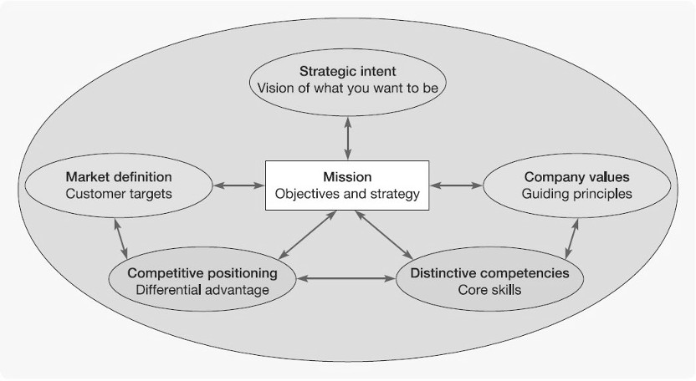

3. What strategic focus does the move signify? What alternatives are open to Amazon

and how could Amazon pursue them?

• By launching the Fire smartphone, it seems that Amazon would hope that it is winning

shares from its competitors in the market by ‘presenting new capabilities’ in a smartphone.

• It also could, also, try to expand the market by:

• Focusing on new uses (probable: the suggestion is competitors’ phones do not offer   
 the same level of capabilities)

• Getting new users (possible)

• Increasing use frequency (particularly purchases on Amazon website).

• It could, also, try to increase its share by:

• Creating alliances (possible).

• Finally, it could try to increase productivity by:

• Increasing price (not probable)

17

© Pearson Education Limited 2017

Brigitte Nicoulaud, *Marketing Strategy & Competitive Positioning*, 6th edition,   
 Instructor’s Manual on the web

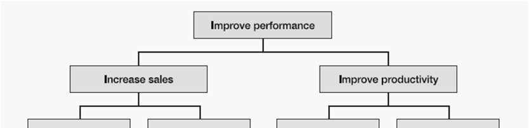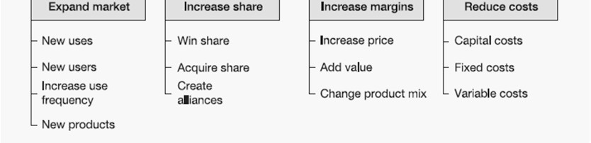

• Adding value (possible as already included with the extra capabilities provided they   
 give genuine value to customers)

• Reducing costs (may be possible).