CHAPTER TWO

Introduction to the Financial Statements

Concept Questions

C2.1. The change in shareholders’ equity is equal earnings minus net payout to shareholders only if earnings are comprehensive earnings. See equation 2.4. Net income, calculated according to U.S. GAAP is not comprehensive because some income (“other comprehensive income”) is booked as other comprehensive income outside of net income. See equation 2.5.

C2.2. False. Cash can also be paid out through share repurchases.

C2.3. Net income available to common is net income minus preferred dividends. The earnings per share calculation uses net income available to common (divided by shares outstanding)
C2.4. For one of two reasons:

- The firm is mispriced in the market.
- The firm is carrying assets on its balance sheet at less than market value, or is omitting other assets like brand assets and knowledge assets. Historical cost accounting and the immediate expensing of R&D and expenditures on brand creation produce balance sheets that are likely to be below market value.

C2.5. P/E ratios indicate growth in earnings. The numerator (price) is based on expected future earnings whereas the denominator is current earnings. If future earnings are expected to be higher than current earnings (that is, growth in earnings is expected), the P/E will be high. (If future earnings are expected to be lower, the P/E ratio will be low). P/E ratios can also be high because the market is too optimistic in its earnings growth foreasts. Chapter 6 elaborates.

C2.6. Some examples:
- Expensing research and development expenditures.
- Using short estimated lives for depreciable assets – resulting is high depreciation charges.
- Expensing store opening costs before revenue is received.
- Not recognizing the cost of stock options.
- Expensing advertising and brand creation costs.
- Underestimating bad debts
- Not recognizing contingent warranty liabilities from sales of products.
See Box 2.4.

C2.7. Accounting methods that would explain the high P/B ratios in the 1990s:
- More of firms’ assets were in intangible assets (knowledge, marketing skill, etc.) – and thus not on the balance sheet – rather than in tangible assets than are booked to the balance sheet.
- Firms became more conservative in booking tangible net assets (that is they carried them at lower amounts on the balance sheet), by recognizing more liabilities such as pension and post-employment liabilities and by carrying assets at lower amounts through restructuring charges, for example.
The other factor: stock prices rose above fundamental value, adding to the difference between price and book value.

C2.8. Dividends are distributions of the value created in a firm; they are not a loss in generating value. So accountants calculate the value added (earnings), add it to equity, and then treat dividends as a distribution of the value added (by charging dividends against equity in the balance sheet).

C2.9. Plants wear out. They rust and become obsolescent. So value in the original investment is lost. Accordingly, depreciation is an expense in generating value from operations, just as wages are.

C2.10. Like depreciation of plant, amortization of intangibles recognizes a loss of value. Patents expire, and so the value of the original investment is lost. So, just as the cost of plant is expensed against the revenue the plant produces, the cost of patents is expensed against the revenue that the patent produces.

C2.11. Matching nets expenses against the revenues they generate. Revenues are value added to the firm from operations; expenses are value given up in earning revenues. Matching the two gives the accountant’s measure of net value added, and so measures the success in operations. Matching uncovers profitability.

C2.12. The fundamental analyst wants to anchor on “what we know” so not to mix “what we know” with speculation. So he tells the accountants: Tell me what you know, don’t speculate; leave the speculation to me, the analyst. The reliability criterion enforces this request.

Exercises
Drill Exercises

E2.1. Applying Accounting Relations: Balance Sheet, Income Statement and Equity
Statement

- Liabilities = Assets – Shareholder’s equity
= $400 - $250
= $150 million

- Net Income = Revenues – Expenses
$30 = ? - $175
? = $205 million

- Ending equity = Beginning equity + Comprehensive Income – Net Payout
$250 = $230 + ? - $12
? = $32 million

As net income (in the income statement) is $30 million, $2 million was reported as “other comprehensive income” in the equity statement.

- Net payout = Dividends + Share repurchases – Share issues

As there were no share issues or repurchases, dividend = $12.

E2.2. Applying Accounting Relations: Cash Flow Statement

Change in cash = CFO – Cash investment – Cash paid out in financing activities
$130 = $400 - ? - $75
? = $195 million

E2.3. The Financial Statements for a Savings Account

a.
___________________________________________________________________________

BALANCE SHEET INCOME STATEMENT
Assets (cash) $100 Owners’ equity $100 Revenue $5
Expenses 0
Earnings $5
STATEMENT OF CASH FLOWS STATEMENT OF OWNERS’ EQUITY
Cash from operations $5 Balance, beginning of year $100
Cash investment 0 Earnings 5
Cash in financing activities: Dividends (withdrawals) (5)
Dividends (5) Balance, end of year $100
Change in cash $ 0

b.
As the $5 in cash is not withdrawn, cash in the account increases to $105, and owners’ equity increases to $105. Earnings are unchanged.
______________________________________________________________________
BALANCE SHEET INCOME STATEMENT
Assets (cash) $105 Owners’ equity $105 Revenue $5
Expenses 0
Earnings $5

STATEMENT OF CASH FLOWS STATEMENT OF OWNERS’ EQUITY
Cash from operations $5 Balance, beginning of year $100
Cash investment 0 Earnings 5
Cash in financing activities: Dividends (withdrawals) (0)
Dividends (0) Balance, end of year 1 $105
Change in cash $ 5 ______________________________________________________________________
- With the investment of cash flow from operations in a mutual fund, the financial statements would be as follows:
_______________________________________________________________________
BALANCE SHEET INCOME STATEMENT
Assets (cash) $100 Revenue $5
Mutual Fund 5 Equity $105 Expenses 0
Total assets $105 Total $105 Earnings $5
STATEMENT OF CASH FLOWS STATEMENT OF OWNERS’ EQUITY
Cash from operations $5 Balance, end of year $100
Cash investment (5) Earnings 5
Cash in financing activities: Dividends (withdrawals) (0) Dividends (0) Balance, end of year $100
Change in cash $ 0
_______________________________________________________________________
E2.4. Preparing an Income Statement and Statement of Shareholders’ Equity
Income statement:
Sales $4,458
Cost of good sold 3,348
Gross margin 1,110
Selling expenses (1,230)
Research and development (450)
Operating income (570)
Income taxes 200
Net loss (370)

Note that research and developments expenses are expensed as incurred.

Equity statement:

Beginning equity, 2012 $3,270

Net loss $(370)
Other comprehensive income 76 (294) ($76 is unrealized gain on securities)
Share issues 680
Common dividends (140)

Ending equity, 2012 $3,516

Comprehensive income (a loss of $294 million) is given in the equity statement. Unrealized gains and losses on securities on securities available for sale are treated as other comprehensive income under GAAP.

Net payout = Dividends + share repurchases – share issues

= 140 + 0 – 680

= - 540
That is, there was a net cash flow from shareholders into the firm of $540 million.

Taxes are negative (that is, the effect on income is positive) because income is negative (a loss). A loss yields a tax benefit that he firm can carry forward to reduce future taxes.

E2.5. Classifying Accounting Items

- Current asset
- Net revenue in the income statement: a deduction from revenue
- Net accounts receivable, a current asset: a deduction from gross receivables
- An expense in the income statement. But R&D is usually not a loss to shareholders; it is an investment in an asset.
- An expense in the income statement, part of operating income (and rarely an extraordinary item). If the restructuring charge is estimated, a liability is also recorded, usually lumped with “other liabilities.”
- Part of property, plan and equipment. As the lease is for the entire life of the asset, it is a “capital lease.” Corresponding to the lease asset, a lease liability is recorded to indicate the obligations under the lease.
- In the income statement
- Part of dirty-surplus income in other comprehensive income. The accounting would be cleaner if these items were in the income statement.
- A liability
- Under GAAP, in the statement of owners equity. However from the shareholders’ point of view, preferred stock is a liability
- Under GAAP, an expense. However from the shareholders’ point of view, preferred dividends are an expense. Preferred dividends are deducted in calculating “net income available to common” and for earnings in earnings per share.
- As an expense in the income statement.

E2.6. Violations of the Matching Principle

- Expenditures on R&D are investments to generate future revenues from drugs, so are assets whose historical costs ideally should be placed on the balance sheet and amortized over time against revenues from selling the drugs. Expensing the expenditures immediately results in mismatching: revenues from drugs developed in the past are charged with costs associated with future revenues. However, the benefits of R&D are uncertain. Accountants therefore apply the reliability criterion and do not recognize the asset. Effectively GAAP treats R&D expenditures as a loss.
- Advertising and promotion are costs incurred to generated future revenues. Thus, like R&D, matching requires they be booked as an asset and amortized against the future revenues they promote, but GAAP expenses them.
- Film production costs are made to generate revenues in theaters. So they should be matched against those revenues as the revenues are earned rather than expensed immediately. In this way, the firm reports its ability to add value by producing films.

E2.7. Using Accounting Relations to Check Errors

Ending shareholders’ equity can be derived in two ways:

1. Shareholders’ equity = assets – liabilities

2. Shareholders’ equity = Beginning equity + comprehensive income – net dividends
So, if the two calculations do not agree, there is an error somewhere. First make the calculations for comprehensive income and net dividends:
Comprehensive income = net income + other comprehensive income
= revenues – expenses + other comprehensive income
= 2,300 –1,750 – 90
= 460
Net dividend = dividends + share repurchases – share issues
= 400 +150 –900
= - 350
Now back to the two calculations:
- Shareholders’ equity = 4,340 – 1,380
= 2,960
2, Shareholders’ equity = 19,140 + 460 – (-350)
= 19,950
The two numbers do not agree. There is an error somewhere.

Applications
E2.8. Finding Financial Statement Information on the Internet
This is a self-guiding exercise. Students can take it further by downloading financial statements from the SEC EDGAR site or firms’ corporate Web site into a spreadsheet. For Kimberley Clark annual reports, go to:
http://www.kimberly-clark.com/investors/financial_information/annualreports.aspx

E2.9. Testing Accounting Relations: General Mills Inc.
This exercise tests some basic accounting relations.
- Total liabilities = Total assets – stockholders’ equity
= 17,679 – 5,648
= 12,031
(b) Total Equity (end) = Total Equity (beginning) + Comprehensive
Income – Net Payout to Common Shareholders
5,648 = 5,417 + ? – 737
? = 968
Net payout to common = cash dividends + stock purchases – share issues
= 648 + 692 - 603
= 737

E2.10. Testing Accounting Relations: Genetech Inc.

Revenue = Net income + Net expenses (including taxes)
= $784.8 + 3,836.4
= $4,621.2 million
(b) ebit = Net income + Interest + Taxes
= $784.8 - 82.6 + 434.6
= $1,136.8 million
(Note: net interest is interest income minus interest expense)
(c) ebitda = Net income + interest + taxes + depreciation and amortization
= Ebit + depreciation + amortization
= $1,136.8 + 353.2
= $1,490.0 million
Depreciation and amortization is reported as an add-back to net income to get cash flow from operations in the cash flow statement.
- Long-term assets = Total assets – Current assets
= $9,403.4 – 3,422.8
= $5,980.6 million
Total Liabilities = Total assets – shareholders’ equity
= $9,403.4 – 6,782.2
= $2,621.2 million
Short-term Liabilities = Total liabilities – Long-term Liabilities
= $2,621.2 - 1,377.9
= $1,243.3 million
- Change in cash and cash equivalents = Cash flow from operations – Cash used in investing
activities + Cash from financing activities
Change in cash and cash equivalents is given by the changes in the amount is the balance sheet
= $270.1 – 372.2 = -$102.1

So, -$102.1 = $1,195.8 - $451.6 + ?
So ? = -$846.3 million
That is, there was a cash outflow of $846.3 million for financing activities.

E2.11. Find the Missing Numbers in the Equity Statement: Cisco Systems Inc.
Total Equity (end) = Total Equity (beginning) + Comprehensive
Income – Net Payout to Common Shareholders
a.
$32,304 = $31,931 + 6,526 -?
? = $6,153
- Net payout to common = cash dividends + stock purchases – share issues
6,153 = 0 + ? – 2,869
= 9,022

E2.12. Find the Missing Numbers in Financial Statements: General Motors
a.
Total Equity (end) = Total Equity (beginning) + Comprehensive
Income – Net Payout to Common Shareholders

-56,990 = -37,094 + ? – 283
? = -19,613 (a loss)

b.

Comprehensive income = Net income + Other comprehensive income
-19,613 = -18,722 + ?
? = - 891

c.
Net income = Revenue – expenses and losses
-18,722 = ? – 60,895
? = 42,173

d.
June 30, 2008 December 31, 2007

Assets 136,046 148,883
Liabilities ? = 193,036 ? = 185,977
Equity -56,990 -37,094

E2.13. Mismatching at WorldCom
Capitalizing costs takes them out of the income statement, increasing earnings. But the capitalized costs are then amortized against revenues in later periods, reducing earnings. The net effect on income in any period is the amount of costs for that period less the amortization of costs for previous periods. The following schedule calculates the net effect. The numbers in parentheses are the amortizations, equal to the cost in prior periods dividend by 20.

1Q, 2001 2Q, 2001 3Q, 2001 4Q, 2001 1Q, 2002
1Q, 2001 cost: $780 $780 $ (39) $ (39) $ (39) $ (39)
2Q, 2001 cost: 605 605 (30) (30) (30)
3Q, 2001 cost: 760 760 (38) (38)
4Q, 2001 cost: 920 920 (46)
1Q, 2002 cost: 790 790
Overstatement of earnings $780 $566 $691 $813 $637

The financial press at the time reported that earnings were overstated by the amount of the expenditures that were capitalized. That is not quite correct.

E2.14. Calculating Stock Returns: Nike, Inc.

The stock return is the change in price plus the dividend received. So, Nike’s stock return for fiscal year 2010 is

Stock return = $73.38 - $57.83 + $1.06 = $16.61

The rate-of-return is the return divided by the beginning-of-period price: $16.61/57.83 = 28.72%.

Minicases

M2.1. Reviewing the Financial Statements of Kimberley-Clark Corporation
Introduction
This case runs through the basics of financial statements. It also introduces the student to Kimberley-Clark (KMB), the firm that is followed in the Continuing Case that runs from chapter-to-chapter in the text. The instructor may use this case for a broader discussion of the accounting principles that were discussed in the chapter. You can dig deeper than questions A- P in the case. At this point, it is important to get students familiar with walking around financial statements.
The Financial Statements
The financial statements in the case are reproduced here in case they are needed for case discussion.

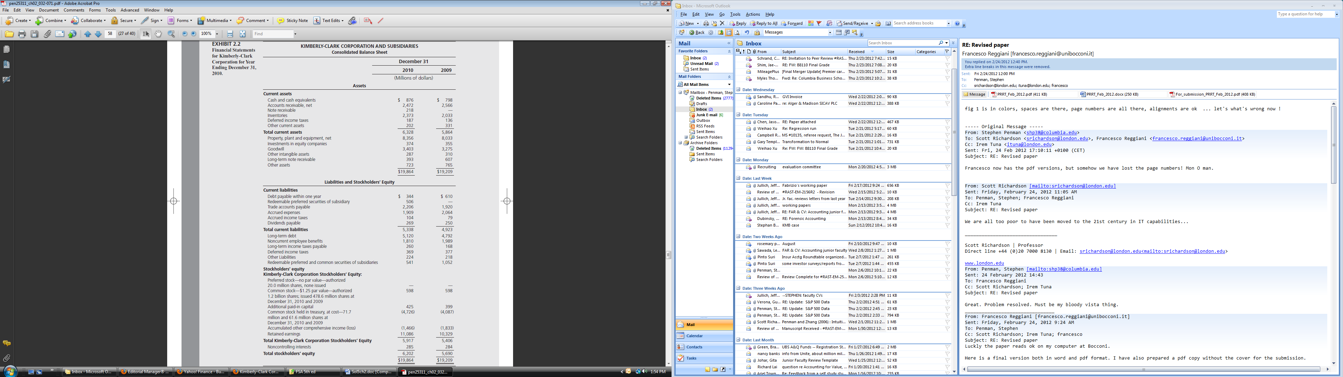
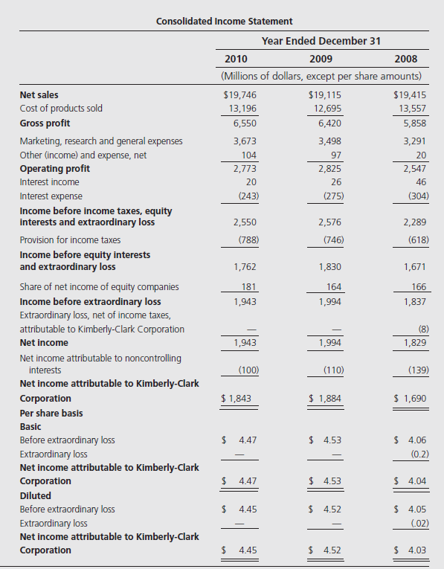

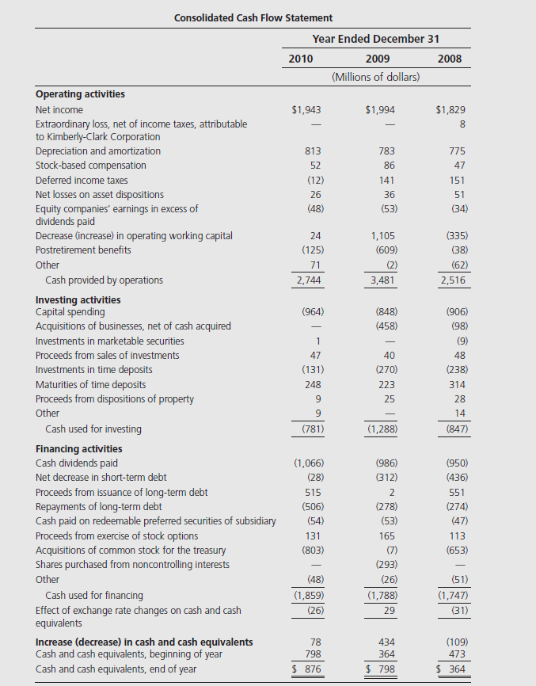

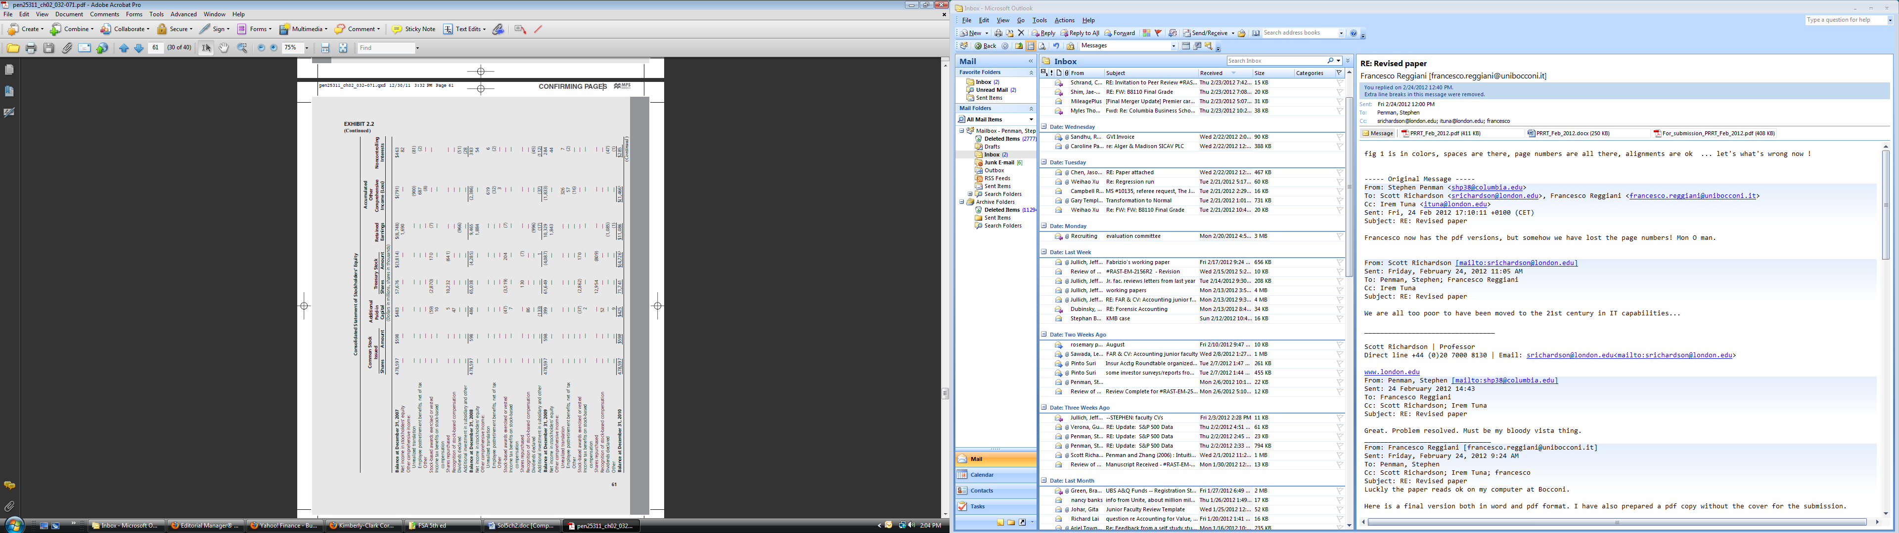

The Questions
A Shareholders’ equity = assets – liabilities
$6,202 = $19,864 – $13,662
Liabilities are current liabilities plus long-term liabilities. The balance sheet does not report the total—the reader must do the totaling. Note that GAAP requires redeemable preferred stock to be classified outside shareholders’ equity – in what is called a mezzanine. This preferred stock has been included as a liability in the calculation above (as indeed it is from a common shareholders’ point of view).
Common shareholders’ equity of $5,917 million is total equity of $6,202 million less noncontrolling interests of $285 million.
Net income = revenue – expenses
$1,943 = $19,746 - $17,803
This is a little crude because there are some income line items among expenses. Interest income can be netted against interest expense here: net interest expense = $243 – 20 = $223 million. Share of equity income in subsidiaries ($181 million) is a net income number (revenue – expenses in subsidiaries). So a better way of getting to net income (before noncontrolling interests) is:
$1,943 = $19,746 – 17,984 + 181
(where expenses include net interest expense). The common shareholders’ income is $1,843 million because $100 million of consolidated income from the group of companies applies to the minority shareholders in subsidiary companies.
Cash from operations + cash from investment + cash from financing – effect of
exchange rate = change in cash and cash equivalents
$2,744 - 781 - 1,859 - 26 = $78
- We are interested in income to the common shareholders, for it is their shares, trading at $65.24, that we are interested in valuing in this book.
Other comprehensive income (OCI) is in the Statements of Stockholders’ Equity, made up as follows:
Foreign currency translation gain $ 326
Employee postretirement benefits 57
Other (16)
Other comprehensive income $ 367
Employee postretirement benefits are a gain from a program for employee benefits that must be reported in OCI rather than in the income statement.
Comprehensive income (to common) = net income + other comprehensive income
$2,210 = $1,843 + 367
IFRS does not report other comprehensive income in the equity statement. Firms have the option of reporting OCI in the income statement, below net income, such that income totals to Comprehensive Income, or in a separate comprehensive income statement. For year 2013 on, U.S. GAAP will conform to the IFRS requirement, so you will not see OCI in the equity statement anymore. See Chapter 9.
- Net payout (to common) = dividends + stock repurchases – share issues
$1,698 = $1,085 + 809 – 196
The share issues are the total of the net additions to Additional Paid-In Capital which includes a negative amount of $37 million for shares previously issued to employees as compensation but now forfeited (presumably because they did not vest). The forfeiture of shares by employees is treated as a negative share issue. Shares issued to employees of $170 million (probably in exercise of stock options) were issued out of Treasury. Note: the item, Recognition of Stock-based Compensation, is a strange animal that we will get to in Chapter 9. Why would compensation be an increase in shareholders’ equity? The answer is the odd treatment of employee stock options under FASB Statement 123R and IFRS 2.
These calculations must reconcile to the change in common equity for the year that is reported in the balance sheet:
Ending common equity = Beginning common equity + Comprehensive income – Net
Payout
$5,917 = 5,406 + 2,210 – 1,698
You will notice a $1 discrepancy with the closing equity in the balance sheet. That is the -$1 “other” in the retained earnings column in the equity statement for which we have no explanation.
- Revenue is recognized at time of sale (that is, when title to the goods passes to the customer), less any discount for expected sales returns from customers.
- Gross margin = sales revenue – cost of sales
$6,550 = $19,746 – 13,196 (as reported)
Effective tax rate = tax expense/income before tax
= $788/$2,550
= 30.90%
Note that any income reported below in other comprehensive income is always after tax. That includes share if net income in equity companies and all items in other comprehensive income.
ebit = Income before tax + net interest expense
= $2,550 + 223
= $2,773
ebitda = ebit + depreciation + amortization
= $2,773+ 813
= $3,586
Depreciation and amortization are obtained from the cash flow statement where they are added back to net income to get cash from operations. Usually depreciation is not reported as a line item in the income statement because it appears at a number of points—in cost of goods sold, marketing expenses, research expenses, general expenses, and administrative expenses.
Sales growth rate (2010) = sales(2010)/sales(2009) – 1
= $19,746/$19,115 - 1
= 3.30%
Similarly, the growth rate for 2009 = $19,115/$19,415 –
= -1.55%
- Basic earnings per share is net income available for common divided by current shares outstanding. The calculation uses a weighted average of outstanding shares during the year.
Diluted earnings per share is based on shares that would be outstanding if contingent equity claims (like options, warrants and convertible bonds and preferred stock) were converted into common shares. The numerator makes an adjustment for estimated earnings from the proceeds from the share issues at conversion. (The treasury stock method can be explained at this point.)
- Only those inventory costs that are incurred for the purchase or manufacture of goods sold are included in cost of goods sold. The costs incurred for goods not sold are retained in the balance sheet. This results in a matching of revenues with the costs incurred in gaining the revenues.
- Advertising and promotion expenditures are included in Market, Research and General Expenses on the income statement. The number, $698 million is found in footnote 1 to the financial statements. Treating the expenditure as an expense in the income statement results in mis-matching if the advertising produces generates sales in subsequent years.
- Research and development costs are also expensed as incurred (under FASB statement No. 2), so the $317 million is reported in the income statement, aggregated in the same line item as advertising. The treatment violates the matching principle if the R & D is expected to produce future revenue. Current revenues are charged with the cost rather than the future revenues that the R & D generates. Matching requires that the costs be capitalized and amortized against the future revenues. However, GAAP considers the future revenues to be too uncertain – too speculative -- so does not recognize the asset. An exception is R & D for software development where costs are capitalized in the balance sheet if the development results in a “technical feasibility” product. IFRS allows capitalization and amortization of the “Development” part of R&D but not the “Research” component.
- The $80 million is the allowance for doubtful accounts (credit losses) for 2010. This allowance is an estimate of portion of the gross receivables that are expected not to be collected. So gross receivables (before the estimate) are $2,552 million.
- Deferred taxes are taxes on the difference between reported income and taxable income that is due to timing differences in the measurement of income. If reported income is greater than taxable income, a liability results: there is a liability to pay taxes on the reported income that is not yet taxed. If reported income is less than taxable income, an assets results: the firm has paid taxes on income that has not yet been reported. KMB has both. Accounting Clinic VI deals with the accounting for income taxes.
- Goodwill is the difference between the price paid for acquiring another firm and the amount at which the net assets acquired are recorded on the balance sheet. Goodwill in carried on the balance sheet until it is deemed to be impaired, at which point it is written down to its estimated fair value (FASB Statement No. 142). The goodwill increase in 2010 must be due to an acquisition: KMB acquired another firm and recognized the difference between the purchase price and the fair value of the assets acquired as goodwill. (There could have been an impairment also, but footnotes say otherwise.)
- Net income is calculated with accrual accounting. The difference between net income and cash flow provided by operations is due to the accruals, that is, the non-cash components in net income due to accrual accounting (like receivables in revenues and payables in expenses).
- The following items are (probably) close to fair value:
Cash and cash equivalents
Accounts receivable (provided the allowance for doubtful debts is unbiased)
Note receivable
Accounts payable
Debt (current and long-term)
Accrued expense liabilities -- if they are estimated in an unbiased way
Income taxes payable
Dividends payable
- The total price of the equity is price per share multiplied by shares outstanding:
Market price of equity = $65.24 x 406.9 = $26,546.2 million
Shares outstanding are issued shares (478.6 million) minus shares in Treasury (71.7 million).
The P/E ratio is always calculated on a per-share basis = $65.24/$4.47 = 14,60. The per-share earnings are basic earnings per share. Note that we will make a dividend adjustment to this (trailing P/E) in the next chapter:
Trailing P/E = (65.24 + 2.64)/4.47 = 15.19
The dividend adjustment in the numerator is made because dividends reduce price (in the numerator) but do not affect earnings. So this P/E is does not depend on dividends.
The P/B ratio = Market value of equity/Book value of equity
= $26,546.2/$5,917
= 4.49
The P/B ratio is above the median historical ratio in Figure 2.2. The P/E ratio is about at the level of the median P/E for much of the 1980s (in Figure 2.3) but below the median P/E in the 1990s. It is a little less than the median P/E in 2009. In March 2011, the P/E ratio for the S&P 500 was 14.

- End of Year Price Beginning of Year Price Dividend Rate-of-Return
2011 65.24 62.88 2.64 7.95%
2010 62.88 46.11 2.40 41.57%
2009 46.11 64.55 2.32 -24.97%
2008 64.55 68.49 2.12 - 2.66%

