Macroeconomics, 5Ce (Williamson)
Chapter 2 Measurement

1) Gross domestic product is defined as
A) the value of all goods produced in the economy in a given time period within the borders of Canada.
B) the market value of all goods and services produced in the economy during a given time period within the borders of Canada.
C) the total market value of the final goods and services produced during a given time period within the borders of Canada.
D) the total market value of all the intermediate goods and services produced in the economy for a given time period within the borders of Canada.
E) the market value of all goods and services produced by Canadian residents domestically and abroad.
Answer: A
Type: MC Page Ref: 30-31

2) GDP is published by Statistics Canada as part of the
A) GDP Statistical Review.
B) Labour Force Statistics.
C) National Income and Expenditure Accounts (NIEA).
D) Survey of Current Business.
E) Current Population Survey.
Answer: C
Type: MC Page Ref: 31

3) The three approaches to measuring GDP are called the
A) accounting approach, the income approach, and the expenditure approach.
B) product approach, the cost approach, and the expenditure approach.
C) product approach, the income approach, and the expenditure approach.
D) accounting approach, the statistical approach, and the income approach.
E) accounting approach, the statistical approach, and the product approach.
Answer: C
Type: MC Page Ref: 31

4) Approaches to measuring GDP include
A) cost approach.
B) GDP approach.
C) income approach.
D) trade approach.
E) value-subtracted approach.
Answer: C
Type: MC Page Ref: 31
5) Acme Steel Co. produces 1,000 tons of steel. Steel sells for $30 per ton. Acme pays wages of $10,000. Acme buys $15,000 worth of coal, which is needed to produce the steel. Acme pays $2,000 in taxes. Acme's contribution to GDP is
A) $15,000.
B) $20,000.
C) $30,000.
D) $45,000.
E) $60,000.
Answer: A
Type: MC Page Ref: 31-32

6) Intermediate goods are
A) irrelevant in the overall economy.
B) purchased by consumers.
C) goods that are produced and used as inputs into the production process.
D) sold to foreigners.
E) not a consumption good.
Answer: C
Type: MC Page Ref: 31

7) Jim's Nursery produces and sells $1,100 worth of flowers. Jim uses no intermediate inputs. He pays his workers $700 in wages, pays $100 in taxes and pays $200 in interest on a loan. Jim's profit is
A) $100.
B) $200.
C) $400.
D) $800.
E) $1,000.
Answer: A
Type: MC Page Ref: 31-32

8) Acme Steel Co. produces 1,000 tons of steel. Steel sells for $30 per ton. Acme pays wages of $10,000. Acme buys $15,000 worth of coal, which is needed to produce the steel. Acme pays $2,000 in taxes. Acme's profit is
A) $0.
B) $2,000.
C) $3,000.
D) $15,000.
E) $25,000.
Answer: C
Type: MC Page Ref: 31-32
9) Pamela's bakery produces 500 loaves of bread in a given year. Pamela pays $100 for flour and yeast, pays $600 in wages, pays $50 in interest on an existing loan, and pays $100 in taxes to the government. One of Pamela's bread slicing machines, which cost $75 each, wears out over the course of the year and must be scrapped. Pamela's profit for the year equals $75. Pamela's bread, therefore, sells for
A) $0.50 per loaf.
B) $1.00 per loaf.
C) $2.00 per loaf.
D) $1.50 per loaf.
E) cannot tell, insufficient information.
Answer: C
Type: MC Page Ref: 32

10) The value of a producer's output minus the value of all intermediate goods used in the production of that output is called the producer's
A) net output.
B) accounting profit.
C) value added.
D) profit margin.
E) costs of production.
Answer: C
Type: MC Page Ref: 32

11) Value added is equal to the value of a firm's production minus
A) all of its costs of production.
B) labour costs.
C) investment expenditures.
D) intermediate goods used in production.
E) costs of production.
Answer: D
Type: MC Page Ref: 31-32

12) Suppose that the government collects $3 million in taxes, pays $2 million in Employment Insurance benefits, pays $0.5 million in interest on the national debt, and pays workers $1 million to sit at their desks and work as little as possible. The government's contribution to GDP is
A) $0.
B) $1 million.
C) $1.5 million.
D) $3 million.
E) $3.5 million.
Answer: B
Type: MC Page Ref: 32
13) The product approach to calculating GDP values government production at
A) market prices.
B) its cost of production.
C) its estimated value to society.
D) the total amount of taxes it collects.
E) its intermediate costs.
Answer: B
Type: MC Page Ref: 33

14) The expenditure approach is calculated as
A) C + I + G.
B) C + I + X.
C) C + I + G + NX.
D) C + I + NX.
E) the value approach.
Answer: C
Type: MC Page Ref: 34-35

15) The expenditure approach to calculating GDP includes
A) consumption.
B) intermediate goods.
C) wage income.
D) net factor payments.
E) taxes.
Answer: A
Type: MC Page Ref: 34-35

16) Jim's Nursery produces and sells $1,100 worth of flowers. Jim uses no intermediate inputs. He pays his workers $700 in wages, pays $100 in taxes and pays $200 in interest on a loan. Jim's contribution to GDP is
A) $900.
B) $1,000.
C) $1,100.
D) $1,800.
E) $2,000.
Answer: C
Type: MC Page Ref: 35

17) The expenditure approach to calculating GDP includes
A) wage income.
B) investment.
C) all forms of taxation.
D) the sum of government spending on goods and services, transfer payments, and interest on the national debt.
E) corporate profits.
Answer: B
Type: MC Page Ref: 35
18) The income approach to calculating GDP is
A) the sum of all business income earned.
B) the sum of all consumer income earned.
C) all the spending on goods and services earned by consumer's income.
D) the sum of all incomes earned from production.
E) net of taxes.
Answer: D
Type: MC Page Ref: 35

19) The income approach to calculating GDP includes
A) consumer spending.
B) exports of income earned.
C) net interest income.
D) government surpluses.
E) investment.
Answer: C
Type: MC Page Ref: 35

20) The income-expenditure identity is best paraphrased as
A) all spending generates income.
B) all profits are used for investment spending.
C) on average, consumers cannot save.
D) on average, government can spend no more than what it collects in income taxes.
E) all income is spent.
Answer: A
Type: MC Page Ref: 35

21) Inventory investment consists of
A) construction expenditures, raw materials, and inventories of finished goods.
B) goods in process, raw materials, and purchases of office machinery.
C) raw materials, goods in process, and construction expenditures.
D) inventories of finished goods, goods in process, and raw materials.
E) used finished goods.
Answer: D
Type: MC Page Ref: 35

22) Additions to inventory is
A) not counted as an expenditure in GDP accounting.
B) counted as an intermediate input.
C) counted as a component of investment spending.
D) subtracted from sales revenue in calculating profit income.
E) considered national savings.
Answer: C
Type: MC Page Ref: 35
23) To calculate value added, we need to subtract
A) only the cost of domestically produced intermediate inputs.
B) only the cost of foreign-produced intermediate inputs.
C) the cost of domestic- and foreign-produced intermediate inputs.
D) total imports.
E) the cost of all goods and services exported.
Answer: C
Type: MC Page Ref: 36

24) Even when measured accurately, GDP may be a misleading measure of economic welfare because it cannot account for
A) the value of government spending and how efficiently we produce goods and services.
B) how efficiently we produce goods and services and the value of non-market production.
C) the value of non-market production and the consequences of an unequal distribution of income.
D) the consequences of an unequal distribution of income and the value of government spending.
E) the cost of intermediate goods and services.
Answer: C
Type: MC Page Ref: 36-37

25) GDP may inaccurately measure the value of aggregate output because it may not properly account for
A) production in the underground economy and the true value of government production.
B) the true value of government production and the proper value of purchases and sales of used goods.
C) the proper value of purchases and sales of used goods and depreciation of consumer durables.
D) the depreciation of consumer durables and production in the underground economy.
E) all services produced.
Answer: A
Type: MC Page Ref: 36-37

26) Government expenditures includes
A) federal defense spending.
B) consumer spending.
C) residential spending.
D) financial investment.
E) inventory investment.
Answer: A
Type: MC Page Ref: 37-39

27) The components of consumption expenditures include
A) nondurable goods consumption.
B) purchases of used cars and books.
C) government consumption.
D) investment in stocks and bonds.
E) donations.
Answer: A
Type: MC Page Ref: 37-39
28) Recently, consumption has comprised approximately
A) 28% of GDP.
B) 58% of GDP.
C) 40% of GDP.
D) 80% of GDP.
E) 15% of GDP.
Answer: B
Type: MC Page Ref: 37-39

29) The components of investment expenditures include
A) investment in stocks and bonds.
B) residential investment.
C) investment in plant and equipment abroad.
D) investment in consumer's education.
E) investment in health care.
Answer: B
Type: MC Page Ref: 37-39

30) Investment spending is
A) a smaller share of GDP than consumption.
B) a larger share of GDP than consumption.
C) less volatile than consumption.
D) less volatile than GDP.
E) the share of stock prices to GDP.
Answer: A
Type: MC Page Ref: 37-39

31) Investment spending is
A) less volatile than consumption spending.
B) much more volatile than consumption spending.
C) equally as volatile as government spending.
D) equally volatile as GDP.
E) a larger fraction of GDP than consumption is.
Answer: B
Type: MC Page Ref: 37-39

32) In recent years, which of the following has comprised less than 5% of GDP?
A) imports
B) exports
C) net exports
D) investment
E) government spending
Answer: C
Type: MC Page Ref: 37-39
33) Government expenditures does not include
A) state and local spending.
B) federal non-defense spending.
C) transfers.
D) federal defense spending.
E) government investment.
Answer: C
Type: MC Page Ref: 37-39

34) When there is rapid inflation,
A) growth in nominal GDP exceeds growth in real GDP.
B) growth in real GDP exceeds growth in nominal GDP.
C) growth in real GDP and nominal GDP are roughly equal.
D) there can never be any growth in nominal GDP.
E) government tries to increase growth in real GDP.
Answer: A
Type: MC Page Ref: 39-42

For the following question(s), suppose that an economy produces only food and clothing, and that price and quantity data are given in the table below.

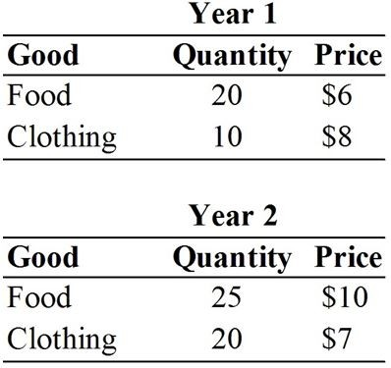

35) Year 1 nominal GDP is
A) $200.
B) $270.
C) $310.
D) $390.
E) $450.
Answer: A
Type: MC Page Ref: 39-42

36) Year 2 nominal GDP is
A) $200.
B) $270.
C) $310.
D) $390.
E) $450.
Answer: D
Type: MC Page Ref: 39-42
37) Suppose that Year 1 is the base year. Year 2 real GDP is
A) $200.
B) $270.
C) $310.
D) $390.
E) $450.
Answer: C
Type: MC Page Ref: 39-42

38) Suppose that Year 2 is the base year. Year 1 real GDP is
A) $200.
B) $270.
C) $310.
D) $390.
E) $450.
Answer: B
Type: MC Page Ref: 39-42

For the following question(s), suppose an economy produces only pens and pencils, and that the quantity and price data is given by this table:

 | Pens | Pencils
Year 1 quantity | 15 | 10
Year 1 price | $12 | $12
Year 2 quantity | 17 | 12
Year 2 price | $14 | $15

39) What is the real GDP in year 2 using base year 1?
A) $418
B) $300
C) $360
D) $338
E) $294
Answer: D
Type: MC Page Ref: 39-42

40) What is the real GDP in year 1 using base year 2?
A) $418
B) $300
C) $360
D) $338
E) $294
Answer: C
Type: MC Page Ref: 39-42
41) What is the real GDP in year 1 using base year 1?
A) $418
B) $300
C) $360
D) $338
E) $294
Answer: B
Type: MC Page Ref: 39-42

42) What is the real GDP in year 2 using base year 2?
A) $418
B) $300
C) $360
D) $338
E) $414
Answer: A
Type: MC Page Ref: 39-42

43) What is approximately the growth rate of real GDP using base year 1?
A) 13%
B) 20%
C) 33%
D) 39%
E) 25%
Answer: A
Type: MC Page Ref: 39-42

44) What is the inflation rate using base year 1?
A) 10%
B) 15%
C) 20%
D) 25%
E) 13%
Answer: C
Type: MC Page Ref: 42-44

45) Real GDP values current production at
A) current year prices.
B) the best estimate of next year's prices.
C) the average of price levels over the entire sample period.
D) base year prices.
E) the purchase price not the asking prices of goods and services.
Answer: D
Type: MC Page Ref: 39-42
46) Construction of chain-weighted real GDP employs the technique of a(n)
A) Herfindahl index.
B) Fisher index.
C) Gini index.
D) body mass index.
E) inflation rate index.
Answer: B
Type: MC Page Ref: 39-44

47) In Canada, real GDP is currently calculated using
A) a variable-weighting scheme.
B) a chain-weighting scheme.
C) a fixed-weighting scheme.
D) an autoregressive scheme.
E) constant-inflation scheme.
Answer: B
Type: MC Page Ref: 39-44

48) To calculate the change in chain-weighted real GDP from one year to the next, we use
A) first-year prices.
B) second-year prices.
C) the percentage change in prices from the first year to the second.
D) average prices over the two years.
E) base-year prices.
Answer: D
Type: MC Page Ref: 39-44

49) Suppose that g1 represents the ratio of year 2 GDP to year 1 GDP, both valued at year 1 prices. Suppose that g2 represents the ratio of year 2 GDP to year 1 GDP, both valued at year 2 prices. The ratio of chain-weighted year 2 GDP to chain-weighted year 1 GDP equals
A) (g1 + g2)/2.
B) (g1 × g2)/2.
C) (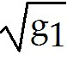 + 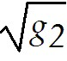)/2.
D) 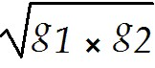.
E) 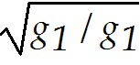.
Answer: D
Type: MC Page Ref: 39-44

50) The implicit GDP price deflator can be defined as
A) (Nominal GDP + Real GDP) / 2.
B) (Nominal GDP / Real GDP) ∗ 100.
C) Nominal GDP - Real GDP.
D) (Real GDP / Nominal GDP) ∗ 100.
E) the consumer price index.
Answer: B
Type: MC Page Ref: 39-44
For the following question(s), suppose that an economy produces only bread and computers. Assume that all production is consumed in each year, and that price and quantity data are given in the table below.

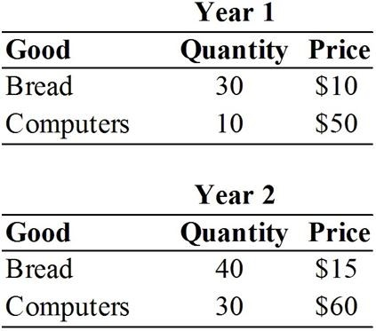

51) If Year 1 is the base year, the GDP price deflator for Year 2 is approximately
A) 100.0.
B) 126.3.
C) 131.3.
D) 181.0.
E) 211.0.
Answer: B
Type: MC Page Ref: 39-44

52) If Year 1 is the base year, the CPI for Year 2 is approximately
A) 100.0.
B) 126.3.
C) 131.3.
D) 181.0.
E) 211.0.
Answer: C
Type: MC Page Ref: 39-44

53) If a particular measure of real GDP consistently underestimates growth in real GDP, then the rate of inflation as measured by the GDP deflator
A) will consistently be overestimated.
B) will consistently be underestimated.
C) will be overestimated and underestimated equally often.
D) cannot be calculated.
E) is not a good predictor of the inflation rate in the CPI.
Answer: A
Type: MC Page Ref: 44-45
54) When we try to measure real GDP and the price level, if we underestimate the growth in real GDP, we will
A) always underestimate the rate of inflation.
B) sometimes underestimate the rate of inflation.
C) always overestimate the rate of inflation.
D) sometimes overestimate the rate of inflation.
E) not be able to measure the rate of inflation.
Answer: C
Type: MC Page Ref: 44-45

55) Significant problems with measuring real GDP and the price level include
A) changes in the number of consumers.
B) changes in relative price levels.
C) changes in standards of living.
D) purchases of used goods.
E) changes in consumption patterns.
Answer: B
Type: MC Page Ref: 44-45

56) Changes in the relative prices of goods causes problems measuring real GDP because
A) consumers change their buying habits.
B) consumers buy less of the cheaper good.
C) firms produce more of the cheaper good.
D) price deflators only measure the price level.
E) they tend to be inaccurate.
Answer: A
Type: MC Page Ref: 44-45

57) Significant problems with measuring real GDP and the price level include
A) changes in the importance of intermediate goods.
B) purchases of used goods.
C) changes in the population size.
D) changes in the quality of goods over time.
E) changes in the size of the government.
Answer: D
Type: MC Page Ref: 44-45

58) It is difficult to accurately measure real GDP because
A) it does not include taxes.
B) it does not include money transfers.
C) it does not accurately take into account the introduction of new goods.
D) it cannot take into account changes in government policy over time.
E) it does not take into account intermediate goods.
Answer: C
Type: MC Page Ref: 44-45
59) An example of a stock would be
A) real GDP.
B) savings.
C) investment.
D) the amount of money in circulation.
E) government spending.
Answer: D
Type: MC Page Ref: 47-50

60) An example of a flow would be the
A) rate at which water goes down the drain.
B) amount of water in a bathtub.
C) percent of pollutants in tap water.
D) pressure of water in a pipe.
E) rate at which the cold water comes out of the tap.
Answer: A
Type: MC Page Ref: 47-50

61) Private disposable income is equal to
A) Y + TR + INT - T.
B) Y + NFP +TR + INT - T.
C) Y - TR - INT + T.
D) Y + CA - G.
E) Y - NFP - R - INT + T.
Answer: B
Type: MC Page Ref: 47-50

62) Suppose that GDP is equal to 1,000, national saving is equal to 200, the current account deficit is equal to 100, and the government budget deficit is equal to 50. Private savings must equal
A) 150.
B) 200.
C) 250.
D) 300.
E) 350.
Answer: C
Type: MC Page Ref: 47-50

63) Suppose that GDP is equal to 1,000, national saving is equal to 200, the current account deficit is equal to 100, and the government budget deficit is equal to 50. Investment must equal
A) 150.
B) 200.
C) 250.
D) 300.
E) 350.
Answer: D
Type: MC Page Ref: 47-50
64) Suppose that in a given country in a given year, GNP equals $2,000, investment expenditures equal $200, government expenditures equal $150, and the current account surplus equals $50. Consumption expenditures therefore equals
A) $1,000.
B) $120.
C) $140.
D) $160.
E) $230.
Answer: D
Type: MC Page Ref: 47-50

65) Additions to the nation's capital stock are brought about through
A) the current account surplus.
B) investment.
C) investment and the current account surplus.
D) investment and the government budget surplus.
E) government deficit.
Answer: B
Type: MC Page Ref: 47-50

66) National savings must equal
A) I + NX + NFP.
B) I - NX - NFP.
C) Y - NFP + C + G.
D) Yd - C.
E) T - TR - INT - G.
Answer: A
Type: MC Page Ref: 47-50

67) The unemployment rate equals
A) 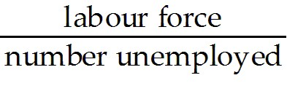.
B) 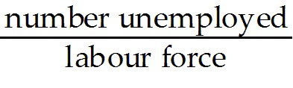.
C) 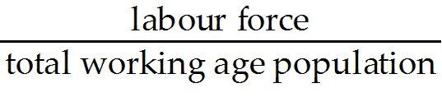.
D) 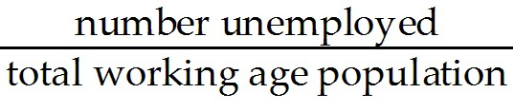.
E) 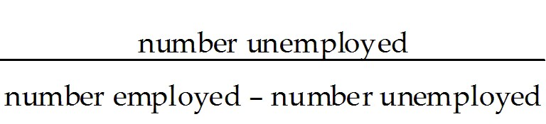.
Answer: B
Type: MC Page Ref: 50-53
68) The participation rate equals
A) .
B) .
C) .
D) .
E) 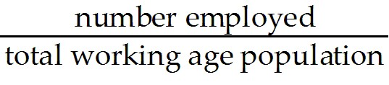.
Answer: C
Type: MC Page Ref: 50-53

69) The employment/population ratio equals
A) 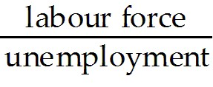.
B) 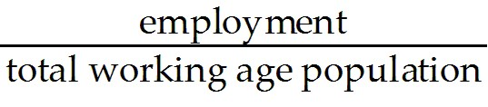.
C) .
D) 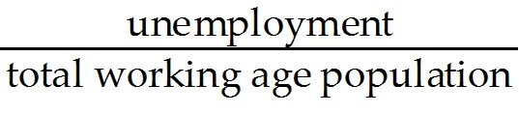.
E) 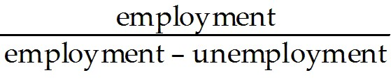.
Answer: B
Type: MC Page Ref: 50-53

70) Discouraged workers are
A) those who have given up looking for work, even though they would like to be employed.
B) those who quit working because they are dissatisfied with their jobs.
C) those who unmotivated workers who bring down a country's productivity.
D) those who would like to find a second job to supplement their income, but have not yet found one.
E) those who only work in the summer months.
Answer: A
Type: MC Page Ref: 50-53

71) When an unemployed worker becomes discouraged and leaves the labour force,
A) the unemployment rate increases.
B) the labour force participation rate increases.
C) the employment/population ratio decreases.
D) the unemployment rate decreases.
E) the employment/population ratio increases.
Answer: D
Type: MC Page Ref: 50-53
72) Problems with interpreting the unemployment rate as a measure of labour market tightness include
A) biases in the CPI and dissatisfied workers.
B) dissatisfied workers and discouraged workers.
C) discouraged workers and variations in how intensively the unemployed search for work.
D) variations in how intensively the unemployed search for work and biases in the CPI.
E) the rental vacancy rate.
Answer: C
Type: MC Page Ref: 50-53

73) List and discuss two reasons why national income accountants could make errors in measuring GDP.
Answer: GDP could be mismeasured because of the existence of the underground economy, and because there are no market prices for the government's contribution to GDP. The NIEA measures only market activity, so if there are illegal transactions involving drugs and prostitution, for example, these will go unrecorded, as will cash transactions and barter transactions designed to avoid taxation. All of this illegal activity falls under the umbrella of "underground" activities. As well, when the government produces goods and services, what is recorded in GDP are the wages and salaries paid to employees. But this could overvalue some government goods and services, and undervalue some others.
Type: ES Page Ref: 36-37

